Table Name -Worker
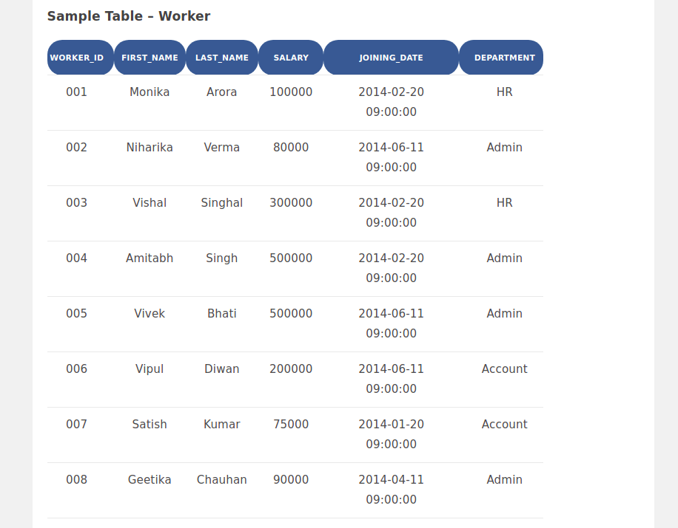
Table Name - Bonus

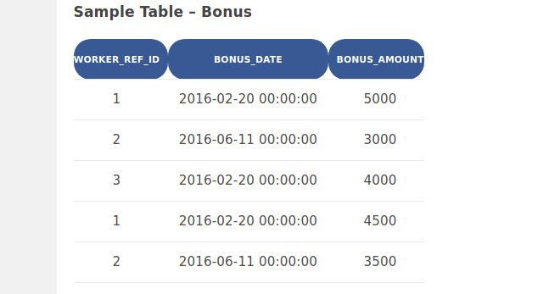

Table Name -Title
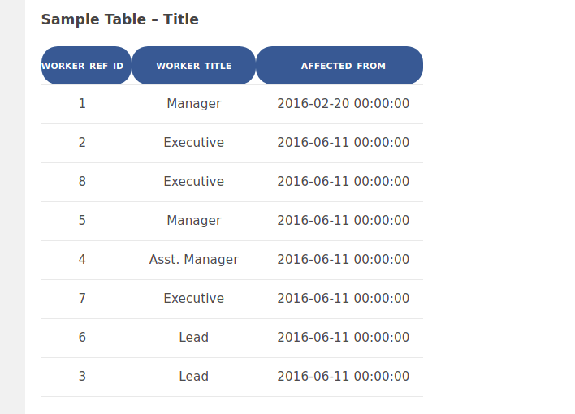

Q-1. Write an SQL query to fetch “FIRST_NAME” from Worker table using the alias name as <WORKER_NAME>.
Ans : Select FIRST_NAME AS WORKER_NAME from Worker;

Q-2. Write an SQL query to fetch “FIRST_NAME” from Worker table in upper case.
Ans : Select upper(first_name) from worker
Q-3. Write an SQL query to fetch unique values of DEPARTMENT from Worker table.
Ans : Select distinct department from worker
Q-4. Write an SQL query to print the first three characters of FIRST_NAME from Worker table.
Ans : Select substring(first_name,1,3) from worker
Q-5. Write an SQL query to find the position of the alphabet (‘a’) in the first name column ‘Amitabh’ from Worker table.
Ans : Select instr(first_name, binary'a') from Worker where first_name = 'Amitabh';
Q-6. Write an SQL query to print the FIRST_NAME from Worker table after removing white spaces from the right side.
Ans : Select rtrim(first_name) from Worker
Q-7. Write an SQL query to print the DEPARTMENT from Worker table after removing white spaces from the left side.
Ans : Select ltrim(first_name) from Worker
Q-8. Write an SQL query that fetches the unique values of DEPARTMENT from Worker table and prints its length.
Ans : Select distinct length(department) from Worker
Q-9. Write an SQL query to print the FIRST_NAME from Worker table after replacing ‘a’ with ‘A’.
Ans : Select replace(first_name,"a","A") from Worker
Q-10. Write an SQL query to print the FIRST_NAME and LAST_NAME from Worker table into a single column COMPLETE_NAME. A space char should separate them.
Ans : Select concat(first_name," ",last_name) as complete_name from Worker
Q-11. Write an SQL query to print all Worker details from the Worker table order by FIRST_NAME Ascending.
Ans : Select concat(first_name," ",last_name) as complete_name from Worker
Q-12. Write an SQL query to print all Worker details from the Worker table order by FIRST_NAME Ascending and DEPARTMENT Descending.
Ans : Select * from Worker order by first_name asc, department desc
Q-13. Write an SQL query to print details for Workers with the first name as “Vipul” and “Satish” from Worker table.
Ans : Select * from Worker where first_name in ("Satish","vipul")
Q-14. Write an SQL query to print details of workers excluding first names, “Vipul” and “Satish” from Worker table.
Ans : Select * from Worker where first_name not in ("Satish","vipul")
Q-15. Write an SQL query to print details of Workers with DEPARTMENT name as “Admin”.
Ans : Select * from Worker where department='Admin'
Q-16. Write an SQL query to print details of the Workers whose FIRST_NAME contains ‘a’.
Ans : Select * from Worker where first_name like '%a%'
Q-17. Write an SQL query to print details of the Workers whose FIRST_NAME ends with ‘a’.
Ans : Select * from Worker where first_name like '%a'
Q-18. Write an SQL query to print details of the Workers whose FIRST_NAME ends with ‘h’ and contains six alphabets.
Ans : Select * from Worker where first_name like '______h'
Q-19. Write an SQL query to print details of the Workers whose SALARY lies between 100000 and 500000.
Ans : Select * from Worker where salary between 100000 and 500000
Q-20. Write an SQL query to print details of the Workers who have joined in Feb’2014.
Ans : Select * from Worker where year(joining_date)= 2014 and month(joining_date)=2
Q-21. Write an SQL query to fetch the count of employees working in the department ‘Admin’.
Ans : Select count(*) from Worker where department='Admin'
Q-22. Write an SQL query to fetch worker names with salaries >= 50000 and <= 100000.
Ans : Select first_name from Worker where salary between 50000 and 100000
Q-23. Write an SQL query to fetch the no. of workers for each department in the descending order.
Ans : select department, count(worker_id) no_of_workers from worker
group by department
order by no_of_workers desc
Q-24. Write an SQL query to print details of the Workers who are also Managers.
Ans : select distinct w.first_name, t.worker_title from worker w
inner join title t
on w.worker_id = t.worker_ref_id
and t.worker_title in ('manager');
Q-25. Write an SQL query to fetch duplicate records having matching data in some fields of a table.
Ans : select worker_title, affected_from, count(*) from title
group by worker_title, affected_from
having count(*) > 1;
Q-26. Write an SQL query to show only odd rows from a table.
Ans : select * from worker where mod (worker_id, 2) <> 0;

Q-27. Write an SQL query to show only even rows from a table.
Ans : select * from worker where mod (worker_id, 2) =0;
Q-28. Write an SQL query to clone a new table from another table.
Ans : CREATE TABLE WorkerClone LIKE Worker;
Q-29. Write an SQL query to fetch intersecting records of two tables.
Ans : (select * from worker) intersect (select * from workerclone);
Q-30. Write an SQL query to show records from one table that another table does not have.
Ans : select * from worker minus select * from title;
Q-31. Write an SQL query to show the current date and time.
Ans : select now()
Q-32. Write an SQL query to show the top n (say 10) records of a table.
Ans : select * from worker limit 10;
Q-33. Write an SQL query to determine the nth (say n=5) highest salary from a table.
Ans : select salary from worker order by salary desc limit 4,1;
Q-34. Write an SQL query to determine the 5th highest salary without using TOP or limit method.
Ans : select salary from worker w1
where 4 = (select count( distinct ( w2.salary ) ) from worker w2 where w2.salary >= w1.salary);
Q-35. Write an SQL query to fetch the list of employees with the same salary.
Ans : select w.first_name, w.salary from worker W, worker W1
where (W.salary= W1.salary) and (W.first_name!= W1.first_name)
Q-36. Write an SQL query to show the second highest salary from a table.
Ans : select max(salary) from worker
where salary not in (select max(salary) from worker);
Q-37. Write an SQL query to show one row twice in results from a table.
Ans : select * from worker W where W.worker_id=1
union all
select * from Worker W1 where W1.worker_id=1 ;
Q-38. Write an SQL query to fetch intersecting records of two tables.
Ans : (select * from worker) intersect (select * from workerclone);
Q-39. Write an SQL query to fetch the first 50% records from a table.
Ans : select * from worker
where worker_id <= (select count(worker_id)/2 from worker);
Q-40. Write an SQL query to fetch the departments that have less than five people in it.
Ans : select department from worker
group by department having count(worker_id) < 5;
Q-41. Write an SQL query to show all departments along with the number of people in there.
Ans : select department, count(worker_id) as 'no.of workers' from
worker group by department having count(worker_id);
Q-42. Write an SQL query to show the last record from a table.
Ans : select * from worker where worker_id = (select max(worker_id) from worker);
Q-43. Write an SQL query to fetch the first row of a table.
Ans : select * from worker where worker_id = (select min(worker_id) from worker);
Q-44. Write an SQL query to fetch the last five records from a table.
Ans : select * from worker where worker_id <=5 union
select * from (select * from worker w order by w.worker_id desc) as w1 where w.worker_id <=5;
Q-45. Write an SQL query to print the name of employees having the highest salary in each department.
Ans : select t.first_name from(select max(salary) as totalsalary,department from
worker group by department) as tempnew inner join worker t on tempnew.department=t.department and tempnew.totalsalary=t.salary;
Q-46. Write an SQL query to fetch three max salaries from a table.
Ans : select distinct salary from worker a where 3 >= (select count(distinct salary)
from worker b where a.salary <= b.salary) order by a.salary desc;
Q-47. Write an SQL query to fetch three min salaries from a table.
Ans : select distinct salary from worker a where 3 >= (select count(distinct salary)
from worker b where a.salary >= b.salary) order by a.salary desc;
Q-48. Write an SQL query to fetch nth max salaries from a table.
Ans : select distinct salary from worker a where n >= (select count(distinct salary)
from worker b where a.salary <= b.salary) order by a.salary desc;
Q-49. Write an SQL query to fetch departments along with the total salaries paid for each of them.
Ans : select department, sum(salary) from worker group by department
Q-50. Write an SQL query to fetch the names of workers who earn the highest salary.
Ans : select first_name, salary from worker where salary=(select max(salary)
from worker);

