**THEME BASED PROJECT REPORT**

**ON**

**GSM BASED HOME AUTOMATION**

**Maneesh (1602-18-734-021)**

**Meghana Naik (1602-18-734-022)**

**Megha Syam (1602-18-734-023)**

**Azeem Pasha (1602-18-734-024)**

**DEPARTMENT OF ELECTRICAL AND ELECTRONICS ENGINEERING** **VASAVI COLLEGE OF ENGINEERING (Autonomous) (Affiliated to Osmania University)  Ibrahimbagh , Hyderabad-31**

**ABSTRACT**

            The project “GSM BASED HOME CONTROL” is intended to automate the certain functions of home appliances. The main scope of this project is that we can control our home from anywhere in the world where GSM network is available. In this project we are building a home automation system, where one can control the home appliances, using the simple gsm based phone, just by sending SMS through his phone. In this project, no smart phone is required, just the old phone will work to switch ON and OFF any device.

With the recent expansion of communication networks, smart home applications can be further enhanced with new dimension of capabilities that were not available before. The device is much helpful in controlling home. It reduces the wastage of valuable time and our daily life become easier and flexible.

In this project, how to set up your mobile phone to control a relay through a simple SMS is shown. The mobile phone will send the messages and a SIM900 module will receive the message.

SIM900 modules are handy for a variety of different applications including vehicle tracking, remote automation, or even for simple things like feeding your fish when you are not home.

The SIM900 module will communicate with arduino through serial communication and the arduino will turn the relay on or off according to the message it receives.

**INTRODUCTION**

We are amid an era where the technology has solved most of our problems. The proposed home automation system allows user to switch ON and OFF the lights, fans etc. From any part of the world since this system is controlled using GSM module. The concept behind this is to receive the sent message string from mobile and then processing it to perform the desired function. This is most useful for people living alone since it allows them to remotely monitor their appliances.

This system can be implemented with other communicating modules like Bluetooth module, WI-FI module etc. But they have range limitation i.e. they can operate up to a certain distance depending on the range. But GSM based system allows the user to control the device from any part of the world if he should be subscribed to a service provider. The system will also give the current status of appliances.

**COMPONENTS**

* **Arduino Uno**: We use Arduino due to its simplicity and it also provides a much digital pin to interface with LCD, GSM module and relay module at the same time.
* [**GSM SIM900A**](https://microcontrollerslab.com/sim300d-gsm-module/): If you are familiar with GSM module then you have known how it works if not search it on our website. We use only three pins of GSM RX, TX, and ground.
* **2 Channel Relay Module**: It switches on and off using a 5v logical signal from Arduino. It can bear up to 250VAC and 10A. These modules have 2 channels so we can control 2 AC devices at a time.
* **External 12 Volt Supply**: 12-volt dc supply is required for the GSM module.
* **AC bulbs with holders**: AC bulbs are used to represent devices and appliances. Because it is easy to handle and very useful when you are prototyping any AC project.
* **AC wire with plug**:  Good quality wire should be used because we are working with higher voltages. It is always useful to use electrical tape to protect connections.
* **Cell phone, Bread board**

**BLOCK DIAGRAM AND WORKING**



In this project, **Arduino** is used for controlling whole the process. Here we have used GSM wireless communication for controlling home appliances. We send some commands like “Turn_ on1”, “Turn_ off” and so on for controlling AC home appliances. After receiving given commands by Arduino through GSM, Arduino send signal to relays, to switch ON or OFF, the home appliances using a relay driver. When we send SMS to GSM module by Mobile, then GSM receives that SMS and sends it to Arduino. Now Arduino reads this SMS and extract main command from the received string and stores in a variable. After this, Arduino compare this string with predefined string. If match occurred, then Arduino sends signal to relay via relay driver for turning ON and OFF the home appliances. And relative result also be sent to the user regarding the state of the appliance.

**CIRCUIT DIAGRAM AND DESCRIPTION**

Connections of this **GSM based home automation circuit** are quite simple, usually the RX and TX pin of GSM module can be directly connected at TX and RX pin of Arduino respectively but in our project we are connecting the RX and TX pins of the GSM to pin number 8 and 7 respectively. And GSM module is powered by using a 12-volt adaptor. The digital input pins of the relay are connected to pins number 2 and 3 on the Arduino for controlling Light and Charger respectively.

5-volt pin on the Arduino is connected to Vcc on the relay.

|  |  |  |  |
| --- | --- | --- | --- |
| **ARDUINO** | **RELAY** | **ARDUINO** | **GSM** |
| Pin-2 | IN1 | Pin-8 | RX |
| Pin-3 | IN2 | Pin-7 | TX |
| 5 v | VCC | GND | GND |
| GND | GND |  |  |

C:\Users\Admin\Desktop\GSM final.tif

**CODE DESCRIPTION**

#include <SoftwareSerial.h>  // Library for using serial communication

SoftwareSerial SIM900(7, 8);  // Pins 7, 8 are used as used as software serial pins

String incomingData;  // for storing incoming serial data

String message = ""; // for storing incoming serial data

int relay_pin1 = 2;  // Initialized a pin for relay module

int relay_pin2 = 3;  // Initialized a pin for relay module

void setup()

{

   Serial.begin(115200);  // baud rate for serial monitor

  SIM900.begin(19200);  // baud rate for GSM shield

   pinMode(relay_pin1, OUTPUT);   // Setting early pin as output pin

   digitalWrite(relay_pin1, HIGH);  // Making relay pin initially low

   pinMode(relay_pin2, OUTPUT);

   digitalWrite(relay_pin2, HIGH);

  SIM900.print("AT+CMGF=1\r");    // set SMS mode to text mode

  delay(100);

  SIM900.print("AT+CNMI=2,2,0,0,0\r");   // set gsm module to tp show the output on serial out

  delay(100);

}

void loop()

{

  receive_message(); //Function for receiving sms

  if(incomingData.indexOf("Turn_on1")>=0)  // if received command is to turn on relay

  {

     digitalWrite(relay_pin1, LOW);

    message = "Switch1 is turned ON";

     send_message(message);  // Send a sms back to confirm that the relay is turned on

  }

  if(incomingData.indexOf("Turn_off1")>=0)  // if received command is to turn off relay

  {

     digitalWrite(relay_pin1, HIGH);

     message = "Switch1 is turned OFF";

     send_message(message);  // Send a sms back to confirm that the relay is turned off

  }

  if(incomingData.indexOf("Turn_on2")>=0)

  {

     digitalWrite(relay_pin2, LOW);

    message = "Switch2 is turned ON";

     send_message(message);

  }

  if(incomingData.indexOf("Turn_off2")>=0)

 {

    digitalWrite(relay_pin2, HIGH);

    message = "Switch2 is turned OFF";

    send_message(message);

  }

}

void receive_message()

{

  if (SIM900.available() > 0)

  {

     incomingData = SIM900.readString();   // Get the data from the serial port.

     Serial.print(incomingData);

     delay(10);

  }

}

void send_message(String message)

{

  SIM900.println("AT+CMGF=1");    //Set the GSM Module in Text Mode

  delay(100);

  SIM900.println("AT+CMGS=\"+917981276675\"");   // Replace it with your mobile number

  delay(100);

  SIM900.println(message);     // The SMS text you want to send

  delay(100);

  SIM900.println((char)26);    // ASCII code of CTRL+Z

  delay(100);

  SIM900.println();

  delay(1000);

}

**Output on serial monitor:-**

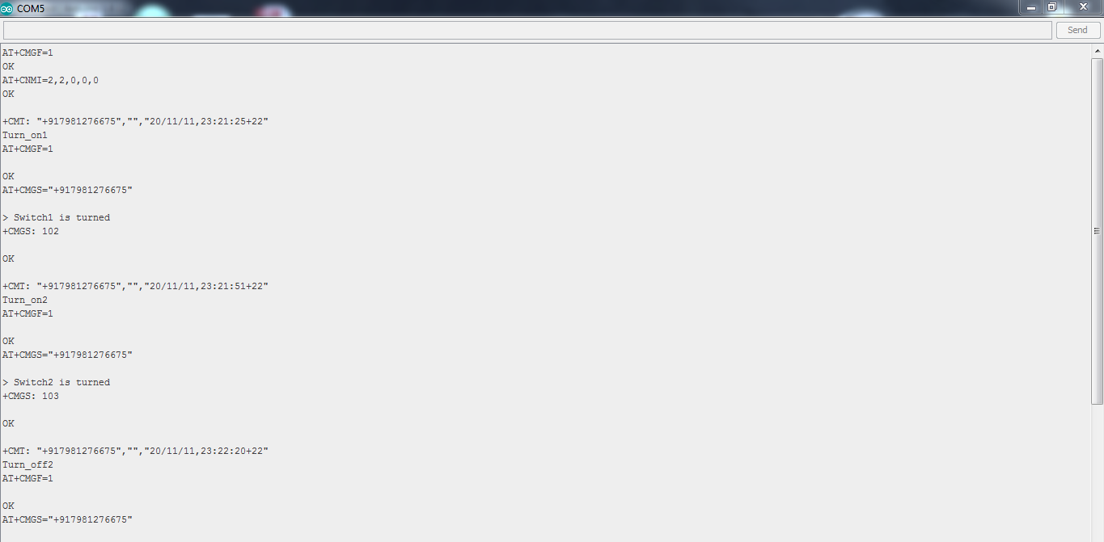

**IMPLEMENTATION AND RESULTS**

After the connections are made and checked properly the system is now ready for use. The system works by sending a predefined text string from a mobile phone which can be present in any part of the world. The string is then received by the Arduino which decodes it and checks if it matches with the already stored string in command. If it matches the Arduino drives the relay which further switches ON and OFF the electrical appliances. The sending and receiving of the strings from/ to the Arduino can be achieved by AT commands.

**CONCLUSION AND FUTURE SCOPE**

 With the help of proposed system we can control the connected electrical appliances remotely. This helps in reducing power consumption. This result of this project shows that microcontroller is a very power device for building smart electronic projects/devices like Home Automation System that can control the devices remotely.

 There are several drawbacks of this system which can be further improved. Using GSM module and sending text message may cost charges so an interface can be developed for communication of Arduino with a mobile phone. A GUI can be made which shows a blueprint of the room in which appliances like lights and fans can be controlled by touching them on the screen. A feedback mechanism or a power consumption mechanism can be added which shows the current status of appliances and power consumed by them. For a small demonstration purpose, a Lcd screen is attached which shows the status of appliances i.e. ON or OFF. Further, an acknowledgment SMS can be sent from Arduino to Mobile which tells whether the appliances are ON or OFF.

**REFERENCES / BIBLIOGRAPHY**

**Create.arduino.cc -** For how to use a relay.

**Randomnerdtutorials.com -** As a guide to SIM900 GSM GPRS shield with Arduino.