**Name**: Meghna Ijjapureddy

**Batch** **Code**: LISUM20

**Submission** **Date**: 5th May 2023

**Submitted** **to**: Data Glacier

Model Saving and deploying:

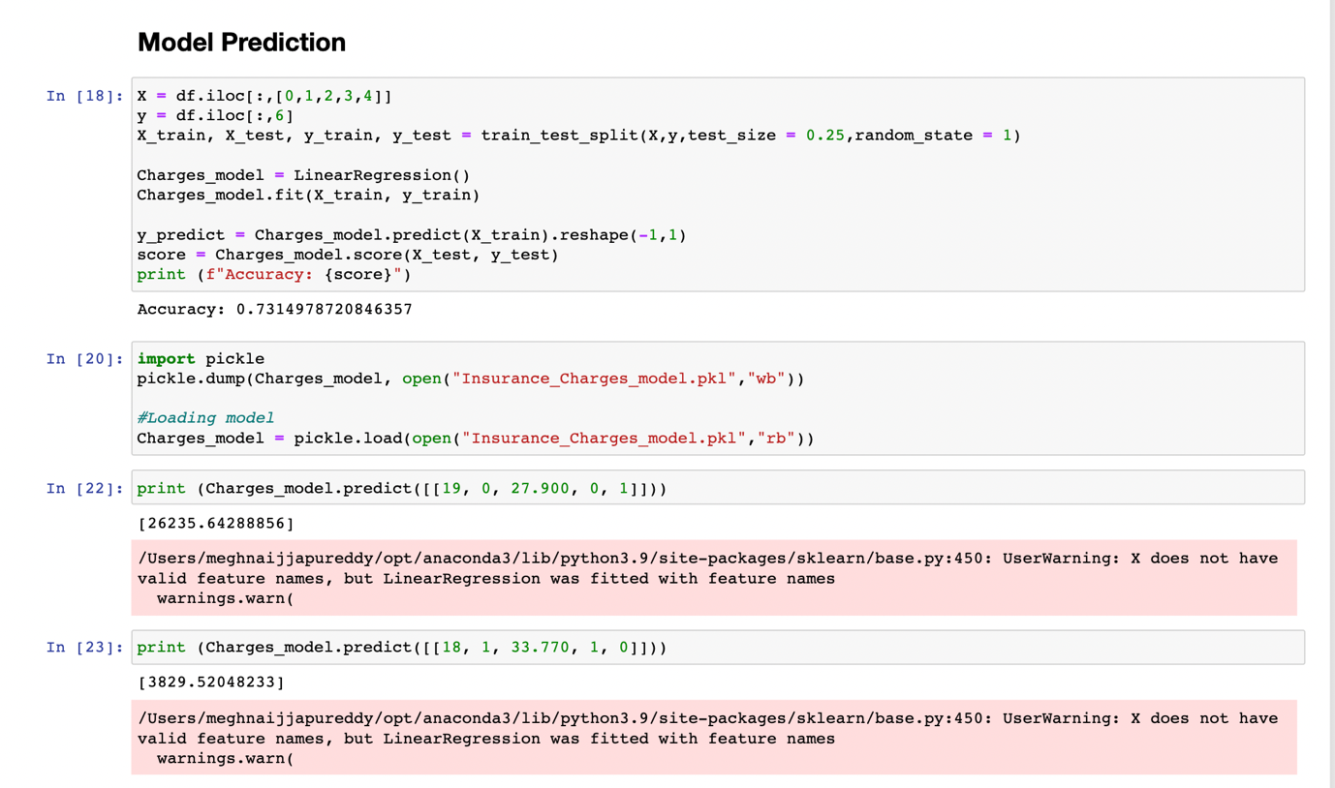

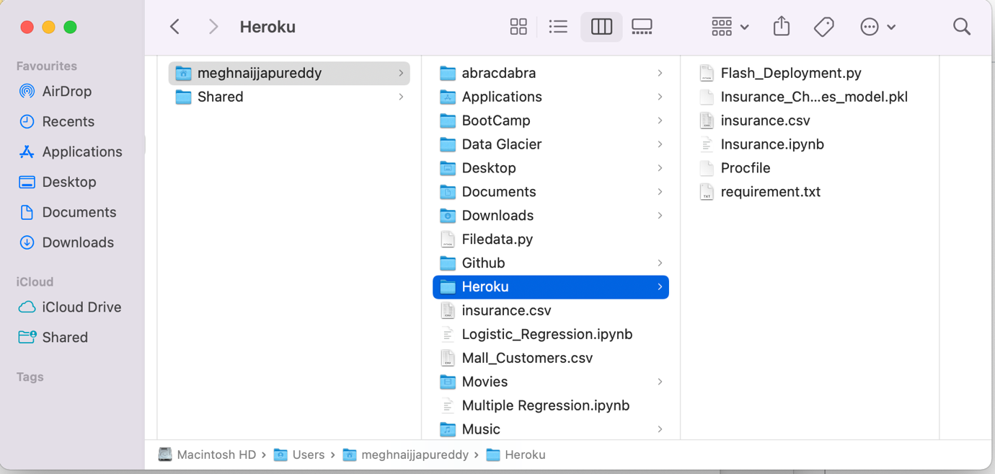

Flask Deployment

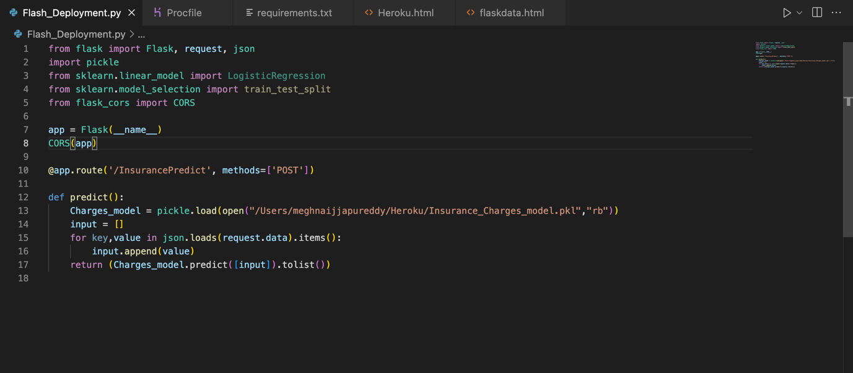

HTML code:

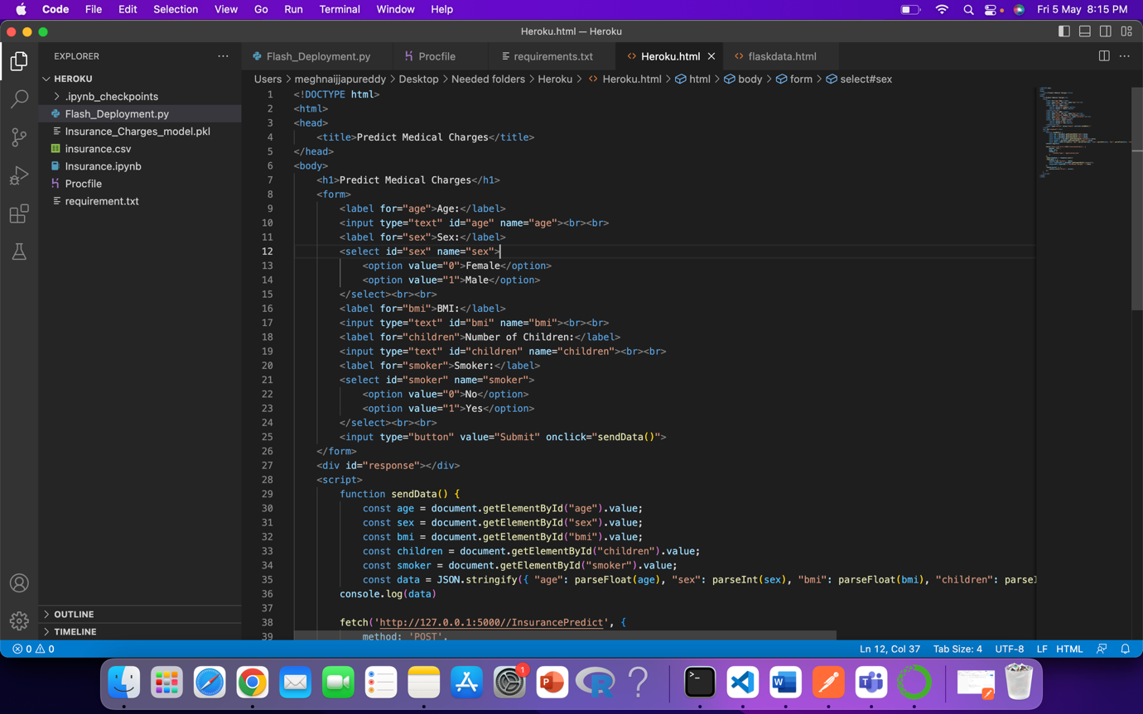

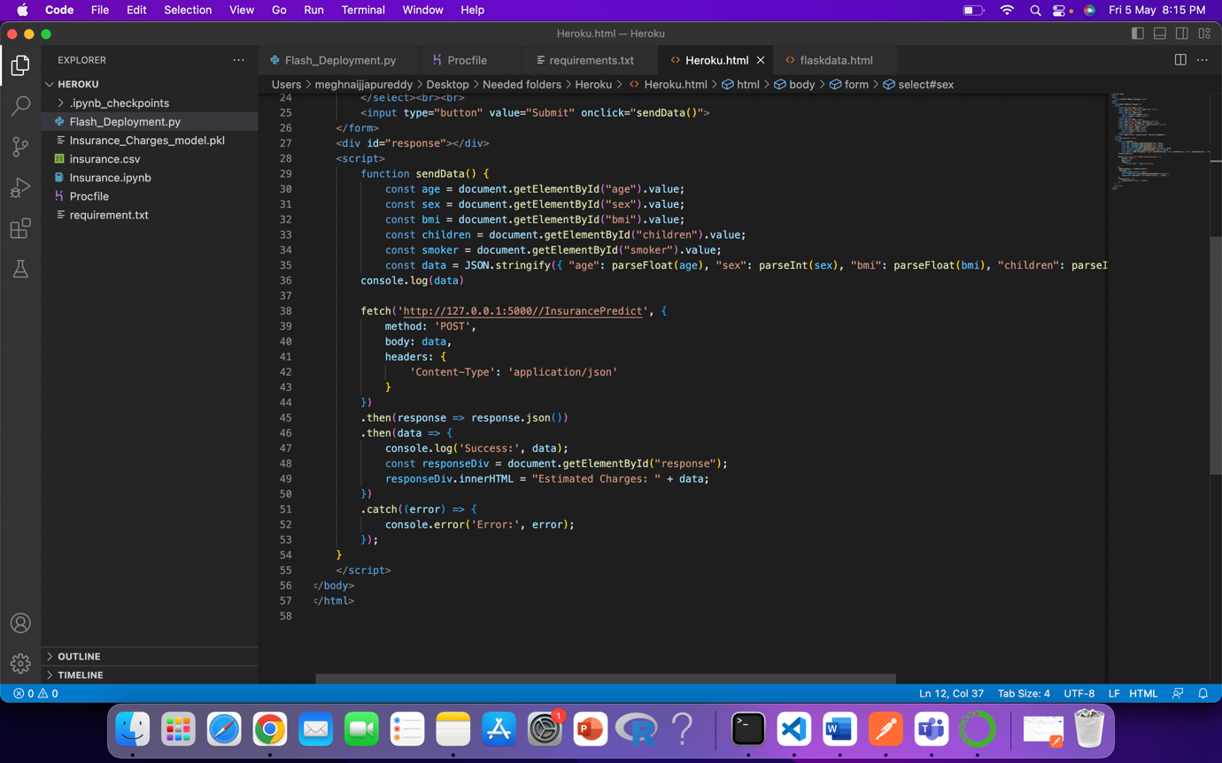

HTML web page:

