package connection;

import org.bson.Document;

import com.mongodb.client.FindIterable;

import com.mongodb.client.MongoClient;

import com.mongodb.client.MongoClients;

import com.mongodb.client.MongoCollection;

import com.mongodb.client.MongoDatabase;

import com.mongodb.client.MongoIterable;

public class collection_two {

public static void main(String[] args) {

// Creating a Mongo client

MongoClient mongoClient = MongoClients.*create*("mongodb://localhost:27017");

MongoDatabase database = mongoClient.getDatabase("myDb");

MongoCollection<Document> collection = database.getCollection("products");

Document priceRangeQuery = new Document("price", new Document("$gte", 700).append("$lte", 900));

FindIterable<Document> products = collection.find(priceRangeQuery);

for (Document product : products) {

System.*out*.println(product.toJson());

}

}

}

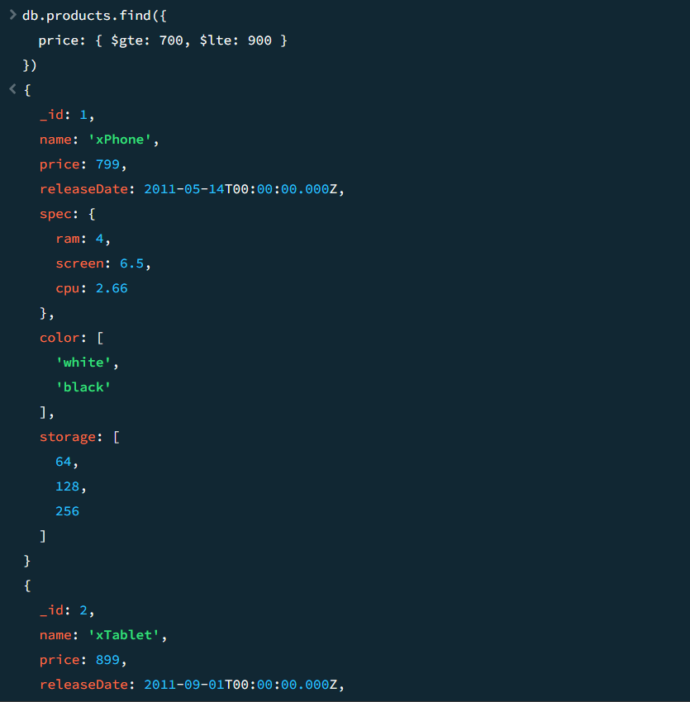

package connection;

import java.util.Arrays;

import org.bson.Document;

import com.mongodb.client.AggregateIterable;

import com.mongodb.client.FindIterable;

import com.mongodb.client.MongoClient;

import com.mongodb.client.MongoClients;

import com.mongodb.client.MongoCollection;

import com.mongodb.client.MongoDatabase;

import com.mongodb.client.MongoIterable;

public class collection_two {

public static void main(String[] args) {

// Creating a Mongo client

MongoClient mongoClient = MongoClients.*create*("mongodb://localhost:27017");

MongoDatabase database = mongoClient.getDatabase("myDb");

MongoCollection<Document> collection = database.getCollection("products");

AggregateIterable<Document> result = collection.aggregate(Arrays.*asList*(

new Document("$match", new Document("price", new Document("$ne", null))), // filter documents where price is not null

new Document("$group", new Document("_id", null)

.append("totalPrice", new Document("$sum", "$price"))

.append("count", new Document("$sum", 1)))

));

for (Document doc : result) {

System.*out*.println("Total Price: " + doc.getInteger("totalPrice"));

System.*out*.println("Count: " + doc.getInteger("count"));

}

}

}

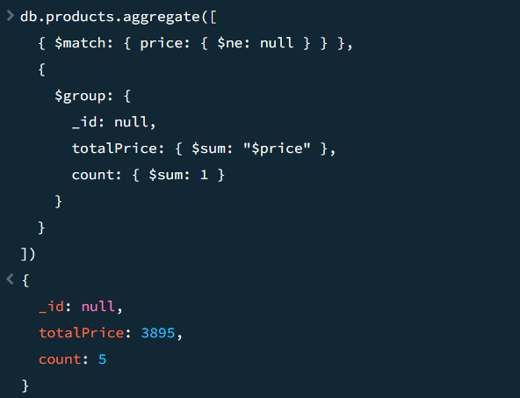

package connection;

import java.util.Arrays;

import org.bson.Document;

import com.mongodb.client.AggregateIterable;

import com.mongodb.client.FindIterable;

import com.mongodb.client.MongoClient;

import com.mongodb.client.MongoClients;

import com.mongodb.client.MongoCollection;

import com.mongodb.client.MongoDatabase;

import com.mongodb.client.MongoIterable;

public class collection_two {

public static void main(String[] args) {

// Creating a Mongo client

MongoClient mongoClient = MongoClients.*create*("mongodb://localhost:27017");

MongoDatabase database = mongoClient.getDatabase("myDb");

MongoCollection<Document> collection = database.getCollection("sales");

AggregateIterable<Document> result = collection.aggregate(Arrays.*asList*(

new Document("$sort", new Document("item", 1).append("price", -1)),

new Document("$group", new Document("_id", "$item")

.append("maxPrice", new Document("$first", "$price"))

.append("document", new Document("$first", "$$ROOT"))),

new Document("$replaceRoot", new Document("newRoot", "$document"))

));

for (Document doc : result) {

System.*out*.println(doc.toJson());

}





