**Task 1: Exploratory Data Analysis (EDA) and Business Insights**

**Market Potential:** South America and North America appear to have the highest market potential based on the transaction volume.

**Regional Focus:** Businesses operating in these regions might need to prioritize their marketing and sales efforts to capitalize on the higher transaction activity.

**Expansion Strategy:** If a business is looking to expand into new regions, South America and North America could be attractive options due to their existing transaction volume.

**Sales Strategy:** The business might want to focus on promoting and expanding its Books and Electronics categories to further increase sales.

**Product Mix:** The current product mix seems to be skewed towards Books and Electronics, which could be a strategic decision or a reflection of market demand.

**Inventory Management:** The business might need to adjust its inventory levels to match the sales performance of each category.

**Product Strategy:** The business might want to focus on promoting and expanding the product lines of ActiveWear Smartwatch, SoundWave Headphones, and HomeSense Desk Lamp to further increase sales.

**Inventory Management:** The business might need to adjust its inventory levels to match the sales performance of each product.

**Customer Preferences:** The chart provides insights into customer preferences. For example, it seems that customers are interested in fitness and technology products (ActiveWear Smartwatch, SoundWave Headphones) as well as home decor (HomeSense Desk Lamp).

**Market Potential:** North America appears to be the most promising market for all product categories.

**Regional Preferences:** There might be regional preferences for certain product categories. For example, Books seem to be more popular in North America and Asia compared to South America.

**Marketing Strategy:** The business might need to tailor its marketing strategies to each region to cater to specific preferences.

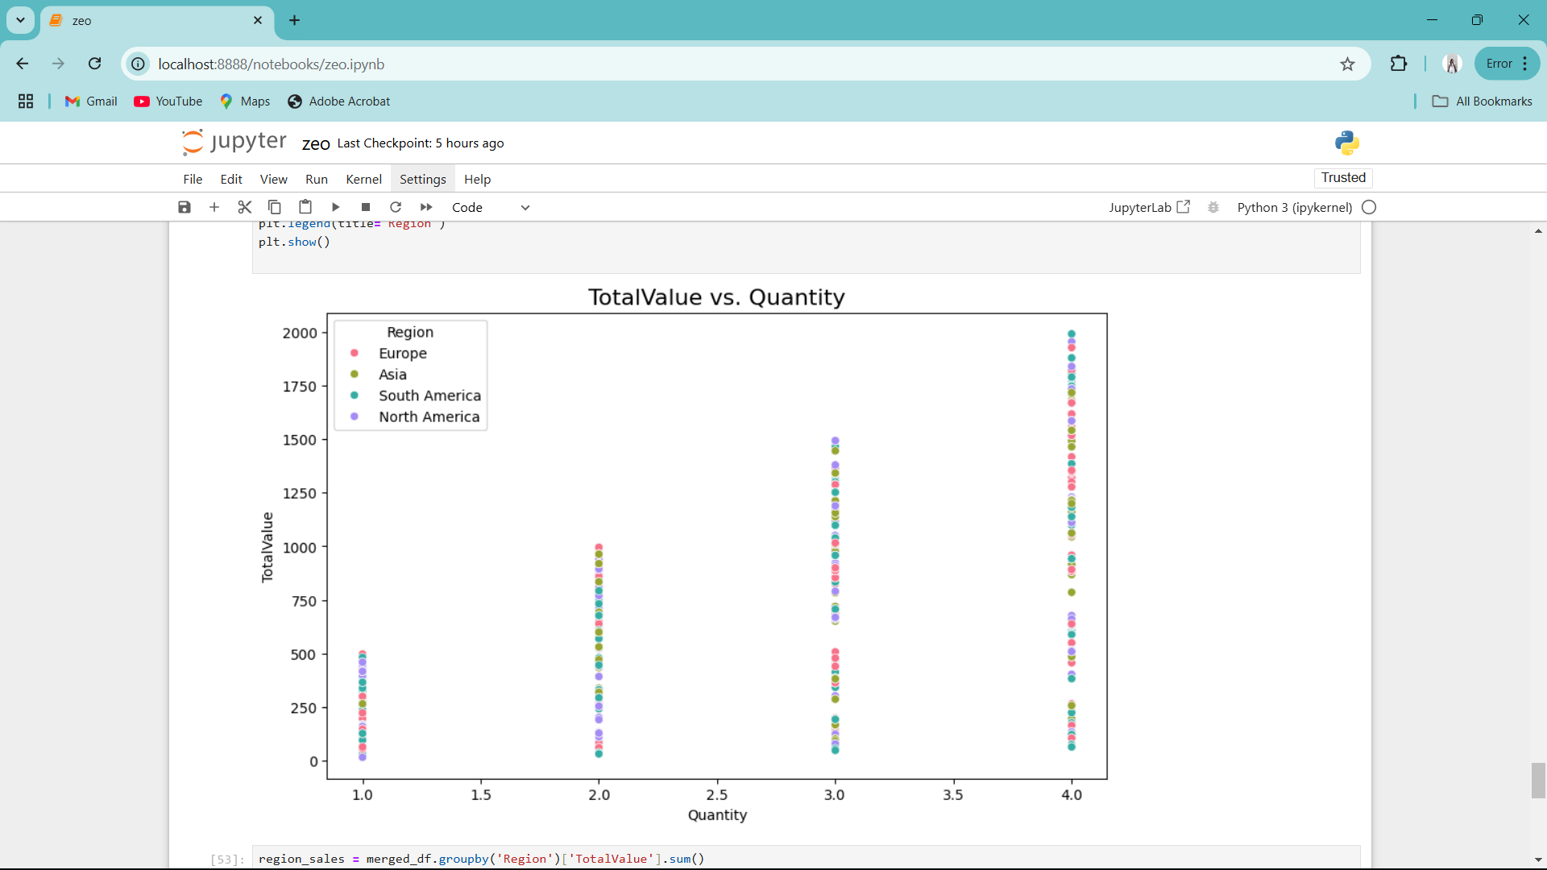

**Sales Performance:** Regions with a higher concentration of data points towards the upper right corner of the plot (e.g., North America) might have higher sales performance, indicating larger transactions with higher quantities.

**Regional Differences:** The distribution of data points for each region can reveal insights into regional sales patterns and customer behavior.

**Outliers:** Any data points that are significantly far from the general trend might represent unusual transactions or potential anomalies that require further investigation.