

**Task Level: Advanced**

**Crime Rate Analysis in 2022 across India's States and Union Territories: A Comprehensive Data-Driven Study**

**By Meghna Ghosh**

**Data Analytics Intern at CodEvo Solutions**

**Id: 592zr1wq**

**Date: 26/08/2024**

**CONTENTS**

|  |  |  |
| --- | --- | --- |
| S. No | Content | Page no. |
| 1.  2.  3.  4.  5.  6. | About this Report  Methodology  Analytical Tools and Techniques  Visualization and Findings  Recommendations  Conclusion | 3  4  5  6-8  9  10 |

**ABOUT THIS REPORT**

This report presents an in-depth analysis of crime rates across India in the year 2022, focusing on all states and union territories. The primary objective of this study is to provide a comprehensive understanding of the crime landscape in the country, identify key trends, and offer insights that can inform policy decisions and safety initiatives.

In recent years, crime has been a critical concern for governments, law enforcement agencies, and the public alike. With the advent of advanced data analytics and the availability of large datasets, it has become possible to analyze crime patterns more accurately and efficiently. This report leverages data sourced from the Open Government Data (OGD) platform, ensuring that the findings are based on reliable and up-to-date information.

The analysis presented in this report is driven by the need to understand the varying crime rates across different regions of India. It aims to uncover the underlying factors contributing to these variations and highlight areas that require immediate attention from policymakers and law enforcement agencies.

By organizing, cleaning, and analyzing the data in Microsoft Excel, and visualizing it using Power BI, this report provides a clear and actionable view of the crime situation in India. The visualizations are designed to be intuitive, allowing readers to quickly grasp the key trends and insights. This report not only serves as a tool for understanding the current crime landscape but also as a foundation for future research and policy formulation.

In addition to identifying and analyzing crime trends, this report also offers recommendations for mitigating crime and enhancing public safety. These recommendations are grounded in the data-driven insights derived from the analysis, ensuring that they are both practical and effective.

**METHODOLOGY**

Data Collection:

Data from the Open Government Data (OGD) platform for 2022 includes crime statistics across various categories for all states and union territories.

Data Cleaning and Preparation:

The dataset was cleaned in Excel, addressing missing data, removing duplicates, and normalizing for consistency.

Data Organization:

Cleaned data was structured into tables with rows for incidents and columns for variables like state and crime type, divided into sheets for clarity and validated for accuracy.

Analytical Tools and Techniques:

Analysis was conducted using Microsoft Excel and Power BI.

* Descriptive Analysis: Calculated basic statistics to understand key trends and variations.
* Trend Analysis: Examined temporal patterns to spot significant changes in crime rates.
* Comparative Analysis: Compared crime rates across regions to identify high and low crime areas.
* Geospatial Analysis: Used Power BI maps to visualize the geographical distribution of crimes across India.

Visualization:

Visualizations were created to clearly present the findings, including bar charts, line graphs, and geospatial maps. Interactive dashboards allowed for dynamic data exploration, ensuring insights were accessible and actionable.

**ANALYTICAL TOOLS AND TECHNIQUES**

This report used Microsoft Excel and Power BI for data analysis and visualization, each contributing uniquely to the comprehensive analysis of crime rates across India in 2022.

Microsoft Excel

* Data Cleaning: Excel was used to clean the raw data, handle missing values, remove duplicates, and normalize the dataset for consistency.
* Data Organization: Excel’s tabular structure and pivot tables were utilized to organize and categorize crime data by type, region, and other variables, making it easier to analyse.
* Preliminary Analysis: Basic statistical functions (e.g., averages, medians) were applied to gain initial insights into trends and variations across regions.
* Pivot Tables and Charts: Excel’s pivot tables and basic charts facilitated the summarization and preliminary visualization of data.

Power BI

* Interactive Dashboards: Power BI enabled the creation of interactive dashboards that allowed for in-depth exploration of the data, enhancing the ability to derive actionable insights.
* Advanced Visualizations: Various visualization options, including bar charts, line graphs, and geospatial maps, were used to clearly represent complex data and trends.
* Geospatial Analysis: Power BI’s mapping features highlighted the geographical distribution of crimes, identifying hotspots and regional disparities.
* Trend Analysis: Temporal visualizations tracked changes in crime rates over the year, highlighting significant trends and anomalies.
* Data Integration and Modeling: Power BI’s capabilities allowed for deeper analysis, such as calculating crime rates per capita and exploring correlations between crime types.
* Report Generation: The findings were compiled into a visually appealing and easily shareable report, ensuring effective communication of insights.

**VISUALIZATION AND FINDINGS**

This section presents the visualizations and key insights from the 2022 crime data analysis across India, created using Power BI and Microsoft Excel.

1. Visualization Techniques

1.1. Interactive Dashboards

Purpose: Enable dynamic data exploration by filtering regions, crime types, and time periods.

Outcome: Facilitates in-depth investigation of crime trends and regional spikes.

1.2. Bar Charts and Histograms

Purpose: Compare crime rates across states and show the distribution of crime types.

Outcome: Highlights regions with high or low crime rates and prevalent crime types.

1.3. Line Graphs

Purpose: Illustrate monthly crime rate trends throughout 2022.

Outcome: Reveals patterns, fluctuations, and seasonal variations in crime rates.

1.5. Pie Charts

Purpose: Represent the proportion of different crime types.

Outcome: Provides insight into the composition of crimes within regions.

**-KEY FINDINGS AND INSIGHTS**

Crime Rates across States vs. Union Territories

* States: Generally report higher crime rates compared to Union Territories, reflecting larger populations and greater crime volumes.
* Union Territories: Tend to have lower crime rates due to smaller populations and limited geographical scope.

Crime Types Comparison

* Violent Crimes: States show higher occurrences of violent crimes, including murder, rape, and grievous hurt. Union Territories have fewer instances but show higher per capita rates in some violent categories.
* Murder and Attempted Murder: States like Uttar Pradesh and Maharashtra report higher total cases. Union Territories, such as Delhi, show significant rates per capita.
* Rape: States report high total numbers, while Union Territories show higher rates per capita.

Property Crimes:

* Robbery and Dacoity: Higher total cases in states, with Union Territories showing higher per capita rates.
* Arson: States have more total incidents, but Union Territories exhibit notable rates per capita.

Other Crimes:

* Kidnapping and Abduction: States record more total cases; Union Territories report higher per capita rates.
* Rioting: Higher total numbers in states; Union Territories have higher rates per capita.

Regional Trends

* States: Exhibit broader crime trends due to larger and more diverse populations. High-volume crimes include murder, rape, and robbery.
* Union Territories: Show more pronounced per capita crime rates in certain categories, indicating localized issues despite smaller total numbers.

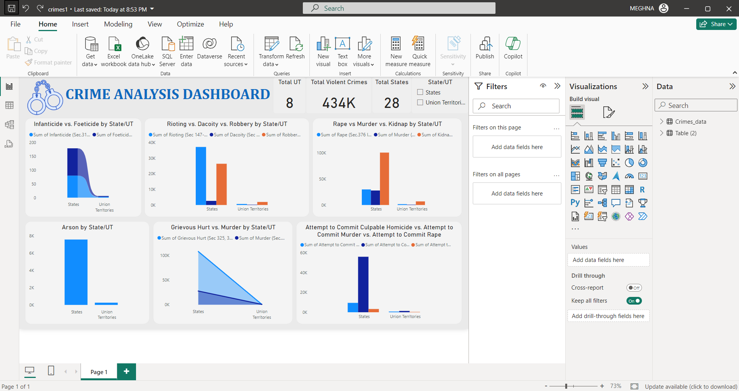

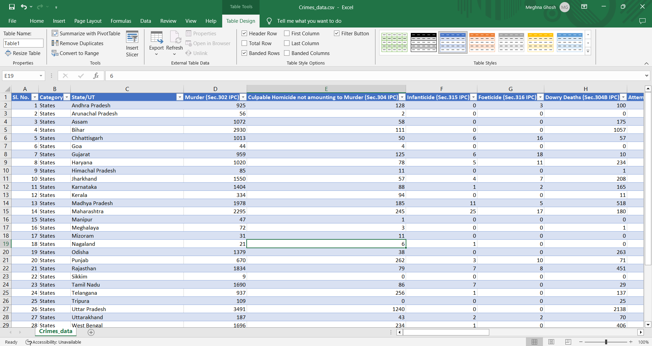

**Recommendations**

Strengthening Law Enforcement and Resources

* Enhanced Patrol: Increase police presence in high-crime areas.
* Resource Allocation: Boost funding for regions with high crime rates.

Targeted Crime Prevention Programs

* Violent Crime Prevention: Focus on domestic violence, rape, and organized crime.
* Property Crime Reduction: Support community initiatives and neighborhood watch schemes.

Improving Data Collection and Reporting

* Enhanced Reporting: Standardize crime reporting across regions.
* Regular Updates: Ensure timely data updates.

Community Engagement and Awareness

* Public Campaigns: Educate on crime prevention and support services.
* Community Policing: Strengthen law enforcement and community relationships.

Focused Research and Analysis

* Ongoing Research: Invest in research on crime trends.
* Program Evaluation: Regularly assess crime prevention programs.

Addressing Regional Disparities

* Customized Strategies: Tailor prevention efforts to regional needs.
* Equitable Resource Distribution: Allocate resources based on regional crime challenges.

**CONCLUSION**

This comprehensive analysis of crime data across India for the year 2022 has provided valuable insights into the patterns, trends, and regional disparities of criminal activities. Through meticulous data collection from the Open Government Data platform, systematic cleaning, and detailed visualization using Microsoft Excel and Power BI, we have elucidated significant findings about crime distribution and trends. The analysis reveals pronounced regional variations, with some states experiencing alarmingly high rates of violent crimes, while others face elevated property crime rates. Trends over time indicate fluctuations in crime rates with notable peaks and troughs, influenced by various factors including seasonal patterns and socio-economic conditions.

The findings underscore the need for targeted interventions and resource allocation to address crime effectively. Enhanced law enforcement presence in high-crime areas, coupled with robust crime prevention programs, is crucial for mitigating violent and property crimes. Improved data collection and reporting practices will ensure accurate and timely analysis, supporting more responsive policy-making. Community engagement and awareness campaigns will foster better public cooperation and understanding of crime prevention measures. Additionally, strengthening victim support services and rehabilitation programs is essential for addressing the needs of victims and reducing recidivism.

Addressing regional disparities through customized strategies and equitable resource distribution will ensure that interventions are effectively tailored to the unique crime challenges faced by different states and Union Territories. As we move forward, ongoing research and evaluation of crime prevention programs will be vital in adapting to evolving crime trends and enhancing the efficacy of crime reduction efforts. This report serves as a foundation for informed decision-making and strategic planning aimed at creating safer communities across India.