Frame
728

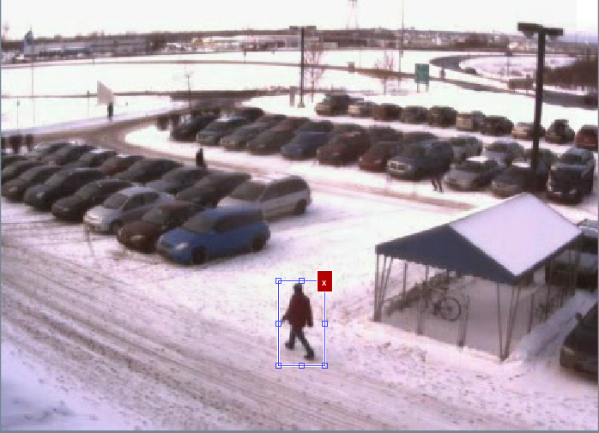

Centroid for ground truth=(226,243)
Centroid after resampling=(223,241)

