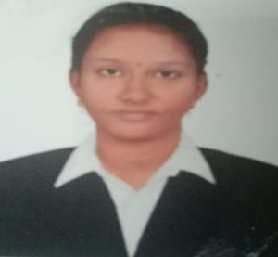
Curriculum Vitae

Details

Name: N. Koushika

Email:kowshika199810@gmail.com

Career Objective:

To secure a challenging position in a reputable organization to expand my learnings, knowledge and skills.

EDUCATIONAL QUALIFIACTION
QUALIFICATION | INSTITUTION | YEAR OF PASSING | PERCENTAGE
M.Sc  (GEOINFORMATICS) | GANDHIGRAM RURAL UNIVERSITY,  DINDIGUL. | 2020 | 80
B.Sc  (MATHS) | PARVATHY’S ARTS & SCIENCE COLLEGE, DINDIGUL. | 2018 | 65
HSC | ST. JOSEPH’S MATRIC.HR.SEC.SCHOOL, DINDIGUL. | 2015 | 85
SSLC | ST. JOSEPH’S MATRIC.HR.SEC.SCHOOL, DINDIGUL. | 2013 | 92

Experience
Name Of the Company | Position of the job | Date of Joining | No of Years
Goodland Geospatial Company | Junior Lidar Engineer | 28.07.2021 | 1 year 5 months  (Still working)

PROJECTS
- The case study is done on “Creation of soil erosion toolbar in ArcGIS by python”.
- The internship project is done on “Creation of carbon sequestration toolbar in ArcGIS by python”.
- The internship company’s project is done on “Digitization of feature in Andhra Pradesh under Mandapalli package”.

LANGUAGE AND SOFTWARE PROFICIENCY:

* ARCGIS, ERDAS IMAGINE

* MS OFFICE

* Micro station V8, AutoCAD

* C, C++

*Global Mapper, Google Earth Explorer

PERSONAL DETAILS:

Name : N. Koushika
Father's Name : K. Narayanan

Mother’s Name : S. Ananthi
Mother's tongue : Tamil
Date of Birth : 10. 02.1998
Language Known: Tamil & English
Mobile Number : 9384231902, 8610696209

I hereby declare that the information furnished are true and correct to my best of knowledge and belief.

Place : Yours sincerely,
Date : N. Koushika.

