Steps to To configure tomcat in intellij

1. Download the tomcat -9.
2. We have to get smart tomcat from intellij - plugin download and restart ur intellij.

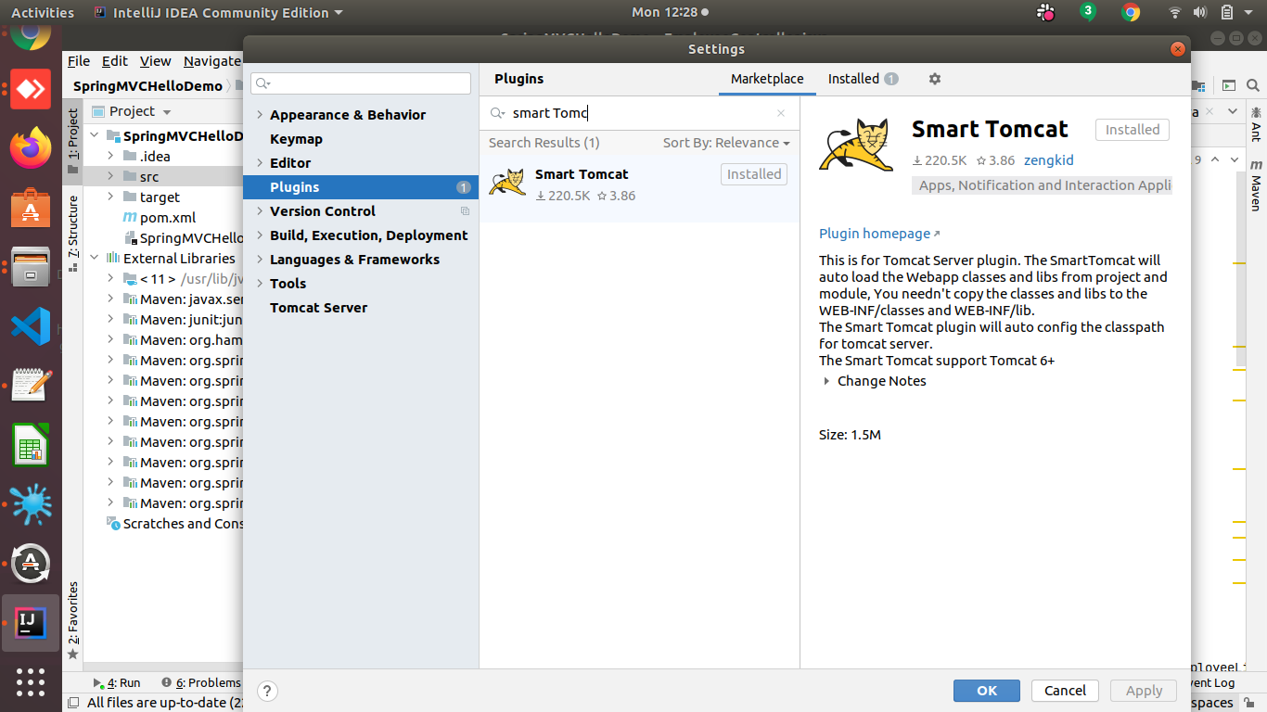mcat

2)We have to get smarttomcat from intellij - plugin download and restrat ur intellij.

3)Go to file - Tomcat Server click on + iocn give path where it is installed

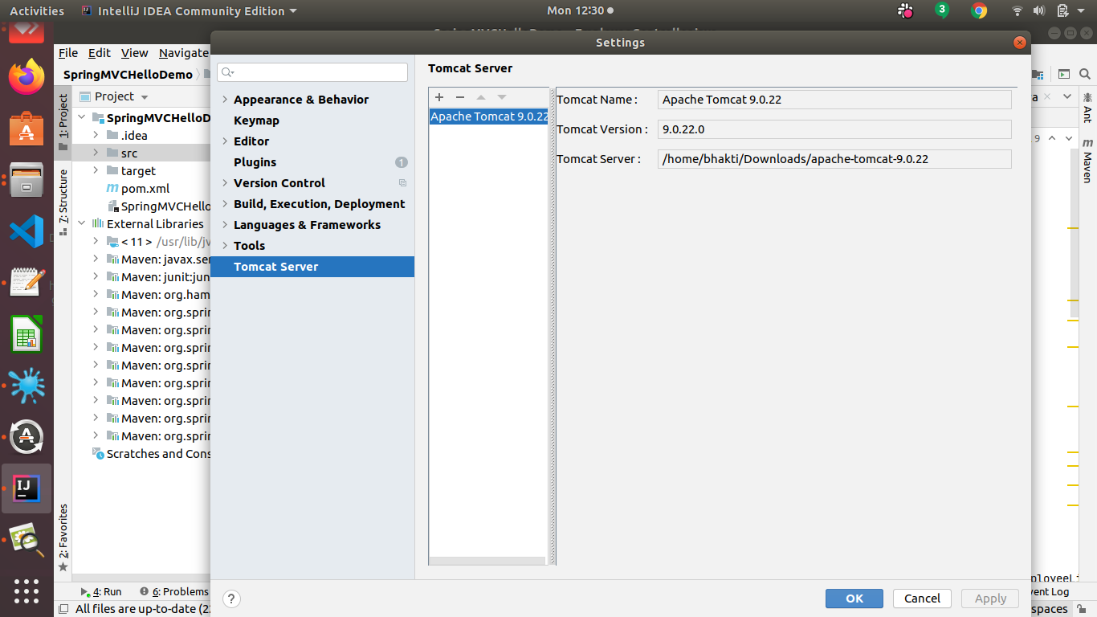

4)Right Click on ur project (Spring MVCDemo)- open module settings - Remove target.

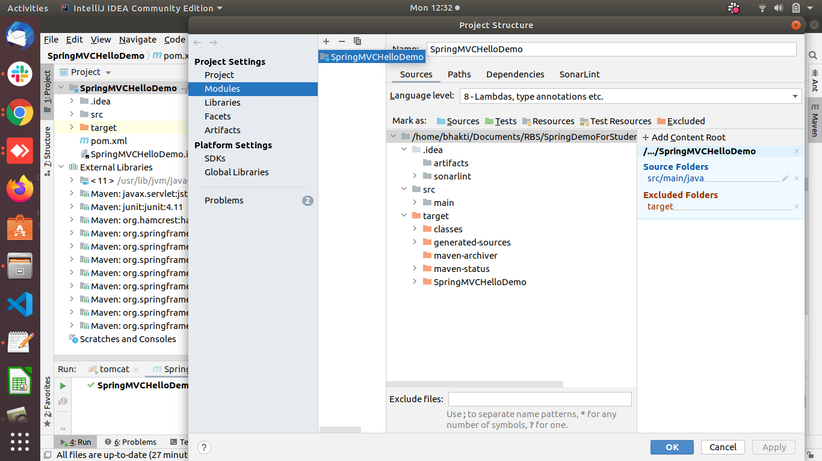

5)Click on ur project - open module settings - click on artifacts (click on + icon) - others

create war file. After creating war file -

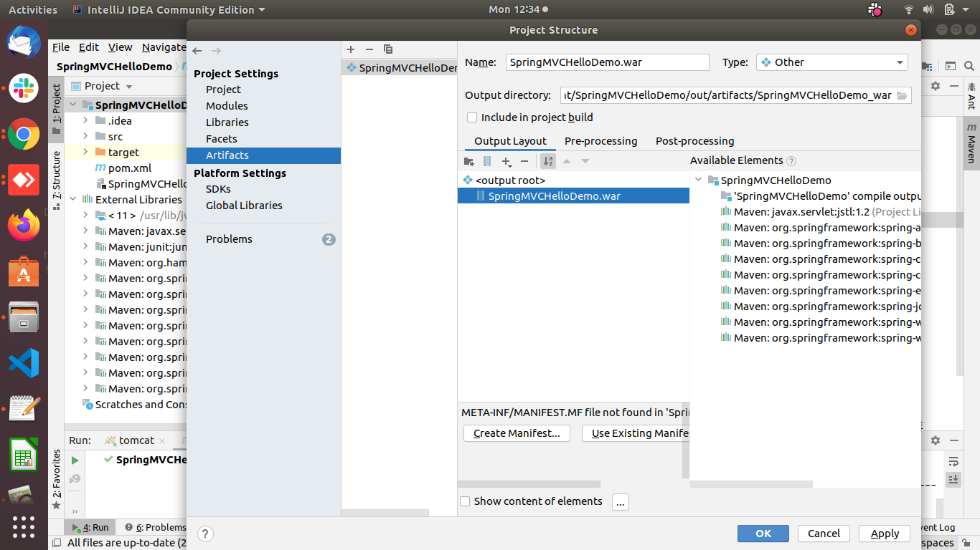

6) click on edit Configurations

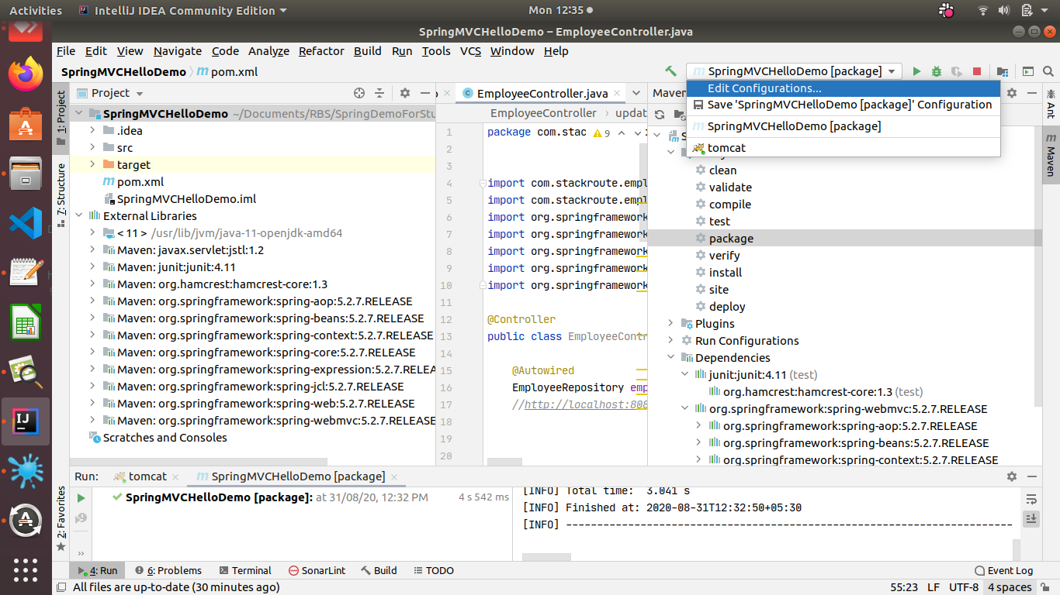

Click on template - click on + icon- once u click on + icon following page will get displayed

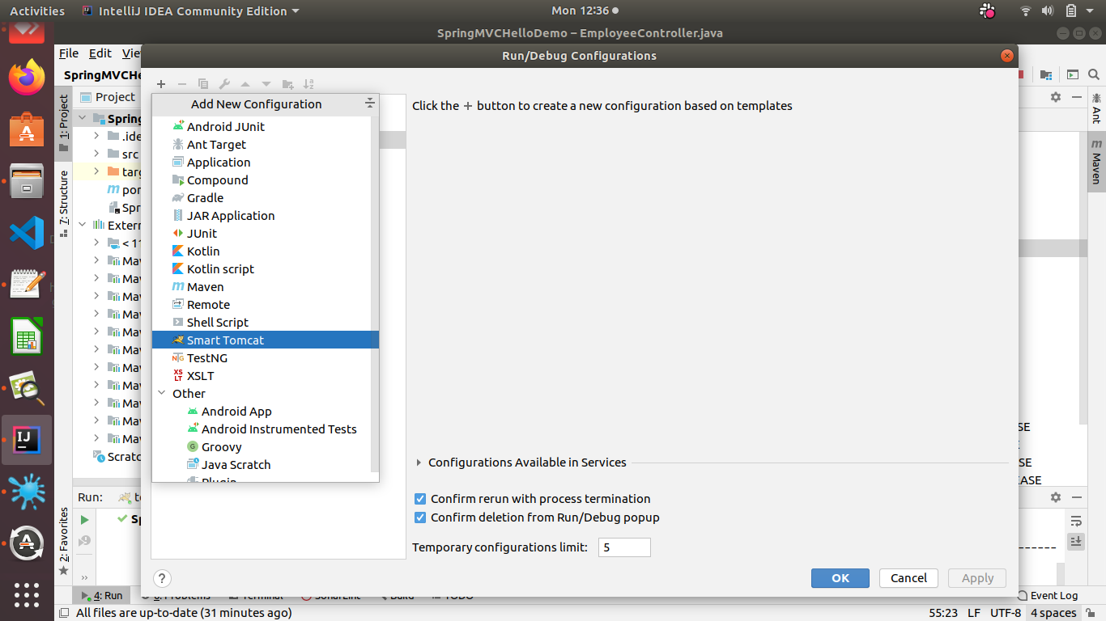

Click on smart tomcat

Following page will be displayed

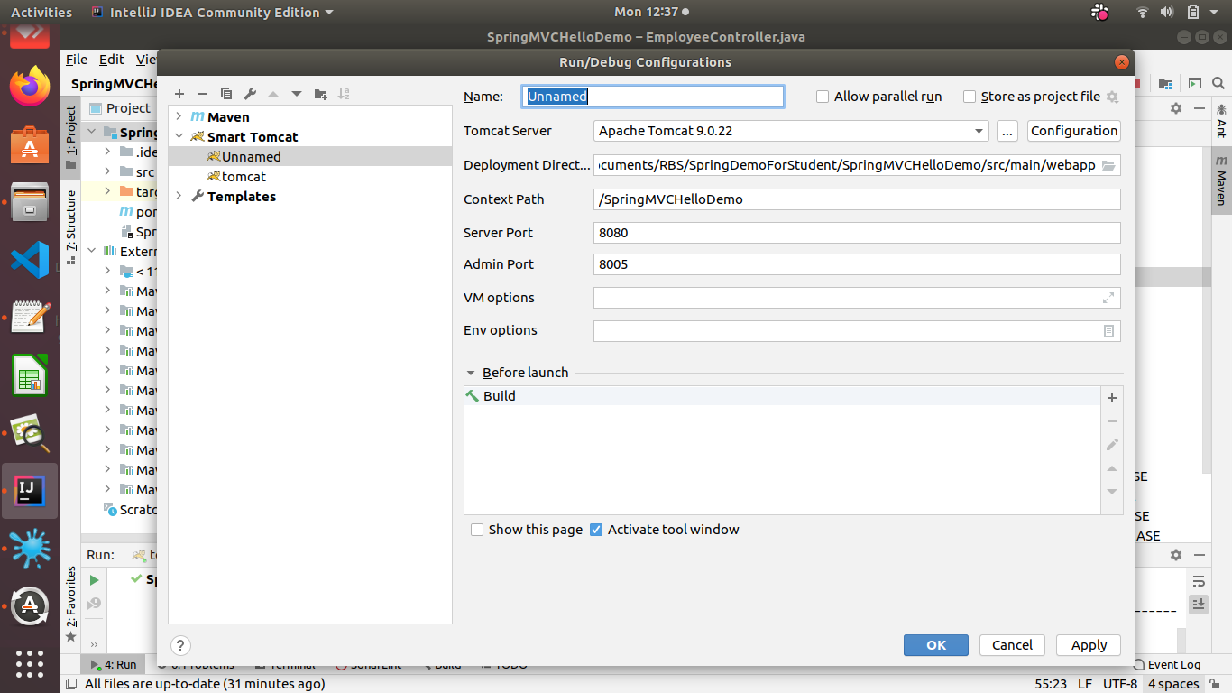

So before u give directory path delete target folder by going to open module setting (alreday its there in top)

.

Now again come to edit configurations -

Click on smart tomcat -

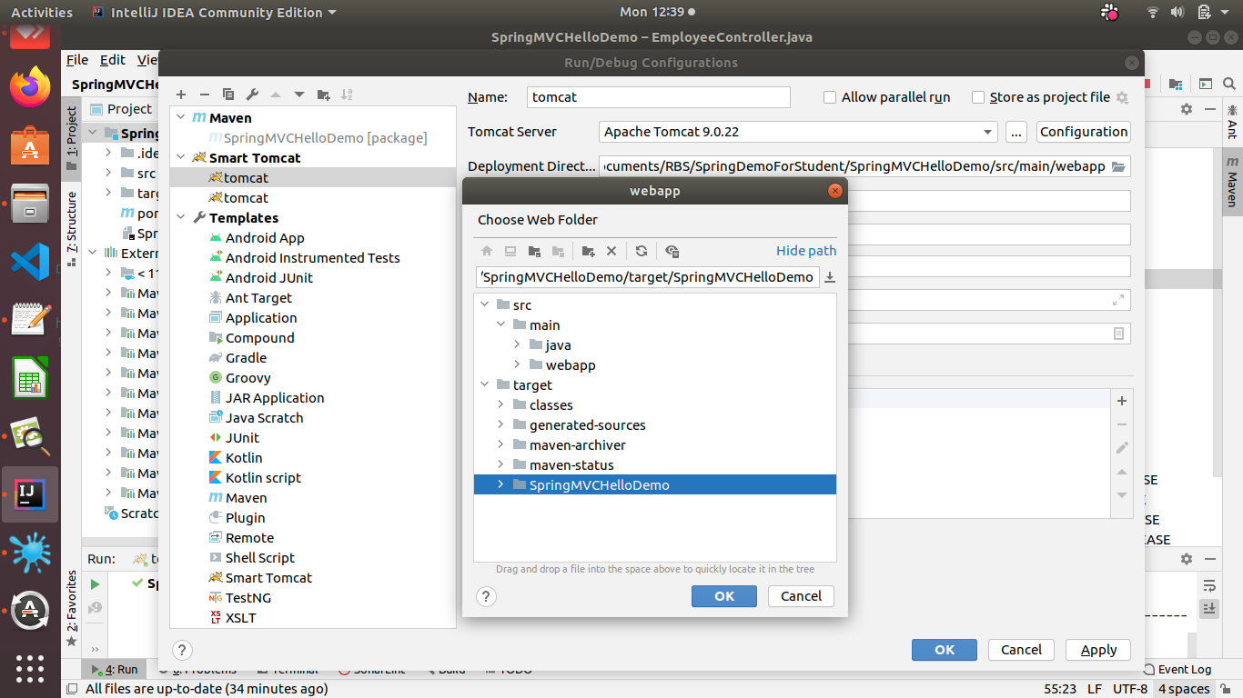

Now Build the artifact.

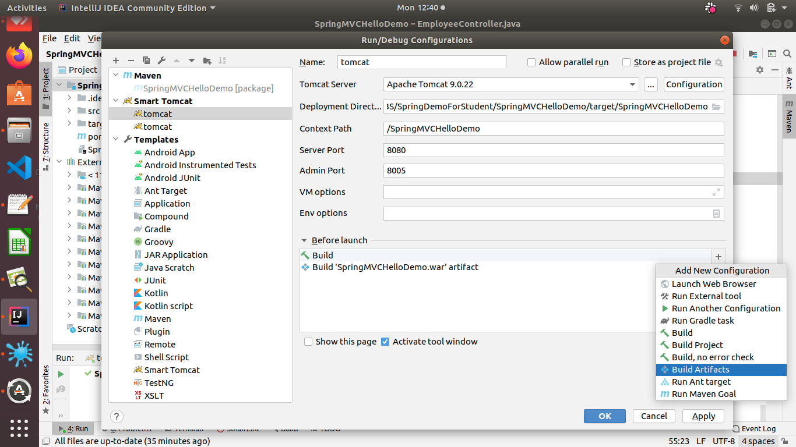

Once done click on ok run the tomcat -

Enter the url on ur browser-http://localhost:8080/SpringMVCHelloDemo/