1. The public link of ipython file on the Google Colab where the EDA is performed.

<https://colab.research.google.com/drive/12pO54EEOw0Xv7RuQtp5cvnJzL2JKS_Fz?usp=sharing>

1. Launched instance: m4.xlarge
2. Screenshot of the running instances

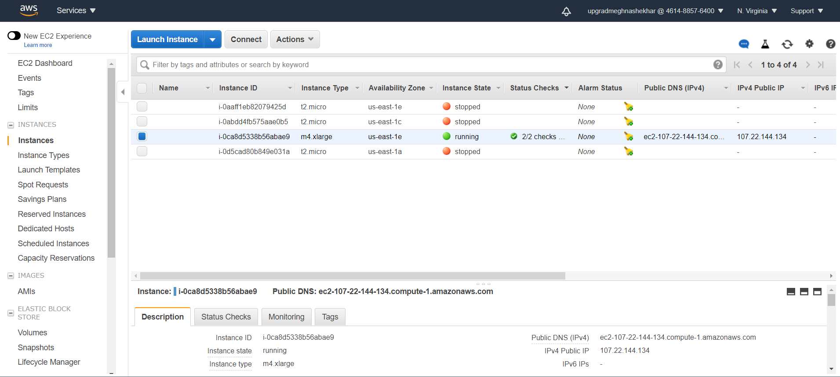

1. Screenshot of the terminal with Anaconda installed on EC2 instance

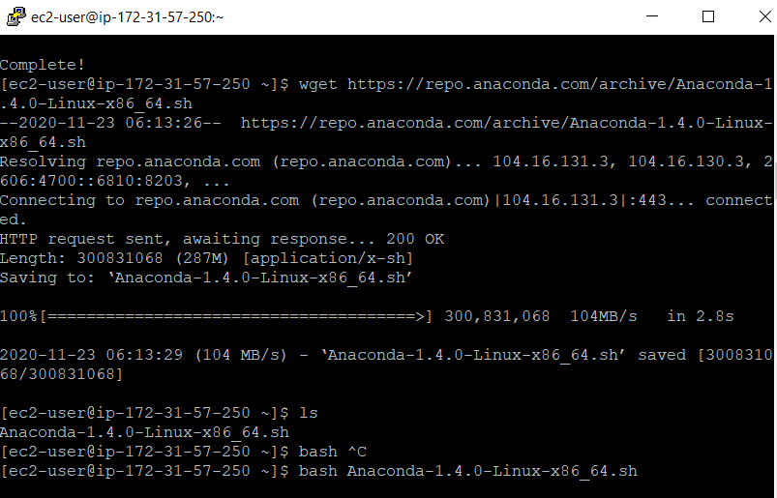

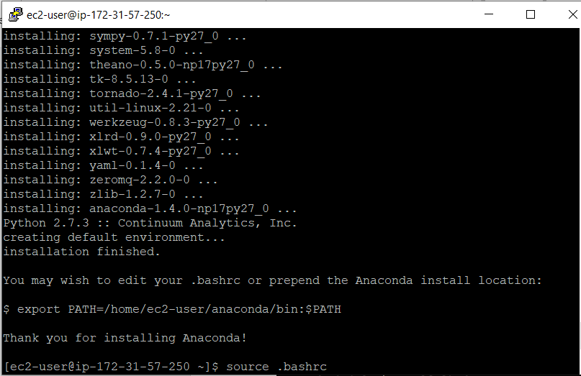

1. Screenshot of the terminal running the jupyter notebook

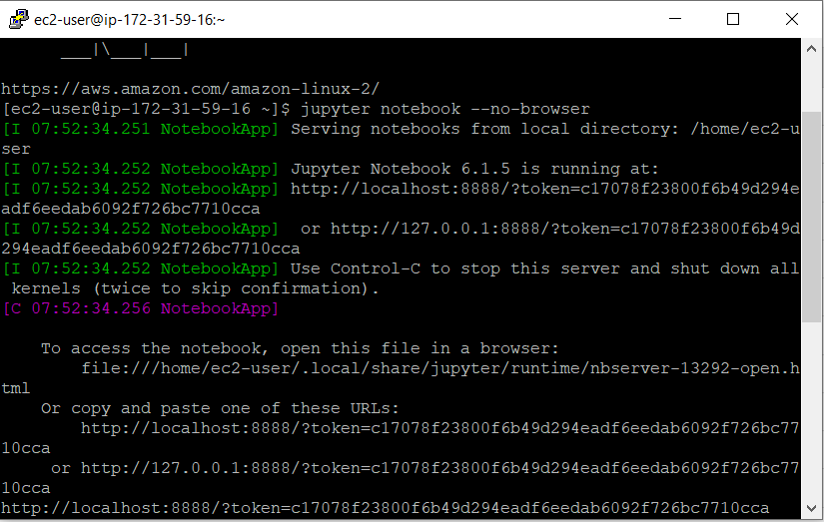

1. Screenshot of the summary page of the database which you used to store the results.

