1. Count of unique device ids in the train table

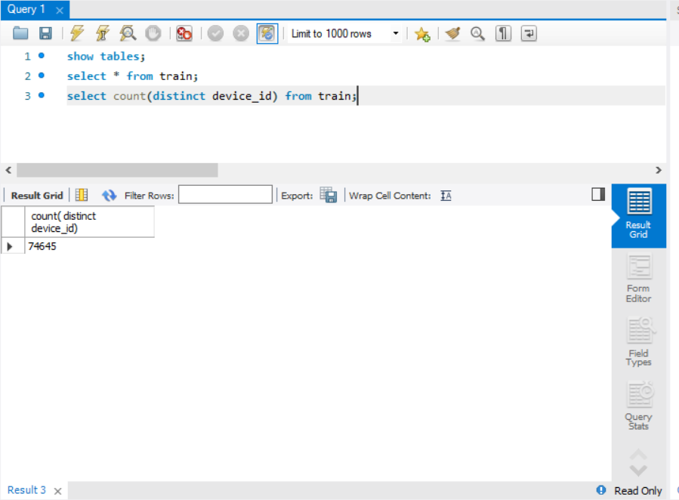

1. Check whether there are any duplicate device ids present in the brand device table. If yes, how many duplicates?

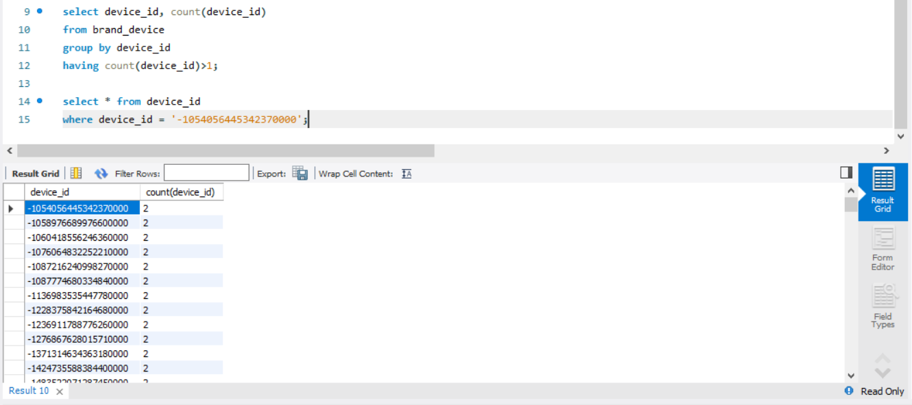

\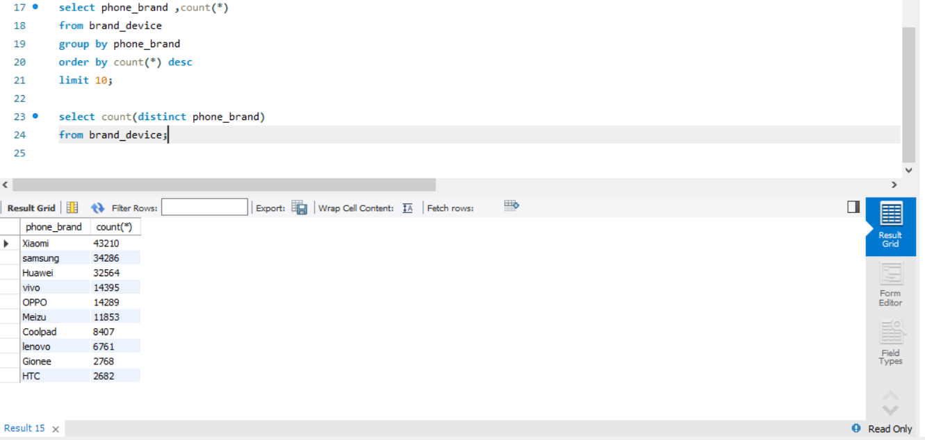

1. Number of unique phone brands from the brand device table

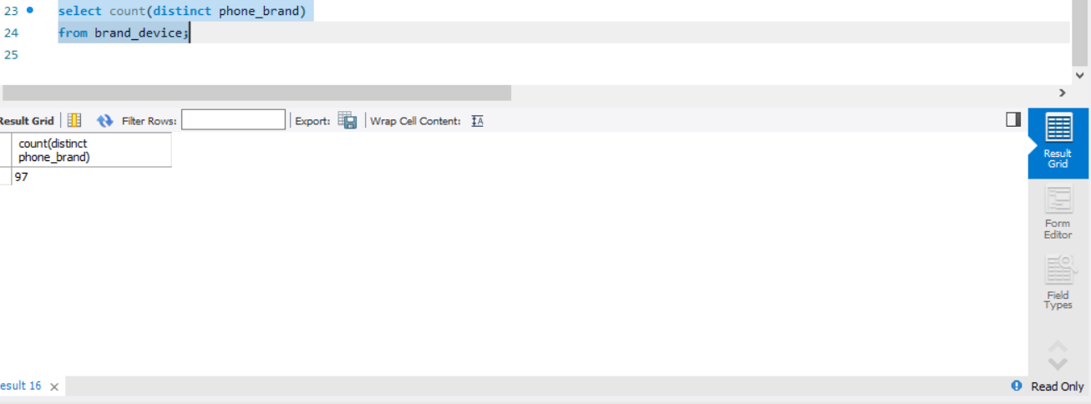

1. Count of device ids where the latitude and longitude detail are zero, from the events table

