**Deployment**

## 

## **Create GitHub project**

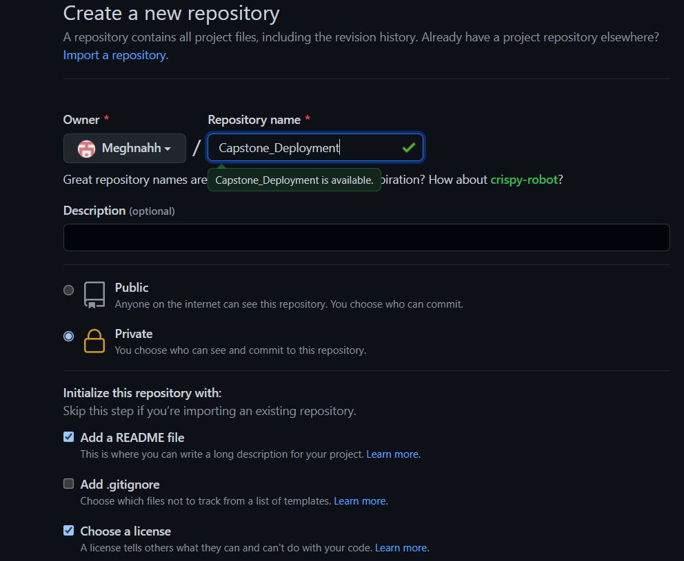

**Docker deployment**

## **Create EC2**

**Select amazon linux as AMI**

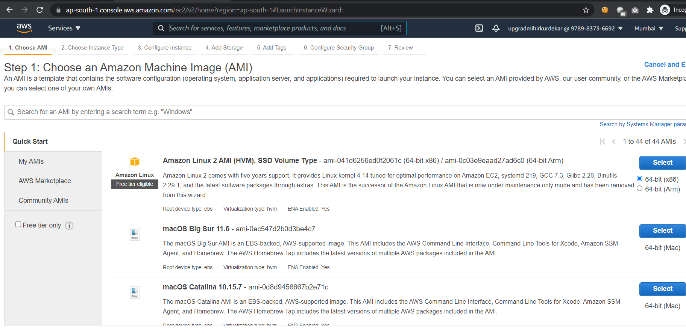

**Security group for EC2**

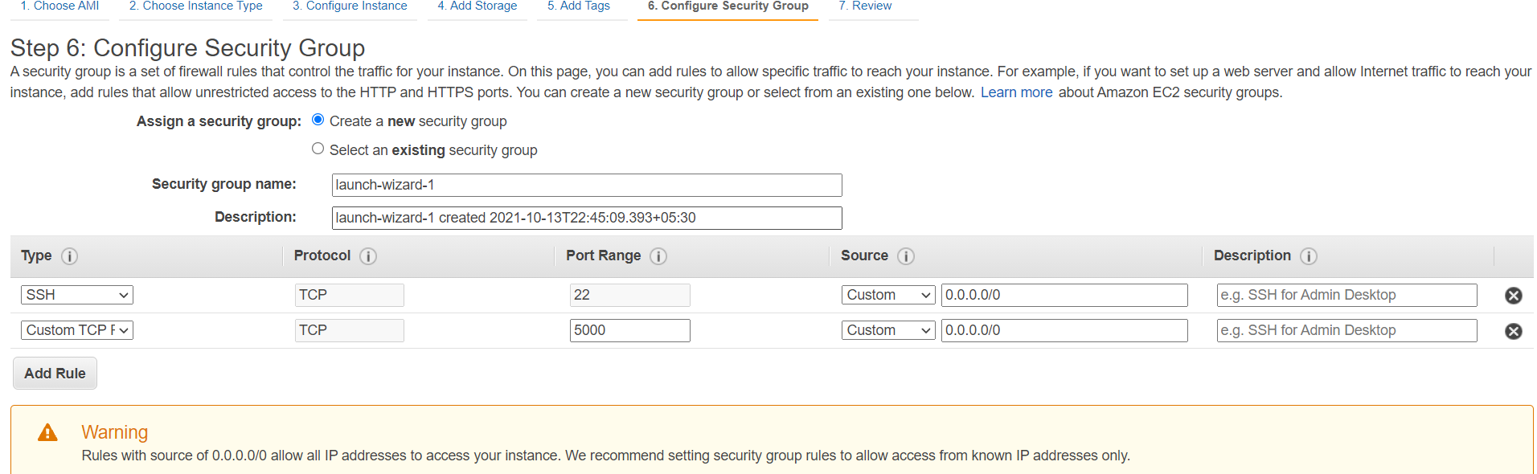

## **Install git, docker and flask**

**sudo yum update**

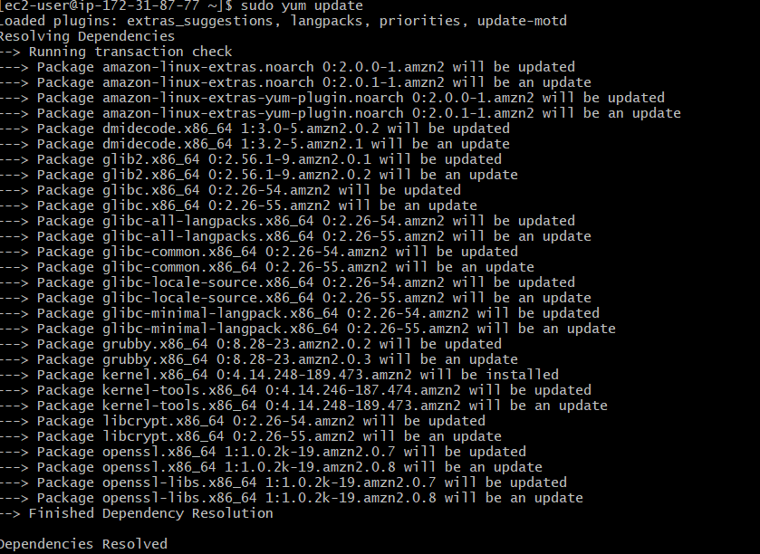

**sudo yum install docker**

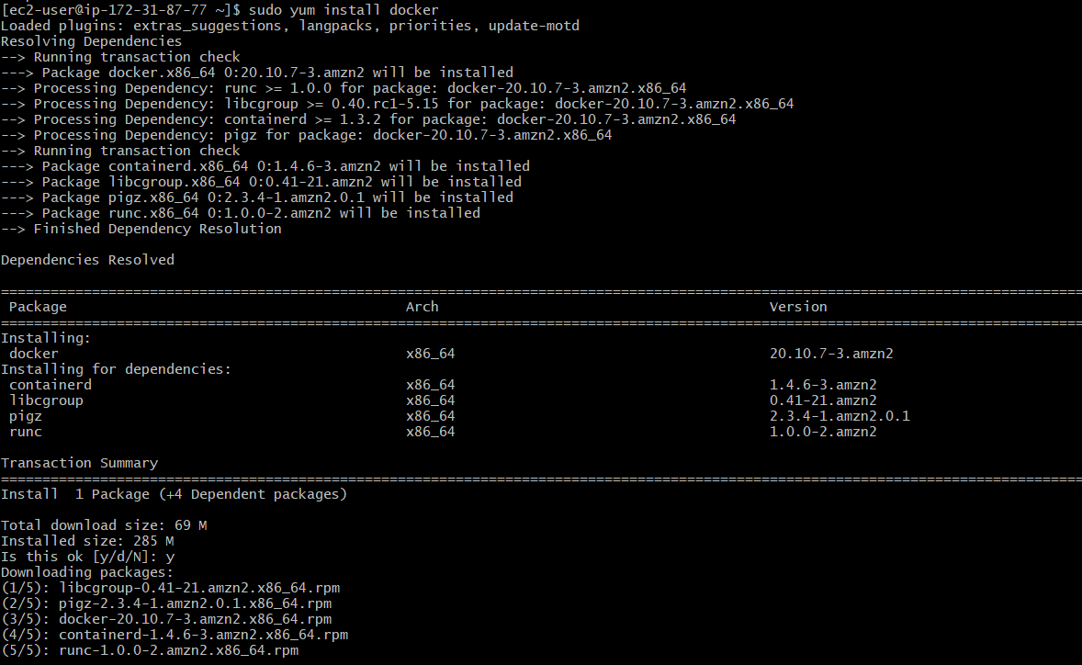

**sudo yum install git**

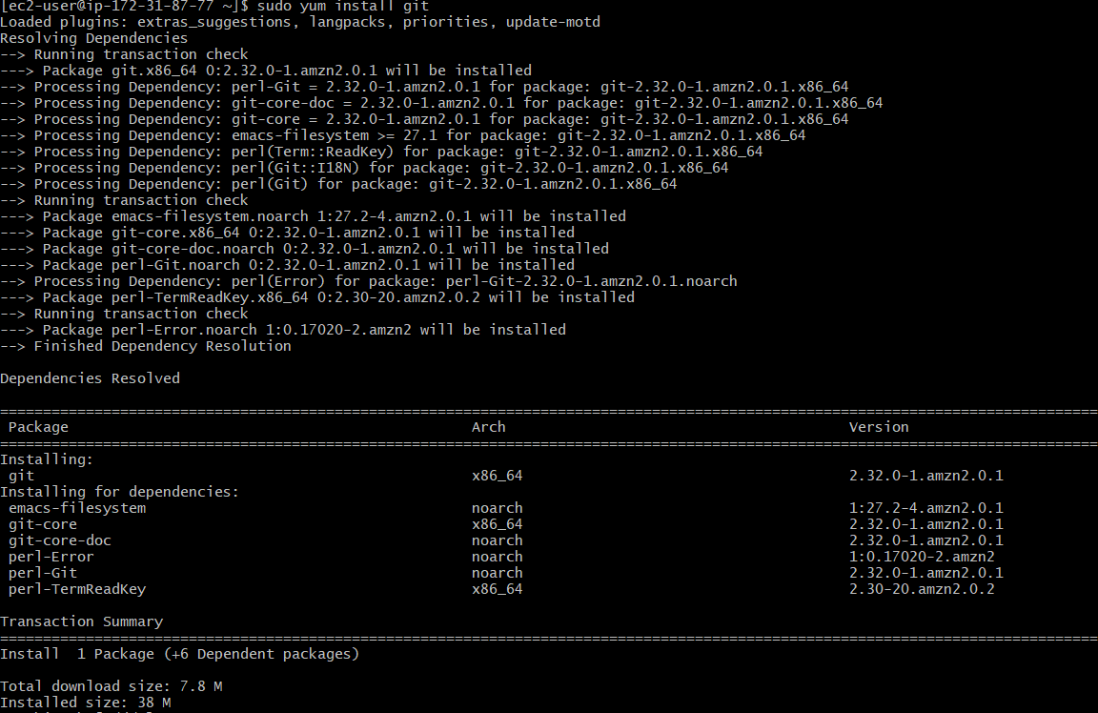

**sudo yum install pip**

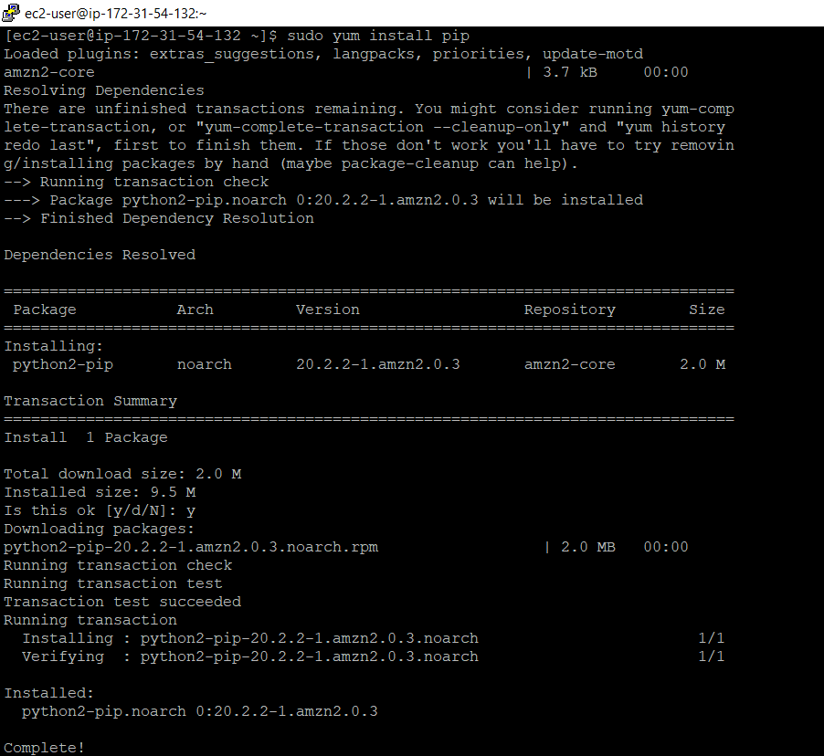

**sudo pip install flask**

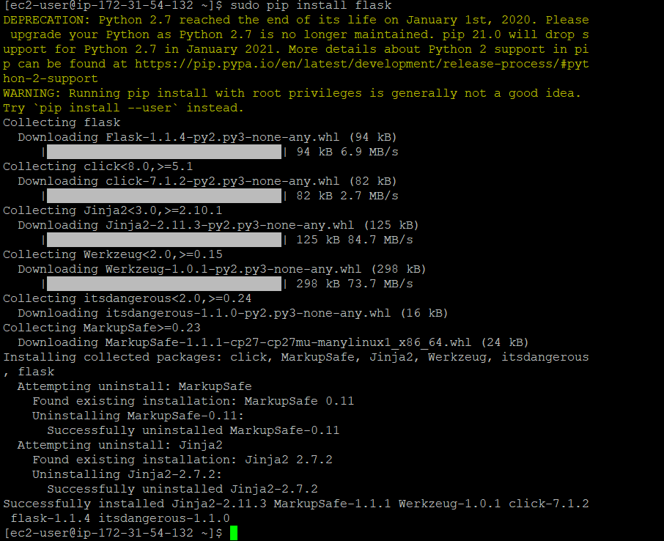

## **Start docker**

**sudo service docker start**

**sudo usermod -a -G docker ec2-user**

**sudo reboot**

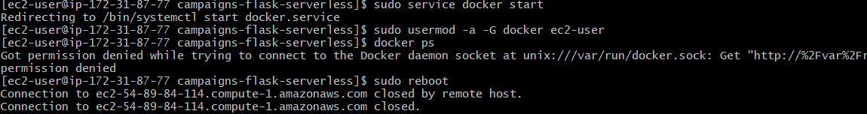

**sudo service docker start**

**docker ps**

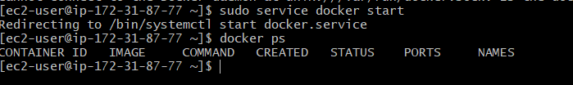

## **Get Source code into EC2**

**git clone** [**https://github.com/mihirkurdekar/campaigns-flask-serverless.git**](https://github.com/mihirkurdekar/campaigns-flask-serverless.git)



## **Build and start docker**

**docker build -t campaigns .**

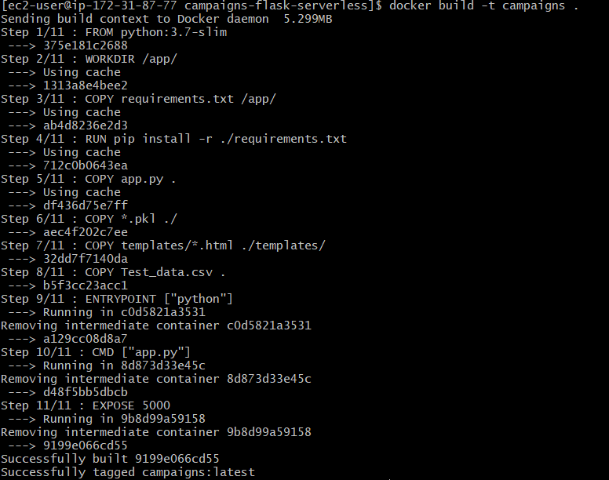

**docker run -t -d -p 5000:5000 campaigns**

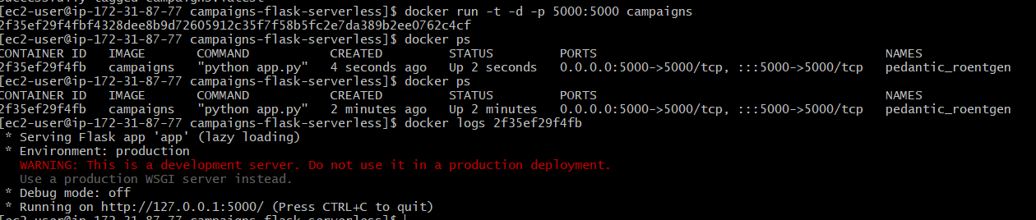

# **Deployed App screen shots**

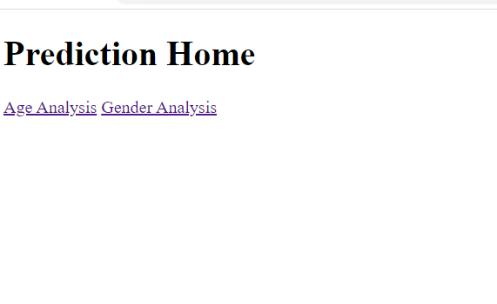

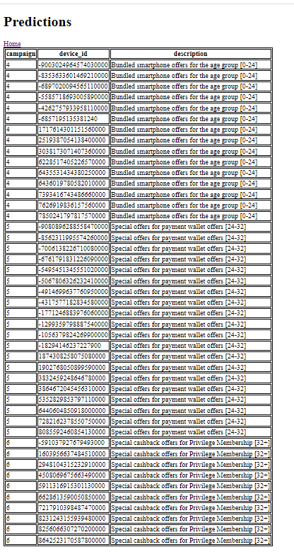

Path: /gender on click of gender

