**Department of Electronics & Telecommunication Engineering,**

Bhivarabai Sawant Institute of Technology & Research

**HAND GESTURE RECOGNITION SYSTEM**

**Project by -**

1. **Meghsham Jade (4215)**
2. **Gaurav Thakur (4253)**
3. **Nikita Mane (4225)**

# Introduction –

* Human-computer interaction (HCI) also named Man-Machine Interaction (MMI) refers to the relation between the human and the computer or more precisely the machine, since the machine is insignificant without suitable utilisation by the human.
* Gestures are used for communicating between humans and machines as well as between people using sign language.
* Gestures can be static (posture or certain pose) which requires less computational complexity or dynamic (sequence of postures) which is more complex but suitable for real-time environments different methods have been proposed for acquiring information necessary for recognition gesture systems.
* 2 common technologies for hand gesture recognition
  + **Glove-based method**
    - Using special glove-based device to extract hand posture.
  + **Vision-based method**
    - 3D hand/arm modeling.
    - Appearance modeling.
* Some methods used additional hardware devices such as data glove devices and color markers to easily extract the comprehensive descriptions of gesture features.
* Other methods based on the appearance of the hand use the skin color to segment the hand and extract necessary features, these methods are considered easy, natural and less costly compared with the method mentioned before.

# Objective -

The objectives of this project are:

* This HGRS aims to enable computers to communicate with users through body language, unlocking a broader command set.
* enhancing the interactive human-machine interface
* revolutionizing the way we interact with technology in our daily lives.

# Block Diagram -

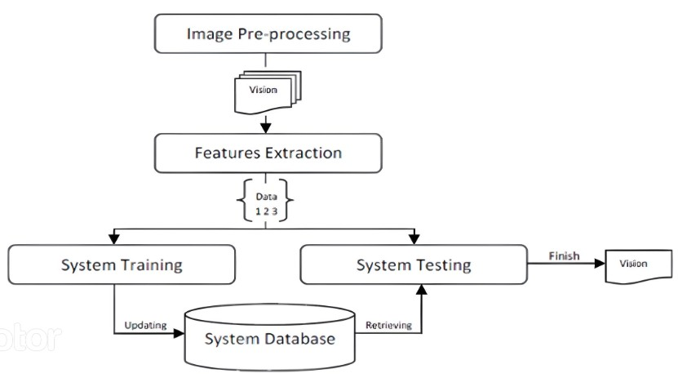

**Description -**

* **Input Image Acquisition**
  + Here the system captures visual data using cameras or sensors, acquiring real-time images of the user's hand gestures, which serve as the raw input for gesture recognition.
* **Pre-processing**
  + The acquired images undergo pre-processing to enhance quality and reduce noise. This may involve tasks like image filtering, background subtraction, and normalization to prepare the data for accurate feature extraction.
* **Feature Extraction**
  + Feature extraction involves identifying key characteristics or patterns within the preprocessed images. It transforms complex visual data into meaningful numerical descriptors, capturing the unique aspects of the hand gestures.
* **Gesture Classification**
  + In this phase, the system employs machine learning or pattern recognition algorithms to classify the extracted features into predefined gesture categories, determining the user's intended action or command.
* **Development of Appropriate Command**
  + Once a gesture is classified, the system maps it to an appropriate command or action, enabling interactions with the computer or application, such as controlling a virtual environment or performing specific tasks based on recognized hand gestures

# Hardware and software used -

* **Hardware Components**
  + Camera (RGB or depth camera (e.g., Microsoft Kinect, Intel RealSense), 3D camera, infrared sensor.)
  + Processing Unit (CPU: Multi-core processors (e.g., Intel Core i7 or AMD Ryzen series)
  + Memory ( RAM (8GB or more recommended), SSD or HDD for storage.)
* **Software Components**
  + Operating System (Windows)
  + Gesture Recognition Algorithms (Libraries and frameworks for computer vision and machine learning, such as: 1] OpenCV: For image processing and computer vision tasks, 2] TensorFlow: For building and training machine learning models, 3] PyTorch: Another deep learning framework for model development., 4] MediaPipe: Offers pre-trained models for hand tracking and gesture recognition.)
  + Communication Protocols (Libraries for communication between the system and other devices or applications, such as sockets for TCP/IP, Bluetooth APIs, or USB communication libraries.)
  + Gesture Database ( A database management system (DBMS) for storing and managing predefined gestures and training data.)

# Conclusion –

The gesture recognition algorithm is relatively robust and accurate. Convolution can be slow, so there is a tradeoff between speed and accuracy. In the future, we will investigate other methods of extracting feature vectors, without performing expensive convolution operations.

In summary, we got to know the versatility of gesture recognition methods and their relevance in diverse application areas. The choice of method depends on specific use cases, and ongoing research aims to enhance both the accuracy and efficiency of these systems.

# Reference –

# https://www.researchgate.net/publication/284626785_Hand_ Gesture_Recognition_A_Literature_Review

# ttps://www.linkedin.com/posts/jaydipdhavale_subwaypubg-bgmi-activity-7095022221370286081-V2ZA? utm_source=share&utm_medium=member_desktop

# <https://youtu.be/_97R28lJj4o?si=AchsrU6UlnIj0eOP>

# https://youtu.be/pDXdlXlaCco?si=EnTWtH9w4yRyqm8