Employee Management System

This project demonstrate the dynamic employee management system. The project is developed with help of Angular for application development. The web application presents a generic system to maintain employees details.

Features
The developed web application has following features:
(1) A form to add new employees
(2) View employees list in a table format.
(3) Edit existing employee details.
(4) Delete existing employee details
(5) Form validations with error messages

Technology
To develop this web application, the following technology has been used:
- Angular version 19
- Node version 22
- Typescript version 5
- R⨉JS for asynchronous API call
- Angular Standalone Components
- Angular Routing
- HTML5
- CSS3

How to Run ?

Step-1
- Clone the repository from GitHub to your local device.
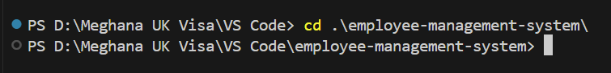

Step-2 Application Build
- Please perform the following command in power shell terminal to enter into frontend application.
cd employee-management-system
- Please perform the following command in power shell terminal to build the frontend application.
Npm install
- Please perform the following command in power shell terminal to run the development server.
ng serve
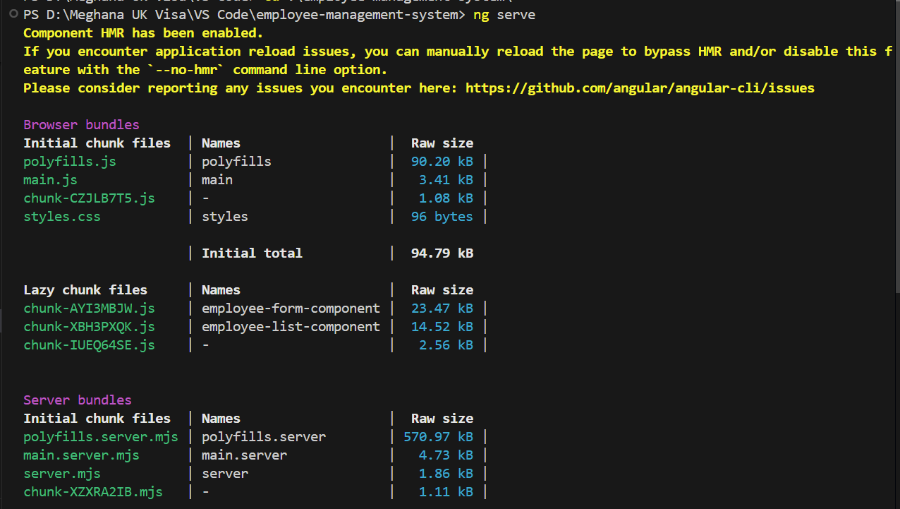

Step-3 Open Web Application
- Please access the web application with following URLs.
http://localhost:4200/
localhost:4200/form
localhost:4200/list

