**PROJECT REPORT**

**On**

**“FACE RECOGNITION ATTENDANCE SYSTEM”**

**(CSE V Semester Mini project)**

**2020-2021**



**Submitted to: Submitted by:**

Mr. SHAUMITRO CHATOPHADHAY Mr. MEGHWANT SINGH

(CC-CSE-E-V-Semester) Roll. No.: 1918469

**Guided by:** CSE-E-V-Semester

Dr. AKSHARA PANDE Session: 2020-2021

(Resource Person)

**DEPARTMENT OF COMPUTER SCIENCE AND INFORMATION TECHNOLOGY**

**GRAPHIC ERA HILL UNVERSITY, DEHRADUN**

**CERTIFICATE**

### Certified that Mr. MEGHWANT SINGH (Roll No. - 1918469) has developed mini project on “Face recognition attendee system” for the CS V Semester Mini Project Lab in Graphic Era Hill University, Dehradun. The project is been carried out by Students is their own work as best of my knowledge.

Mr. SHAUMITRO CHATOPHADHAY

**Project Co-coordinator**

**CC-CSE-E-V-Sem**

(CSE Department)

GEHU Dehradun

Dr. AKSHARA PANDE **Project Guide**

Resource Person

(CSE Department)

GEHU Dehradun

**ACKNOWLEDGMENT**

I would like to express our gratitude to The Almighty Shiva Baba, the most Beneficent and the most Merciful, for completion of project.

I wish to thank our parents for their continuing support and encouragement. We also wish to thank them for providing us with the opportunity to reach this far in our studies.

I would like to thank particularly our project Co-coordinator Mr. SHAUMITRO CHATOPHADHAY and our Project Guide Dr. AKSHARA PANDE for his patience, support and encouragement throughout the completion of this project and having faith in us.

I also acknowledge like to all the teachers who help us in developing the project.

At last but not the least I greatly indebted to all other persons who directly or indirectly helped us during this work.

**Mr. MEGHWANT SINGH**

**Roll No. - 1918469**

**CSE-E-V-Sem**

**Session: 2020-2021**

**GEHU, Dehradun**

**TABLE OF CONTENTS**

**ABSTRACT**

1. **INTRODUCTION** 
   1. Project Introduction and Motivation
2. **PROJECT METHODOLOGY** 
   1. **Working of Project using Flow chart**
3. **SNAPSHOT REALATED OF PROJECT** 
   1. Result Analysis and Few Screenshots
4. **CONCLUSION**

1. **REFERENCE**

**ABSTRACT**

“Face recognition attendance system” is a facial recognition technology to identify and verify a person with the help of person’s facial features and automatically mark attendance. It is a live image processing method based project which has one objective of collecting image and treat it for recording the attendance. Image processing is a concept in which we take an image as an input, and perform particular operations according to user or project output according to the given objective.

The main objective of this project is to create a user friendly interface where user can work freely both technical as well as a layman can able to access it.

It will basically use system camera through which it able to recognize everyone and will add them as new user and after added, they will be available in records. And whenever user takes attendance, they will be scanned again and will be identified according to their images already taken during registering.

**CHAPTER** **1**

**INTRODUCTION**

1. **Project Introduction and Motivation**

Project name is “ Face recognition attendance system” it recognizing people by their faces in pictures and video feeds in seen from all sources starting from social media to smart phone cameras. A face recognition system is basically built for matching real human faces with a digital image. But a computer can only recognizes pixel values ranging from 0 to 255 in background. In computer vision face recognition has been a method for ages and still evolving with time. In this method where I have perform some operations on an image, in order to get an enhanced version to extract important but useful information from the image. It can also be explained as signal processing in which image an input is and intensified image or May we input’s feature or characteristic acts as an output. This project follows hog algorithm.

Face recognition attendance system is the challenging project but it is very important it gave me motivation how to overcome problems. It increase critical thinking and time management in developing an integral GUI system also show how future technology will make life flexible and develop creativity. This project also give how real project like face recognition library or verification system work in real world.

This project follows some basic steps included in it.

1. Import an image via image acquisition tools.
2. Analysing and manipulating(i.e. doing some changes) the input image.
3. Displaying output, which can be either enhanced or altered image, any property of that image or any output based on its analysis.

Image processing is based on 2 types which are:

**Analogue Image Processing:**

Analogue image processing is applied on analogue signals and it processes only 2-d signals. Using electrical signals we can manipulate images. There are 2 types of signals in analogue image processing i.e. Periodic or non-periodic.

**Digital Image Processing:**

Digital image processing is applied to the digital images i.e. a matrix of small pixels and elements or colours. There are various algorithms and software available for performing this process. In today’s world it is a growing industry in most of the fields.

* In this project I have used **Programming Language which** is **PYTHON**.
* **Library** **used** are **opencv** and **face recognition**.
* **Software** used is PyCharm and PyQt GUI designer.
* **Operating System** used here is **Window 10 Home** with8 GB RAM.

So basically this project will to create an attendance system project that will able to use webcam to detect faces of any person and record the attendance live in an excel sheet which can we view easily .

**CHAPTER** **2**

**PROJECT METHODOLOGY**

Face recognition follows series of several steps:

1. First, look at a picture or video and find all the faces in it
2. Second, focus on each face and be able to understand that even if a simple face is turn in a weird direction or in bad lighting, it is still the same person.
3. Third most important it pick out unique features of the face that you can use to tell it apart from other people like how big the eyes or nose are , how long the face is.
4. Final step, compare the unique features of that face to all the you already know to determine the person’s name

There are few steps under which it works.

**Step 1: Finding all the faces or Capturing:**

In this we used HOG algorithm which is Histogram of Oriented Gradients which use to detect faces encoding .The first requirement is to capture the image and that can be easily done by scanning the image or video of user in front of camera, so that camera can access the present record of user’s face.

**Step 2: Posing and Projecting faces or Extraction:**

After capturing the image, it extracts the unique facial data or some unique facial identification so that, it can help the software to detect the face with some particular signs.

**Step 3: Encoding Faces and Comparing:**

The simplest approach to face recognition is to directly compare the unknown face we found in step 2 with all the pictures we have of people that have already been tagged. After extraction, we move further to the comparison from different databases present in this world. Check any dataset given to us.

**Step 4: Finding the person’s name from the encoding and do matching:**

Last step is the easiest in the whole process. All we have to do now is just find the person in our database of known people who has the closest measurements to our test image. It gets performed during the comparison, it works as a best case in this, i.e. if we find any kind of match in any another image, then we will be able to see the result.

**WORKING OF PROJECT**

Flow chart for face recognition library

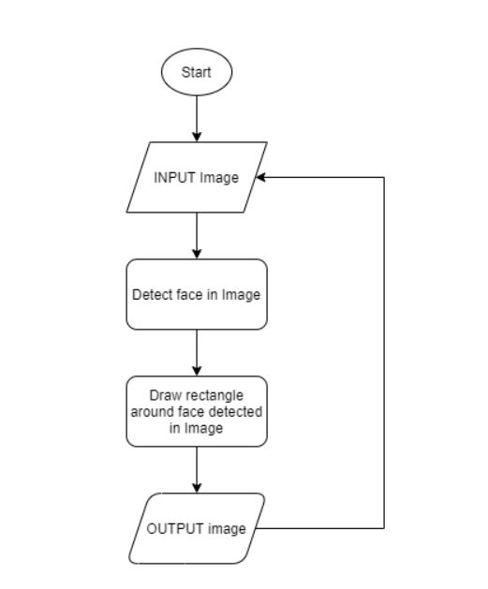

The working of project can easily understand by its flow chart below is the basic flow chart for the project explain in the form of diagram.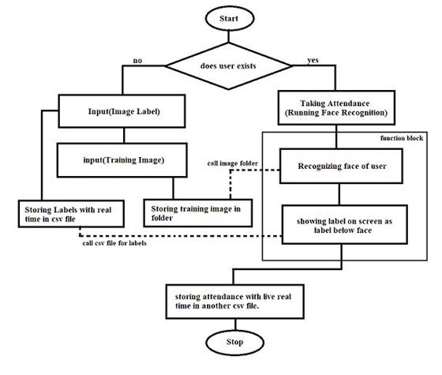

**Basic Face Matching :** Now we are ready to build a real time face attendance system where in webcam captured frames will be matched against the existing database images and if the match is found then it will store it in a CSV file called ‘Attendance’ along with name and time we need to store it. Only once the file will store the matched image’s details, if the same image is received again may be then it’ll not update. Path setting to the directory containing the face image database. Read every image and the images array. Appends the file names into a main list called Names and remove the extension. 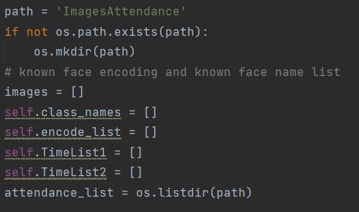

Find the face encodings of images in the database and keeping them in a list to use later with incoming frames as shown in about flowchart. 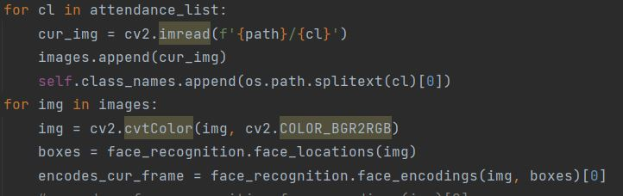

Now Capturing video frames (webcam use)

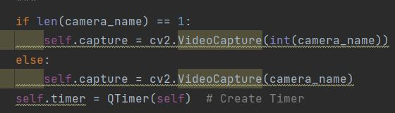

Iterating through frames then the same process is followed by the first detection face location then gets the face encoding values. Here now the incoming images are tested with the previously stored encodings. Then the face distance is also computed. Last but not least we call Attendance function along with the person name that is identified. Start Read from attendance file, Storing data (Name, Time, Date, Present) if previously not stored.

**CHAPTER** **3**

**SNAPSHOT REALATED TO PROJECT**

**RESULT ANALYSIS WITH SCREENSHOT**

This is the starting screen of the project when we run the project python code

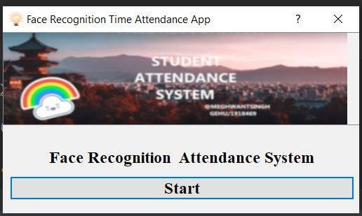 **Start GUI screen**

After that below GUI interface open which contain Date, Time and person detail. In which webcam screen which capture the person image and then from rectangle around his/her face.

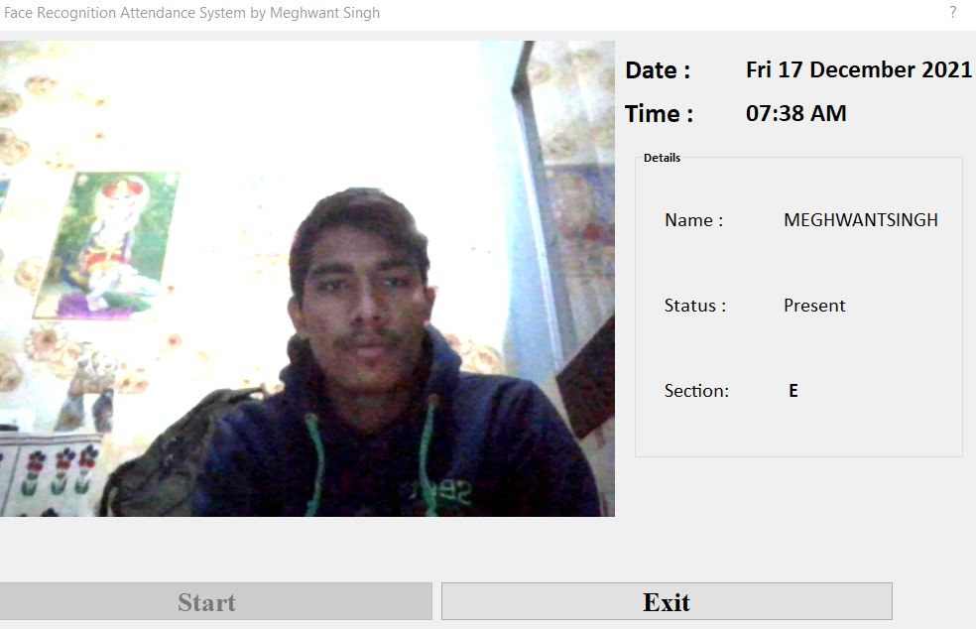

Meghwant

Now the final result of the project is store inside the .CSV file which contains attendance list.

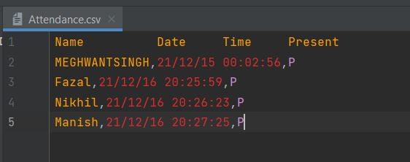

Attendance.csv file

Below image shows how actually the information store in Excel Sheet.

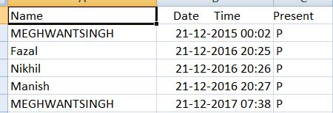

Excel attendance sheet **CHAPTER 4**

**CONCLUSION**

Face recognition attendance system gives the knowledge about how machine learning concept work in real world projects. It use python learning library which help in identifying faces accurately. We have used this to build a face attendance system which can be helpful in schools, universities or any other place. It reduces manual labor time and automatically records in day to day life. This also notes the date and time of arrival thus can acquire information about person coming in late after a specified time.

The future of face recognition system is very bright it used in many field from defense to banking, Airlines to schools and is still growing which help human to improve efficiency and reduce manual time.

**REFRENCE**

1. Computer Vision : Face recognition Quick starter in python book
2. Github and stack over flow for solving problems
3. Geeks for geeks site for face recognition
4. Analyticsindiamag.com site for steps to mark attendance.csv file
5. YouTube channel code with harry for python