AI PROJECT PLAN
Predictive Analytics for Customer Churn Using Public Telecom Datasets
A Comprehensive Project Plan and Feasibility Document
Prepared for: Week 1 Internship Task — AI Project Planning and Documentation
Document Type: Project Plan Report
Date: September 2026

1. Executive Summary
This document presents a comprehensive project plan for an artificial intelligence (AI) initiative centered on predictive analytics, specifically the prediction of customer churn for a subscription-based telecommunications service. The project uses publicly available, well-documented datasets to simulate a realistic, end-to-end machine learning lifecycle: from problem framing and hypothesis formulation through data collection, exploratory analysis, feature engineering, model development, evaluation, and deployment planning. The plan is designed to reflect industry best practices in AI project management, including agile iteration, data governance, ethical review, and scalability planning, while remaining feasible for a small team or an individual contributor working within a ten-week cycle.
The primary business problem addressed is churn: the loss of subscribers to a service. Churn prediction is one of the most common and high-value applications of predictive analytics because even small improvements in retention have an outsized effect on recurring revenue. By building a model that flags at-risk customers in advance, a business can intervene with targeted retention offers, thereby reducing revenue loss. This project plan treats the technical work (data science and machine learning) as inseparable from the surrounding project management disciplines of scoping, risk management, governance, and stakeholder communication.

2. Project Objectives
The project is guided by the following primary and secondary objectives:
- Primary Objective: Design, build, and validate a machine learning model capable of predicting whether an individual subscriber is likely to churn within the next billing cycle, using historical account, usage, and billing data.
- Secondary Objective 1: Identify the key behavioural and demographic drivers of churn so that the business can act on insights, not just predictions.
- Secondary Objective 2: Establish a repeatable, well-documented data pipeline and modelling workflow that can be retrained on new data with minimal manual intervention.
- Secondary Objective 3: Produce a governance and ethics framework that ensures the model is fair, explainable, and compliant with data protection expectations, even though the underlying dataset is public and anonymised.
- Secondary Objective 4: Deliver a clear, decision-ready report and visualisation set that non-technical stakeholders can use to prioritise retention campaigns.
These objectives were chosen deliberately to balance technical rigor with business relevance. A model that achieves high accuracy but produces no actionable insight is of limited value to decision-makers; conversely, a set of insights without a validated predictive mechanism lacks the forward-looking capability that stakeholders expect from an AI investment. The objectives above therefore combine predictive performance, interpretability, governance, and communication.

3. Hypothesis Formulation
Before any data is touched, a predictive analytics project should articulate falsifiable hypotheses. This discipline prevents the common failure mode of 'fitting a model to see what happens' and instead anchors the analysis in testable business assumptions.

3.1 Primary Hypothesis
H1: A subscriber's likelihood of churning can be predicted above a random baseline using a combination of tenure, contract type, monthly charges, payment method, and service usage patterns, with an area-under-the-curve (AUC) score meaningfully above 0.5 (target ≥ 0.80).

3.2 Secondary Hypotheses
- H2: Customers on month-to-month contracts churn at a significantly higher rate than those on one- or two-year contracts.
- H3: Customers who pay via electronic check have a higher churn propensity than those using automatic bank transfer or credit card payment.
- H4: Lower tenure (newer customers) correlates with higher churn probability, reflecting a critical 'onboarding risk window.'
- H5: The absence of value-added services (such as online security or tech support) is associated with increased churn risk.
Each hypothesis will be tested statistically during exploratory data analysis (e.g., chi-square tests for categorical associations, point-biserial correlation for continuous variables against the churn label) and again implicitly through feature-importance analysis once a model is trained. This dual validation — statistical and model-based — increases confidence that any relationships found are genuine rather than artifacts of a particular algorithm.

4. Tool and Technology Selection
The technology stack for this project was chosen to prioritise transparency, reproducibility, and low barrier to entry, since the exercise simulates a realistic but resource-constrained AI initiative. Python was selected as the primary language due to its dominant ecosystem for data science and machine learning, extensive community support, and compatibility with nearly every tool in the stack below.
Category | Tool / Technology | Purpose
Language | Python 3.11 | Core scripting, data manipulation, and modelling
Data Handling | pandas, NumPy | Cleaning, transforming, and structuring tabular data
Visualization | Matplotlib, Seaborn, Plotly | Exploratory analysis and stakeholder-facing charts
Modelling | scikit-learn, XGBoost | Baseline and gradient-boosted classification models
Experiment Tracking | MLflow | Logging model parameters, metrics, and artefacts
Data Source | Kaggle / IBM Telco Customer Churn dataset | Publicly available, well-structured churn dataset
Version Control | Git / GitHub | Source control and collaboration
Environment | Jupyter Notebook, VS Code | Interactive analysis and script development
Deployment (future) | Flask/FastAPI, Docker | Packaging the model as a callable service

Model choice follows a deliberate progression rather than jumping directly to the most complex algorithm. A logistic regression baseline is trained first, both because it is fast to iterate on and because its coefficients are directly interpretable, which supports the hypothesis-testing goals above. Random Forest and XGBoost classifiers are then trained as candidate 'production' models, since gradient-boosted trees consistently perform well on structured/tabular churn-style data and offer feature-importance outputs that remain reasonably interpretable through SHAP (SHapley Additive exPlanations) analysis.

5. Methodology

5.1 Data Collection
The project uses a publicly available customer churn dataset (the IBM/Kaggle Telco Customer Churn dataset is used as the reference structure), which contains roughly 7,000 customer records with demographic attributes, account information, subscribed services, and a binary churn label. Because the dataset is static and public, 'collection' in this context means: (a) verifying the licence permits the intended use, (b) downloading and checksum-verifying the file, (c) storing a versioned, read-only copy of the raw data separate from any working copies, and (d) documenting provenance (source URL, retrieval date, and licence) in a data dictionary.

5.2 Data Cleaning and Preprocessing
- Handle missing or malformed values (e.g., blank TotalCharges fields for customers with zero tenure).
- Standardise categorical encodings (Yes/No, service tiers) and correct inconsistent labels.
- Detect and treat outliers in continuous fields such as MonthlyCharges and tenure using IQR-based methods.
- Encode categorical variables using one-hot encoding for nominal fields and ordinal encoding where a natural order exists (e.g., contract length).
- Address class imbalance in the churn label (typically ~27% positive class) using techniques such as class weighting or SMOTE (Synthetic Minority Oversampling Technique), evaluated for their effect on precision/recall trade-offs.

5.3 Exploratory Data Analysis (EDA)
EDA is used to test the hypotheses defined in Section 3 and to surface unexpected patterns. Planned analyses include churn-rate breakdowns by contract type, tenure cohort, and payment method; correlation heatmaps across numeric features; and distribution plots comparing churned versus retained customers on key variables. All findings are logged with supporting visualisations so that later modelling decisions can be traced back to evidence.

5.4 Feature Engineering
- Tenure buckets (e.g., 0–6 months, 6–12 months, 1–2 years, 2+ years) to capture non-linear relationships.
- A 'services adopted' count aggregating add-on subscriptions (security, backup, tech support, streaming).
- Interaction terms between contract type and payment method, informed by hypothesis H3.
- Average monthly spend relative to tenure, as a proxy for customer value trajectory.

5.5 Model Training
The dataset is split into training (70%), validation (15%), and held-out test (15%) sets using stratified sampling to preserve the churn/non-churn ratio across splits. Three model families are trained and compared: Logistic Regression (interpretable baseline), Random Forest (non-linear, robust to outliers), and XGBoost (gradient boosting, typically the strongest tabular performer). Hyperparameters are tuned via 5-fold cross-validated grid search / randomized search on the training set only, with the validation set reserved for model selection and the test set used exactly once for final, unbiased evaluation.

5.6 Evaluation Techniques
Because churn prediction involves class imbalance and asymmetric business costs (a missed churner is usually costlier than a false alarm), accuracy alone is an insufficient metric. The evaluation plan uses:
- ROC-AUC — overall ability to rank churners above non-churners.
- Precision, Recall, and F1-score — particularly recall on the churn class, since missing a true churner has direct revenue cost.
- Precision-Recall curve — more informative than ROC under class imbalance.
- Confusion matrix analysis — to understand the practical trade-off between false positives (wasted retention offers) and false negatives (lost customers).
- Calibration curve — to confirm predicted probabilities can be trusted for prioritising outreach, not just used for ranking.
- SHAP value analysis — to explain individual predictions and validate global feature importance against the hypotheses in Section 3.

6. Data Governance, Scalability, and Ethical Considerations

6.1 Data Governance
Even though the dataset used in this project is public and pre-anonymised, the project plan treats it with the same governance discipline that would be required for production customer data. This includes maintaining a documented data dictionary, recording data lineage from raw source to each transformed feature, applying access controls to any derived files that could theoretically be re-identified if merged with other sources, and establishing a retention policy for intermediate artefacts (raw data, cleaned data, model binaries, and logs).

6.2 Scalability
The current dataset is small enough to process on a single machine using pandas, but the pipeline is designed with scalability in mind so that it could be extended to a live, larger-scale customer base. Planned scalability considerations include: modularising the preprocessing pipeline using scikit-learn Pipelines so that steps can later be swapped for distributed equivalents (e.g., Spark or Dask) without redesigning the logic; containerising the training and inference code with Docker so it can be deployed to cloud compute (AWS, GCP, or Azure) on demand; and designing the feature engineering steps to be computed incrementally (streaming-compatible) rather than requiring a full-dataset recomputation for each new batch of customers.

6.3 Ethical Considerations
- Fairness: Model predictions are checked for disparate impact across sensitive or proxy attributes (e.g., gender, if present, and geographic region) to ensure retention offers are not systematically withheld from particular groups.
- Transparency: SHAP-based explanations are produced for individual predictions so that business users can understand why a customer was flagged, supporting accountability.
- Avoiding manipulative use: The model is intended to trigger retention support (better service, fair offers), not to enable exploitative dark-pattern retention tactics that penalise customers who attempt to cancel.
- Data minimisation: Only the fields genuinely predictive of churn are retained in the final feature set; features with no analytical value are dropped rather than stored indefinitely.
- Human-in-the-loop: The model output is treated as a decision-support signal for a retention team, not as an autonomous trigger for account-level actions.

7. Potential Challenges and Risk Mitigation Strategies
AI initiatives fail more often from process and data issues than from algorithmic ones. The table below enumerates the risks judged most relevant to this project, together with their likelihood, potential impact, and the corresponding mitigation strategy.
Risk | Likelihood | Impact | Mitigation Strategy
Class imbalance skews model toward majority class | High | High | Use stratified sampling, class weighting, SMOTE, and evaluate with precision/recall/F1 rather than accuracy alone.
Data quality issues (missing/malformed values) | Medium | Medium | Automated data-validation checks at ingestion; documented cleaning rules; unit tests on the preprocessing pipeline.
Overfitting to training data | Medium | High | Cross-validation, regularisation, held-out test set used only once, and monitoring of train/validation performance gaps.
Model bias against protected or proxy groups | Low-Medium | High | Fairness audits with disaggregated performance metrics; remove or carefully handle sensitive proxy features.
Scope creep during exploratory phase | Medium | Medium | Fixed hypothesis set agreed up-front; changes to scope require explicit sign-off and timeline reassessment.
Timeline slippage due to model-tuning iterations | Medium | Medium | Time-boxed tuning cycles (max 2 iterations per model family); early baseline model to de-risk the schedule.
Public dataset not representative of a real business context | High | Low-Medium | Explicitly frame findings as a simulation; document assumptions and required validation steps before real-world use.
Tooling/environment failures (library version conflicts) | Low | Low | Pinned dependency versions, virtual environments, and a documented reproducible setup (requirements.txt).

8. Project Timeline and Milestones
The project is planned across a ten-week cycle, structured into ten overlapping phases to allow iterative feedback rather than a rigid waterfall sequence. The Gantt chart below visualises phase durations and overlaps, followed by a milestone table that maps each key deliverable to its target week.
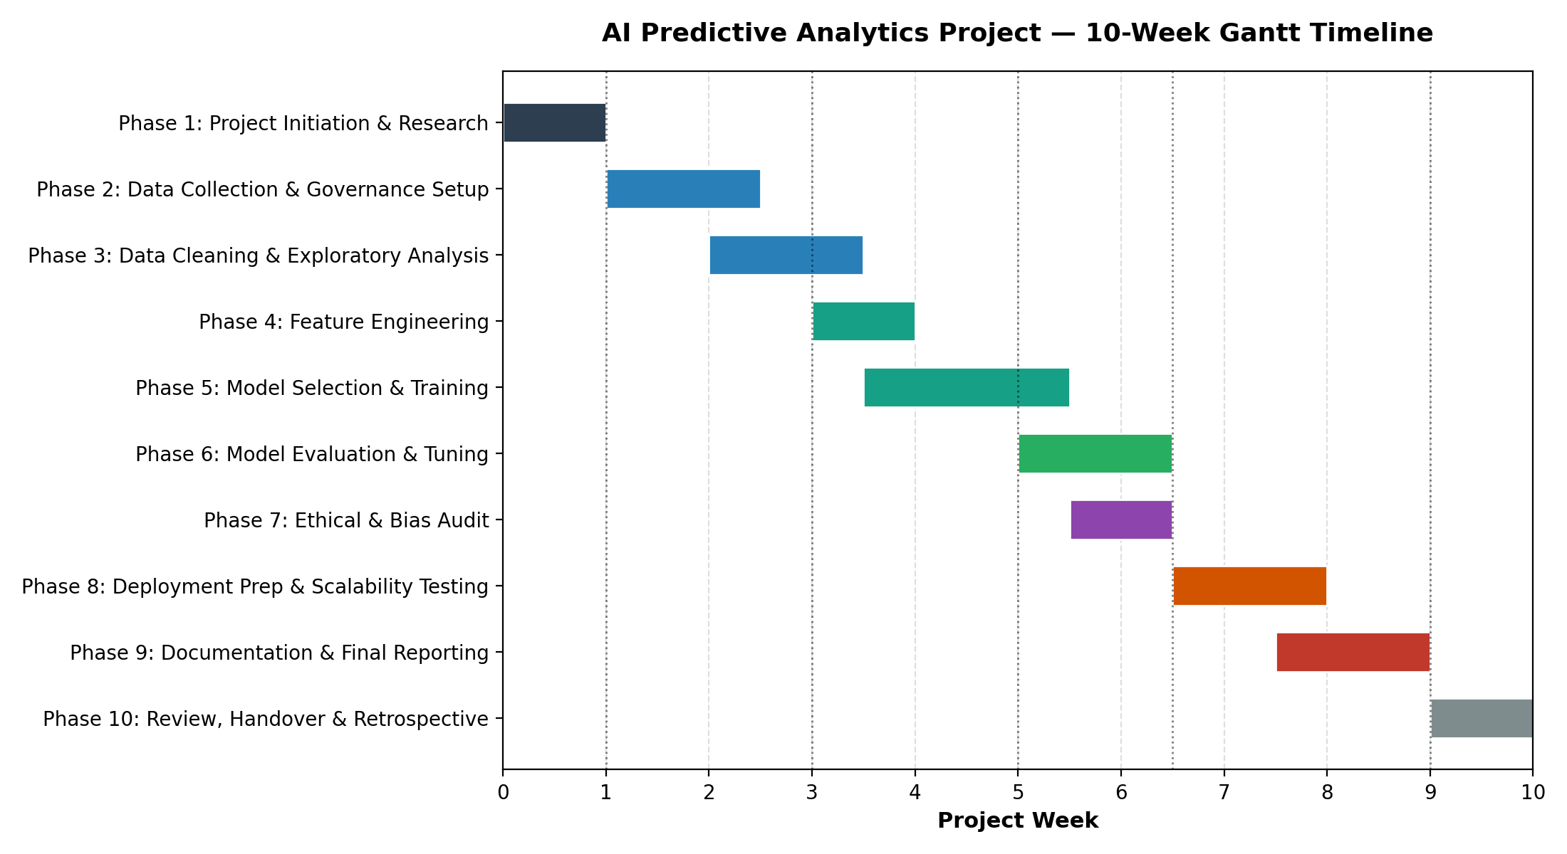

8.1 Key Milestones
Week | Milestone | Description
1 | M1: Data Access Confirmed | Dataset sourced, licence verified, raw copy stored; hypotheses and objectives finalised.
3 | M2: Clean Dataset Ready | Cleaning, preprocessing, and exploratory data analysis complete; hypotheses statistically tested.
5 | M3: Baseline Model Trained | Logistic regression baseline and first candidate models trained and cross-validated.
6.5 | M4: Final Model Approved | Best-performing model selected after tuning; fairness and evaluation checks passed.
9 | M5: Final Report Submitted | Documentation, visualisations, and final report compiled and delivered to stakeholders.

9. Expected Outcomes
- A validated churn-prediction model achieving a target ROC-AUC of 0.80 or higher on the held-out test set, with recall on the churn class prioritised over raw accuracy.
- A ranked list of the top drivers of churn (e.g., contract type, tenure, payment method), each supported by both statistical testing and SHAP-based model explanations.
- A reusable, documented data pipeline (ingestion → cleaning → feature engineering → training → evaluation) that can be retrained on updated data with minimal manual rework.
- A governance and ethics checklist that can be reused on future predictive analytics projects involving customer-level data.
- A final report and presentation-ready visualisation set that translates technical findings into retention-strategy recommendations for a non-technical audience.
Collectively, these outcomes demonstrate not only technical competence in building a predictive model, but also the broader project management discipline — planning, risk management, governance, and communication — required to take an AI initiative from idea to a defensible, decision-ready result.

10. Conclusion
This project plan lays out a structured, ten-week pathway for developing a predictive analytics solution for customer churn using a publicly available dataset. By explicitly formulating hypotheses before touching the data, selecting tools for transparency and reproducibility, and embedding governance, ethical review, and risk mitigation into the plan from the outset — rather than treating them as an afterthought — the project is designed to produce a result that is both technically sound and responsibly built. The milestone-based timeline provides checkpoints for course correction, and the evaluation framework ensures that success is measured in terms that matter to the business problem, not just model accuracy. The approach outlined here is intentionally general enough to be adapted to other predictive analytics use cases beyond churn, making it a reusable template for future AI project planning.

