**Software Engineering CEN 302**

**Project**

**Part 2**

**BINF III C**

**Group members:** Adela Kaçorri, Adela Kondakçiu, Griselda Ramadani, Megi Lala

**Objectives:**

* Creating a functional application to book appointments
* Registering the clients that want to book an appointment
* Displaying the available time for each type of service
* Displaying the reservations
* Having the ability to cancel the appointment without disrupting the normal activity/schedule

**Description of application:**

The application will consist of the main page where the clients and workers can sign up or sign in by selecting the type of user they are. Once registered, they will be able to login and access their profile.

Regarding the client, once logged in they can have the possibility to see their profile. It will include their name, last name, username, date of birth, phone number and email address. On their Reservation page, they will be able to see all the reserved appointments they have made. For the upcoming ones they will have the option to cancel it 3 hours in advance. On their Book page, they will be able to book an appointment by selecting the type of service they want and the hour which is still available.

Regarding the workers, once logged in they can have the possibility to see their profile. It will include their name, phone number, email address and the type of service they offer in the center. In the Reservation page they will be able to see the reservations made and can have the option to cancel the appointment.

**Development model:**

The development model that our group has chosen for this project is the plan-driven model.

**Users:**

Personnel

Clients

**User requirements:**

- The clients and personnel will be able to create an account by registering on the website and they will have the option to log in to their profile by their username/ email and password that has been created.

Personnel:

-Display on page the appointments that are reserved during the week.

-Display on page appointments details by search using date.

-Display on page updated appointments of the week after cancellation .

Clients:

-Display on page the schedule of each girl in the personnel to book the preferred time by searching the type of service.

-Display on page the previous, current and future appointments.

-Display on page updated appointments of the week after cancellation.

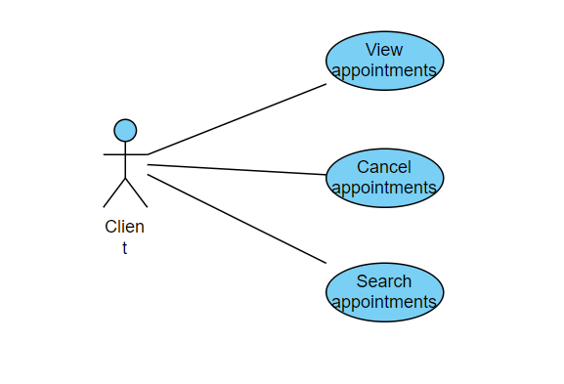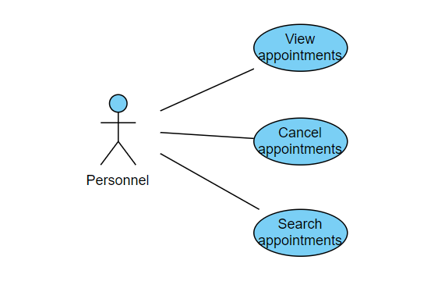

**System requirements:**

- The system will offer the options of registering for new clients and personnel and also the log-in option to access the account created by clicking the specified button.

-For registration of the clients, the system will require to fill in the data including name, last name, username, date of birth, phone number and email address.

-For login, the system will require the username/email and the password to enter the profile.

-For each week the system will generate for each worker a list of appointments specifying the name, last name of client, date and hour.

-Each worker will have in their page a search bar where the worker will be able to search appointments in specific dates entered and see the name, last name, date and hour of the appointment.

-Beside the upcoming appointment, there will be a cancel button to remove the scheduled appointment and the system will generate the updated appointments for both the client and worker. The system should delete the canceled appointments by not showing the information in the worker and clients page and making that time available.

-In the clients page, there will be a search bar to search the type of service they want to select and after clicking, the available times for the week will be shown.

-For each week the system will generate a list of appointments specifying the name, last name of client, date and hour.

- The system should automatically save the changes made by the users showing all the appointments available and those which are not.