**Software Engineering CEN 302**

**Project**

**BINF III C**

**Group members:** Adela Kaçorri, Adela Kondakçiu, Griselda Ramadani, Megi Lala

**Group leader:** Megi Lala

**Objectives:**

* Creating a functional application to book appointments
* Registering the clients that want to book an appointment
* Displaying the available time for each type of service
* Displaying the reservations
* Having the ability to cancel the appointment without disrupting the normal activity/schedule

**Description of application:**

The application will consist of the main page where the clients and workers can sign up or sign in by selecting the type of user they are. Once registered, they will be able to login and access their profile.

Regarding the client, once logged in they can have the possibility to see their profile. It will include their name, last name, username, date of birth, phone number and email address. On their Reservation page, they will be able to see all the reserved appointments they have made. For the upcoming ones they will have the option to cancel it 3 hours in advance. On their Book page, they will be able to book an appointment by selecting the type of service they want and the hour which is still available.

Regarding the workers, once logged in they can have the possibility to see their profile. It will include their name, phone number, email address and the type of service they offer in the center. In the Reservation page they will be able to see the reservations made and can have the option to cancel the appointment.

**System modeling:**

For this part of the project, we have decided to approach the application from the interaction perspective, where we will model the interactions between the components of a system.

Therefore, we will use the Interaction model to identify the actors in the system, the component and display component interactions. The two UML diagram types used are Use Case diagram and Sequence diagram as shown below.

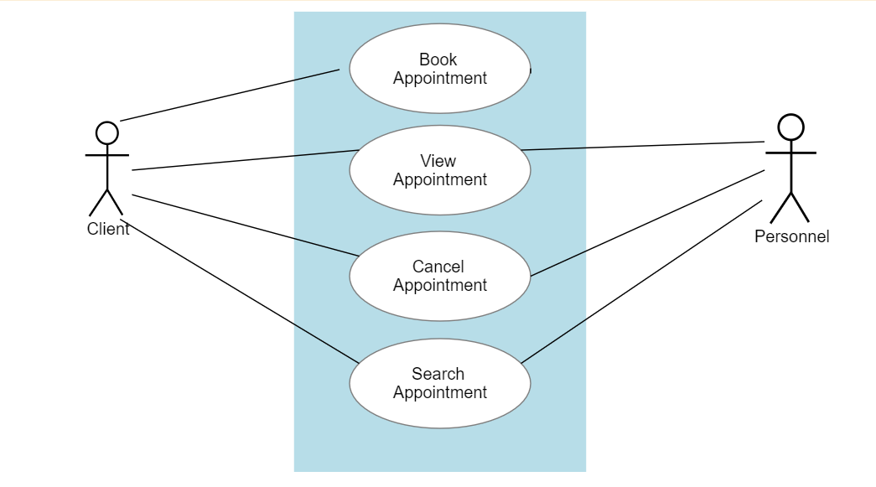

As seen in the **Use Case diagram**, the two actors in the system are the client and the personnel. Inside of the container we can clearly see the use cases/ tasks of each actor. The client will be able to book, view, cancel and search for appointments in the application, whereas the personnel will be able to view, cancel and search for the appointments.

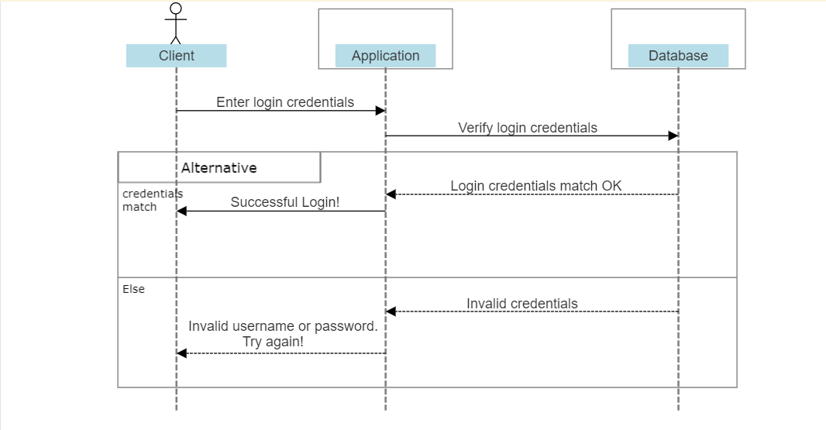

In the **Sequence diagram** above we have depicted the login procedure in our application and there is included the actor which in this case is the client and the two objects which are the application and the database. The client should be able to enter the login credentials (username and password) in the Login page of the application. Then this information will be sent to the database in order to check and verify that first there is someone registered with that username and then if the credentials entered match. If the credentials match that a message will appear to the client “Successful Login!”, otherwise the message “Invalid username or password. Try again!” will be displayed on the screen.