Get request

Get by id

Post request

Put

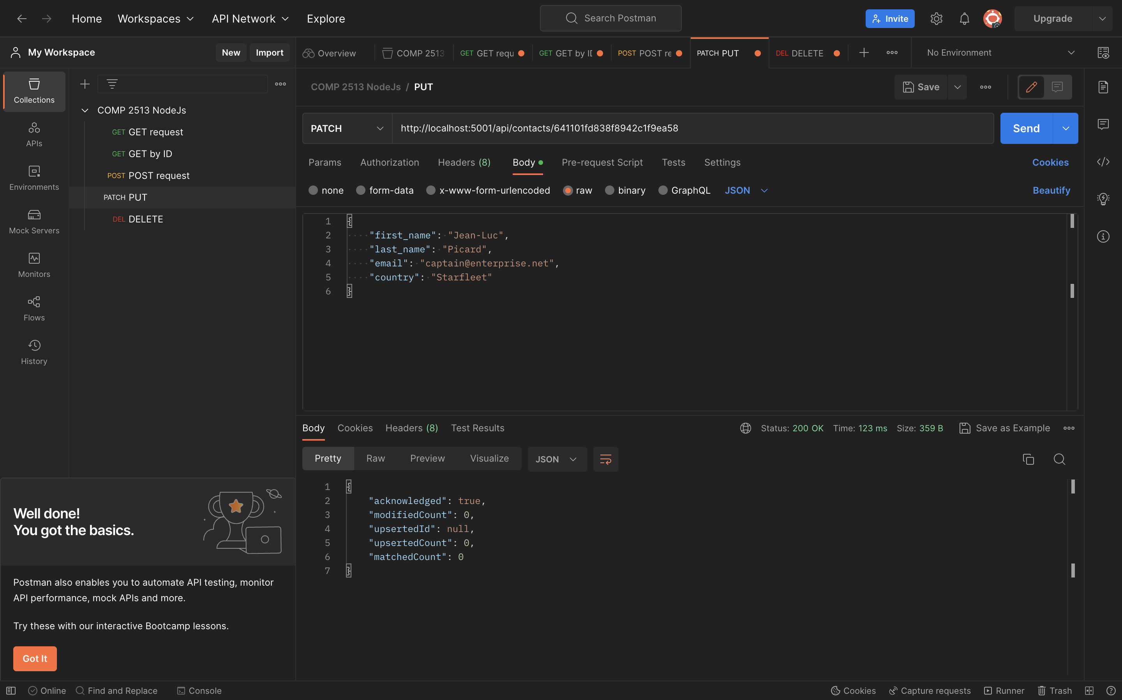

Delete

