Usability Problem | On Torontopearson.com, when browse some documents on the page, users has to use the scroll wheel to view the text at the top of the web page, which is not conducive to users rechecking the information they have obtained before.
Heuristic(s) Violated | H3
Screenshot | 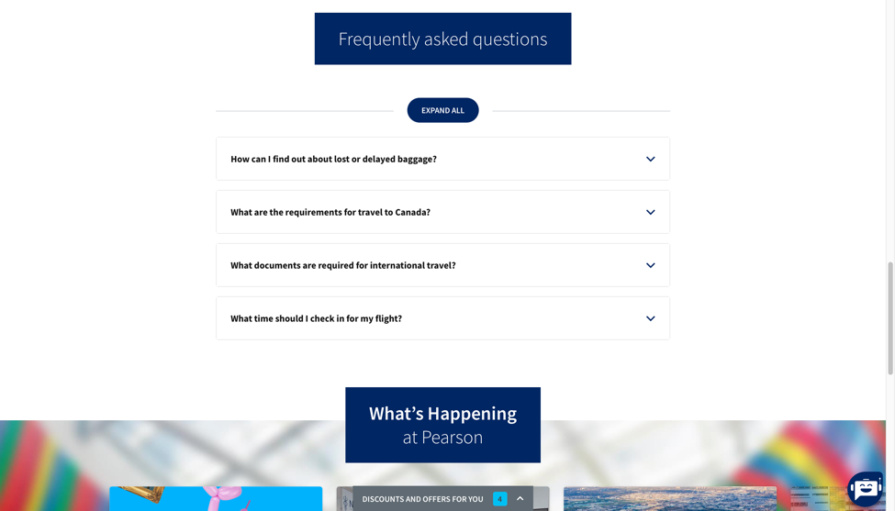
Advice |   In order to adjust the H3, I design a button in the left corner above the robot. Click it can help user to come back to the top of the page

Usability Problem | On Torontopearson.com, the help section is buried in the footer and is not comprehensive, making it difficult for users to find assistance when encountering issues.
Heuristic(s) Violated | H10
Screenshot | 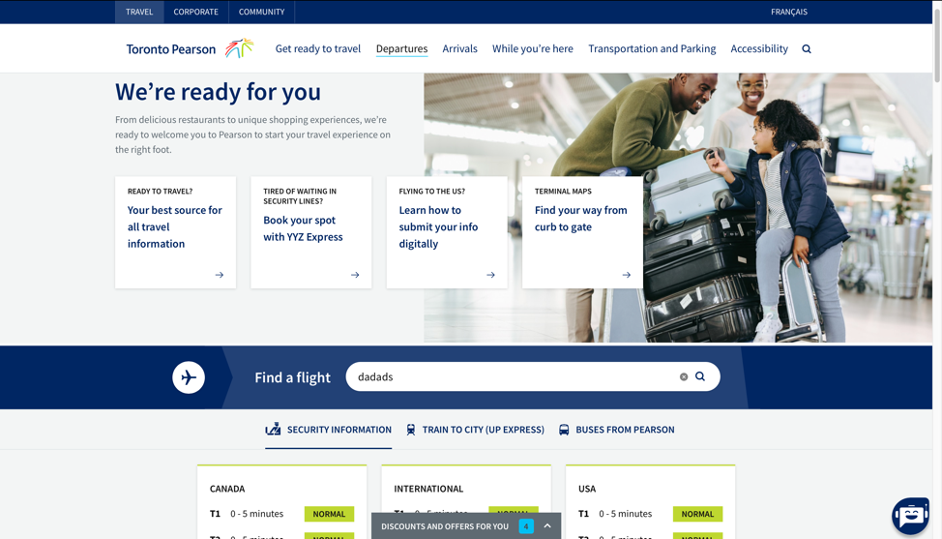
Advice |   Help  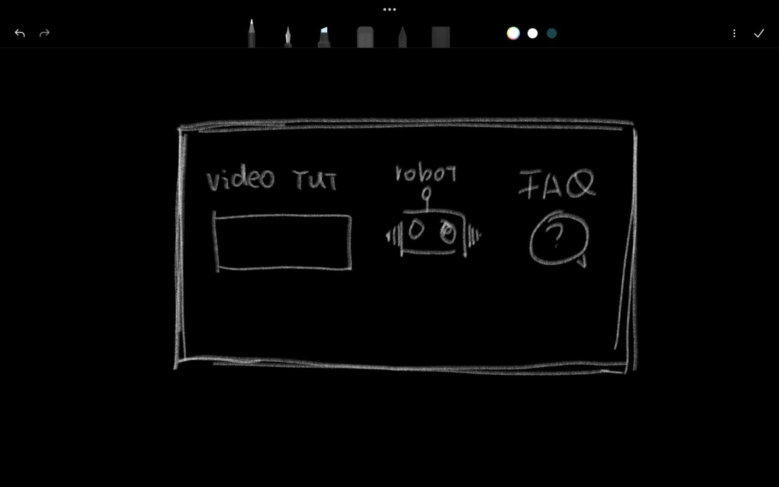  Create a visible help icon or link in the main navigation bar that directs users to a detailed help center. Include a searchable FAQ, video tutorials, and live chat support for real-time assistance.
Usability Problem | On Torontopearson.com, when searching for flights or navigating between different sections, there is no clear indication that the page is loading or that the system is processing the request.
Heuristic(s) Violated | H1
Screenshot | 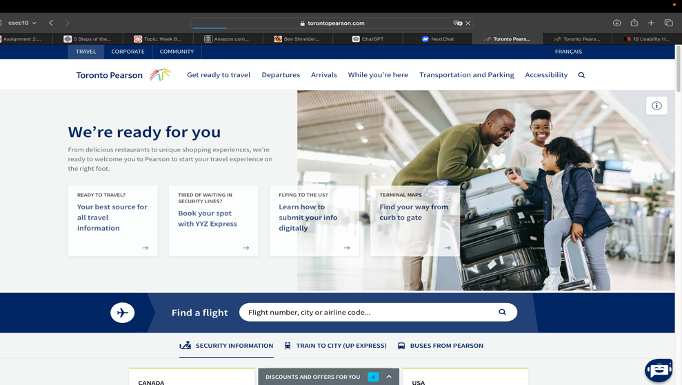
Advice | 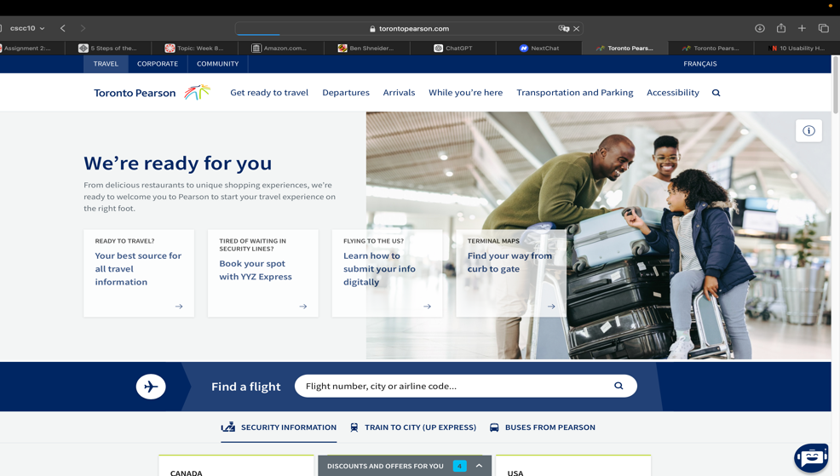  Implement a loading spinner or progress bar to inform users that their action is being processed. For example, when a user searches for flights, a loading indicator should appear until the results are displayed.

