Name: Changze Wu
Student Number: 1008837840
LINA01
Assignment 3
Question 1:
Consider the following constituent:
[extremely delighted by those positive online product reviews]
1. Identify the phrase head (i.e., identify the actual word that represents the head).
Head: [delighted]
2. Draw the syntactic tree of the phrase.
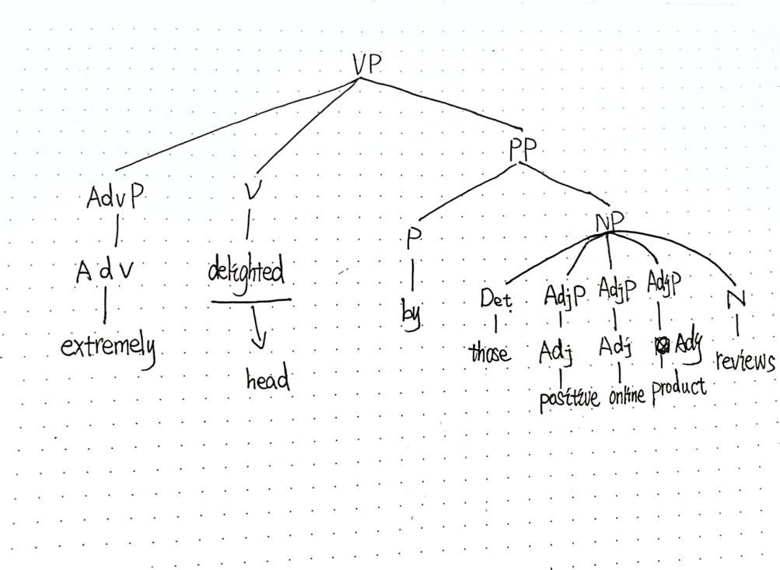

Questions 2:
Consider the following constituent:
[accidentally stomped on his fruitloops with his winter boots]
1. Identify the phrase head (i.e., identify the actual word that represents the head).
Head: [stomped]
2. Draw the syntactic tree of the phrase.
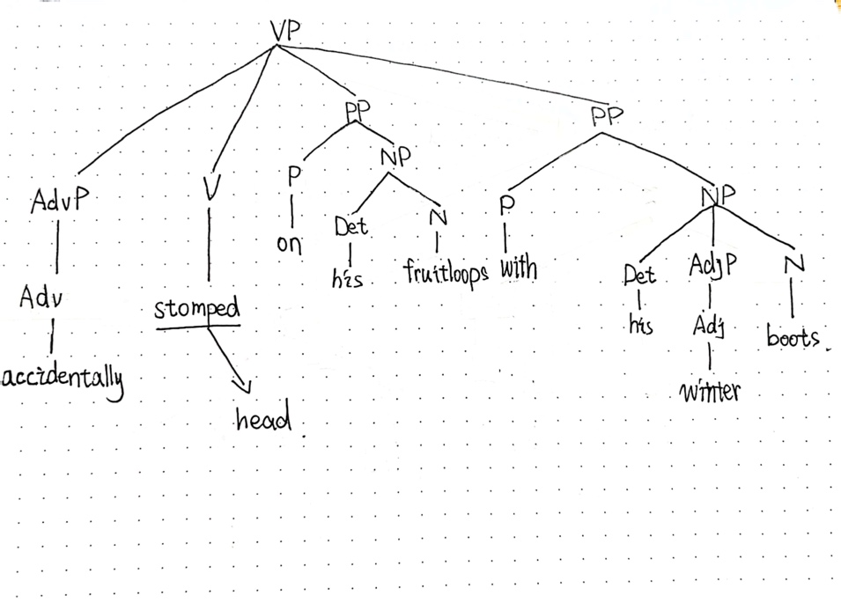

Questions 3:
Consider the following sentence:
[The intense rain pelted the cracked windshields.]
1. List ALL the phrase structure rules (PSRs) that can account for the structure of the sentence
(including the clause structure).
Cl -> [NP VP].
NP₁ -> [Det AdjP N]
NP₂ -> [Det AdjP N]
VP -> [V NP]
AdjP₁ -> [Adj]
AdjP₂ -> [Adj]
2. Draw the syntactic tree of the sentence.
