MedTrust AI
Reliability-Aware Clinical Decision Routing
Final Research Demonstration Report
MIMIC-IV Clinical Database Demo v2.2

Executive Summary
MedTrust AI investigates whether clinical AI reliability should be assessed using predictive confidence alone or using both predictive confidence and explanation reliability. The framework produces an additional Explanation Reliability Score (ERS) and combines it with calibrated predictive confidence to route predictions into ACCEPT, REVIEW or DEFER.

Research Problem
A model may produce a high-confidence prediction while its explanation is unstable or unreliable. MedTrust AI therefore treats explanation reliability as a complementary reliability signal rather than defining reliability only through model confidence.

Dataset
MIMIC-IV Clinical Database Demo v2.2 was used. The current dataset contains 126 records/stays and 9 positive ICU mortality outcomes.
Because this experiment uses the MIMIC-IV DEMO dataset, the results are methodological and should not be interpreted as clinical performance evidence.

Models
Logistic Regression, Random Forest and XGBoost were evaluated. XGBoost was additionally calibrated using sigmoid calibration.

Model Performance
Model | Accuracy | Precision | Recall | F1 | AUROC | AUPRC
Logistic Regression | 0.8500 | 0.0000 | 0.0000 | 0.0000 | 0.6667 | 0.3269
Random Forest | 0.8500 | 0.0000 | 0.0000 | 0.0000 | 0.5000 | 0.3026
XGBoost | 0.9000 | 0.0000 | 0.0000 | 0.0000 | 0.6944 | 0.5769
Calibrated XGBoost | 0.9000 | 0.0000 | 0.0000 | 0.0000 | 0.8056 | 0.6111

Explainability
SHAP TreeExplainer was used to estimate feature contributions for the XGBoost model.
- spo2_min — mean absolute SHAP = 0.5496
- anchor_age — mean absolute SHAP = 0.4109
- glucose_min — mean absolute SHAP = 0.4010
- phosphate_mean — mean absolute SHAP = 0.3751
- ph_max — mean absolute SHAP = 0.3391
- ph_min — mean absolute SHAP = 0.3301
- resp_rate_min — mean absolute SHAP = 0.3238
- glucose_mean — mean absolute SHAP = 0.2318
- mbp_min — mean absolute SHAP = 0.1712
- sbp_max — mean absolute SHAP = 0.1519

Explanation Reliability
Average Explanation Reliability Score (ERS): 0.7537
Minimum ERS: 0.6130
Maximum ERS: 0.9809
The prototype ERS combines explanation stability, feature-ranking consistency, sign consistency and faithfulness under controlled perturbations.

Reliability-Aware Routing
MedTrust AI combines 50% calibrated predictive confidence and 50% explanation reliability for the prototype joint reliability score.
ACCEPT threshold: 0.70
REVIEW threshold: 0.50

Routing Comparison
Strategy | ACCEPT | REVIEW | DEFER | Coverage | Accepted Error
MedTrust_Route | 20 | 0 | 0 | 1.0000 | 0.1000
Confidence_Only_Route | 20 | 0 | 0 | 1.0000 | 0.1000
Routing changed for 0 test cases.
High-confidence / low-ERS cases identified: 0

Graphs

Model Performance
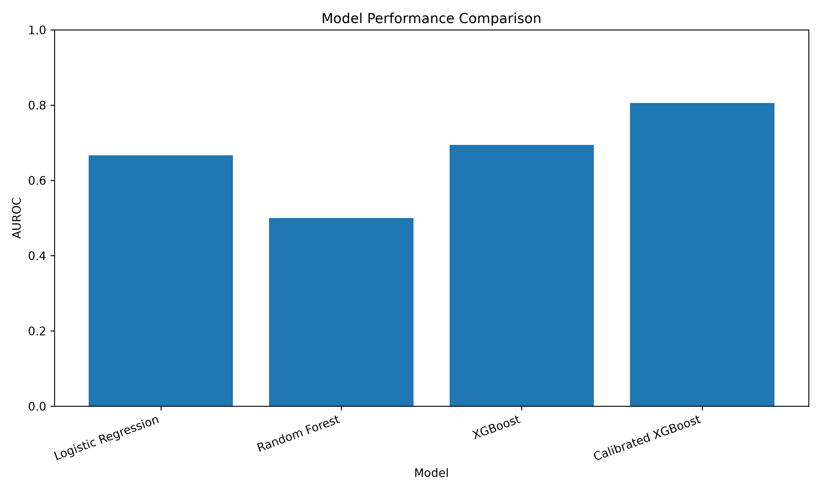

SHAP Feature Importance
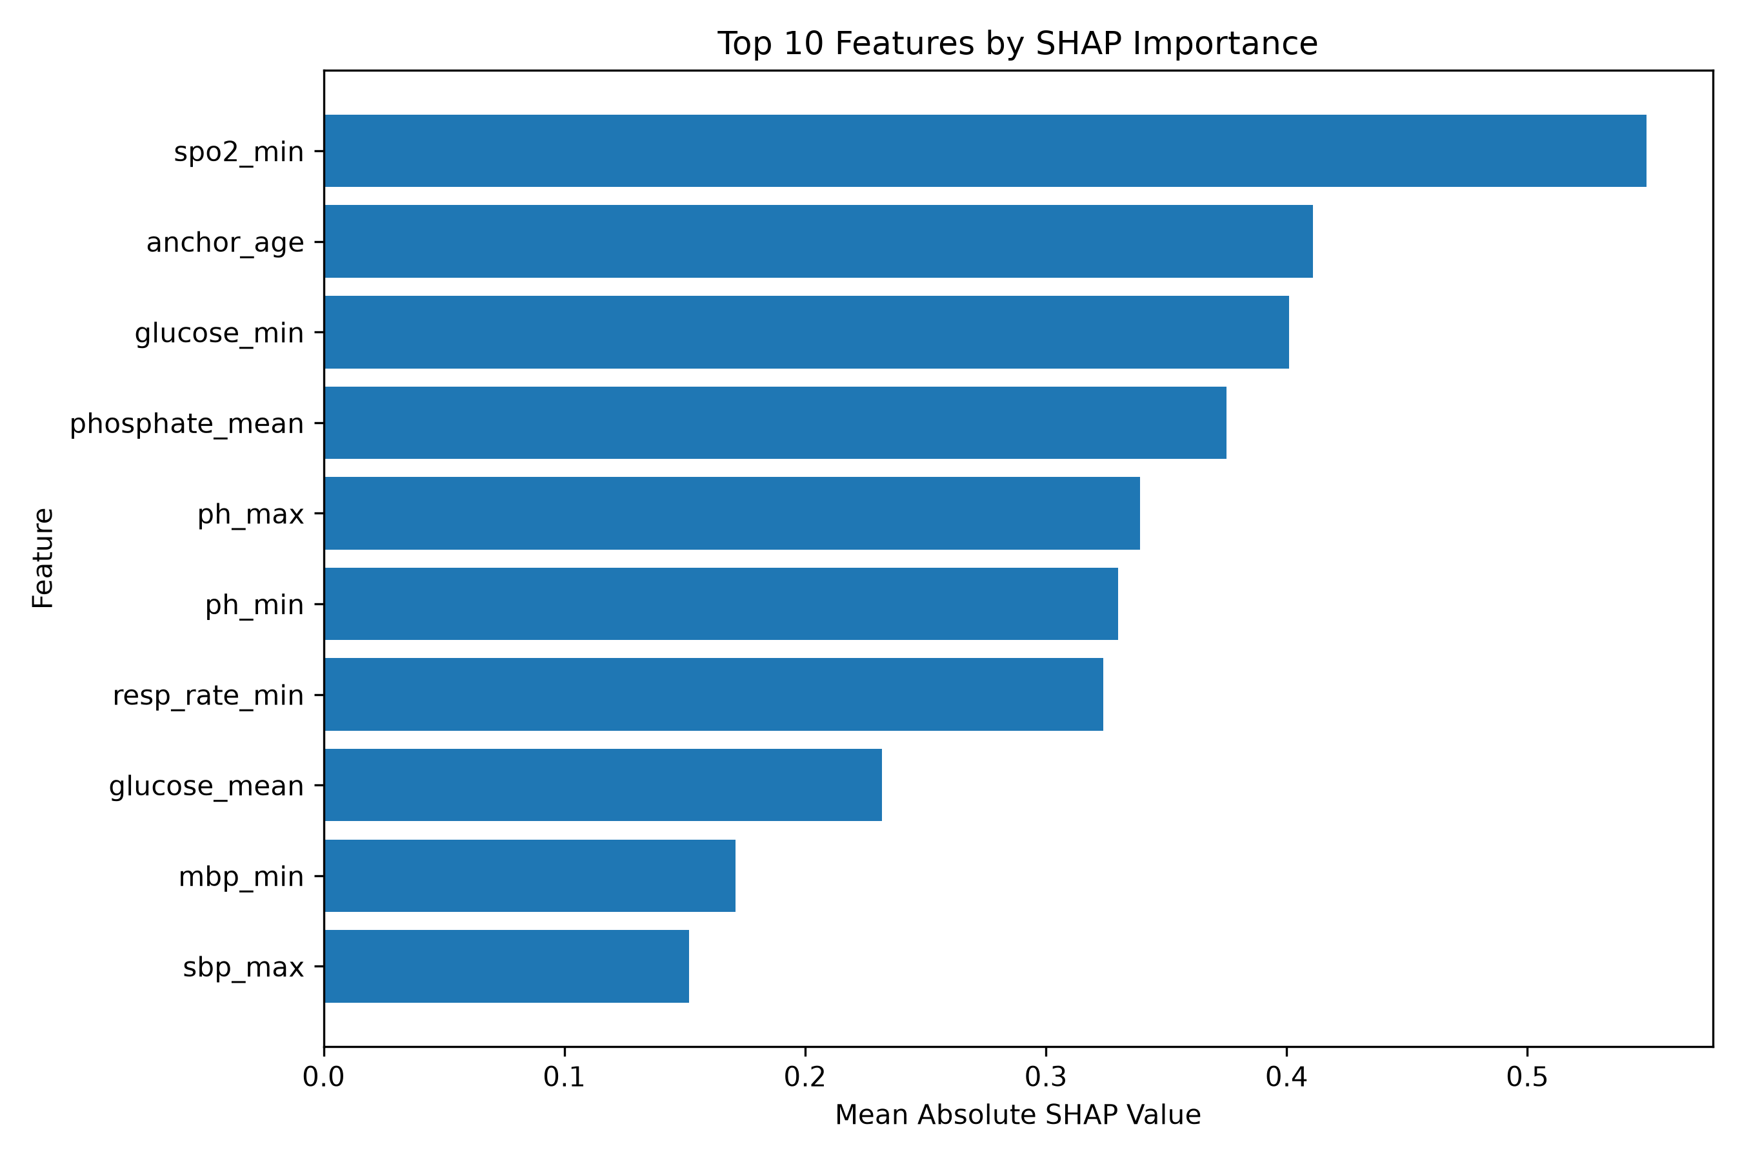

Routing Distribution
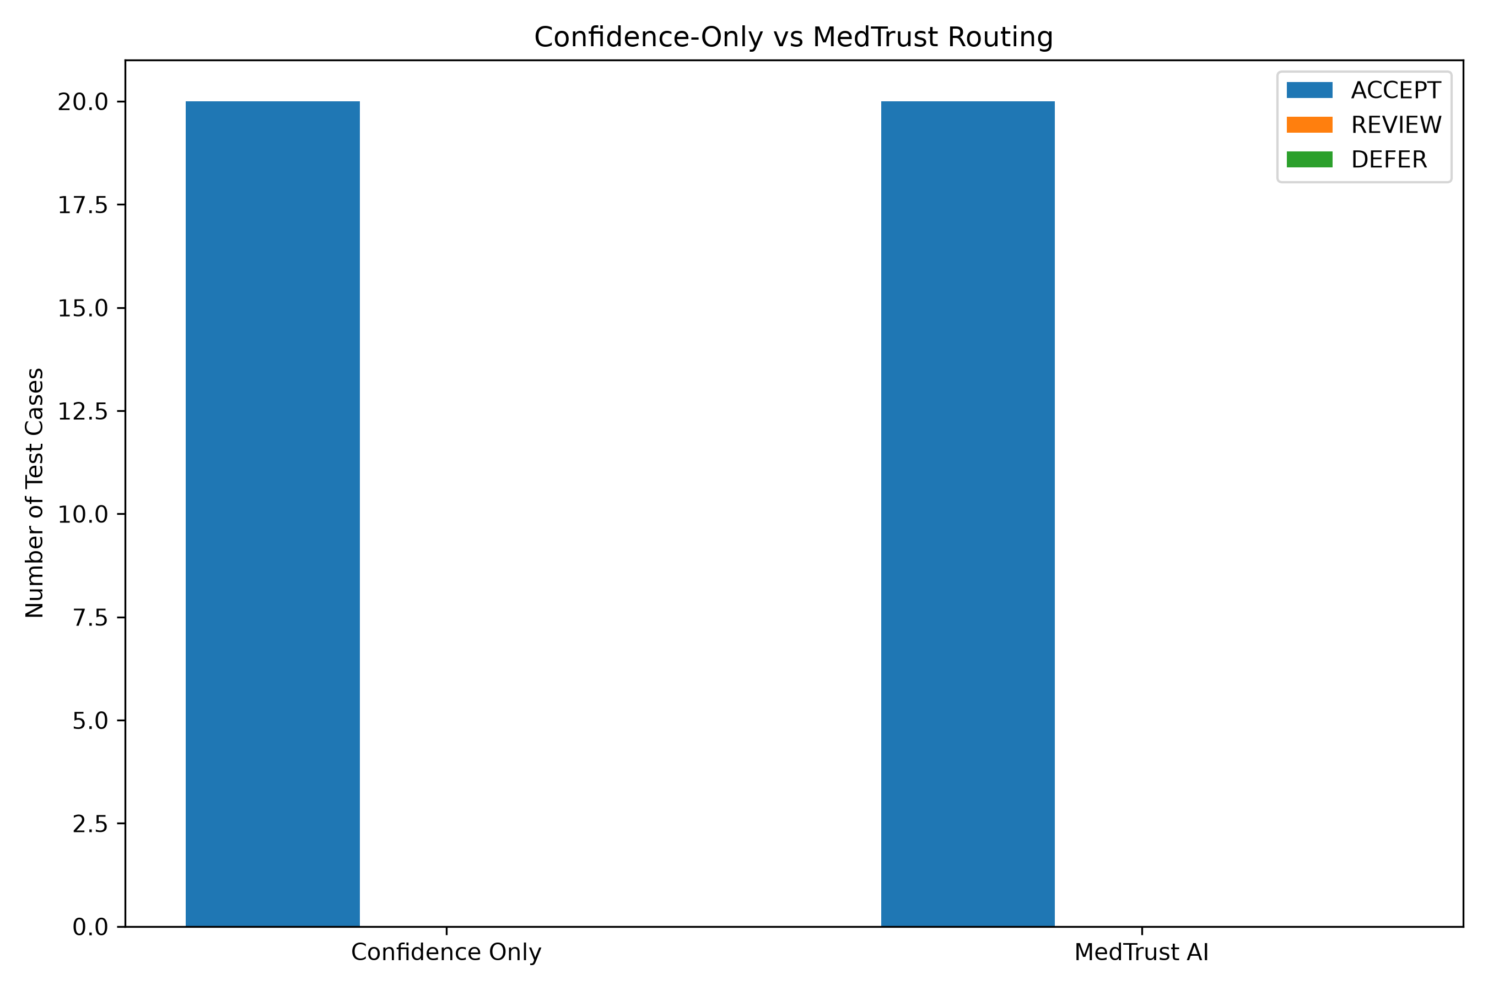

Predictive Confidence vs Explanation Reliability
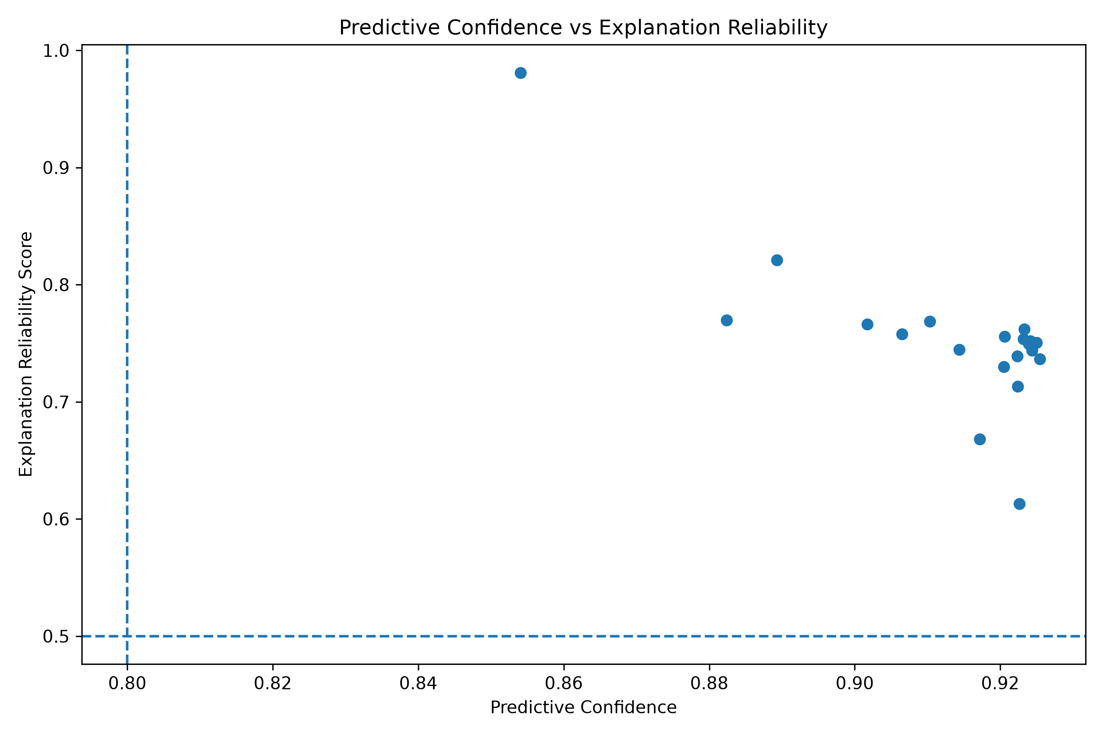

Coverage vs Accepted Error
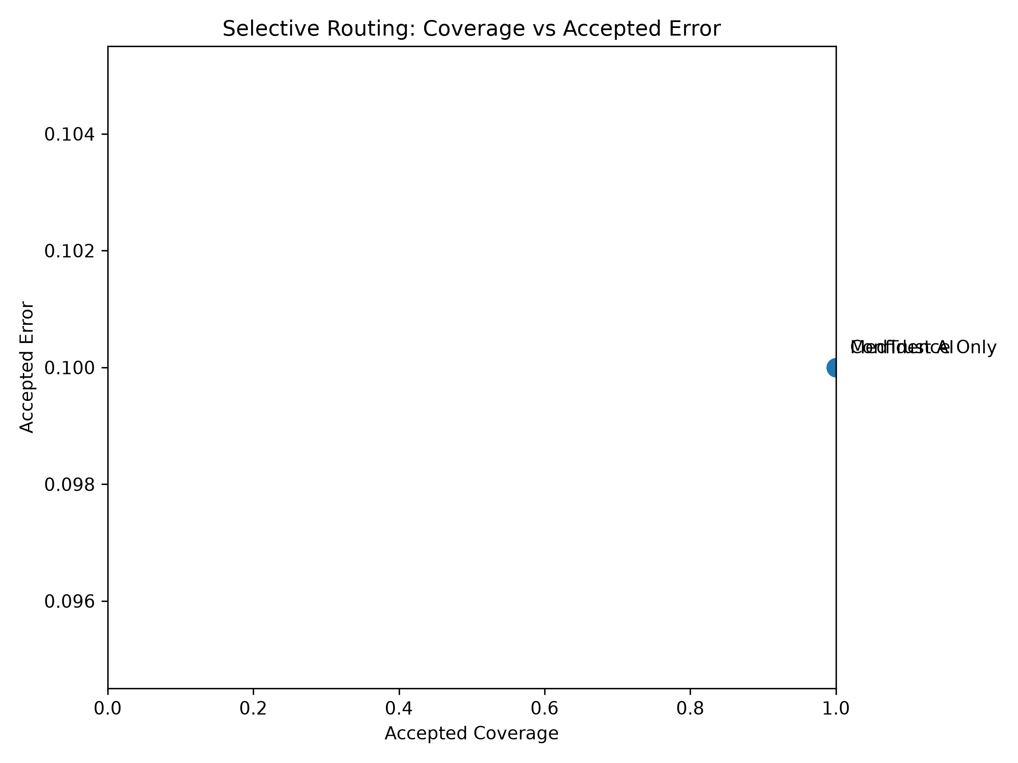

Limitations
- The current experiment uses the MIMIC-IV DEMO dataset.
- The number of mortality-positive cases is very small.
- Performance estimates may therefore be unstable.
- The current ERS is a research prototype requiring further validation.
- Prototype routing thresholds and weights should be selected using validation data in the final study.
- The results should not be interpreted as evidence for clinical deployment.

Future Work
- Validate the framework on the full MIMIC-IV dataset.
- Perform temporal validation.
- Perform external validation using eICU-CRD.
- Further formalize and validate the Explanation Reliability Score.
- Freeze routing thresholds using validation data before final testing.
- Add confidence intervals and statistical comparisons.
- Evaluate out-of-distribution and domain-shift cases.

Conclusion
MedTrust AI demonstrates a reliability-aware clinical decision-routing concept in which calibrated predictive confidence is complemented by explanation reliability. The framework provides ACCEPT, REVIEW and DEFER routes instead of relying exclusively on model confidence.
The current results are a methodological demonstration using the available MIMIC-IV demo dataset. Full MIMIC-IV and external eICU validation are required before clinical conclusions can be made.

