***Furniture Marketplace E-commerce Website***

## **Project Overview:**

This document ensures that the website functions smoothly and provides a seamless user experience. Verifies that the system gracefully handles issues like invalid search queries, failed transactions, or missing product information. It ensures users receive clear feedback without disruptions. The goal is enhance the user experience by preventing disruption due to technical errors.

## **Day 5 -** Testing Error Handling and Backend Integration for a Furniture Website**:**

**Functional Testing**

*PRODUCT LISTING**:(TC001)*

Verifying that the product listing page displays products correctly and its properly populated with data.

**1:** Navigation to the product page.

**2:** Verifying that the all products are displayed with the correct names, images and prices.

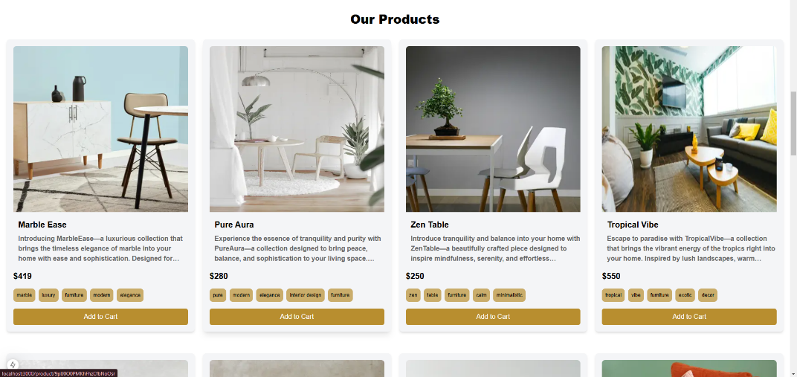

*PRODUCT DETAIL PAGE :(TC002)*

We ensure that each product detail page displays loads correctly and the right information

**1:** Click on a product from the listing page to open its detail page.

**2:** Ensure the page loads correctly with accurate details(names, images and prices).

**3:** Verifying the “Add to Cart” button correctly adds product to card .

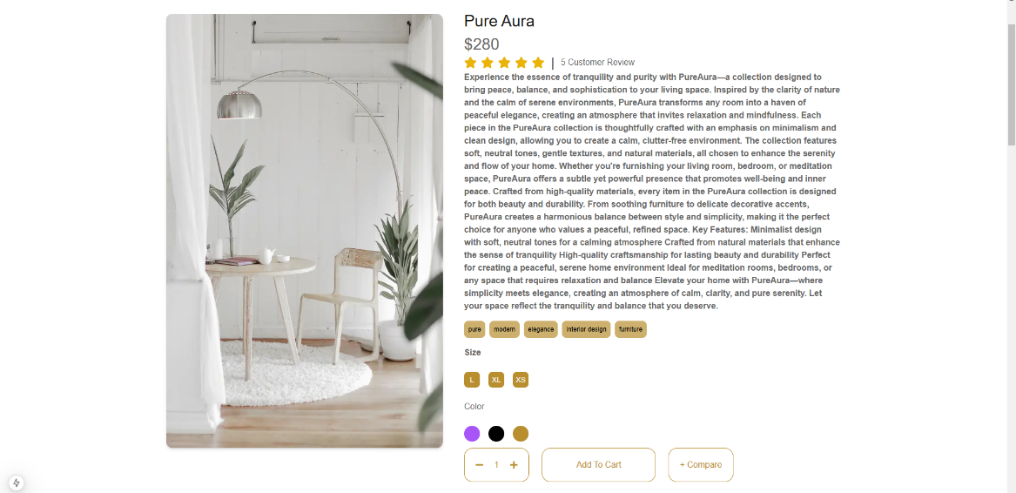

*CART OPERATIONS: :(TC003)*

Verifying that the correct behavior of the shopping cart when adding removing and updating cart items and also product total amounts.

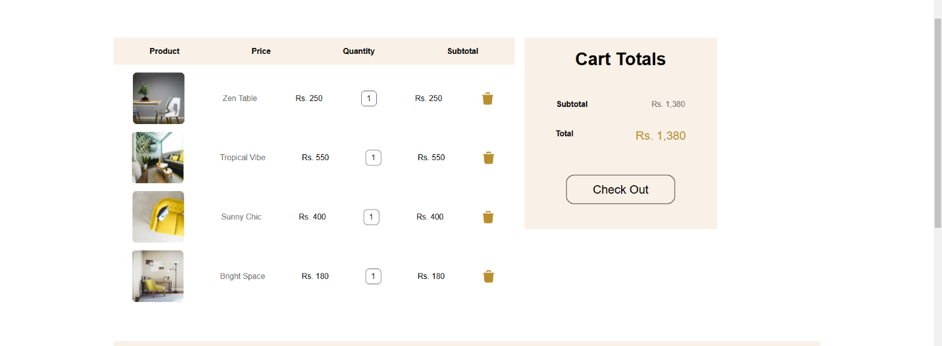

*Device Responsiveness :(TC004)*

**No issue** All components render correctly across all devices including mobile and tablet

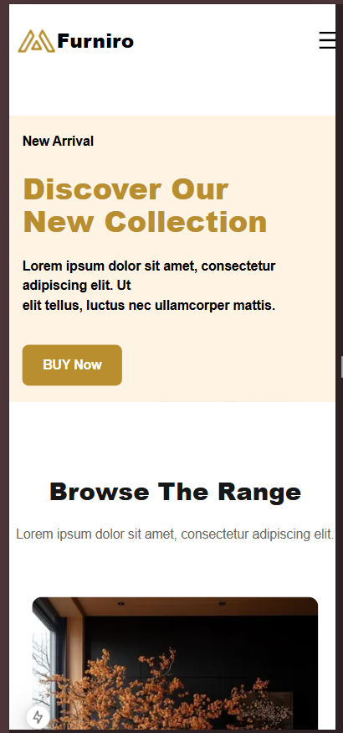 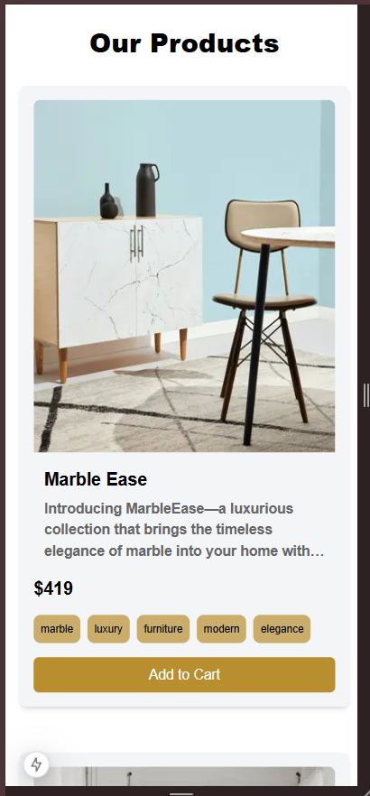

*Tested API with Thunder client:(TC004)*

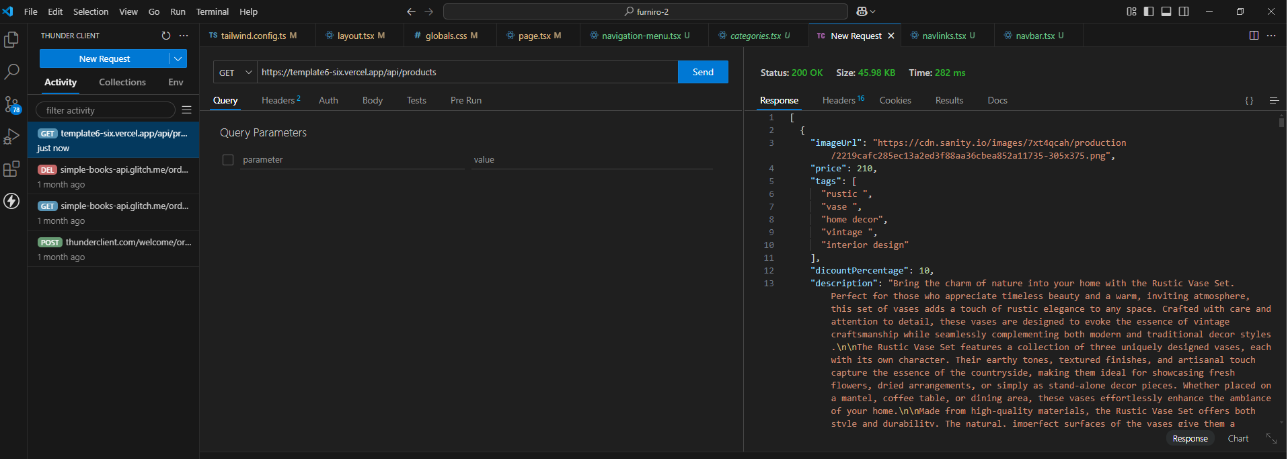

**.Error Handling**

**No issue** :**Error handling** All Api errors are handles gracefully with clear fallback messages for use Added try catch blocks to handle API errors gracefully and display clear ,user friendly fallback messages

**Cross-browser Compatibility**

**No issue** : consistent functionality and design across Chrome, Edge, and other tested browser

|  |  |  |  |  |  |  |  |  |
| --- | --- | --- | --- | --- | --- | --- | --- | --- |
|  |  |  |  |  |  |  |  |  |

**SEO:**

Checking with LigthHouse

