

**E-PROJECT**



**STUDENT:** Ubaid Sajid Khatri Web Developer

**STUDENT:** Mustafa Atiq Web Developer

**STUDENT:** Mehak Fatima Web Developer

**STUDENT:** Muhammad Talha Web Developer

**STUDENT:** Omer Usmani Web Developer

# DOCUMENTATION: BRIDGE XPERT WEBSITE

**INTRODUCTION**

Bridge Xpert is a comprehensive dedicated to showcasing the marvels

Of bridges from around the world. Through captivating imagery, informative content, And user friendly navigation. Bridge xpert aims to educate and inspire visitors about The engineering feats and architectural wonders of bridges

# HOMEPAGE STRUCTURE

The homepage of bridge xpert is designed to engage visitors and provide easy access to key sections of the website. Its consists of the following sections:

* **Banner Section:** A visually striking banner introduces Users to the website and sets the tone for their browsing experience

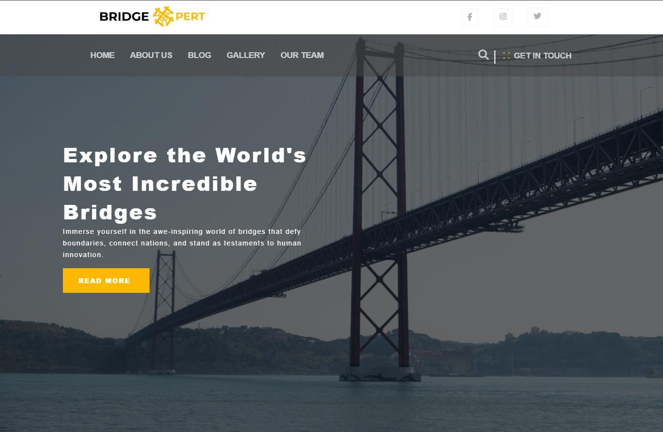

* + **Bridge Slider:** A dynamic slider showcases a curated selection of breathtaking bridges, highlighting their architectural beauty and significance.



* + **Team Section:** This section introduces the team members behind bridge xpert, adding a personal touch to the website and fostering a sense of connection with its creators



* + **Blog Section:** A dedicated Section invites users to explore informative and engaging blog articles about various aspect of bridges, seamlessly linked to the blog page for further reading.

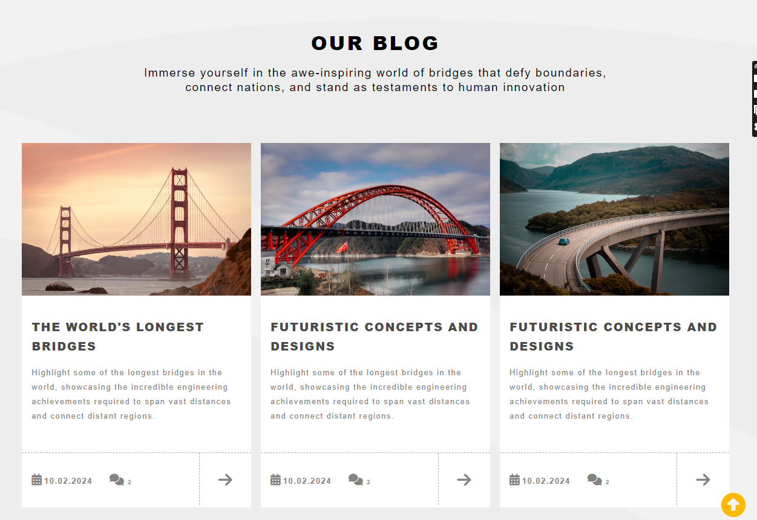

* + **Navigation:** Bridge xpert features intuitive navigation, allowing users to easily explore different sections of the website and access relevant information the navigation menu is prominently displayed and offers clear categorization of content, ensuring a smooth browsing experience for users.



**HOMEPAGE**





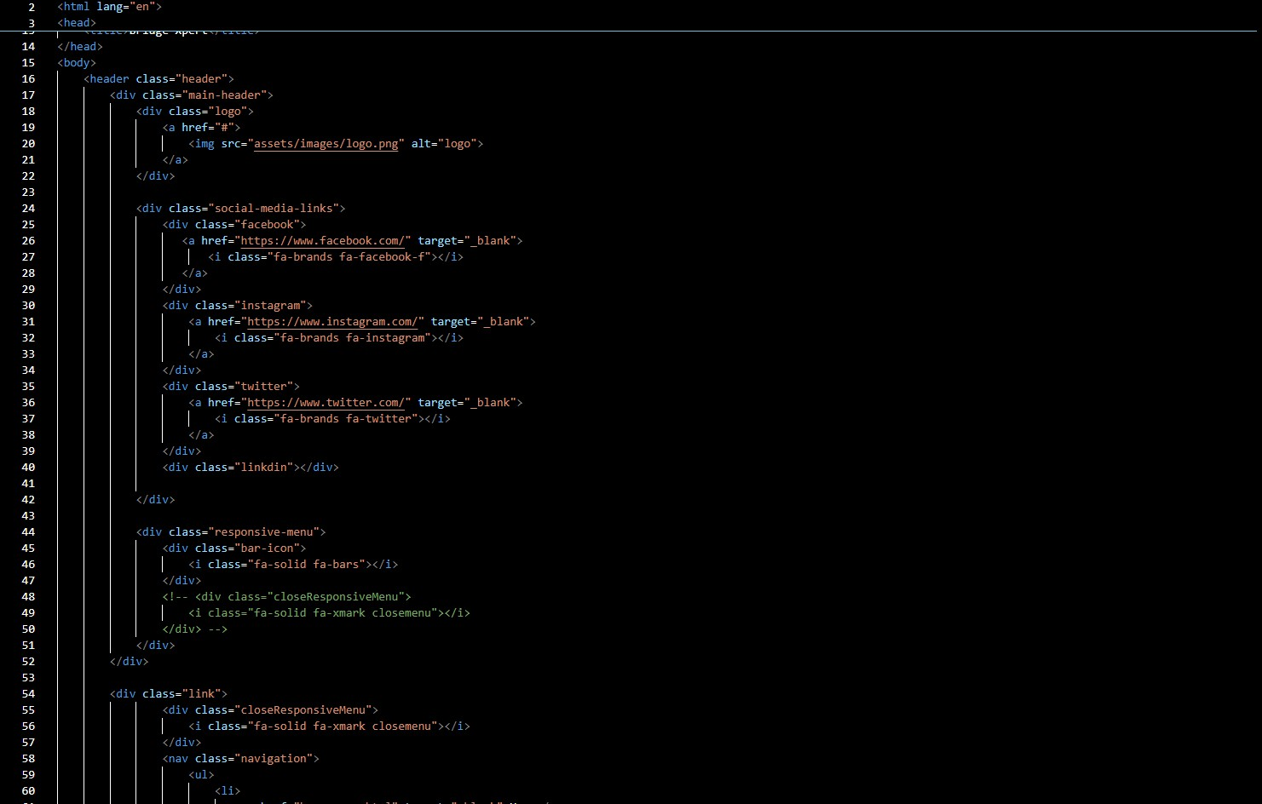

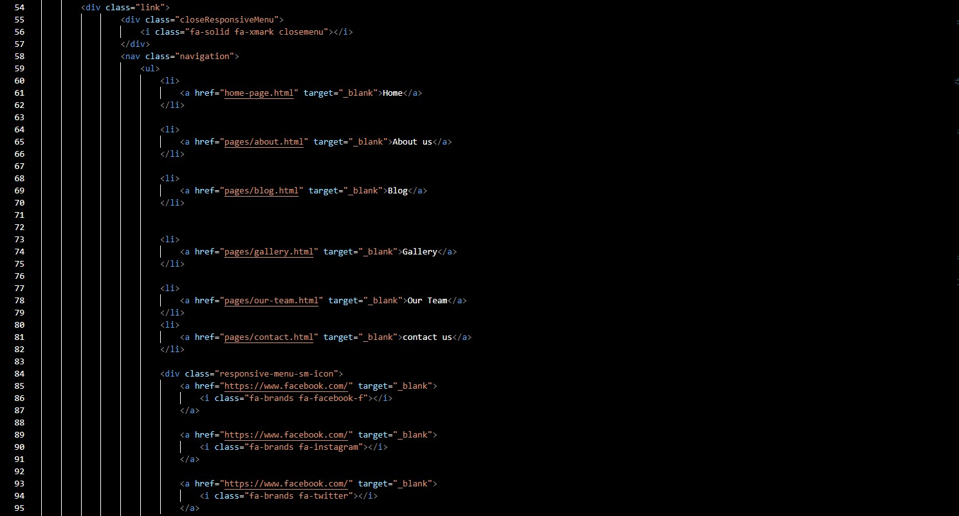

**ABOUT US PAGE**



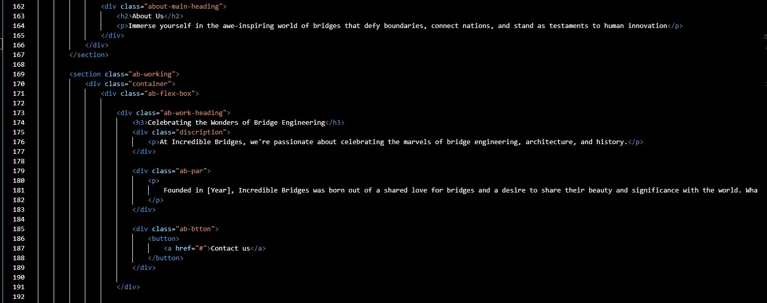

**BLOG PAGE**

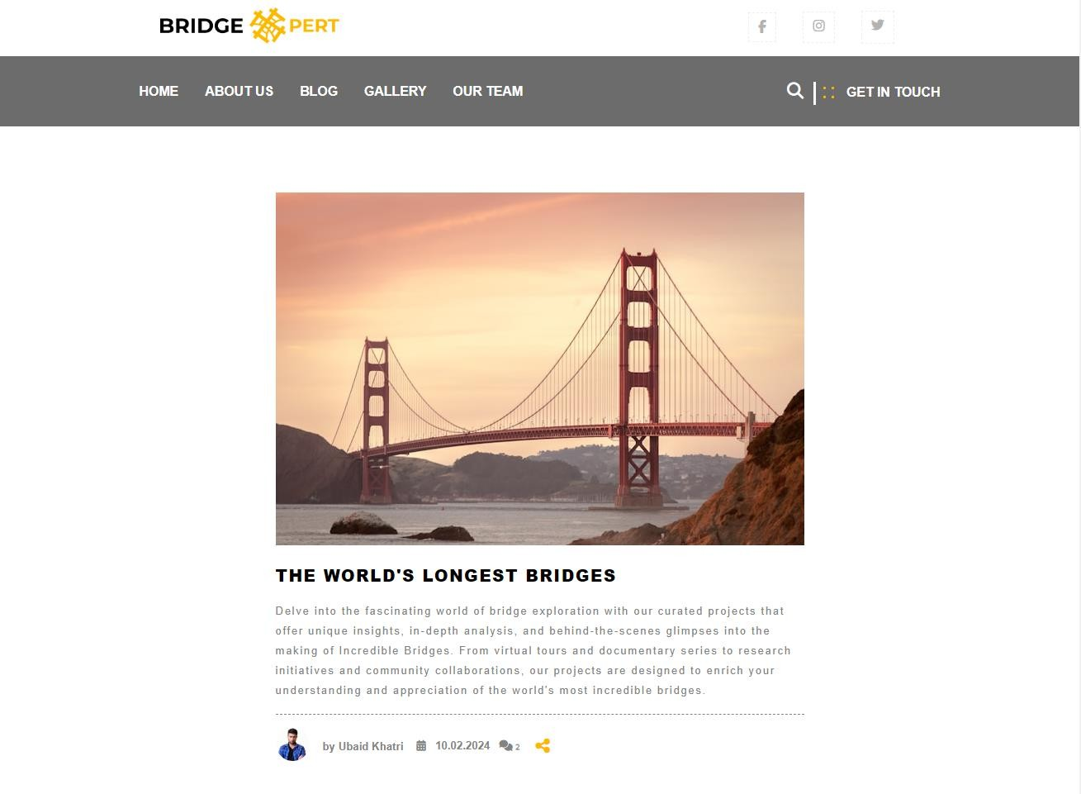

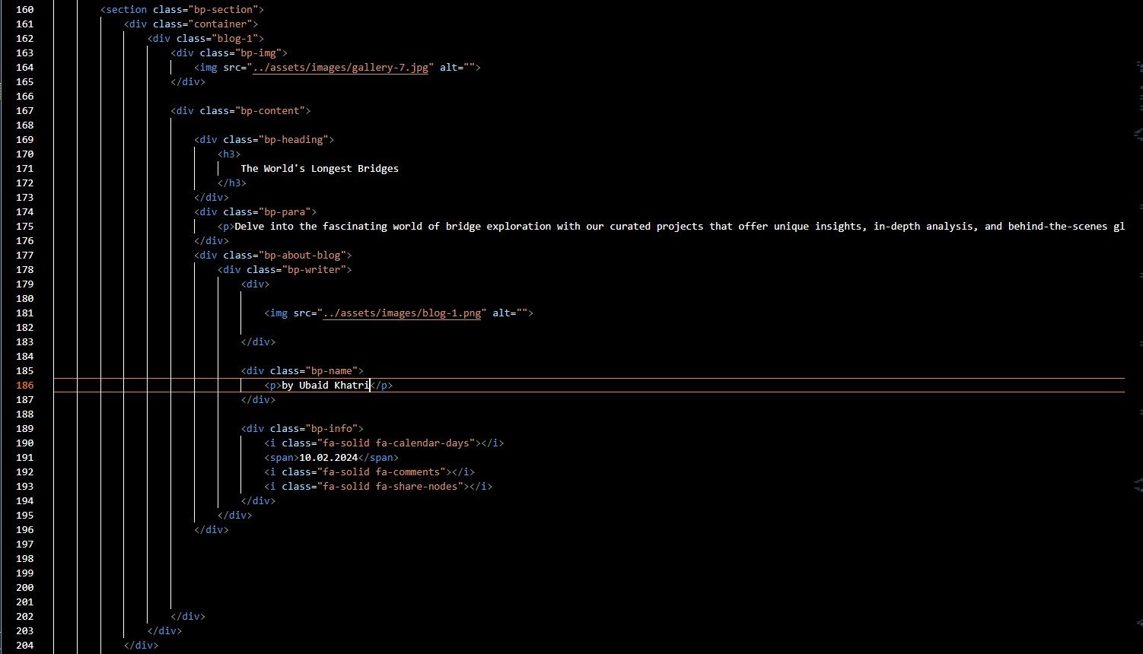

**GALLERY PAGE**

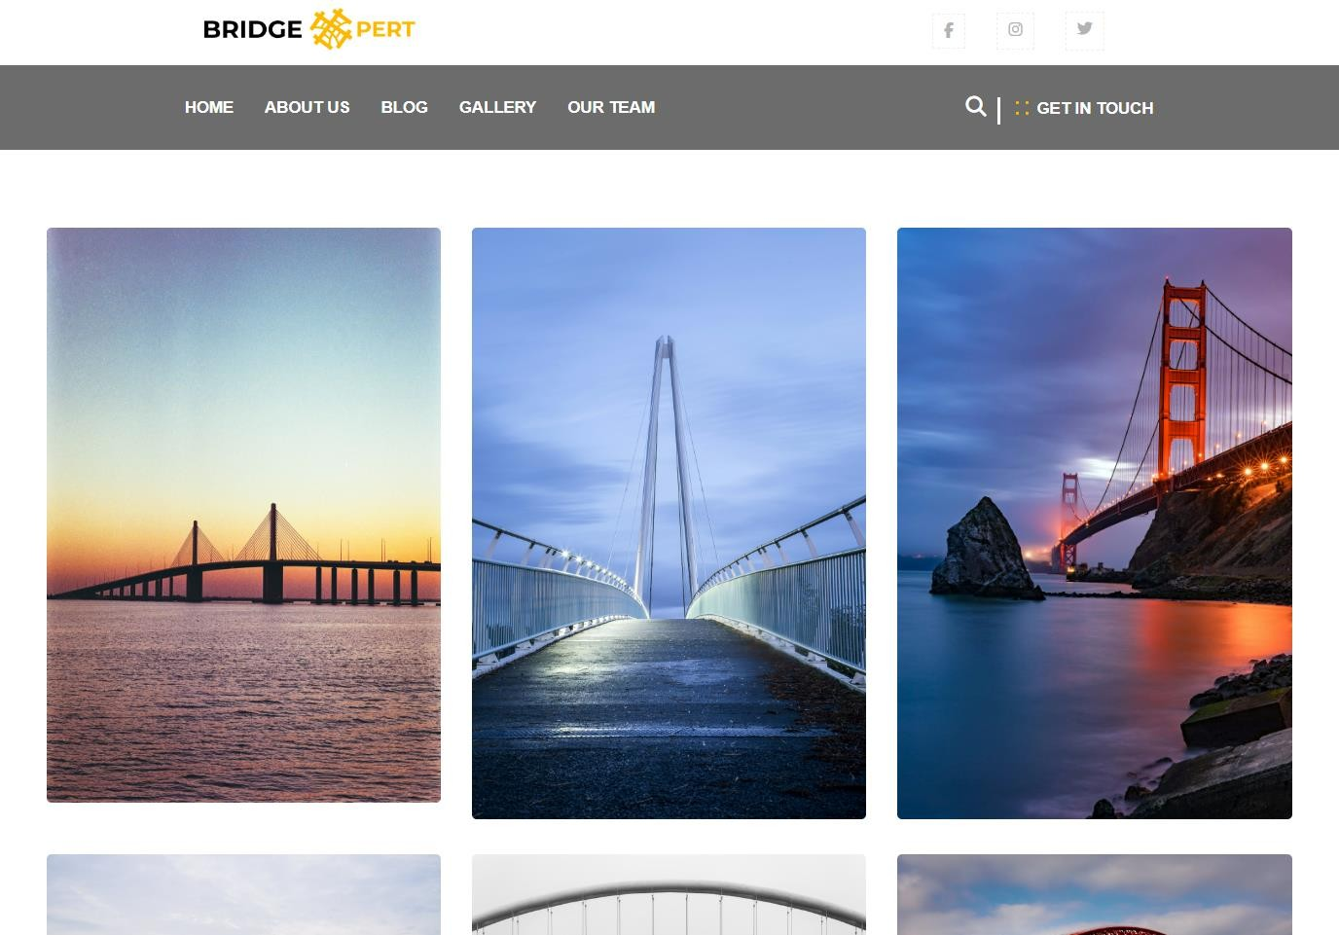

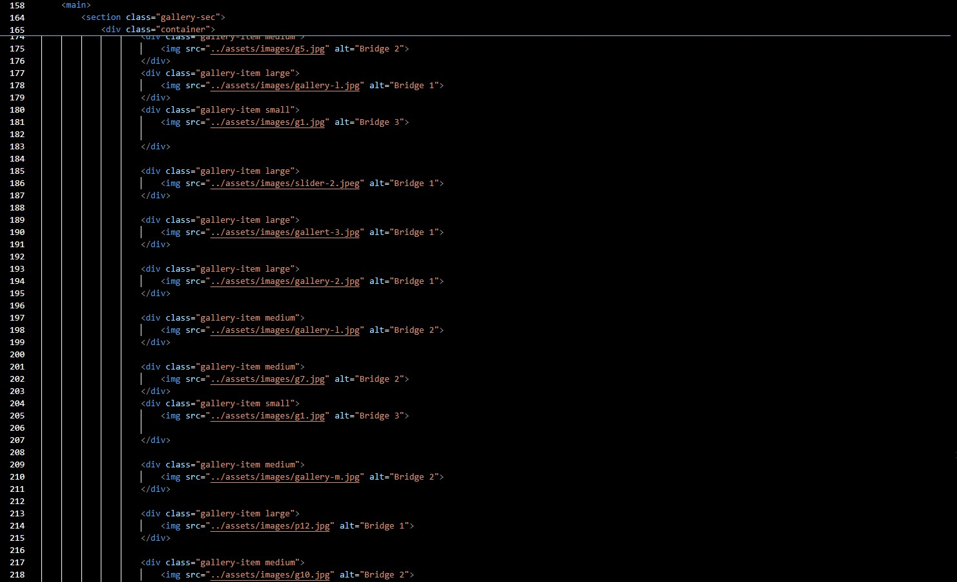

**OUR TEAM PAGE**



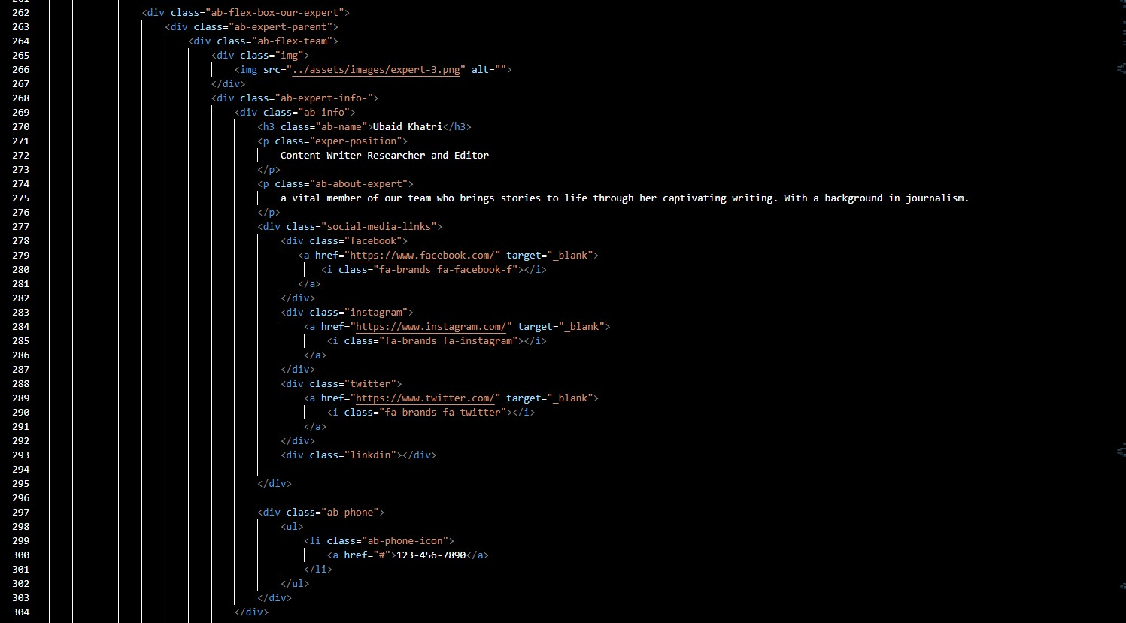

**FOOTER**



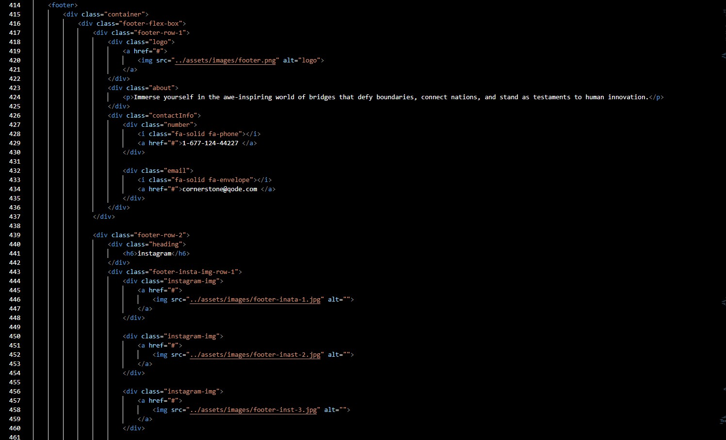

**PURPOSE**

The purpose of bridge xpert is to serve as a comprehensive resource for anyone interested in learning about bridges. Whether users are enthusiasts, students, or professionals in the field of engineering or architecture, bridge xpert aims to provide valuable insights, educational content, and visual inspiration related to bridges worldwide.

**CONCLUSION**

Bridge xpert offers a visually appealing, informative, and user-friendly platform for exploring the fascinating world of bridges. With its engaging content, intuitive navigation, and seamless functionality, bridge xpert is poised to become a go- to destination for bridge enthusiasts and learners alike.

**THANK YOU**