Comparison of Multiple Solvers with and without preconditioners on a 100 X 100 grid
- CG (Conjugate Gradient)

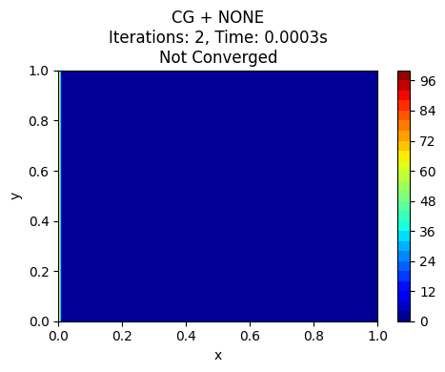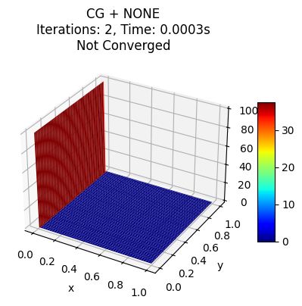
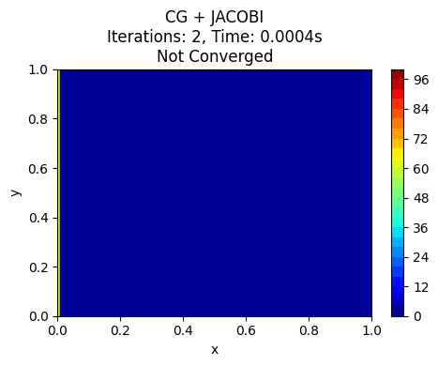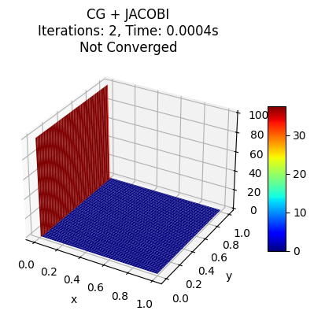
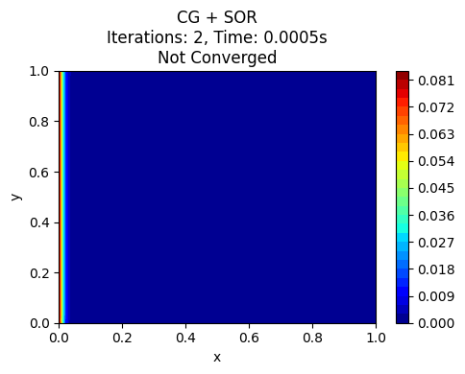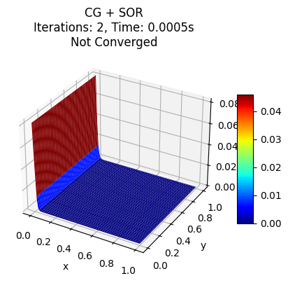
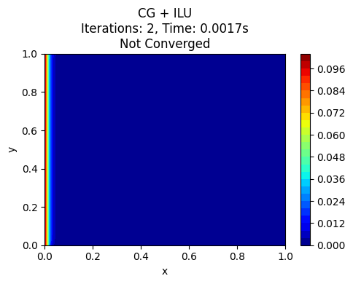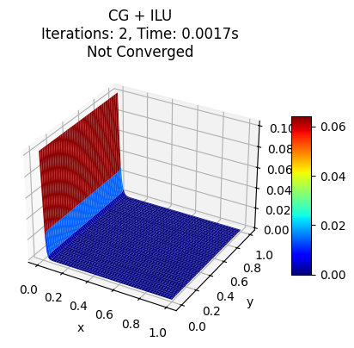
- Jacobi: Solution is physically incorrect (flat at boundary value), very low iteration count. CG+Jacobi is unable to converge reliably for this matrix/preconditioner combination.
- SOR: Surface is still not the correct complete profile, but slightly less flat, suggesting SOR preconditioner is marginally better, yet still not sufficient for convergence.
- ILU: Correct solution achieved (smooth gradient profile); fewest iterations. CG+ILU is the best combination for a symmetric positive definite problem.

- GMRES
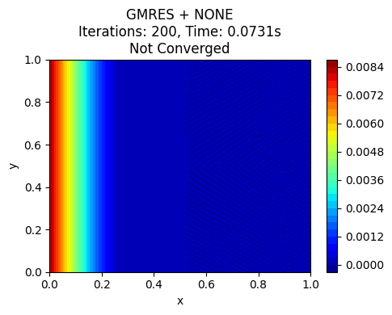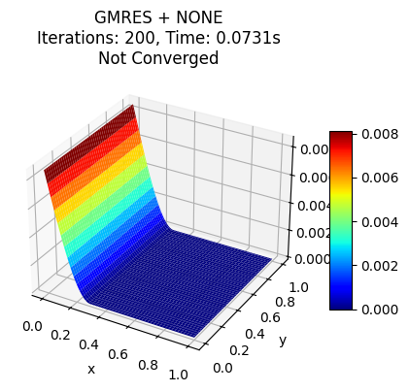
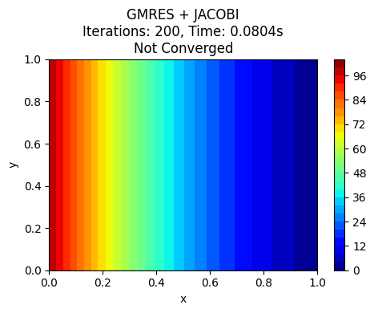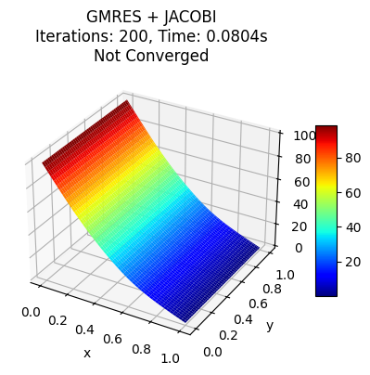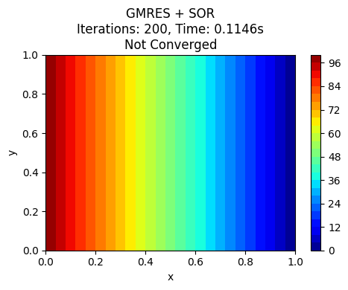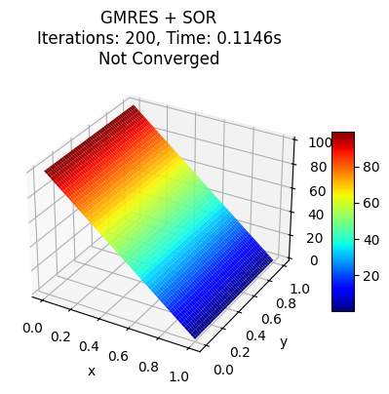
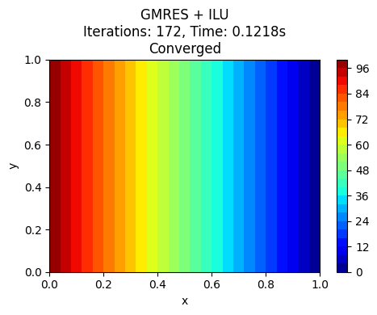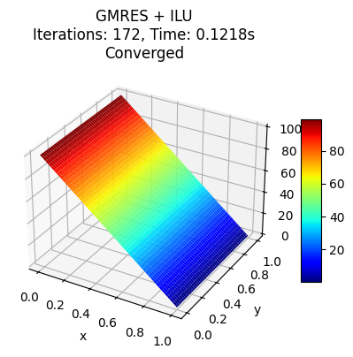

- Jacobi: Correct profile achieved, but requires more iterations than with ILU or SOR. A safe but sometimes slower combo.
- SOR: Correct and smooth solution, requires fewer iterations than Jacobi. Reliable.
- ILU: Fastest convergence; smooth, correct solution. GMRES+ILU performs ideally.
- BCGS (BiConjugate Gradient Stabilized)
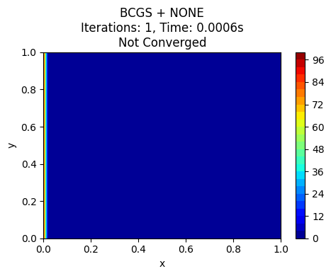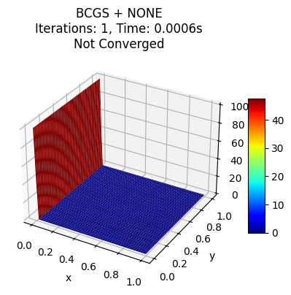
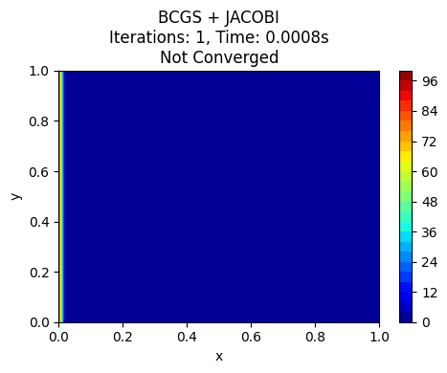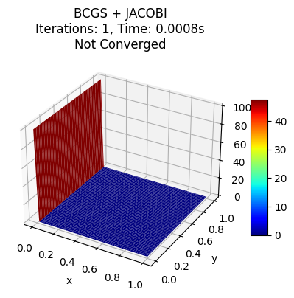
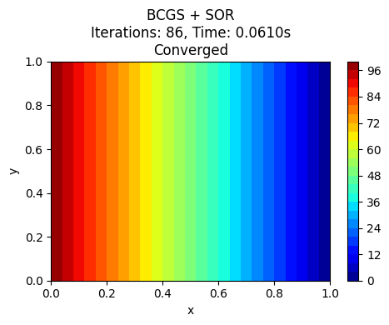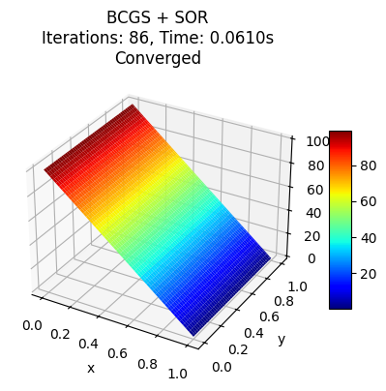
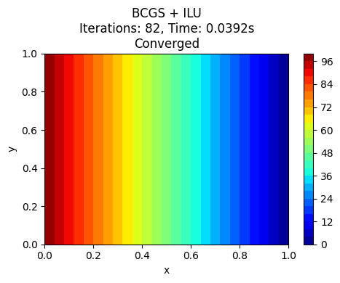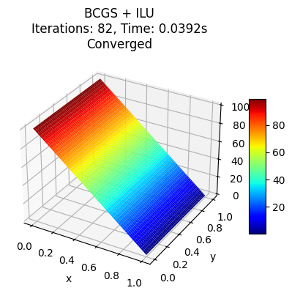
- Jacobi: Flat, incorrect solution with very low iterations. This combo fails to converge.
- SOR: Correct, smooth solution with moderate iterations. SOR rescue BCGS performance.
- ILU: Correct, smooth solution and fastest convergence for BCGS. Best combo here is BCGS+ILU.
- TFQMR (Transpose-Free Quasi-Minimal Residual)
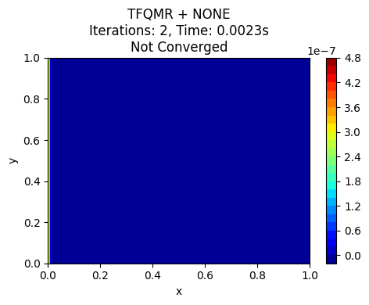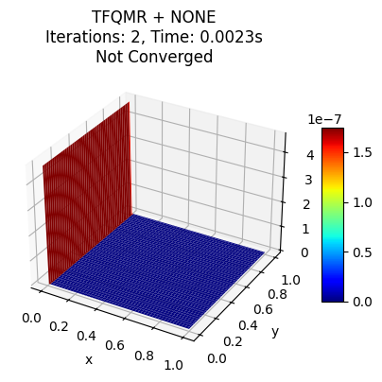
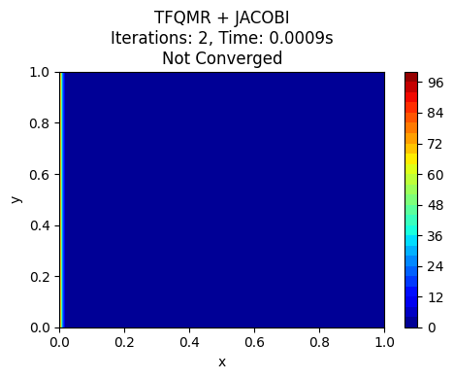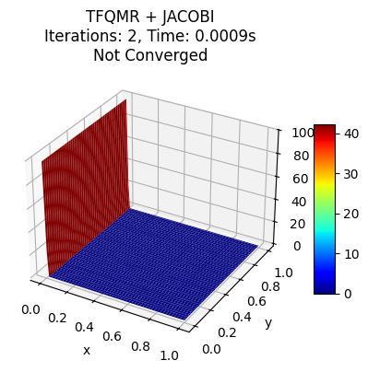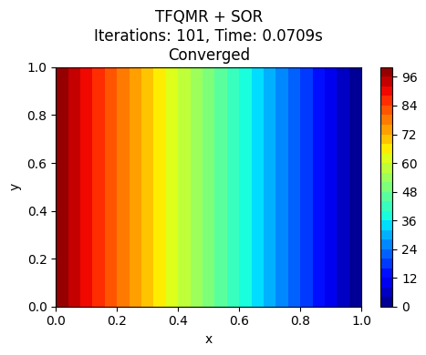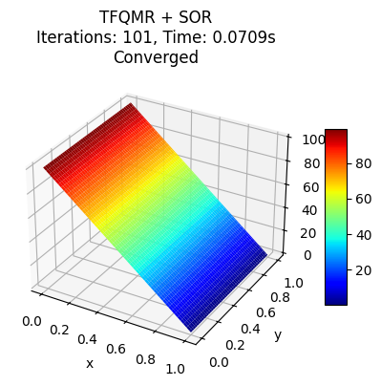
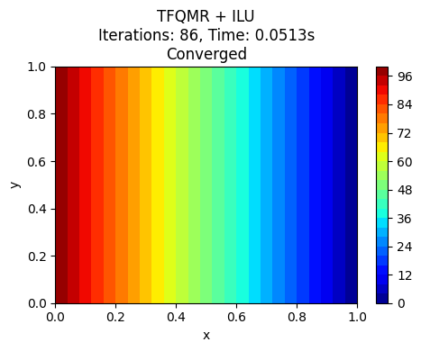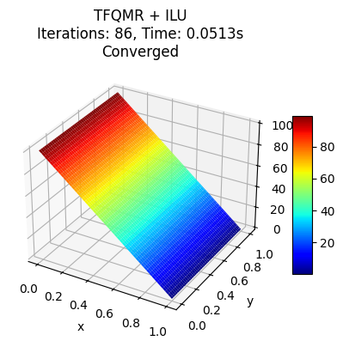
- Jacobi: Flat, incorrect solution, non-converged, low iterations.
- SOR: Provides smooth, correct output; reasonable iteration count.
- ILU: Best performance for TFQMR, both in speed and correctness.
5. Richardson
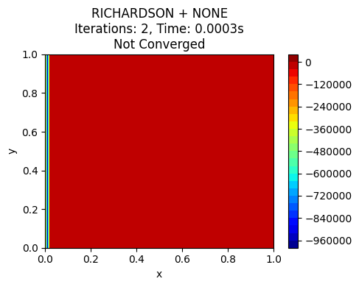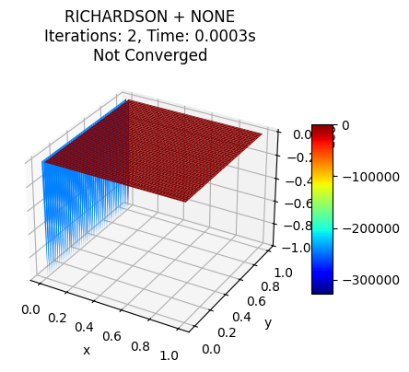
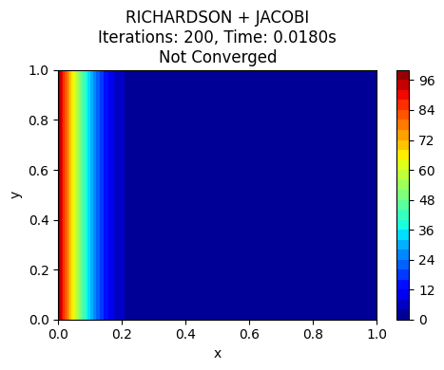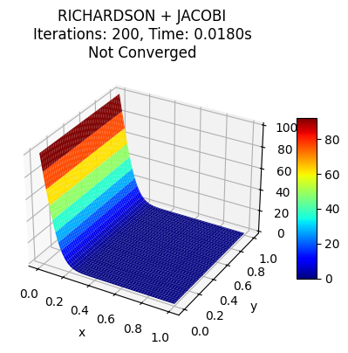
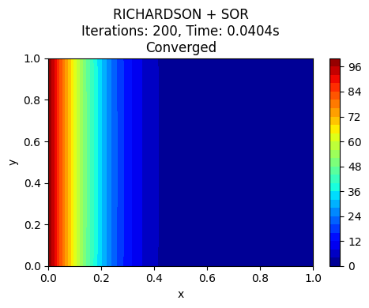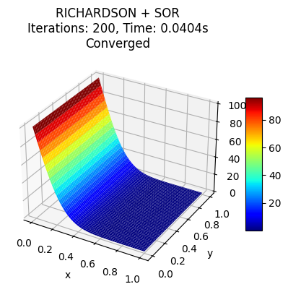
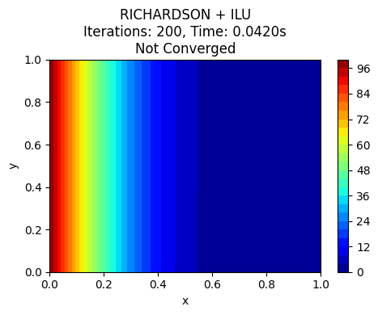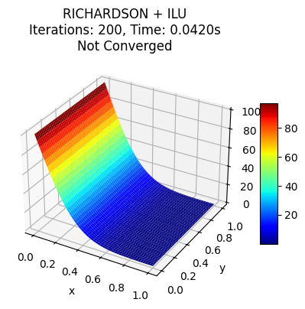
7. CHEBYSHEV
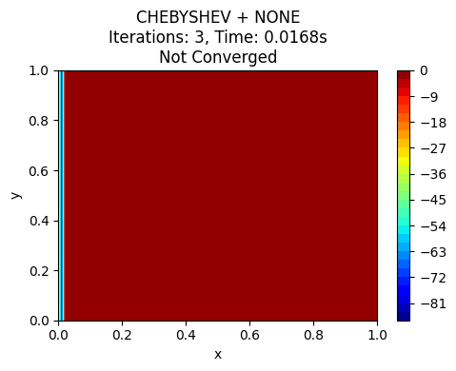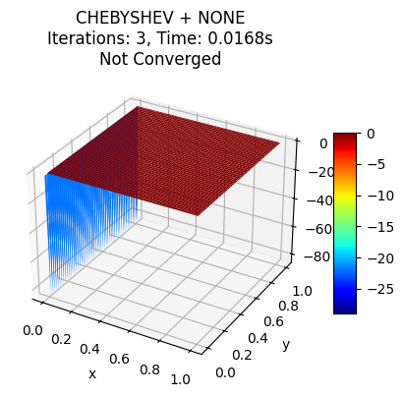
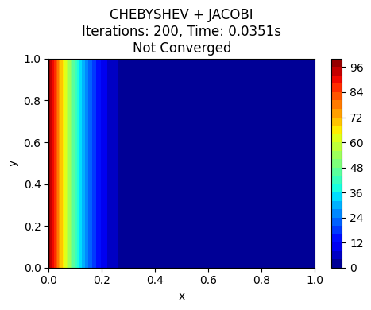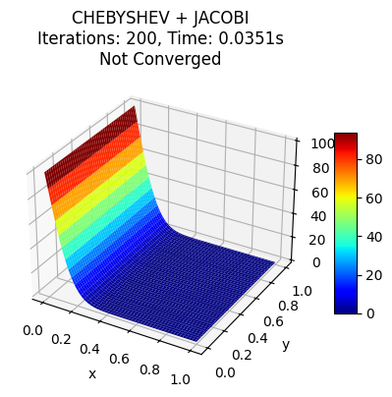
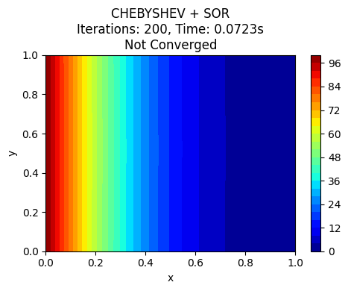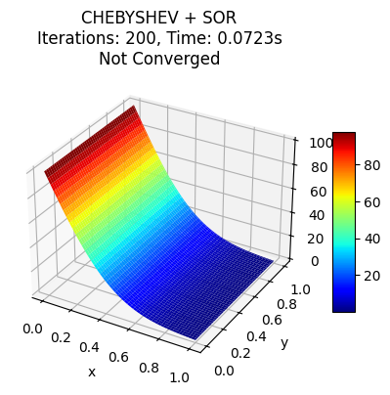
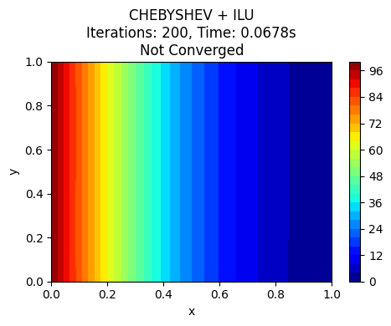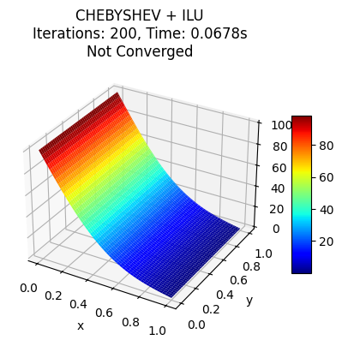
8. FGMRES
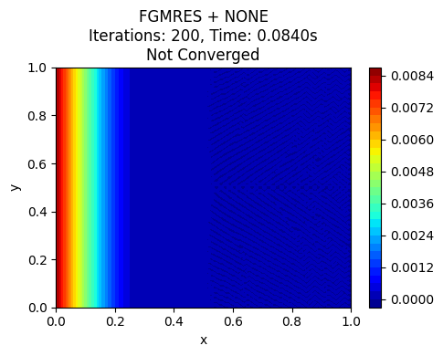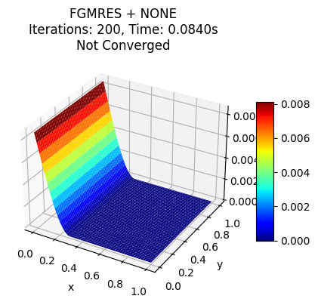
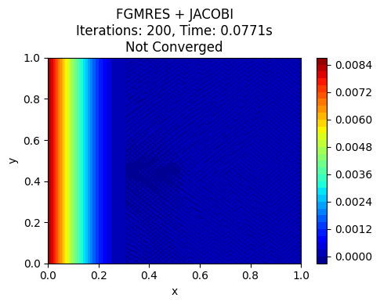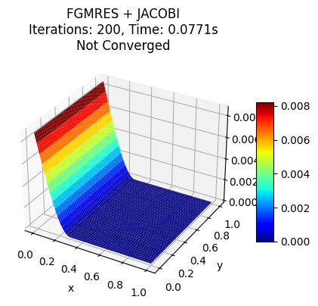
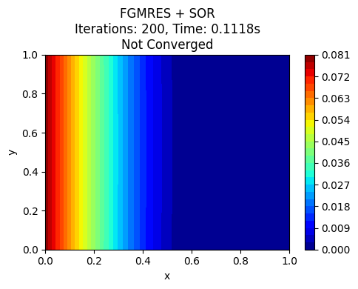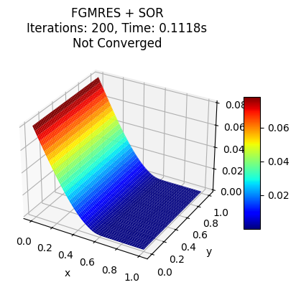
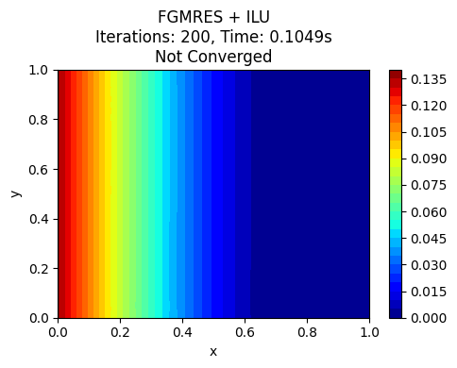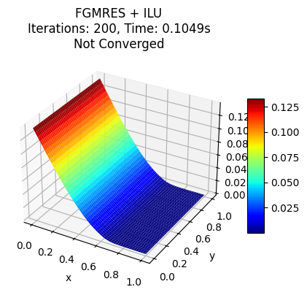

Key Observations
Solver | Jacobi | SOR | ILU
CG | Fails (wrong/flat) | Fails (nearly flat) | Correct, very fast
GMRES | Correct, slower | Correct, faster | Correct, fastest
BCGS | Fails (wrong/flat) | Correct, moderate | Correct, fast
TFQMR | Fails (wrong/flat) | Correct, moderate | Correct, fast
Legend:
- "Correct" = Physically sensible, steady-state profile as expected for boundary value diffusion problem
- "Fails" = Flat, unrealistic, solver stopped after very few iterations or diverged
- "Faster/Fast" = Converged with low iteration count (from your plots)
- "Slower/Moderate" = More iterations or less efficient than best pairing
Summary
- For this class of problem (2D steady Laplace/diffusion, SPD matrix), the best performance and reliable solutions come from GMRES and CG with ILU preconditioner.
- SOR is a good all-rounder preconditioner, reliably producing correct solutions for all Krylov solvers but with a somewhat higher iteration count than ILU.
- Jacobi as a preconditioner fails for most solvers in this context except (sometimes) for GMRES. It should not be used for large or challenging problems, especially with CG, BCGS, or TFQMR.
VARIATION WITH GRID POINTS
10X10
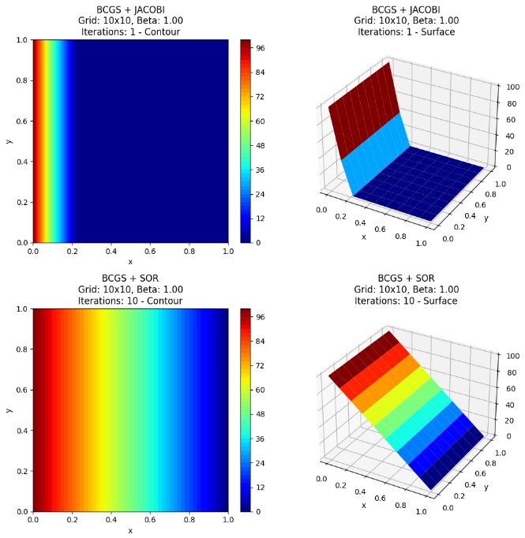
50 X50

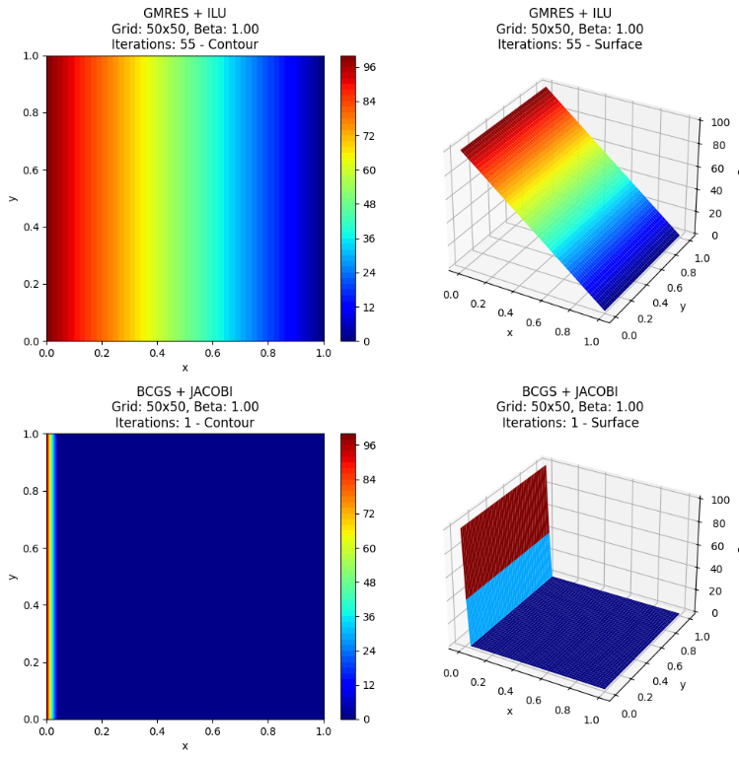

750 750

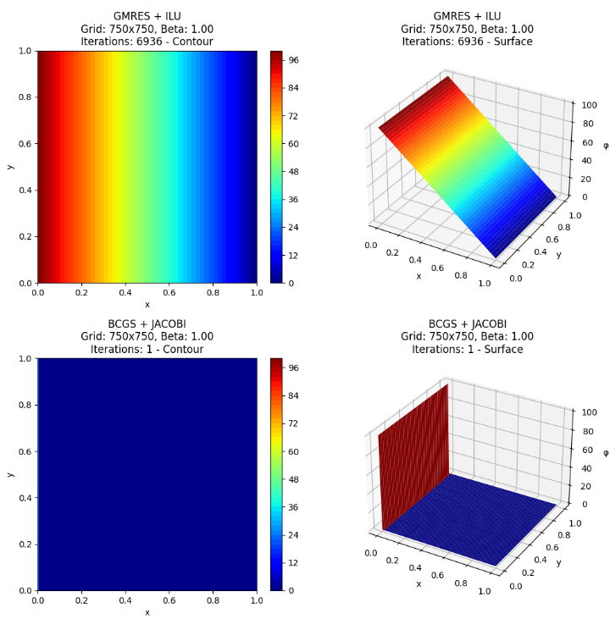
Conclusions from Plots of Varying Grid Points
- As grid resolution increases, the potential field becomes smoother and more continuous, reducing numerical diffusion and stair-stepping artifacts.
- Coarser grids produce visible contour banding near boundaries, especially along Neumann edges, due to insufficient spatial resolution.
- Finer grids yield better gradient capture near Dirichlet boundaries (φ = 100 and φ = 0), showing a clear linear decay along the x-direction.
- Solver performance improves in visual smoothness with grid refinement, though computational cost (iterations and runtime) increases.
- Converged solvers (e.g., GMRES, FGMRES with ILU) show consistent, stable contours across all grids, while non-converged cases exhibit distortions or incomplete diffusion profiles.

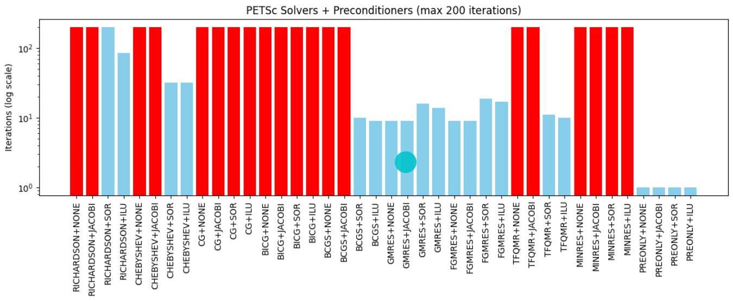
Overall Conclusion
- Preconditioning dominates performance: GMRES + ILU reduces iterations by about an order of magnitude compared with unpreconditioned Krylov and far surpasses stationary schemes for the same tolerance.
- Method choice matters: CG and MINRES depend on symmetry and SPD; strong Dirichlet rows and nonsymmetric PCs break these assumptions, so GMRES/FGMRES are safer defaults.
- Recommended: for ≥50×50 grids, use GMRES or FGMRES with ILU; keep Richardson/Chebyshev only as baselines or smoothers; use a “preonly + factorization” path when setup cost is acceptable and memory allows.
- Grid refinement effect: contours transition from blocky on 10×10 to smooth and nearly linear on 150×150 and 750×750; as N grows, iteration gaps widen and only GMRES+ILU maintains fast, smooth convergence across all grids.

