

**DEPARTMENT OF**

# ELECTRONICS AND COMMUNICATION ENGINEERING

**20IE3050- TECHNICAL INTERSHIP PROJECT REPORT**

ACADEMIC YEAR :2022-2023 III YEAR/V SEMESTER

*Submitted by*

BHIMAVARAPU JEBA MEHAK

2000040016

**KONERU LAKSHMAIAH EDUCATIONFOUNDATION**

(Deemed to be University estd, u/s, 3 of the UGC Act, 1956) (NAAC

Accredited “A++” Grated University)

Green Fields, Guntur District, A.P., India – 522502

**Department of Electronics and Communication Engineering**

(DST - FIST Sponsored Department)

## BONAFIDE CERTIFICATE

This is to certify that this Project report is the bonafide work of **Bhimavarapu Jeba Mehak with Register No. 2000040016** III Year / V Semester, from BSNL for 20IE3050 Technical Internship at Koneru Lakshmaiah Education Foundation in the year 2022-2023.

**Signature of the Faculty in charge Signature of the HOD/ECE**

Submitted for the University Practical Examination held on……………………

**INTERNAL EXAMINER EXTERNAL EXAMINER**

## COMPANY NAME : BSNL PRIVATE LIMTED

**PROJECT: Controlling a IoT Devices by routers and its Branches**

**TOOLS USED :**

Cisco packet

**Cisco packet :**

Cisco Packet Tracer is Cisco's simulation software. It can be used **to create complicated network typologies, as well as to test and simulate abstract networking concepts**. It acts as a playground for you to explore networking and the experience is very close to what you see in computer networks.

**ABSTRACT :**

So, the IoT gateway has a lot more to do than traditional gateway/routers, that essentially act as simple bridges between your LAN and the Internet. The IoT gateway must perform (at least) these following functions:

* Connects all the disparate “things” in your IoT network;
* Translates different communication protocols;
* Provides robust security and authentication for devices and users;
* Aggregates and intelligently filters all the data collected by the various devices;
* Provides on-board intelligence to handle local decision making and monitoring of the network

This required functionality naturally leads to the idea of a “smart IoT gateway”, which has the advanced capabilities needed to intelligently manage the large amounts of data generated by potentially thousands of IoT devices.

**Source Code :**

C2960 Boot Loader (C2960-HBOOT-M) Version 12.2(25r)FX, RELEASE SOFTWARE (fc4)

Cisco WS-C2960-24TT (RC32300) processor (revision C0) with 21039K bytes of memory.

2960-24TT starting...

Base ethernet MAC Address: 0001.97A8.3C21

Xmodem file system is available.

Initializing Flash...

flashfs[0]: 1 files, 0 directories

flashfs[0]: 0 orphaned files, 0 orphaned directories

flashfs[0]: Total bytes: 64016384

flashfs[0]: Bytes used: 4670455

flashfs[0]: Bytes available: 59345929

flashfs[0]: flashfs fsck took 1 seconds.

...done Initializing Flash.

Boot Sector Filesystem (bs:) installed, fsid: 3

Parameter Block Filesystem (pb:) installed, fsid: 4

Loading "flash:/2960-lanbasek9-mz.150-2.SE4.bin"...

######################### [OK]

Smart Init is enabled

smart init is sizing iomem

TYPE MEMORY_REQ

TOTAL: 0x00000000

Rounded IOMEM up to: 0Mb.

Using 6 percent iomem. [0Mb/512Mb]

Restricted Rights Legend

Use, duplication, or disclosure by the Government is

subject to restrictions as set forth in subparagraph

(c) of the Commercial Computer Software - Restricted

Rights clause at FAR sec. 52.227-19 and subparagraph

(c) (1) (ii) of the Rights in Technical Data and Computer

Software clause at DFARS sec. 252.227-7013.

cisco Systems, Inc.

170 West Tasman Drive

San Jose, California 95134-1706

Cisco IOS Software, C2960 Software (C2960-LANBASEK9-M), Version 15.0(2)SE4, RELEASE SOFTWARE (fc1)

Technical Support: http://www.cisco.com/techsupport

Copyright (c) 1986-2013 by Cisco Systems, Inc.

Compiled Wed 26-Jun-13 02:49 by mnguyen

Initializing flashfs...

fsck: Disable shadow buffering due to heap fragmentation.

flashfs[2]: 2 files, 1 directories

flashfs[2]: 0 orphaned files, 0 orphaned directories

flashfs[2]: Total bytes: 32514048

flashfs[2]: Bytes used: 11952128

flashfs[2]: Bytes available: 20561920

flashfs[2]: flashfs fsck took 2 seconds.

flashfs[2]: Initialization complete....done Initializing flashfs.

Checking for Bootloader upgrade..

Boot Loader upgrade not required (Stage 2)

POST: CPU MIC register Tests : Begin

POST: CPU MIC register Tests : End, Status Passed

POST: PortASIC Memory Tests : Begin

POST: PortASIC Memory Tests : End, Status Passed

POST: CPU MIC interface Loopback Tests : Begin

POST: CPU MIC interface Loopback Tests : End, Status Passed

POST: PortASIC RingLoopback Tests : Begin

POST: PortASIC RingLoopback Tests : End, Status Passed

POST: PortASIC CAM Subsystem Tests : Begin

POST: PortASIC CAM Subsystem Tests : End, Status Passed

POST: PortASIC Port Loopback Tests : Begin

POST: PortASIC Port Loopback Tests : End, Status Passed

Waiting for Port download...Complete

This product contains cryptographic features and is subject to United

States and local country laws governing import, export, transfer and

use. Delivery of Cisco cryptographic products does not imply

third-party authority to import, export, distribute or use encryption.

Importers, exporters, distributors and users are responsible for

compliance with U.S. and local country laws. By using this product you

agree to comply with applicable laws and regulations. If you are unable

to comply with U.S. and local laws, return this product immediately.

A summary of U.S. laws governing Cisco cryptographic products may be found at:

http://www.cisco.com/wwl/export/crypto/tool/stqrg.html

If you require further assistance please contact us by sending email to

export@cisco.com.

cisco WS-C2960-24TT-L (PowerPC405) processor (revision B0) with 65536K bytes of memory.

Processor board ID FOC1010X104

Last reset from power-on

1 Virtual Ethernet interface

24 FastEthernet interfaces

2 Gigabit Ethernet interfaces

The password-recovery mechanism is enabled.

64K bytes of flash-simulated non-volatile configuration memory.

Base ethernet MAC Address : 00:01:97:A8:3C:21

Motherboard assembly number : 73-10390-03

Power supply part number : 341-0097-02

Motherboard serial number : FOC10093R12

Power supply serial number : AZS1007032H

Model revision number : B0

Motherboard revision number : B0

Model number : WS-C2960-24TT-L

System serial number : FOC1010X104

Top Assembly Part Number : 800-27221-02

Top Assembly Revision Number : A0

Version ID : V02

CLEI Code Number : COM3L00BRA

Hardware Board Revision Number : 0x01

Switch Ports Model SW Version SW Image

------ ----- ----- ---------- ----------

* 1 26 WS-C2960-24TT-L 15.0(2)SE4 C2960-LANBASEK9-M

Cisco IOS Software, C2960 Software (C2960-LANBASEK9-M), Version 15.0(2)SE4, RELEASE SOFTWARE (fc1)

Technical Support: http://www.cisco.com/techsupport

Copyright (c) 1986-2013 by Cisco Systems, Inc.

Compiled Wed 26-Jun-13 02:49 by mnguyen

Press RETURN to get started!

%LINK-5-CHANGED: Interface FastEthernet0/1, changed state to up

%LINEPROTO-5-UPDOWN: Line protocol on Interface FastEthernet0/1, changed state to up

%LINK-5-CHANGED: Interface FastEthernet0/2, changed state to up

%LINEPROTO-5-UPDOWN: Line protocol on Interface FastEthernet0/2, changed state to up

%LINK-5-CHANGED: Interface FastEthernet0/3, changed state to up

%LINEPROTO-5-UPDOWN: Line protocol on Interface FastEthernet0/3, changed state to up

%LINK-5-CHANGED: Interface FastEthernet0/4, changed state to up

%LINEPROTO-5-UPDOWN: Line protocol on Interface FastEthernet0/4, changed state to up

**OUTPUTS:**

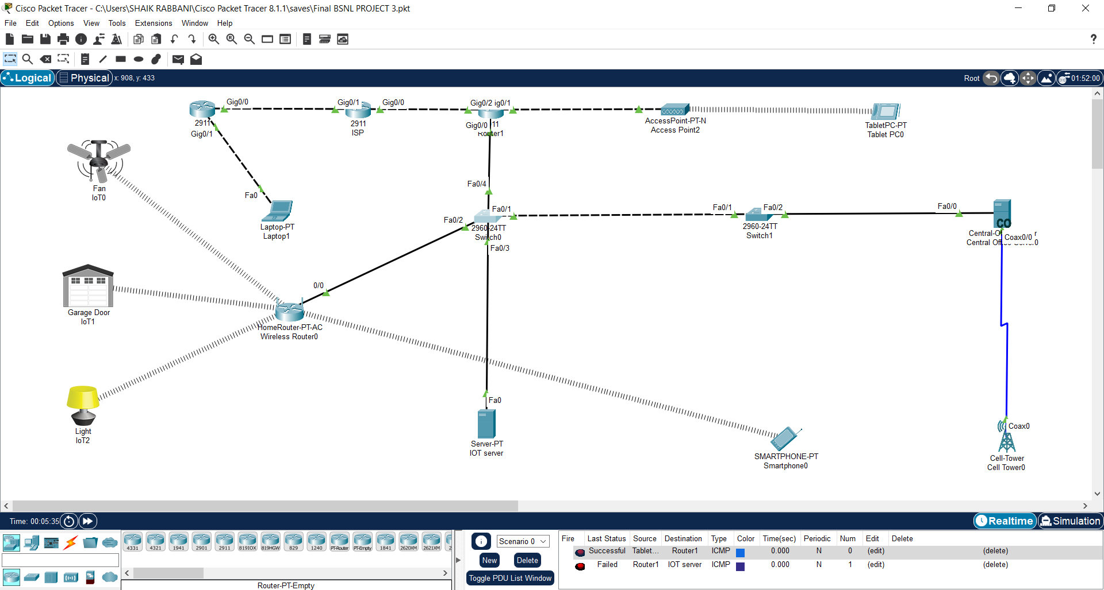

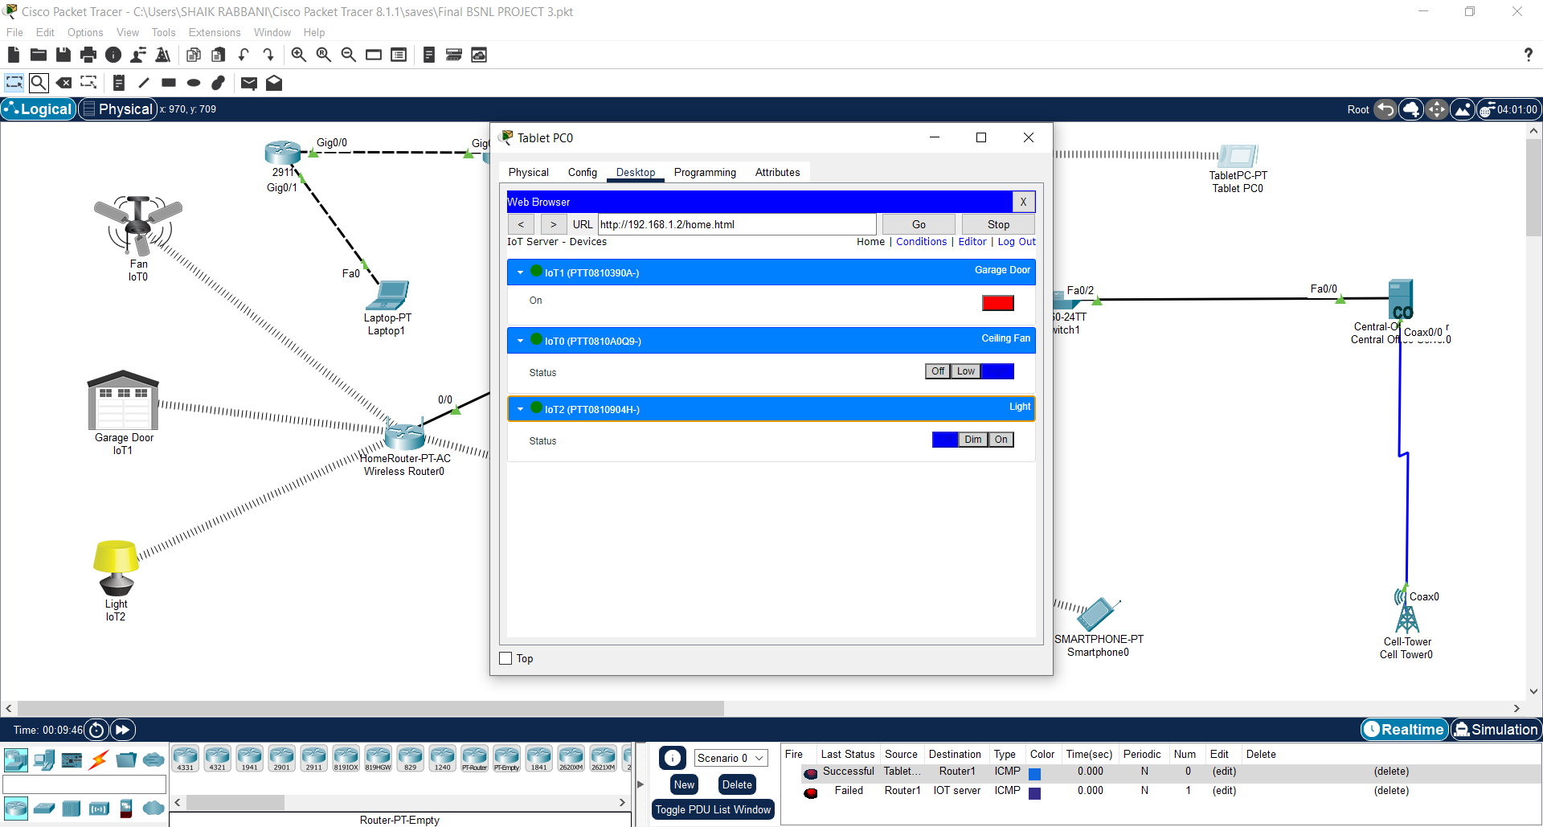

**CONCLUSION :**

During my internship with the company, I learned Cisco tool using Routing. I was able to put these skills in practice in Networking projects. The work was challenging, and I learned Networking. It was a valuable experience.