**Day 3 - API Integration Report - ShopVista**

**API Integration Process**

1. API Understanding

- Utilized Template 4 API endpoint: https://next-ecommerce-template-4.vercel.app/api/product

- API provides product data including:

- Product name

- Image path

- Price

- Description

- Discount percentage

- Category

- Stock level

- Featured product status

2. Data Migration

Successfully migrated data from the provided API to the frontend using the following steps:

1. Created a Product interface to type-check the data

2. Implemented fetch functionality in ProductList component

3. Added error handling and loading states

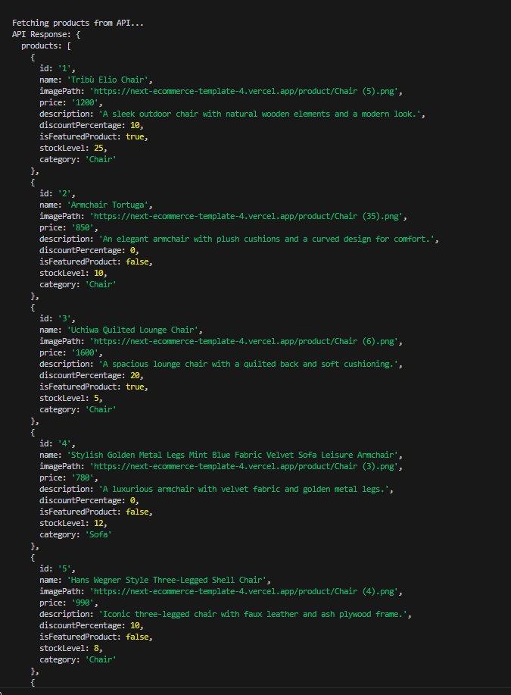

3. Frontend Integration

Implemented the following components and features:

- ProductList component with:

- Product cards with images

- Price display

- Discount percentage when applicable

- Product descriptions

- Loading states

- Error handling

4. Code Snippets

*Product Interface*

*API Integration*

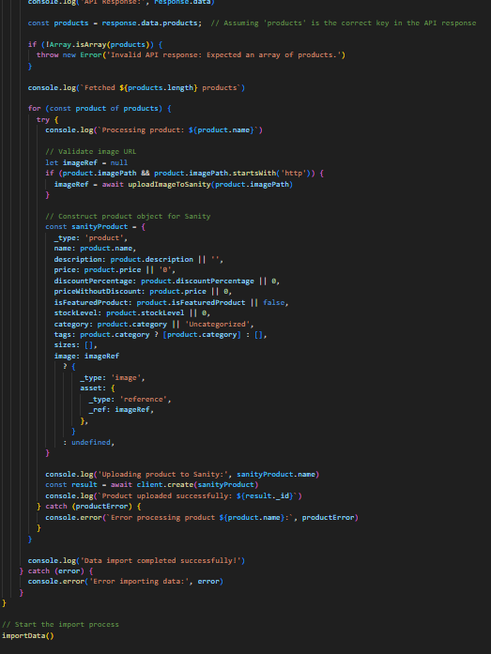

Best Practices Implemented

1. Error Handling

- Implemented try-catch blocks

- Added user-friendly error messages

- Included loading states

2. Clean Code

- Used TypeScript for type safety

- Implemented proper component structure

- Added comments where necessary

3. Responsive Design

- Ensured proper image display

- Made text readable on all devices

Self-Validation Checklist

- API Understanding

- Schema Validation

- Data Migration

- API Integration in Next.js

- Documentation Complete

Notes and Observations

- Successfully integrated Template 4 API

- Implemented proper error handling

- Created responsive design for product display

- Added loading states for better user experience

- Ensured type safety with TypeScript interfaces