**LAB NO4**

|  |  |
| --- | --- |
| Topic | To familiar with OLTP system reporting |
| Objectives | * To learn report generation in OLTP systems |

|  |
| --- |
| Lab Discussion: Theoretical concepts and Procedural steps |

## Tables:

Customer Table

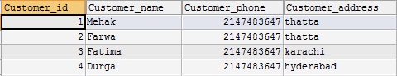



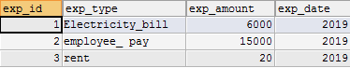



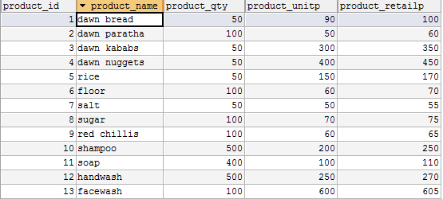



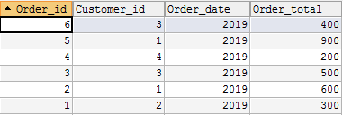

**Stored procedure** contains following queries:

1. **Total sales in a month** (Use only order table).
2. **Profit/loss in a month** (Use product (to account for purchasing costs), expenditure as well as order tables).
3. **Highest selling product of the month** (By highest sold quantity)
4. **Lowest selling product of the month** (By lowest sold quantity)

