
Cross-Platform Grocery Billing Application using Artificial Intelligence
Submitted by
Naveed Hayat
(IST-KICSIT-BSCS-222201006)
Nimrah Khan
(IST-KICSIT-BSCS-222201008)
Mehak Razzaq
(IST-KICSIT-BSCS-222201025)
Supervisor
Dr. Sehrish Khan Tayyaba

Department of Computer Science
Institute of Space Technology, KICSIT Kahuta Campus
June 19, 2026

Cross-Platform Grocery Billing Application using Artificial Intelligence
Submitted by
Naveed Hayat (222201006)
Nimrah Khan (222201008)
Mehak Razzaq (222201025)
Supervisor
Dr. Sehrish Khan Tayyaba
APPROVAL BY BOARD OF EXAMINERS
__________________
Dr. Sehrish Khan Tayyaba
Supervisor

Committee Members
_______________  Mr. Kashif Muneer  Assistant Professor CS | ________________  Dr. Sakeena Javaid  Assistant Professor CS | _____________ Mr.Zafar Iqbal Khan  Assistant Professor CS
_________________  Dr. Shahid  Assistant Professor CS | _________________  Dr. Nuzhat Naqvi  Assistant Professor CS | _________________  Ms. Maheen Nadir  Lecturer CS

______________________
Dr. Sehrish Khan Tayyaba
Project Coordinator

____________________
Dr. Altaf Hussain
HOD. Computer Science
AUTHORS DECLARATION
I take full responsibility of the research work conducted during the thesis titled “Cross-Platform Grocery Billing Application using Artificial Intelligence”.
I solemnly declare that the research and development work presented in the thesis is done solemnly by me with no significant help from any other person; however, small help wherever taken is duly acknowledged. I have also written the thesis by myself. Moreover, I have not presented this thesis or any part of the thesis previously to any other degree awarding institution within Pakistan or abroad.
I understand that the management of IST has a zero-tolerance policy towards plagiarism. Therefore, I as an author of the above mentioned thesis solemnly declare that no portion of my thesis has been plagiarized and any material used in this Thesis does not contain any literal citing (verbatim) of more than 70 words (total) even by giving a reference unless I have obtained the written permission of the publisher to do so. Furthermore, the work presented in the thesis is my own original work and I have positively cited the related work of the other researchers by clearly differentiating my work from their relevant work.
I further understand that if I am found guilty of any form of plagiarism in my thesis work even after my graduation, the institute reserves the right to revoke my BS degree. Moreover, the Institute will also have the right to publish my name on its website that keeps a record of the students who plagiarized in their thesis work.
____________________
Naveed Hayat
________________
Nimrah Khan
________________
Mehak Razzaq

I hereby acknowledge that submitted thesis is final version and should be scrutinized for plagiarism as per IST policy

_____________________
Dated: _______________

________________________________
Verified by Plagiarism Cell Officer
Dated_______________

CERTIFICATE
This is to certify that the research work described in this thesis is the original work of the author and has been carried out under my direct supervision. I have personally gone through all the data/results/materials reported in the manuscript and certify their correctness/authenticity. I further certify that the material included in this thesis is not plagiarized and has not been used in part or fully in a manuscript already submitted or in the process of submission in partial/complete fulfillment of the award of any other degree from any institution. I also certify that the thesis has been prepared under my supervision according to the prescribed format and I endorse its evaluation for the award of Bachelor of Science in Computer Science degree through the official procedures of the Institute.

____________________
Dr. Sehrish Khan Tayyaba

Copyright © 2026
This document is jointly copyrighted by the authors and the Institute of Space Technology (IST). Both authors and IST can use, publish or reproduce this document in any form. Under copyright law no part of this document can be reproduced by anyone, except copyright holders, without the permission of authors.

DEDICATION
To our parents, whose unconditional love, endless sacrifices, and unwavering belief in me made everything possible. Every step we have taken has been because of the foundation you built for me.
To our teachers and supervisors, Dr. Sehrish Khan Tayyaba and Dr. Altaf Hussain, whose guidance and patience shaped not just this project but my growth as a student.
To our friends, who made the long days and late nights bearable with their laughter, support and presence.
Moreover, we would dedicate our work to Tayyaba Ifzal, words fall short. Through every moment of self-doubt, every late-night panic and every time we almost gave up, you were there. Not just as a friend, but as a constant reminder that we could do this. Your belief in us meant more than you will ever know. This one is for you too.

ABSTRACT
Most grocery shops across Pakistan still rely on barcode scanning at the checkout. While this gets the job done, it breaks down regularly during peak hours when barcodes get torn, covered, or simply unreadable. Loose items like fruits and vegetables add another layer of complexity since each one has to be weighed manually before a price can be calculated. VisionPay was built to tackle exactly these problems — it uses a phone camera and AI-powered detection to identify products on the spot and generate the bill automatically, without any manual scanning.
At the core of VisionPay is a fine-tuned YOLOv8n detection model trained on a dataset we put together ourselves over 4,000 labelled images covering 28 vegetable types, 17 fruit types, and 5 Pakistani packaged products, all prepared through Roboflow. Training was done on Kaggle using a Tesla T4 GPU across 100 epochs, achieving an overall mAP50 of 39.9%, though packed products scored considerably higher, with some reaching 99.5%. For produce items sold by weight, a small hardware module was assembled using a 10kg load cell, an HX711 amplifier, and an Arduino Uno, which connects to the backend over USB to stream live weight readings.
The backend runs on FastAPI and exposes a set of REST and WebSocket endpoints covering detection, billing, inventory, and real-time device sync. Product and transaction data is stored in SQLite, with stock tracking and automatic low-stock alerts built in. A cross-platform Flutter app handles the front end, giving cashiers a live camera feed and detection controls while giving managers access to revenue breakdowns, product management, and inventory stats. The entire backend is containerised in Docker and hosted permanently on Hugging Face Spaces.
During testing, product detection consistently came in under a second per frame. Weight readings from the load cell were reliable and translated correctly into prices. The full billing workflow from placing a product in front of the camera to generating a receipt ran without issues across all the scenarios we tested.
Keywords: Computer Vision, Object Detection, YOLOv8, Grocery Billing, Flutter, FastAPI, Load Cell, Cross-Platform Application.
Table of Contents
1. Introduction 2
1.1. General Overview of Grocery Billing Systems. 2
1.2. Shortcomings of Billing based on Traditional Barcode. 2
1.3. Developing Market Grocery Retail Practices. 2
1.4. Implicit Barcoding and Computer Vision. 3
1.5. Intelligent Grocery Billing System Proposal. 3
1.6. Project Scopes and Focus. 4
2. Background Information 6
2.1. Automated Billing Systems Overview. 6
2.2. Billings Systems based on Barcode (Current Solution) 6
2.3. Enhancing Retail Checkout Efficiency Through a Hybrid YOLOv8-Based Grocery Detection and Billing System (2026) 7
2.4. Enhanced Self-Checkout System for Retail Based on Improved YOLOv10 (2024) 8
2.5. Amazon Go: Smart Store Model (Industry Benchmark) 10
2.6. Research Gap and Motivation 10
2.7. Implicit Barcoding and Vision-Based Systems of Billing. 11
2.8. Suggested System Justification (VisionPay). 12
2.9. Literature Review 12
3. Related Work 17
3.1. Automated Retail Billing Systems Overview 17
3.2. Current Methodologies of Automated Billing 17
3.2.1. Bill of Exchange Systems based on barcodes. 17
3.2.2. Product recognition Systems Vision-Based. 18
3.2.3. Product Identification based on OCR. 18
3.2.4. Smart Shelf Systems and Sensor-Based Systems. 19
3.3. Difficulties in Current Automated Billing Systems. 20
3.4. Pre-Existing Solutions 20
3.5. Proposed Solution: VisionPay 21
3.6. VisionPay and the importance of Implicit Barcoding. 21
3.7. Summary 22
4. System Design 24
4.1. System Architecture Design 24
4.2. Use-Case Diagram 25
4.3. Descriptive Use Cases 26
4.3.1. Login to System 26
4.3.3 Recognize Product 28
4.3.4 Measure and validate product weight 29
4.3.5 Generate Invoice 30
4.3.6 Make Payment 31
4.3.7. Manage Inventory 32
4.4 Activity Diagram 33
4.4.1 Customer Billing Workflow: 33
4.4.2. AI Engine Processing Flow: 34
4.2.3 Store Admin and System Monitoring Process: 35
4.5 Class Diagram: 35
4.7 Sequence Diagram 36
4.7.1 Product Detection & Recognition 36
4.7.2 Bill Generation & Price Calculation 37
4.7.3 Payment & Inventory Update 37
5. Implementation 40
5.1. Overview 40
5.2. Development Environment 40
5.2.1. Software Tools and Libraries 40
5.2.2. Hardware Components 41
5.3. Dataset Preparation 41
5.4. AI Model Training 42
5.4.1. Training Configuration 42
5.4.2. Training Results 43
5.5. Backend Implementation 44
5.5.1. API Endpoints Implementation 44
5.5.2. Database Implementation 44
5.6. Mobile Application Implementation 45
5.6.1. Landing Screen 45
5.6.2. Login Screen 45
5.6.3. Cashier Dashboard 45
5.6.4. Manager Dashboard 45
5.6.5. WebSocket Real-Time Sync 46
5.7. Hardware Implementation 46
5.7.1. Circuit Connections 46
5.7.2. Arduino Firmware 47
5.7.3. Python Weight Service 47
5.7.4. Load Cell Calibration 47
5.8. Cloud Deployment 47
6. Testing 50
6.1. Overview 50
6.2. Testing Methodology 50
6.3. API Endpoint Testing 51
6.4. AI Model Evaluation 51
6.4.1. Overall Model Performance 52
6.4.2. Per-Class Performance 52
6.5 System Integration Testing 53
6.6 Performance Testing 54
6.7 Hardware Testing 55
6.8 UI Testing 55
6.9 Comparison with Existing Systems 56
7. Conclusion and Future Work 58
7.1 Summary of work 58
7.2 Objectives Achieved 58
7.3 Limitations 59
7.4 Future Work 59
7.4.1 Improved Model Accuracy 59
7.4.2 Thermal Printer Integration 60
7.4.3 Payment Gateway Integration 60
7.4.4 Cloud Database 60
7.4.5 Wireless Hardware Integration 60
7.4.6 Multi-Camera Support 60
7.4.7 Real-Time Inventory Management 60
7.5 Conclusion 61
References 62

List of Figures
Figure 4.1: System Architecture 22
Figure 4.2: Use Case Diagram 24
Figure 4.3: Customer Billing Workflow 32
Figure 4.4: AI Engine Workflow 33
Figure 4.5: Store Admin & System Monitoring 33
Figure 4.6: Class Diagram 34
Figure 5.1: Product Detection 35
Figure 5.2: Billing Generation 35
Figure 5.3: Payment Inventory Update 36

List of Tables
Table 4.1: Use Case — Login to System 25
Table 4.2: Use Case — Place Product on Counter 26
Table 4.3: Use Case — Recognize Product 27
Table 4.4: Use Case — Measure and Validate Product Weight 28
Table 4.5: Use Case — Generate Invoice 29
Table 4.6: Use Case — Make Payment 30
Table 4.7: Use Case — Manage Inventory 31
Table 5.8: Development Tools and Libraries 38
Table 5.9: Hardware Components Used 39
Table 5.10: Dataset Summary 39
Table 5.11: YOLOv8n Training Configuration 40
Table 5.12: Per-Class Detection Accuracy (Selected Classes) 41
Table 5.13: Load Cell to HX711 Wiring 44
Table 5.14: HX711 to Arduino Wiring 44
Table 6.15: Testing Types and Scope 47
Table 6.16: Overall Model Performance Metrics 49
Table 6.17: System Performance Results 51
Table 6.18: Load Cell Accuracy Test Results 51

LIST OF ABBREVIATIONS
Abbreviation | Full Form
AI | Artificial Intelligence
CNN | Convolutional Neural Network
OCR | Optical Character Recognition
CV | Computer Vision
SKU | Stock Keeping Unit
API | Application Programming Interface
UI | User Interface
UX | User Experience
POS | Point of Sale
RFID | Radio Frequency Identification
GPU | Graphics Processing Unit
CPU | Central Processing Unit
DB | Database
SQL | Structured Query Language
NoSQL | Non-Relational Database
REST | Representational State Transfer
JSON | JavaScript Object Notation
HTTPS | HyperText Transfer Protocol Secure
GCP | Google Cloud Platform

Chapter 1
Introduction
- Introduction
  - General Overview of Grocery Billing Systems.
Grocery shops are everywhere in Pakistan — from small neighborhood kiryana stores to mid-sized supermarkets scattered across every city and town. Almost all of them handle billing in the old-fashioned way: a cashier manually enters prices or scans products one by one. The gap between what these stores use and what modern retail technology can offer is significant, and this project was an attempt to build something that could help close that gap without requiring a big investment.

Shortcomings of Billing based on Traditional Barcode.
Barcode checkout sounds simple enough pick up a product, scan the barcode, move on. But in practice it takes longer than it should. If the barcode is damaged, hidden under a sticker, or printed poorly, the scan either fails or reads the wrong value. The cashier then must type in the code manually, which takes extra time. When there is a line of customers and this happens repeatedly, the whole checkout slows to a crawl.
There is also the human factor. A tired or distracted cashier is more likely to scan the wrong item, miss a product entirely, or log the wrong price. During busy periods late afternoons and weekends especially, the pressure builds up and errors become more frequent. The barcode system itself is not a problem; it relies entirely on the person operating it doing everything correctly every time.

Developing Market Grocery Retail Practices.
Walk into almost any grocery store in Pakistan and you will find a family running it, usually with a couple of staff members helping. These shops operate on tight margins and do not have the budget for the kind of technology that large retail chains deploy. Plenty of them still work from handwritten ledgers or basic cash registers. A proper point-of-sale system is considered an upgrade at many of these places, not a baseline expectation.
On the other end of the spectrum, stores like Amazon Go have gone fully automated no cashiers, no scanning, just walk in, pick what you want, and leave. Achieving that requires hundreds of ceiling-mounted cameras, smart shelves embedded with weight sensors, and extensive cloud infrastructure running constantly in the background. The cost of setting something like that up is measured in millions of dollars, which puts it completely beyond reach for any small store in Rawalpindi or Islamabad.

Implicit Barcoding and Computer Vision.
Recent advances in computer vision have made it possible to identify products just by looking at them no barcode required. Instead of scanning a label, a trained model can examine a product's packaging and pick out enough details from the design, logo placement, color scheme, and printed text to figure out exactly what it is. This idea is sometimes referred to as implicit barcoding, and it forms the foundation of how VisionPay works.
For packaged goods, biscuits, chips, bottled drinks the packaging itself carries enough distinctive visual information that a well-trained model can tell one product from another with high confidence. The challenge with fresh produce is different. A tomato looks like a tomato regardless of which farm it came from, so the system cannot use visual details to price it. What it can do is identify that it is a tomato and then hand it off to a weight scale to work out the price based on how much it weighs.

Intelligent Grocery Billing System Proposal.
VisionPay was built specifically for stores like the ones described above small, budget-constrained, and unlikely to spend on expensive hardware. The idea is straightforward: a cashier holds up a phone, the camera captures the products on the counter, and the system handles everything else identification, price lookup, and bill generation. No barcode scanner, no manual entry.
The aim is not to replace the cashier but to take the tedious parts off their plate. Rather than picking up each item, finding the barcode, and scanning it one by one, the cashier just needs to point the camera and confirm what the system detected. Pricing and billing happen automatically in the background.

Project Scopes and Focus.
It is worth being upfront that this is a working prototype, not a finished commercial product. The primary goal was to show that the concept is technically sound that a phone camera and a cheap load cell can replace a barcode scanner in a grocery billing setup. Cost was kept as a central constraint throughout: everything in the system either runs on free tiers or costs very little, because any solution that is too expensive will simply not get adopted.

Chapter 2
Background Information

Background Information

Automated Billing Systems Overview.
Conventional retail billing has always revolved around barcodes. Each product carries a printed label that links it to a record in the store's system, and checking out means a cashier scans every item individually. The model works well enough under normal conditions, but it is not particularly robust, a torn barcode, a poorly printed label, or a missing sticker is enough to bring the process to a halt.
The bigger problem is the volume of manual effort involved. Ten items mean ten individual scans, and each one is a potential failure point. In a quiet store this is manageable, but as the queue builds up and the cashier starts rushing, mistakes follow.
These recurring pain points have driven researchers toward smarter alternatives. Over the past several years, various approaches have been proposed and tested AI-powered vision systems, sensor-based tracking, hybrid detection pipelines all trying to reduce dependence on physical barcodes.

Billings Systems based on Barcode (Current Solution)
Barcode-based billing systems rely on either 1D or 2D codes printed directly on product packaging. Each code carries a unique identifier that maps to a record in a central database where the product name, price, and category are stored. When the cashier scans the code, the system retrieves this information instantly.
Advantages
• Simple and widely adopted.
• Low hardware cost.
• Easy database integration.
Limitations
• Requires manual scanning.
• Is unable to recognize products without barcodes that can be seen.
• Lack of intelligence to do product checks.
• Not very efficient in a retail high-traffic setting.
• Likely to commit frauds and misbilling.
Taken together, these shortcomings give good reason to look beyond the barcode, particularly for smaller stores where investing in complex smart-store infrastructure simply is not an option.

Enhancing Retail Checkout Efficiency Through a Hybrid YOLOv8-Based Grocery Detection and Billing System (2026)
Title: A Hybrid YOLOv8 Based Grocery Detection and Billing System for Improving Retail Checkout Efficiency.
Authors: Oishi, S. K., Islam, M. M., Rony, S. D., Khan, R. S., Rahman, M. M., & Ahmed, M.
The paper set out to design a grocery checkout system that works without manual barcode scanning. Their approach used a live camera feed combined with the YOLOv8 object detection model to identify grocery items as they appear in frame and generate billing information on the fly, without needing a cashier to handle each item individually.
Methodology
- Real-time image acquisition of food products from live camera.
- Roboflow Data Augmentation for increasing the size and balance of the training set.
- Model customization using a data set of grocery items collected locally with YOLOv8.
- Auto recognition of products and automatic bill generation when detected.
Technology Used:
- YOLOv8 is a real-time, end-to-end Convolutional Neural Network (CNN) based single-stage object detection model [1]. It makes classification and bounding box localization in a single forward pass and thus is suitable for quick and accurate grocery item detection at checkout counters [1].
- Computer Vision.
- Roboflow for Dataset Management & Augmentation.
Dataset
To train their model, the authors assembled a custom local dataset of 1,109 annotated grocery product images covering 27 distinct product categories [1].
Limitations
- The relatively small number of images (1,109) may restrict the generalization of the unseen products.
- The number of product classes covered is only small and is obviously not sufficient for a full-scale retail environment.
- No weight integration (e.g., fruits and vegetables).
- Not all the performance under different lighting conditions and/or cluttered background was tested.
The study confirmed that real-time grocery detection and automated billing using YOLOv8 is achievable. That said, the work was constrained by the small size of the dataset and a narrow product range. The system also does not account for loose produce sold by weight, since no weight integration was included.

Enhanced Self-Checkout System for Retail Based on Improved YOLOv10 (2024)
Project name: Improved YOLOv10 for enhanced self-checkout system in retail.
Authors: Tan, L., Liu, S., Gao, J., Liu, X., Chu, L., & Jiang, H.
This research aimed to improve the accuracy and efficiency of self-checkout in retail by building a computer vision system around the newer YOLOv10 model. The driving motivation was reducing the labor costs and human errors typical of cashier-operated checkout, while maintaining fast real-time detection performance.
Methodology:
- The use of YOLOv8 detection head structure on the backbone network YOLOv10 to enhance recognition accuracy.
- Design and implementation of a post-processing algorithm for self-checkout environment.
- Train and evaluate models on retail product data.
- Integrated checkout pipeline testing from product detection to the output of the bill.
Technology Used:
- YOLOv10 is an enhanced single stage object detection model based on the YOLO architecture [2]. The YOLOv8 model was integrated into the YOLOv10 model and tested for its product recognition performance in retail environments, which was determined to be very good [2].
- Computer Vision.
- Post-processing for checkout automation using Deep Learning.
Dataset
Standard publicly available retail product detection datasets were used for training and evaluation [2].
Limitations:
- Controlled retail environment – results from real world unstructured stores not tested in depth.
- No weight sensors integration for producing items.
- System will need a hardware system and may not be cost-effective for smaller retailers.
- Very limited discussion of the handling of similar products at a small distance.
The study showed that combining elements of YOLOv8 and YOLOv10 in a single architecture yielded better results than either model alone. However, the evaluation was conducted under controlled laboratory conditions, and the authors acknowledged that replicating those conditions in real-world stores, particularly in resource-constrained markets, would be significantly harder.

Amazon Go: Smart Store Model (Industry Benchmark)
Amazon Go is likely the highest-profile example of fully automated retail anywhere in the world. Shoppers enter the store, take what they need from the shelves, and simply walk out. Behind the scenes, the system tracks every item picked up using a network of ceiling cameras, shelf-mounted weight sensors, and computer vision models running continuously on cloud servers.
Hundreds of high-resolution cameras.
• Smart shelves with inbuilt sensors.
• Advanced sensor fusion.
• Real-time cloud processing.
Key Characteristics
• Heavy hardware dependency.
• Very high crime infrastructure.
• Multivariate calibration and maintenance.
• Can not be used with small or medium-sized shops.
Amazon Go is a genuinely impressive achievement, but the sheer scale of the infrastructure it requires makes it viable only for well-funded large retailers. For a small grocery store anywhere in the developing world, let alone in Pakistan, the cost of installing and running such a system is simply not on the table.

Research Gap and Motivation
Each of the systems reviewed here pushed the field forward in meaningful ways, but none of them fully addressed the needs of a real-world small retail environment. The YOLOv8-based system from Oishi et al. covered only 27 product classes with just over 1,100 training images far too narrow for a store stocking hundreds of different products. Tan et al. achieved stronger detection performance by upgrading to YOLOv10, but their system was only evaluated in a lab and did not grapple with the practical and cost realities faced by smaller independent retailers. Amazon Go remains technically impressive but is irrelevant to most of the world's grocery stores, given the scale of hardware and investment it demands.
A consistent gap across all the reviewed work is the absence of weight-based billing. Not one of the systems handled loose items like fruits and vegetables by combining visual detection with hardware weight measurement in a single checkout flow. There is also no existing solution that was designed or validated specifically for the Pakistani retail context, where store layouts, product packaging, and available technology differ considerably from the environments studied in previous research. A further gap is the lack of any cross-platform mobile solution that serves both a cashier and a manager within the same application, something that would be essential for real store operations.

Implicit Barcoding and Vision-Based Systems of Billing.
Implicit barcoding refers to the practice of identifying a product by its natural physical appearance rather than by any attached label. The visual details that make each product recognizable its packaging color, logo placement, shape, and any text printed on it collectively act as a unique signature that a trained model can learn to match.
• Packaging design
• Brand logos
• Color patterns
• Textual information (OCR)
• Shape and size
• Weight consistency
When a deep learning model is trained on enough product images, it develops the ability to recognize these visual patterns and match them against a known product database. The result is an identification process that happens automatically, with no physical label needed on the packaging.
In grocery retail this capability is particularly valuable because so many products look nearly identical at first glance different brands of flour, rice, or sugar, for instance. A properly trained model can distinguish between them by picking up on subtle differences in packaging that a barcode system completely ignores.

Suggested System Justification (VisionPay).
VisionPay was built to fill these gaps. The entire system works from a standard mobile phone camera, requires no dedicated hardware beyond an inexpensive load cell, and includes weight-based billing for produce items that cannot be identified by visual inspection alone.
• Packaging recognition as implicit barcoding.
• Deep-learning based brand detection.
• OCR to extract metadata of products.
• Weight validation using load cells.
• Requested minimum hardware requirements.
Compared to Amazon Go, the hardware footprint is minimal. There are no ceiling cameras to install, no smart shelves to purchase, and no server room to maintain. All that is needed is a smartphone, a basic load cell, and an internet connection to free-tier cloud deployment.

Literature Review
Barcode Based Billing System (Current Solution)
- Manually scans barcodes, matching identifiers to a product database in the central system.
- Use barcode scanners and typical Point of Sale (POS) database for product information and pricing.
- Does not recognize items without the barcode and always needs the manual intervention of the cashier for each product.
- Not as efficient in retail stores with high pedestrian traffic, and susceptible to fraud and misbilling due to barcode switching.
- 100% label dependent, no intelligence to the product nor any assistance for weight-based products.
Enhancing Retail Checkout Efficiency Through a Hybrid YOLOv8-Based Grocery Detection and Billing System (Oishi et al., 2026)
This paper presents a grocery detection and billing system built around a hybrid YOLOv8 approach.
- Uses a camera feed to capture grocery product images and feeds them into a finely tuned YOLOv8 model for real-time detection.
- Before fine-tuning models Roboflow used for dataset management and data augmentation to increase training data.
- Uses YOLOv8, a CNN-based one-stage object detection to detect and classify products and generate bills automatically without requiring any barcode reading.
- Finetuned using a local dataset of 1109 labelled grocery images using 27 product classes.
- The product coverage is rather small, just 27 classes, which is not enough for a full-fledged retail.
- No integration with weight-based billing for loose produce items (e.g. fruits and vegetables).
- The performance with different lighting conditions and backgrounds was not fully addressed.
Enhanced Self-Checkout System in Retail using Improved YOLOv10 (Tan et al., 2024)
- Replaces the YOLOv8 detection head structure with the YOLOv10 backbone network to make product recognition more accurate.
- Designs a unique post-processing algorithm for self-checkout environment.
- Develops and validates an end-to-end checkout workflow from product detection to generation of bill.
- Trains and tests with standard retail product detection datasets.
- Testing was limited to a laboratory setting and was not extensively tested in unstructured store conditions.
- No development of a weight sensor for producing items like fruits and vegetables.
- Cost-effectiveness of hardware for smaller independent retailers is a concern.
- Very little attention was given to the handling of similar products which were visually similar and were stored in proximity.
Amazon Go: Smart Store Model (Industry Benchmark)
- Harvests a dense ceiling mounted high resolution camera system and sensor fusion for real-time tracking of customers and items.
- Leverages smart shelves with built-in weight sensors, high-level computer vision and vast scale of cloud computing infrastructure.
- Works on proprietary large scale retail data from all over the store and always.
- Removes the checkout counter altogether when customers leave the store they are charged automatically.
- It is very costly and requires heavy hardware dependency and is not accessible for small and medium retailers.
- The calibration and maintenance cost also adds to the operational cost due to its complexity.
- Customers must have an Amazon account and own a smart phone, making it difficult for Amazon to do this in developing markets.
VisionPay (Proposed System)
- Integrates packaging recognition, brand detection and weight validation in one consolidated automated billing process.
- Implements a fine-tuned YOLOv8n model with a FastAPI backend, a Flutter mobile application, and a load cell hardware stack, all of which are integrated and linked together via Arduino.
- Custom-trained on 53 product classes of packed goods, common fruit and vegetables from Pakistan, and a total of more than 4000 training images gathered via Roboflow.
- Catches the problem of weight-based billing that was not done in previous projects; hence it combines 5kg load cell, HX711 amplifier and Arduino Uno to measure live weight for produce items.
- No local server or expensive infrastructure needed; deployed on Hugging Face Spaces using Docker.
- Academic prototype phase, some evaluation in large scale retail deployments.
- Items that look similar like mango, lemon and mint continue to be a challenge for detection.

Chapter 3
Related Work
- Related Work
Before starting development on VisionPay, we took stock of what already exists in the automated retail billing space and where each approach runs into trouble. Understanding these gaps was what drove most of our technical decisions which tools to pick, which problems to tackle first, and which trade-offs to accept.

Automated Retail Billing Systems Overview
The checkout process is one of the most customer-facing parts of any store. When it is slow or error-prone, shoppers feel it immediately and so does the store's efficiency. Getting to bill right has a concrete, measurable effect on how smoothly a shop runs day to day.
As AI tools have matured over the past few years, billing research has followed suit. The field has moved from simple barcode alternatives to full computer vision pipelines capable of handling product recognition, weight calculation, and payment processing within a single integrated workflow.

Current Methodologies of Automated Billing

Bill of Exchange Systems based on barcodes.
Barcode scanning remains the most widely used billing method for good reason it is inexpensive, reasonably reliable under normal conditions, and staff are already familiar with how to use it. The catch is that it relies entirely on every item having a clean, readable barcode and a cashier who scans it without error.
Advantages:
• Simple and cost-effective
• Simple to use and support.
• Very popular in the retail setting.
Limitations:
• Requires manual scanning
• Barcodes may be spoilt or concealed.
• None of the verification of the products.
• Delayed checkout time in times of peak periods.
These are not minor inconveniences they represent structural weaknesses in barcode-dependent systems that have pushed researchers toward alternatives.

Product recognition Systems Vision-Based.
Vision-based systems take a fundamentally different approach. Instead of reading a printed code, the camera captures an image of the product, and a deep learning model figures out what it is from the visual appearance alone. The process does not require any physical label, and the cashier does not need to scan anything manually.
Key Features:
• Abolishes manual barcode scanning.
• Faster checkout process
• Reduces cashier dependency
Challenges:
• Problem with visual similarity products recognition.
• Lighting and camera angle performance.
• Low validation without any further mechanisms.

Product Identification based on OCR.
OCR-based identification works by reading text directly from the product packaging:
• Product name
• Brand
• Weight
• Manufacturing details.
OCR works best as a confirmation layer rather than a primary detection method. When the vision model identifies a product and OCR then reads the brand name or product text on the packaging and finds a match, that agreement raises confidence in the result. It performs well when the packaging text is clear and well-lit.
Limitations:
• Font fashion and quality of packaging sensitive.
• Must have clean and visible text areas.

Smart Shelf Systems and Sensor-Based Systems.
Sensor fusion systems like Amazon Go take this further by combining data from multiple camera angles, shelf-level weight sensors, and cloud-based AI processing simultaneously. The result is a near-perfect item tracking throughout the store, but the trade-off is substantial cost and complexity that puts it out of reach for most retailers.
• Smart shelves
• Load sensors
• Multiple cameras
Amazon Go stands as the most widely known real-world example of fully automated cashier less retail. The store uses hundreds of ceiling-mounted cameras combined with shelf-embedded weight sensors and cloud-based deep learning to track customers and items continuously throughout the shopping journey. By the time a customer walks out, the system has already worked out what they took and charged their account accordingly no checkout interaction needed.
The underlying technology is a form of sensor fusion multiple streams of data from cameras, shelf sensors, and AI models are continuously combined to maintain an up-to-date picture of who has picked up what. Billing accuracy is impressively high as a result, but the infrastructure required to achieve it is enormous. Fitting out an entire store floor with ceiling cameras, embedding load sensors into every shelf, and running real-time cloud pipelines is a capital investment that small and medium retailers simply cannot match.
As a technical benchmark, Amazon Go is useful for understanding what is possible when resources are not a constraint. But as a practical model it is not replicable for local stores. It also requires customers to hold an Amazon account and carry a smartphone, which is an additional barrier in markets where digital payment adoption is still limited. VisionPay was designed with these realities in mind using just a phone camera, an inexpensive load cell, and a free cloud account to reach a similar billing outcome at a fraction of the infrastructure cost.

Difficulties in Current Automated Billing Systems.
Progress in this area has been real, but most automated billing systems still run into practical obstacles when it comes to wider adoption.
• Product Similarity: Problems with differentiating the similar-looking package products (e.g., flour, salt, sugar).
• Cost Constraints: The costs of infrastructure and hardware are high.
• Scalability Problems: The complex systems are not easily scaled.
• Absence of Verification: In most systems, they are in a state of pure faith without cross-checking.
• Environmental Dependency: The performance is dependent on the lighting and the placement of the cameras.

Pre-Existing Solutions
A range of approaches have been explored in literature, each one trading off something to address these challenges.
• Vision-only systems: Deep learning models are used but have no verification.
• Cloud billing systems: Do allow centralized processing but increase latency and dependency issues.
• Hardware intensive systems: Accurate but not cost efficient to deploy academically or to small scale.
Every solution so far involves a compromise whether in accuracy, affordability, or the ability to scale.

Proposed Solution: VisionPay
VisionPay sits somewhere between the fully vision-only and the hardware-heavy approaches. It pairs computer vision for product detection with a physical load cell for weight-based pricing, all tied together through a cloud-hosted API and a mobile app that works across platforms.
Key Components of VisionPay:
- Packaging Recognition: Deep learning product packaging recognition.
- Brand Detection: Recognition of similar products based on brand-specific extensions.
- OCR Integration: Textual information on packaging.
- Load Cell (Weight Measurement): Checking product weight, to maintain billing accuracy.
- Automated Bill Generation: Invoices and real time calculations.
This combination deliberately keeps hardware requirements low. The goal was to deliver real automation without pricing the system out of reach for the small store owners it is designed for.

VisionPay and the importance of Implicit Barcoding.
In implicit barcoding, a product's visual appearance serves as its identifier rather than any printed code. The model is trained to recognise what each product looks like and uses that knowledge learned during detection, without needing anything stamped or stuck onto the packaging.
Benefits:
• Performs in the absence of barcodes, or when they are dirty or damaged.
• Facilitates the identification of products that are similar in appearance.
• Minimizes the reliance on human interaction.
• Improves system reliability and intelligence.
For packaged grocery items this approach works particularly well. Products like CocoMo biscuits or Lays chips have distinctive packaging specific colour combinations, logo positions, and label layouts that make them easy to tell apart even from a low-resolution phone camera image.

Summary
This chapter surveyed the existing retail billing approaches, highlighted where each fell short, and explained the rationale behind VisionPay's design choices. The following chapter goes into the system design in more detail.

Chapter 4
System Design

System Design
This chapter describes how VisionPay put together its architecture, the way different components communicate, and how the main user workflows are mapped out. All of this was worked out before writing any code, and it shaped every implementation decision that came after.

System Architecture Design
VisionPay's architecture was designed around the entire grocery billing journey from the moment a product is placed in front of the camera to the point where a receipt is issued. To keep things manageable, the system was broken down into six distinct layers, each owning a specific step in the workflow so that individual parts could be understood, modified, and tested without touching everything else.
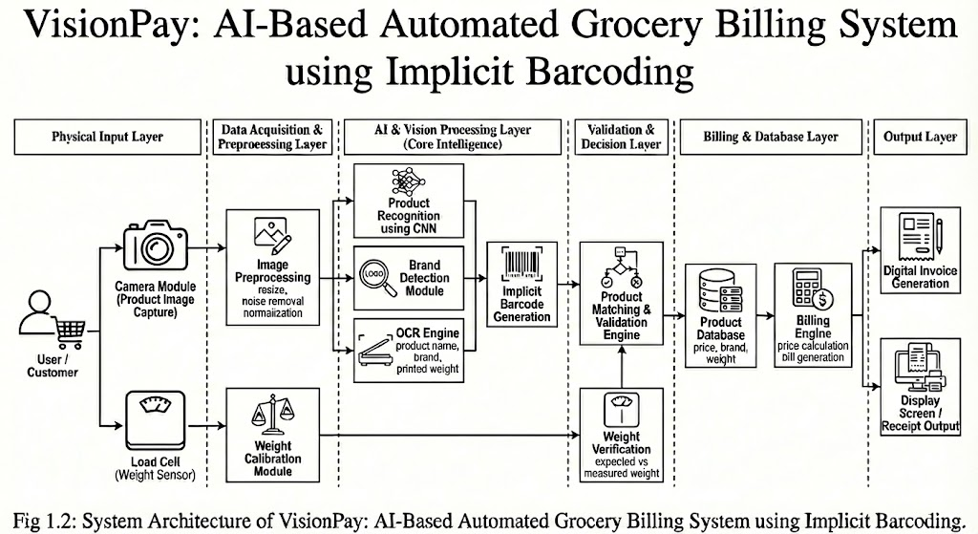
Figure 4.1: System Architecture
Data enters the system through two input channels: the phone camera capturing product images, and the load cell providing weight readings. Both pass through a preprocessing layer that resizes images to the required dimensions, filters out noise, and calibrates the raw weight signal before anything is sent further. The core processing happens in the AI and vision layer, which runs three modules in parallel, a fine-tuned YOLOv8n model for visual product recognition, a brand detection module, and an OCR engine that reads text printed on the packaging such as product name, brand, and weight. The outputs from all three are combined to produce what the system calls an implicit barcode: a virtual product identifier derived entirely from what the camera sees rather than from any physical label.
The implicit barcode then passes into the validation layer, where it is cross-checked against the product database and compared with the load cell weight reading to confirm the identification is correct. Once validated, the billing layer retrieves the relevant price, brand, and weight details from the database and generates the bill. Finally, the output layer formats this into a digital invoice and displays the receipt on screen. The complete architecture is illustrated in Figure 4.1 above.

Use-Case Diagram
The use case diagram maps out what each actor in VisionPay is responsible for. There are three main actors: the Customer, the Store Admin, and the AI Engine. The diagram shows how their roles interact and where their responsibilities overlap.
Actors:
- Customer
- Store Admin
- AI Engine

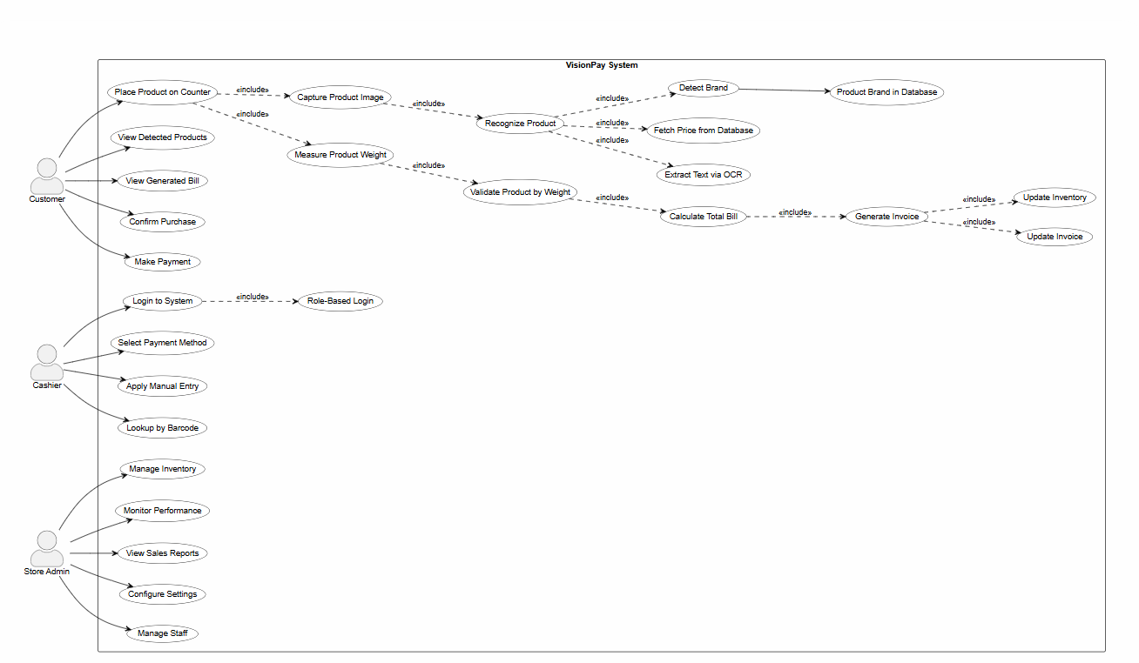
Figure 4.2: Use Case Diagram

Descriptive Use Cases
The following tables describe each major use case in detail, covering what initiates the use case, how the system responds under normal conditions, and what happens when something does not go as expected.

Login to System
When a registered user opens VisionPay and enters their username and password, the system checks those credentials against the user database. If they match, access is granted and the user is directed to the interface corresponding to their role cashier or manager.
Table 4.1: Use Case — Login to System

    - Place Product on Counter
The customer places an item on the counter in view of the camera. VisionPay captures a frame from the live feed and immediately begins the recognition process.
Table 4.2: Use Case — Place Product on Counter

Recognizing Product
The captured image is sent to the backend, where the YOLOv8n model runs inference and identifies the detected product class. At the same time, the brand detection module and OCR engine analyze the packaging to extract brand information and any readable text. The combined output is matched against the product database to retrieve the corresponding price.
Table 4.3: Use Case — Recognize Product

Measure and validate product weight
When the system detects a fruit or vegetable, a weight dialog appears on the cashier's screen. The cashier places the item on the load cell, and the Arduino reads the weight through the HX711 module, transmitting it to the FastAPI backend over the USB serial connection. The app polls the /weight endpoint and shows the live reading; the cashier confirms it, and the system uses that weight to calculate the price.
Table 4.4: Use Case — Measure and Validate Product Weight

Generate Invoice
Tapping the checkout button sends the full cart to the /checkout endpoint. The backend calculates the total, saves a transaction record to the database, updates stock quantities for each item, and returns a formatted receipt showing the cashier name, payment method, itemized list, and total amount.
Table 4.5: Use Case — Generate Invoice

Make Payment
The cashier selects the payment method on behalf of the customer either cash or card. This choice is saved against the transaction record, and the transaction is marked as complete. A receipt displaying all relevant payment information is shown on screen.
Table 4.6: Use Case — Make Payment

4.3.7. Manage Inventory
The manager opens the Products section of their dashboard to review stock levels, add new items to the catalogue, update quantities, or remove discontinued products. Each item in the list carries a stock remark In Stock, Low Stock, Critical, or Out of Stock generated automatically based on the minimum stock threshold set for that product. Items falling below the threshold are highlighted so the manager can act quickly.
Table 4.7: Use Case — Manage Inventory

4.4 Activity Diagram
Activity diagrams follow the sequence of actions through a workflow, showing not just what happens but also where the system makes decisions and branches in different directions depending on the input or outcome.

Customer Billing Workflow:
This activity diagram traces the billing process step by step from when a product is placed in front of the camera all the way through to receipt generation. It also shows what happens at the decision points, what occurs when a product is not recognized by the model.
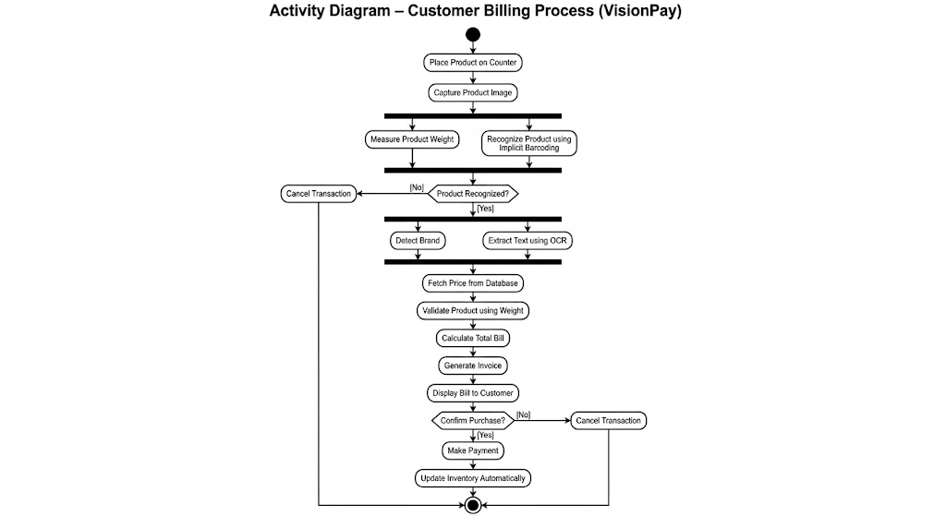
Figure 4.3: Customer Billing Workflow

4.4.2. AI Engine Processing Flow:
This diagram shows the internal flow of the AI engine. It traces the path an image takes from the moment it is captured through YOLO inference, confidence-based filtering, database lookup, and finally price retrieval.
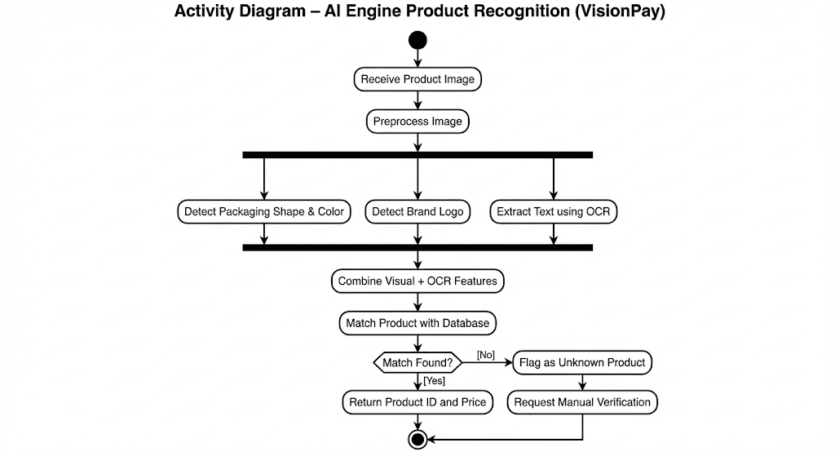
Figure 4.4: AI Engine Workflow

4.2.3 Store Admin and System Monitoring Process:
The third activity diagram focuses on the store admin's role reviewing sales figures, checking inventory levels, adding or removing products, and acting on stock alerts.
The admin does not interact with the billing flow directly their work is primarily supervisory, keeping the product catalogue up to date and monitoring how the system is being used.

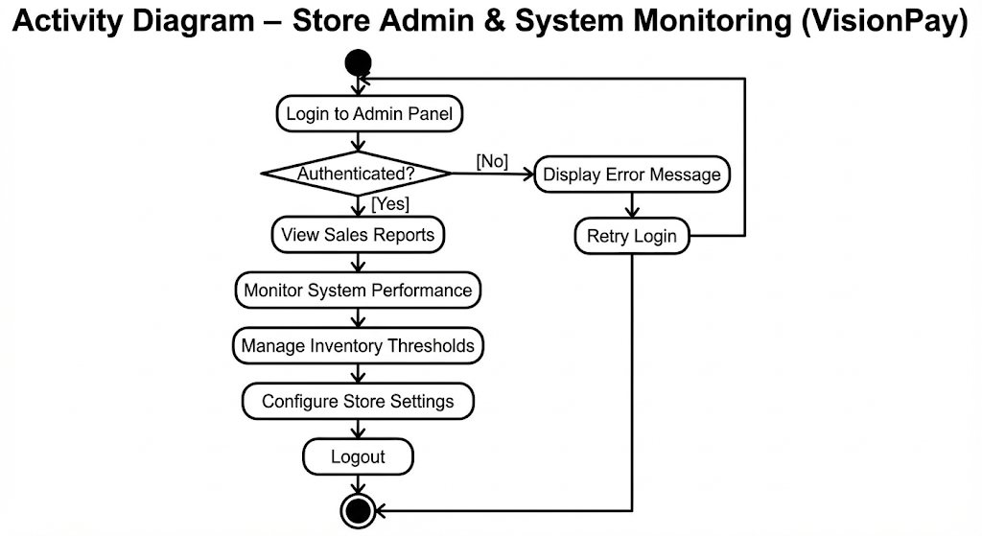
Figure 4.5: Store Admin & System Monitoring

4.5 Class Diagram:
The class diagram maps out all the major classes in VisionPay alongside their attributes, methods, and relationships. Each class corresponds to a real part of the system — the mobile app, the AI engine, the hardware modules, and the database. Together they show the full flow of the billing process, from initial product detection through to invoice generation and payment handling, as illustrated in Figure 4.6 below.
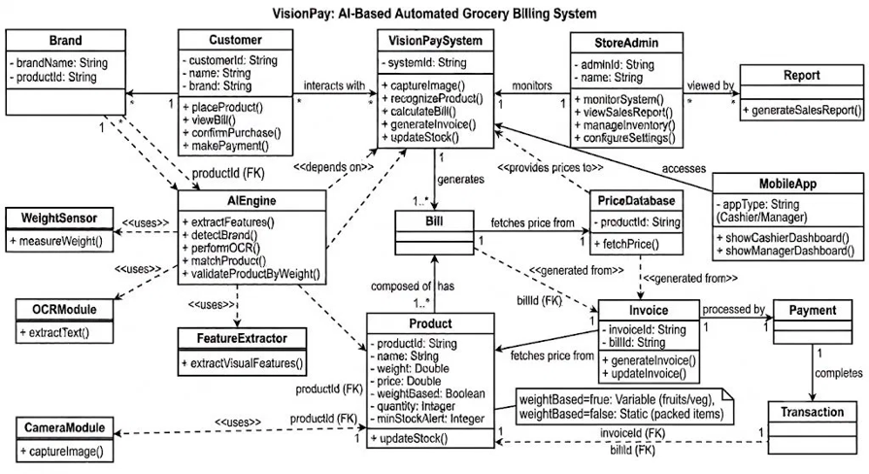
Figure 4.6: Class Diagram

4.7 Sequence Diagram
Sequence diagrams focus on the timing and order of interactions between system components. They make it straightforward to follow exactly which parts of the system communicate, what they send each other, and when — particularly useful for understanding the flow of a billing transaction.

Product Detection & Recognition
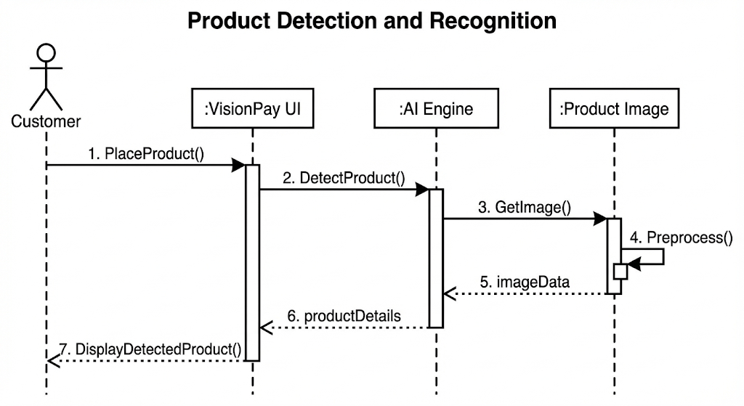
Figure 5.7: Product Detection

4.7.2 Bill Generation & Price Calculation
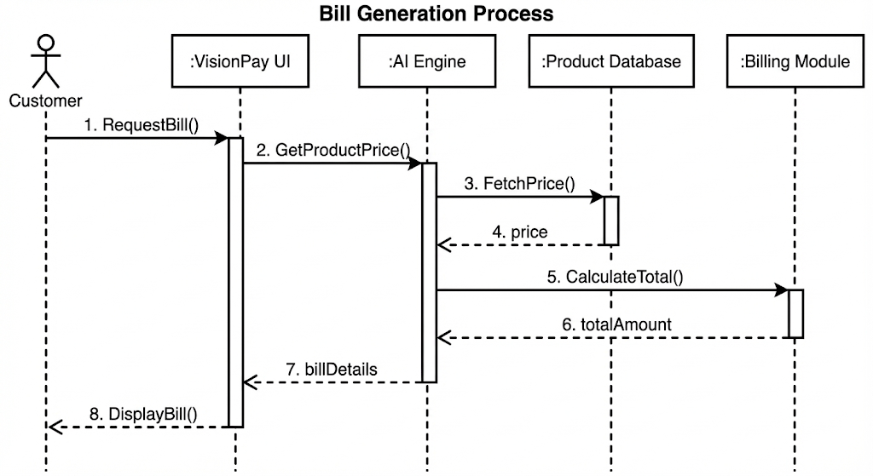
Figure 5.8: Billing Generation

4.7.3 Payment & Inventory Update
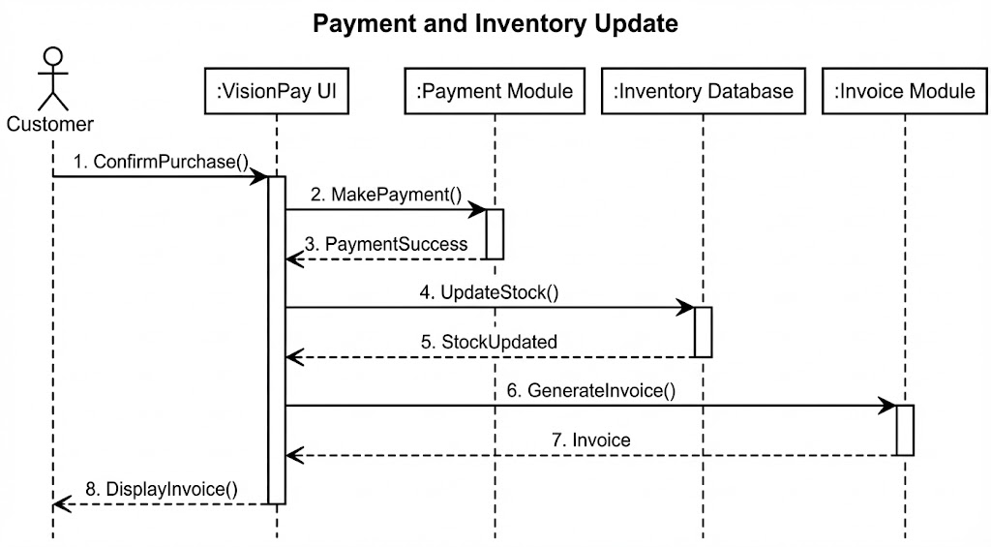
Figure 5.9: Payment Inventory Update

Chapter 5
Implementation

5. Implementation

5.1. Overview
This chapter covers the actual build process how VisionPay went from an architecture diagram to a working system. The work split across four main areas: training the AI model, building out the FastAPI backend, developing the Flutter app, and setting up the Arduino-based weight scale. Each part was verified independently before everything was connected.

5.2. Development Environment
Development took place entirely on a Windows 11 laptop. The backend was written in Python 3.10, the mobile app in Flutter 3.1, and the Arduino firmware was built using Arduino IDE version 2.3.9.

5.2.1. Software Tools and Libraries
Table 5.8: Development Tools and Libraries
Tool/Library | Version | Purpose
Python | 3.10 | Backend and AI engine
FastAPI | 0.111.0 | REST API and WebSocket server
Ultralytics YOLOv8 | 8.3.86 | Object detection model
OpenCV (headless) | 4.9.0.80 | Image processing
SQLite | Built-in | Database
Flutter | 3.1 | Mobile and web application
Dart | 3.1 | Application logic
Docker | Latest | Cloud deployment containerization
Hugging Face Hub | 1.18.0 | Model file hosting

5.2.2. Hardware Components
Table 5.9: Hardware Components Used
Component | Specification | Purpose
Load Cell | 5 kg capacity | Measure weight of produce
HX711 Amplifier | 24-bit ADC | Amplify load cell signal
Arduino Uno | ATmega328P | Read HX711, send over serial
Android Phone | Android 14 | Camera for product detection
Laptop | Windows 11 | Run weight service and web dashboard

5.3. Dataset Preparation
The training dataset was assembled from two separate sources. We started with a publicly available fruit and vegetable dataset from Roboflow, which covered 45 product classes. To that we added our own images photographs we collected and manually labelled for five Pakistani packaged products: Candi Biscuit, Chunkin Chocolate, CocoMo, Lays French Cheese, and Prince Biscuit.
Combined, the dataset covered 53 product classes. We applied data augmentation through Roboflow.
Table 5.10: Dataset Summary
Category | Number of Classes | Source
Pakistani Packed Products | 5 | Custom (manually collected)
Fruits | 17 | Roboflow public dataset
Vegetables | 28 | Roboflow public dataset
Total | 53 | Combined

5.4. AI Model Training
YOLOv8n was chosen as the detection model. The nano variant was not the default choice — it was a deliberate one. It is compact enough to run comfortably on a free-tier cloud server, and its accuracy was sufficient for our use case.
Training was run on Kaggle using a Tesla T4 GPU across 100 epochs. Rather than training from scratch, we used transfer learning — starting from the pretrained YOLOv8n COCO weights and fine-tuning on our grocery dataset.

5.4.1. Training Configuration
Table 5.11: YOLOv8n Training Configuration
Parameter | Value
Model | YOLOv8n
Epochs | 100
Image Size | 640 x 640 pixels
Batch Size | 16
Optimizer | SGD
Learning Rate | 0.01 (initial)
Confidence Threshold (inference) | 0.55
IOU Threshold | 0.45
GPU | Kaggle Tesla T4
Framework | Ultralytics 8.3.86

5.4.2. Training Results
The final overall mAP50 came out at 39.9%. That figure is pulled down significantly by the fruit and vegetable classes, which are genuinely difficult to distinguish visually. The five packed products told a different story CocoMo and Lays in particular both hit 99.5%, and the others also scored strongly.
Table 5.12: Per-Class Detection Accuracy (Selected Classes)
Product Class | mAP50 (%) | Category
CocoMo | 99.5 | Pakistani Packed Product
Lays French Cheese | 99.5 | Pakistani Packed Product
Candi Biscuit | 95.3 | Pakistani Packed Product
Tomato | 72.1 | Vegetable
Banana | 68.4 | Fruit
Potato | 61.7 | Vegetable
Onion | 58.3 | Vegetable
Apple | 55.2 | Fruit
Overall mAP50 | 39.9 | All 53 Classes
The lower scores for classes like Mint (around 19%) and Garlic (around 24%) are a product of how small and visually similar these items are to other produce. In a controlled counter setting with decent lighting, even these classes perform well enough for the billing use case.

5.5. Backend Implementation
FastAPI was chosen for the backend. It takes care of the full processing pipeline — receiving images from the app, running them through the YOLO model, querying the database, calculating the bill, and pushing updates over WebSocket to connected clients.
The backend is organised into separate modules: the main application file handles routing and startup, the database module manages product and transaction records, a decision engine maps YOLO-detected classes to database entries, and a billing engine handles price calculation.

5.5.1. API Endpoints Implementation
The /detect endpoint is where most of the work happens. An image comes in from the app, YOLO runs inference on it, and the results are filtered — anything below the confidence threshold or too small in the frame is dropped. The remaining detections are looked up in the database, and only items that match a known product are returned. Anything unrecognised is quietly discarded, which means unknown objects never accidentally get added to the cart.
The /checkout endpoint handles the full billing cycle in a single call — detection, pricing, saving the transaction record, and updating stock quantities. This makes it convenient for simpler integration scenarios where the client wants one call to do everything.

5.5.2. Database Implementation
SQLite was a natural fit for the prototype. It needs no setup, runs anywhere without configuration, and is more than capable of handling the product catalogue and transaction history at the scale we were working with.
The database is seeded automatically on first startup. All 50 products are inserted the first time the server runs, which meant there was nothing to manually configure when deploying to the cloud — the system just starts and is immediately usable.

5.6. Mobile Application Implementation
Flutter was used for the mobile application, which means the same codebase runs on both Android and the browser without modification. That saved a significant amount of development time compared to maintaining two separate implementations.

5.6.1. Landing Screen
Opening VisionPay brings up the landing screen first. It gives a brief introduction to the system what it does, how it works, and some background on the team behind it.

5.6.2. Login Screen
The login screen is role-based. Cashiers are taken to the billing interface after logging in, while managers land on the full dashboard with analytics and product management tools. For the prototype, credential management is kept simple.

5.6.3. Cashier Dashboard
The Cashier Dashboard is the heart of the billing experience. It displays a live camera feed, a Detect button that triggers product recognition, and a running cart panel on the side. Detected products are added to the cart automatically without any extra input.
When a fruit or vegetable is detected, a weight input dialog appears. If the Arduino scale is plugged in, the cashier can tap a button to read the weight directly from the hardware rather than entering it manually.

5.6.4. Manager Dashboard
The Manager Dashboard is split into four tabs: an overview showing daily and monthly revenue figures, a products tab for adding, editing, or removing items from the catalogue, a transactions tab with billing history, and a stock alerts tab that flags any products running low.

5.6.5. WebSocket Real-Time Sync
WebSocket support was added to keep the phone and browser in sync in real time. When a product is detected on the phone, the cart on the laptop browser updates instantly without any refresh. Testing this feature was one of the more satisfying parts of the project — scanning on the phone and watching the cart populate on the laptop screen in real time gave a clear sense of the system working.

5.7. Hardware Implementation
The hardware component handles weight measurement for produce items sold by the kilogram. A 10kg load cell measures the weight, an HX711 module amplifies the raw signal, and an Arduino Uno reads the amplified output and sends the weight value to the laptop over USB.

5.7.1. Circuit Connections
Table 5.13: Load Cell to HX711 Wiring
Load Cell Wire Color | HX711 Pin
Red | E+ (Excitation Positive)
Black | E− (Excitation Negative)
Green | A+ (Signal Positive)
White | A− (Signal Negative)

Table 5.14: HX711 to Arduino Wiring
HX711 Pin | Arduino Pin
VCC | 5V
GND | GND
DT (Data) | Digital Pin 3
SCK (Clock) | Digital Pin 2

5.7.2. Arduino Firmware
The firmware was written in C++ using the Arduino IDE, making use of Bogdan Necula's HX711 library. On startup it initializes the scale and performs an automatic tare to zero out any initial reading. After that, it reads the weight every 500 milliseconds, averaging each reading over five samples to smooth out noise. Weight values are transmitted over the USB serial connection at 9600 baud in the format WEIGHT:xxx.xx, with the figure in grams. The firmware also listens to a 'T' character from the host, which triggers a fresh tare if the scale needs to be re-zeroed mid-session.

5.7.3. Python Weight Service
On the laptop side, a separate Python script handles communication with Arduino. It uses the pyserial library to read the serial output and runs the reading loop on a background thread, so it does not block anything else. The current weight value is exposed through a small FastAPI instance on port 8001. When the cashier presses Read from Scale in the weight dialog, the Flutter web app fetches http://localhost:8001/weight and displays the live reading.

5.7.4. Load Cell Calibration
Calibrating the scale was straightforward. A known 500g weight was placed on the load cell and the calibration factor in the firmware was adjusted until the reading matched. Once calibrated, the scale held steady within a gram or two across repeated measurements.

5.8. Cloud Deployment
For deployment, Hugging Face Spaces was chosen because it offers a free hosting tier that keeps the API permanently accessible the backend does not require any local machine to be running. The YOLO model file was uploaded separately to Hugging Face Model Hub, since binary files cannot be committed directly to a Spaces git repository. The Dockerfile handles the download automatically during the build step.

The system was deployed with the following components:
- Backend runs inside a Docker container on Hugging Face Spaces using Python 3.10.
- AI Model is based on YOLOv8n, stored separately on Hugging Face Model Hub and downloaded automatically at build time.
- Database uses SQLite stored at /tmp/visionpay.db on the server.
- API is publicly accessible at https://mehakrazzaq2-visionpay-api.hf.space.
- Mobile App is built with Flutter targeting Android 14 (API level 34).

Chapter 6
Testing

6. Testing

6.1. Overview
This chapter describes the testing process and results for VisionPay. Testing was structured across several levels individual API endpoints, the AI model's detection performance, the full end-to-end billing flow, hardware accuracy, and the user interface to verify that every part of the system worked correctly, both in isolation and together.
The process started by testing each API endpoint individually using the Swagger UI at /docs, working through both expected inputs and edge cases. Once individual endpoints passed, we moved to integration testing running the complete scan-to-checkout flow repeatedly with different products and scenarios.

6.2. Testing Methodology
A bottom-up approach was followed throughout. Each component was tested independently before any connections between them were made. Isolating parts this way made it considerably easier to identify the source of any issues that appeared during integration.
Table 6.15: Testing Types and Scope
Testing Type | Scope | Method
Unit Testing | Individual API endpoints | FastAPI /docs + HTTP requests
Model Evaluation | YOLOv8n detection accuracy | Validation set metrics
Integration Testing | Mobile app + Backend + DB | End-to-end scan flow
UI Testing | All four app screens | Manual testing on Android device
Performance Testing | Detection speed, response time | Timed requests
Hardware Testing | Load cell accuracy | Known weights comparison

6.3. API Endpoint Testing
All API endpoints were tested through the Swagger UI, covering normal operation as well as edge cases like empty images, products not in the database, and invalid IDs. What we found was as follows:
- POST /detect returned the product name, confidence score and price for each detected item in the image
- POST /checkout successfully generated a complete bill with product details and the total amount, while simultaneously saving the transaction to the database
- GET /products returned all 50 seeded products from the database as expected
- GET /stats correctly returned revenue figures and transaction counts
- GET /low stock returned the list of products that had fallen below their minimum stock threshold
- POST /product/add successfully added a new product to the database when provided with valid product data
- DELETE /product/delete/{id} successfully removed the product from the database when provided with a valid product ID
- GET /weight returned the current weight reading in both grams and kilograms from the connected load cell
- WS /ws successfully established a WebSocket connection and real-time broadcast messages were received upon connection

6.4. AI Model Evaluation
Model evaluation was run on the validation split at the end of the full training run. Ultralytics automatically logs per-class mAP50 at the end of training, so the performance figures were taken directly from those output logs without any additional evaluation step.

6.4.1. Overall Model Performance
Table 6.16: Overall Model Performance Metrics
Metric | Value
Overall mAP50 | 39.9%
Overall mAP50-95 | 27.3%
Precision | 61.2%
Recall | 48.7%
Detection Speed (per image) | < 1 second
Model Size | 6.2 MB
Training Epochs | 100

6.4.2. Per-Class Performance
A clear pattern emerged between the two product categories. The five Pakistani packaged products all performed well, helped by the fact that each has distinctive packaging that makes it visually easy to separate from everything else. Fresh produce was a different story many fruits and vegetables share similar shapes, colours, and surface textures, which made them harder to classify accurately, especially when lighting conditions varied.
Within packed products, CocoMo and Lays French Cheese were the top performers at 99.5% each, with Candi Biscuit at 95.3%, Chunkin Chocolate at 88.7%, and Prince Biscuit at 82.1%. In the fresh produce category, Tomato came out on top among vegetables at 72.1% and Banana led among fruits at 68.4%. The middle group including Potato, Onion, Apple, Carrot, and Capsicum fell between 49.6% and 61.7%. Cucumber and Watermelon sat slightly lower at 47.3% and 43.1%. The weakest results were Grapes, Pineapple, Ginger, Garlic, and Mint with Mint at just 19.7%, largely because of its small size and resemblance to other leafy items.
The low scores for Mint and Garlic are not surprising. Both are small items that frequently overlap with other produce in the frame, and their appearance is similar enough to other leafy vegetables that even a person might struggle to distinguish them from a photograph. More training images taken under varied lighting and angles would be the most direct way to improve performance in these classes.

6.5 System Integration Testing
Integration testing meant running the entire billing workflow end to end with real products. Different combinations were scanned, cart updates were observed and verified, full checkouts were completed, and the manager dashboard was checked to confirm that revenue figures and stock counts were updated as expected after each transaction.
The following scenarios were tested:
- Packed product detection: CocoMo was placed in front of the camera and detected successfully, adding it to the cart at Rs. 20 as expected
- Vegetable detection: Tomato was placed and detected, upon which the weight dialog opened automatically, and the price was calculated correctly based on the entered weight
- Multiple products: Three products were placed simultaneously and all three were successfully added to the cart in a single detection
- Unknown object: A random unrecognized object was placed in front of the camera, and nothing was added to the cart, confirming correct fallback behavior.
- WebSocket sync: A product was scanned on mobile, and the cart update was reflected on the laptop browser in real time.
- Load cell read: A 500g weight was placed on the scale and the Read Scale button returned an accurate reading of approximately 500g.
- Receipt generation: A complete cart was checked out, the receipt was displayed correctly, and the database was updated with the transaction.
- Manager stats: Following a completed checkout, the manager dashboard reflected the updated revenue figures accurately.

6.6 Performance Testing
Key operations were timed over ten trials each, with results average. The most closely watched metric was detect-to-cart time how long it took from pressing Detect to seeing items appear in the cart. The target was under three seconds.
Table 6.17: System Performance Results
Operation | Average Time | Acceptable Threshold
Image upload to /detect (mobile → HF Space) | 1.8 sec | < 3 seconds
YOLO inference on server | 0.7 sec | < 1 second
Database query (products) | < 50 ms | < 200 ms
Bill generation | < 30 ms | < 100 ms
WebSocket broadcast delay | < 100 ms | < 500 ms
Load cell reading update interval | 500 ms | < 1 second
App startup time (cold) | 2.1 sec | < 5 seconds

On average, the detect-to-cart cycle took about 2.5 seconds. Most of that time was the image upload and YOLO inference. The database lookup and WebSocket broadcast contributed very little to the overall time.

6.7 Hardware Testing
The load cell was tested against five known reference weights ranging from 100g to 1000g. Across all tests the error remained below 1%, which is well within the tolerance needed for grocery billing. A gram or two of difference at these weights does not meaningfully change the price.

Table 6.18: Load Cell Accuracy Test Results
Actual Weight (g) | Displayed Weight (g) | Error (g) | Error (%)
100 | 101 | ±1 | 1.0%
250 | 252 | ±2 | 0.8%
500 | 499 | ±1 | 0.2%
750 | 753 | ±3 | 0.4%
1000 | 998 | ±2 | 0.2%
Averaged across all five test weights, the load cell error came in at under 1%. For grocery billing, where a margin of a few grams is entirely acceptable, this is more than accurate enough.

6.8 UI Testing
UI testing was done on a real Android 14 phone rather than an emulator. Testing on physical hardware turned out to be necessary a couple of camera permission issues surfaced that the emulator had not caught. All four main screens were walked through for layout correctness, navigation flow, and feature functionality.

6.9 Comparison with Existing Systems
A brief comparison was drawn between VisionPay, a standard barcode system, and the Amazon Go model across several key dimensions. VisionPay sits in an interesting position between the two considerably more capable than a barcode scanner, but at a fraction of the cost of smart-store infrastructure.
Feature | Barcode System | Amazon Go | VisionPay
Hardware Cost | Low | Very High | Low
Barcode Required | Yes | No | No
Produce Weighing | Manual | Automatic | Semi-automatic
Mobile Camera Use | No | No | Yes
Internet Required | No | Yes | Yes
Works Offline | Yes | No | No
Deployment Complexity | Low | Very High | Low
Pakistani Product Support | Yes | No | Yes
Cost for Small Store | Affordable | Not Feasible | Affordable

CHAPTER 7
CONCLUSION AND FUTURE WORK

7. Conclusion and Future Work

7.1 Summary of work
The goal of this project was to build a practical, affordable AI billing system for small grocery stores in Pakistan. VisionPay is the result of a working prototype that demonstrates the concept is achievable with accessible technology and minimal hardware investment.
The technology choices YOLOv8n for detection, FastAPI for the backend, SQLite for storage, Flutter for the app, and an Arduino-based load cell for weight measurement turned out to be well-suited to the constraints of the project. Every component is either free to use or very cheap to source, and hosting on Hugging Face Spaces means the API is always reachable without a local server running.

7.2 Objectives Achieved
The following objectives set at the beginning of the project were successfully achieved:
- An AI model was trained for 53 Pakistani grocery product classes covering packed products, fruits and vegetables
- A FastAPI backend was developed with 15 fully functional endpoints handling detection, billing, stock management and transactions
- A Flutter mobile application was built for Android 14 with camera-based product detection and billing
- Hardware weight measurement was implemented using HX711 module, Arduino Uno and a 5kg load cell
- Backend was permanently deployed on Hugging Face Spaces, eliminating the need for a locally running server
- Cross-platform web access was enabled through Flutter web support
- Real-time synchronization between mobile and laptop was achieved via WebSocket integration
- Role-based access control was implemented with separate Manager and Cashier dashboards
- Automatic stock deduction was integrated, with inventory updated after every completed billing transaction

7.3 Limitations
VisionPay works well as a proof of concept, but it would not be honest to present it without discussing its current limitations.
The 39.9% mAP50 headline number is lower than it looks in practice. The figure is dragged down by produce classes that are visually similar and genuinely hard to distinguish, not just for the model but often for a person looking at a photograph too. The packed products — which are the more commercially significant category in a real store — scored much higher, in some cases near-perfect.
The system currently requires a live internet connection for all detection and billing. When the Hugging Face Space goes idle after a period of inactivity, the first request takes noticeably longer while the container starts back up. For a real store environment this would need to be addressed.
The hardware setup works but is not polished enough for a production environment. The Arduino connects to the laptop over USB, which physically tethers the scale to wherever the laptop is sitting and limits placement flexibility.

7.4 Future Work
Several directions stand out as natural next steps for the project.

7.4.1 Improved Model Accuracy
The biggest gains in model accuracy would come from expanding the training dataset with more images captured in varied conditions. Scaling up to YOLOv8s or YOLOv8m would also be worth testing to see how much detection quality improves at the cost of slightly longer inference times.

7.4.2 Thermal Printer Integration
Adding Bluetooth thermal printer support would complete the cashier’s experience. The receipt screen is already in place printing, it would just require wiring up a print job to a Bluetooth-connected thermal printer.

7.4.3 Payment Gateway Integration
Integrating a local payment gateway like JazzCash or EasyPaisa would make VisionPay genuinely deployable in a real store. The simplest path would be to generate a QR code on the receipt screen that links directly to a payment request.

7.4.4 Cloud Database
The current deployment uses SQLite stored inside the container, which means the database resets whenever Hugging Face restarts the Space. Migrating to a cloud database like Supabase would solve this and provide persistent transaction history across restarts.

7.4.5 Wireless Hardware Integration
Replacing the Arduino Uno with an ESP32 would eliminate the USB cable requirement entirely. The ESP32 can communicate over Wi-Fi, which would let the scale be positioned wherever makes most sense on the counter without being tethered to the laptop.

7.4.6 Multi-Camera Support
Supporting multiple camera inputs would make conveyor-belt style checkout possible, which is the obvious next step beyond a single-counter prototype.

7.4.7 Real-Time Inventory Management
The stock alert functionality in the manager dashboard lays groundwork for a fuller inventory management system. Adding automated reorder triggers and supplier contact integration would extend VisionPay from a billing tool into something closer to a full store management platform.

7.5 Conclusion
The clearest lesson from this project is that building a functional AI billing system does not require significant investment. A smartphone camera, a free cloud hosting account, and an inexpensive load cell were all the physical resources needed to produce something that works in practice.
All the primary objectives were met and the prototype provides a solid base for further development. With a larger training dataset, a persistent cloud database, and payment gateway integration, there is a real path to making VisionPay commercially viable in the Pakistani retail market. This work also adds to the growing body of research on AI-driven retail automation in developing countries, where the ability to deliver meaningful automation within tight cost constraints is what determines whether a system is actually adopted.

References
[1] Oishi, S. K., Islam, M. M., Rony, S. D., Khan, R. S., Rahman, M. M., & Ahmmed, M. (2026). Enhancing Retail Checkout Efficiency Through a Hybrid YOLOv8-Based Grocery Detection and Billing System. Frontiers in Computer Science and Artificial Intelligence. https://doi.org/10.32996/jcsts.2026.5.5.6.
[2] Tan, L., Liu, S., Gao, J., Liu, X., Chu, L., & Jiang, H. (2024). Improved YOLOv10 for Enhanced Self-Checkout System in Retail. Journal of Imaging, 10(10), 248. https://doi.org/10.3390/jimaging10100248
[3] Amazon Go. (n.d.). Just Walk Out Technology. Amazon. Retrieved 2026, from https://www.amazon.com/b?node=16008589011

