Q1.
#include<iostream>
using namespace std;

class Solution{
public :

int binarySearch(int arr[],int size, int target){

int low = 0;
int high = size - 1;

while(low < high){

int mid = (low + high)/2;

if(arr[mid]==target){
return mid;
}
else if(target > arr[mid]){
low = mid+1;
}
else{
high = mid - 1;
}
}
return -1;
}
};
int main(){
int arr[] = {2, 5, 8, 12, 16, 23, 38, 56, 72, 91};
int size = sizeof(arr)/sizeof(arr[0]);
Solution s1;
int ans = s1.binarySearch(arr,size,23);
if(ans != -1){
cout<<"23 found at index : "<<ans<<endl;

}
else{
cout<<"23 is not there in the array ! "<<endl;
}
return 0;
}

OUTPUT -

Q2
#include<iostream>
using namespace std;

class Solution{
public :

void merge(int arr[],int low, int mid, int high){

int lsize = mid - low + 1;
int rsize = high - mid;

int larr[lsize], rarr[rsize];

for(int i=0; i<lsize ; i++){
larr[i] = arr[i];
}
for(int j=0; j < rsize ; j++){
rarr[j] = arr[mid+j+1];
}

int i=0,j=0,k=low;

while(i < lsize && j < rsize){

if(larr[i] < rarr[j]){
arr[k] = larr[i];
i++;
k++;
}

else{
arr[k] = rarr[j];
j++;
k++;
}
}

while(i < lsize){
arr[k] = larr[i];
i++;
k++;
}
while( j < rsize ){
arr[k] = rarr[j];
k++;
j++;
}
}
void mergesort(int arr[],int low, int high){

if(low < high){

int mid = (low+high)/2;

mergesort(arr,low,mid);
mergesort(arr,mid+1,high);
merge(arr,low,mid,high);
}
}
};

int main(){
int arr1[] = {12, 11, 13, 5, 6, 7};
int size1 = sizeof(arr1)/sizeof(arr1[0]);

int arr2[] = {38, 27, 43,3, 9, 82, 10};
int size2 = sizeof(arr2)/sizeof(arr2[0]);

Solution s1,s2;
s1.mergesort(arr1,0,size1-1);
s2.mergesort(arr2,0,size2-1);

cout<<"After applying merge sort on first array : "<<endl;

for(int i=0;i<size1;i++){
cout<<arr1[i]<<" ";
}
cout<<endl;
cout<<"After applying merge sort on second array : "<<endl;

for(int i=0;i<size2;i++){
cout<<arr2[i]<<" ";
}
cout<<endl;
return 0;
}

OUTPUT -

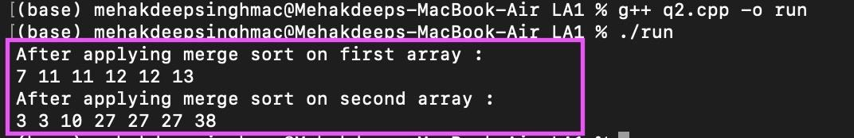

Q3

#include<iostream>
using namespace std;

class Solution{
public :

int partition(int arr[],int low, int high){

int pivot = arr[high];
int i = low - 1;
int j = low;

while( j < high){

if(arr[j] < pivot){
i++;
swap(arr[i],arr[j]);
}
j++;
}
swap(arr[i+1],arr[high]);
return i+1;
}
void quicksort(int arr[], int low, int high){
if(low < high){

int part = partition(arr,low,high);

quicksort(arr,low,part-1);
quicksort(arr,part+1,high);
}
}
};
int main(){

int arr[] = { 4, 2, 6, 9, 2 };
int size = sizeof(arr)/sizeof(arr[0]);

Solution s1;
s1.quicksort(arr,0,size-1);
cout<<"Sorted array by using quick sort algo : ";
for(int i=0 ; i < size; i++){
cout<<arr[i]<<" ";
}
cout<<endl;
return 0;

}

OUTPUT -

Q4

#include<iostream>
using namespace std;

class Solution{
public:
int max_sub_array_sum(int arr[],int size){
int s1 = arr[0];
int s2 = arr[0];

for(int i=1; i < size; i++){

int temp = max(arr[i],arr[i]+s1);
s1 = temp;
if(temp > s2){
s2 = temp;
}
}
return s2;
}
};
int main(){
int arr[] = {-2,-5,6,-2,-3,1,5,-6};
int size = sizeof(arr)/sizeof(arr[0]);

Solution s;
int ans = s.max_sub_array_sum(arr,size);
cout<<"maximum subarray sum is : "<<ans<<endl;
return 0;
}

OUTPUT -

