- Machine Learning

AI VS ML
Artificial intelligence and machine learning are the part of computer science that are correlated with each other.
On a broad level, we can differentiate both AI and ML as:
- AI is a bigger concept to create intelligent machines that can simulate human thinking capability and behavior.
- machine learning is an application or subset of AI that allows machines to learn from data without being programmed explicitly.

What is Machine learning?
- Machine learning is about extracting knowledge from the data.
- Machine learning is a subfield of artificial intelligence, which enables machines to learn from past data or experiences without being explicitly programmed.
- Machine learning enables a computer system to make predictions or take some decisions using historical data without being explicitly programmed.
- Machine learning uses a massive amount of structured and semi-structured data so that a machine learning model can generate accurate result or give predictions based on that data.
- It works only for specific domains such as if we are creating a machine learning model to detect pictures of dogs, it will only give result for dog images, but if we provide a new data like cat image then it will become unresponsive.
- Machine learning is being used in various places such as for online recommender system, for Google search algorithms, Email spam filter, Facebook Auto friend tagging suggestion, etc.

It can be divided into three types:
- Supervised learning
- Reinforcement learning
- Unsupervised learning.

Flow

Data

Pre-processing/EDA
- python-Pandas (for data),
- Mat-Plot (for graphical analysis)

Creating Algorithms/ ML Models (ML)

- Supervised learning
Supervised learning is a machine learning method in which models are trained using labeled data(structured data). In supervised learning, models need to find the mapping function to map the input variable (X) with the output variable (Y).
Supervised learning needs supervision to train the model, which is similar to as a student learns things in the presence of a teacher. Supervised learning can be used for two types of problems: Classification and Regression.
Example: Suppose we have an image of different types of fruits. The task of our supervised learning model is to identify the fruits and classify them accordingly. So to identify the image in supervised learning, we will give the input data as well as output for that, which means we will train the model by the shape, size, color, and taste of each fruit. Once the training is completed, we will test the model by giving the new set of fruit. The model will identify the fruit and predict the output using a suitable algorithm.

Modelling
- predictive modeling is the process by which a model is created to predict an outcome.
- if the outcome (output col) is numerical it is called regression.
- If the outcome (output col) is categorical (i.e as not a certain number but as type of flower/yes or No types etc ) it is called classification

Regression models
For (both linear and non-linear) data are used for predicting a real value, like salary for example. If your independent variable is time, then you are forecasting future values, otherwise your model is predicting present but unknown values. Regression technique vary from Linear Regression to SVR and Random Forests Regression.
learn to implement the following Machine Learning Regression models:
- Simple Linear Regression
- Multiple Linear Regression
- Polynomial Regression
- Support Vector for Regression (SVR)
- Decision Tree Classification
- Random Forest Classification

Simple Linear Regression
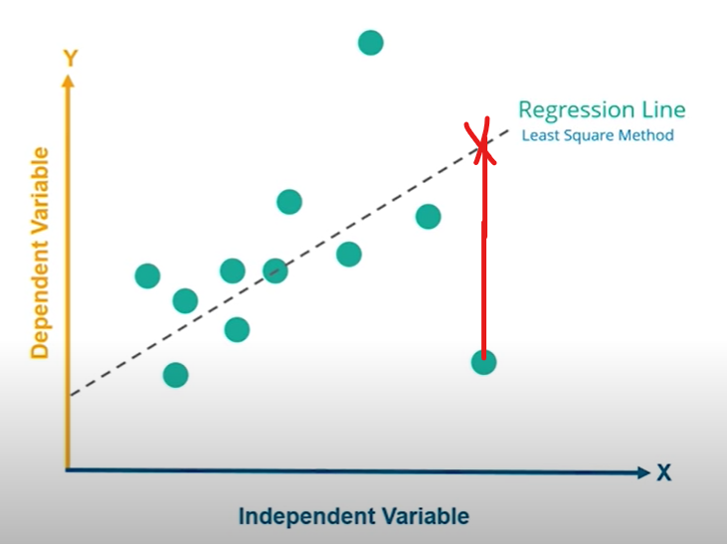

As from above fig you can see,
- Y (output col) is dependent on x(input col)
- Based on past record we can see x and y on graph
- For linear regression we need draw line i.e best fit (dotted line in fig)
- That line is regression line and its equation is y = mx + c, m is slope and , c is constant
- How to know which line is best fit?, as we can draw many line like that in graph
- For best fitted line, as you can see in fig there is red line which is we called mean error
- To calculate mean error we take (yp-y)^2 of each point and sum it , take the line for which sum is min
- we need to draw a line, so that from each point should have minimum error
- some time very far point we can ignore, consideration those as exceptional since its is only
- As, we said that line is regression line, based on x input we can predict what output y will be
- Formula for r-squared error
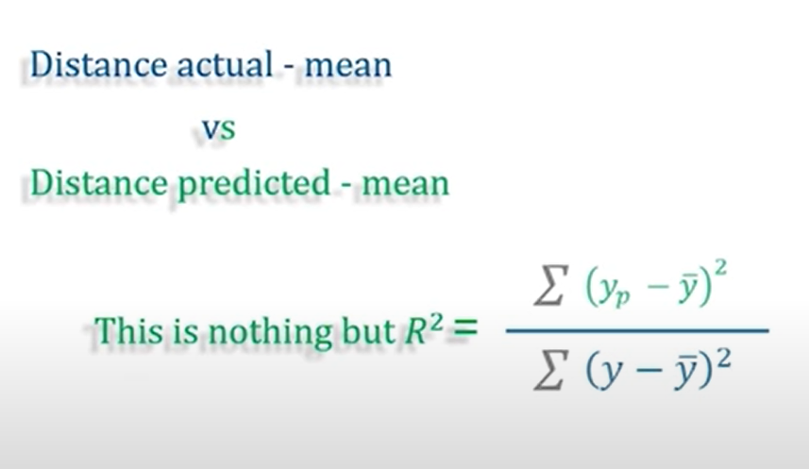

Yp- predict value( red cross point) ,y – original point, ybar – mean
- We take for each point and sum , we get r^2 based that how good is our model , how much percentage it increase on increase x

Multiple Linear Regression
Here it is same as simple linear regression, but we have multiple input instead of one, so equation will be fro regression line be
Y= c+m1*x1+ m2*x2+ m2*x2+…+ mn*xn

Assumptions of Linear Regression
- Linearity
- Homoscedasticity
- Multivariate normality
- Independence of errors
- Lack of multicollinearity
These needs to take care in when building linearity, for more information https://towardsdatascience.com/assumptions-of-linear-regression-5d87c347140

Dummy Variable
- Let say one of the input col is categorical data (not numeric), like Countries

- Let us assume our given record of 3 country(usa, uk, india), so country col has only three countries will repeat, so three Categories.

- To convert as num we can give usa as 0, uk as 1 and india 2, our model look as 0,1,2 as number
But there is a problem with this, as we are giving manually number ,these number make huge effect our other input as we are adding with some random numerical,this not best approach

- For best approach, We will create three col with name of usa, uk, india as col as these are categories these additional col is dummy variables and remove country col

- To fill data of these col, we do as if country col row has usa we fill usa col of that row as 1,if not fill data with 0

- We do this for every category’s col, so now categories col usa, uk, inda as data as either 0 or 1

- Since 0 or 1 data for the respective col ,the does not make effect on other input

Dummy Trap Variable
- Since we added new col so equation also will change
- And we need to remove country col as we convert it into induvial col
- While taking dummy variable we should not take all dummy variable into equation, we should remove any one col of dummy variable this is known as dummy variable trap
- Reason for removing one col from dummy variable is
Example:
- Let’s consider the case of gender having two values male (0 or 1) and female (1 or 0).
- Including both the dummy variable in equation
- If a person is male in such case equation have one extra value 1*slope
- If a person is female in such case equation have one extra value 1*slope
- So our model not effective as one extra point is coming both male and female
- If we take on male col ,when female our male col will be zero, so we can know it is female point
- hence, we don’t need to use both the variables in regression models. This will protect us from dummy variable trap.

Features selection model
https://en.wikipedia.org/wiki/Feature_selection
https://scikit-learn.org/stable/modules/feature_selection.html

Polynomial Regression
Till now we have seen linear regression , now+ we are going to non linear regression
Here it is same as simple linear regression, rather drawing straight line we will fit line according data points
Y= c+m1*x1+ m2*x^2+ m2*x^3+…+ mn*x^n
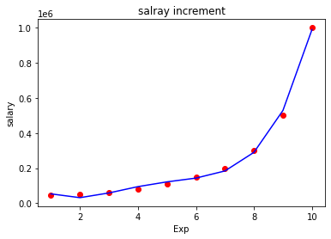

Support Vector for Regression (SVR)

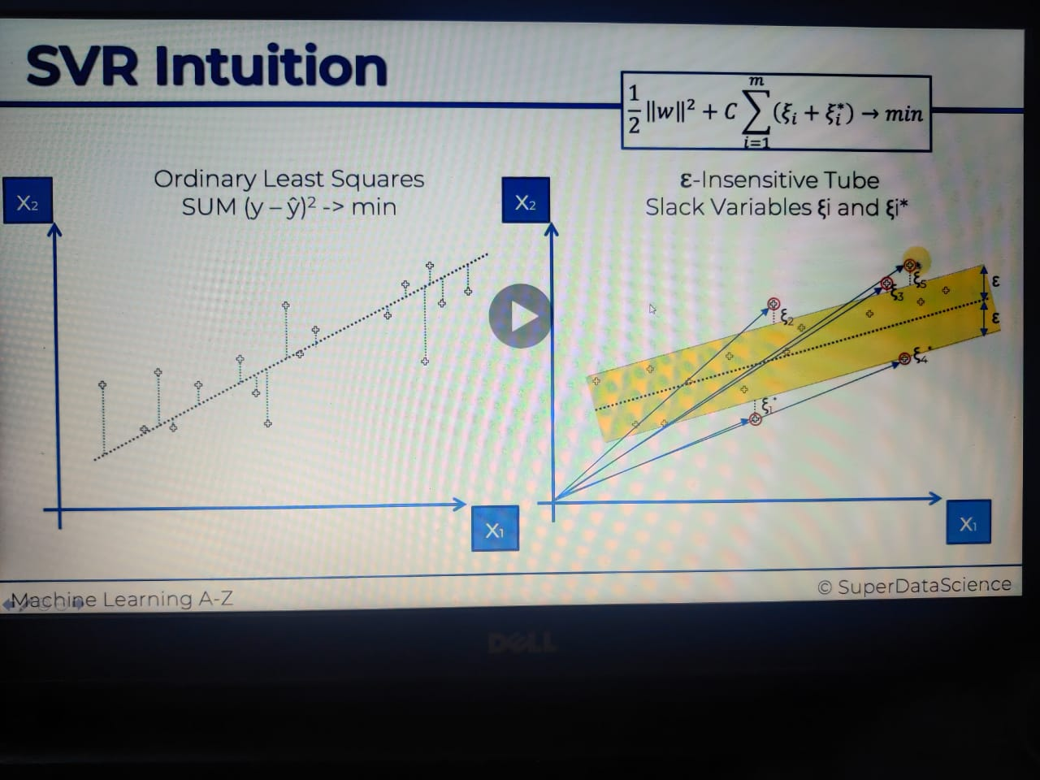
- Here we can see from above pic diff of simple linear regression and Support vector
- Both are same except in svr rather than single line, we will draw a tube
- For best tube will take min difference of external point of tube, refer formula In pic
- External point of tube is called supported vector
- Data point take as vector as you can see blue line from origin
- Full detailed pdf doc https://core.ac.uk/download/pdf/81523322.pdf

Decision Tree Regression

