RAG Bot: A Retrieval-Augmented System for Conversational Document Question Answering
A Practical Implementation Using FastAPI, LangChain, ChromaDB, and Groq
Independent Software Project — Applied AI and Full-Stack Engineering

Abstract
Manually searching long documents for specific information is slow and error-prone, particularly when the same document is consulted repeatedly with varying questions. This paper presents RAG Bot, a document question-answering system that combines Retrieval-Augmented Generation (RAG) with a conversational interface, allowing a user to upload a PDF and ask natural-language questions about its contents. The system parses uploaded documents, splits them into overlapping text chunks, and encodes each chunk as a vector embedding using a HuggingFace sentence-transformer model. At query time, the user's question is embedded using the same model and compared against the stored chunk vectors to retrieve the most relevant passages, which are then supplied as context to a large language model served by Groq. We describe the system's two-part architecture — a FastAPI backend responsible for document ingestion and retrieval, and a Streamlit frontend providing the conversational interface — and document the configuration, deployment, and operational workflow required to reproduce it. We further discuss conversational memory handling, single-document scoping per session, and the practical engineering issues encountered during development, including model deprecation, provider rate limits, and embedding-model caching for latency. We conclude with a discussion of planned extensions, including multi-document knowledge bases and category-scoped retrieval for messaging-platform deployment.
Keywords: retrieval-augmented generation, large language models, vector embeddings, semantic search, ChromaDB, conversational AI, document question answering
I. Introduction
Document-grounded question answering is an increasingly common requirement in software systems that need to make static reference material — manuals, policies, product catalogs, or research material — accessible through natural-language interaction rather than manual search. Traditional keyword search returns matching passages but does not synthesize an answer, while a general-purpose language model without access to the source document cannot answer questions about its specific content and may fabricate plausible-sounding but incorrect responses.
RAG Bot addresses this by combining a retrieval step with a generation step: rather than asking a language model to answer from memory, the system first retrieves the passages most semantically relevant to the question and supplies them as grounding context. This report documents the system's design, the reasoning behind key implementation choices, and the operational workflow for running it.
II. System Overview
The user-facing interface is a single-page conversational UI. On first load, the user is presented with an empty state and a message input supporting document attachment (Figure 1). Once a document is attached, the attachment control is disabled for the remainder of the session, enforcing a one-document-per-conversation constraint at both the interface and API level. Subsequent questions are answered using content retrieved from the uploaded document, with the system maintaining conversational context across turns (Figure 2).
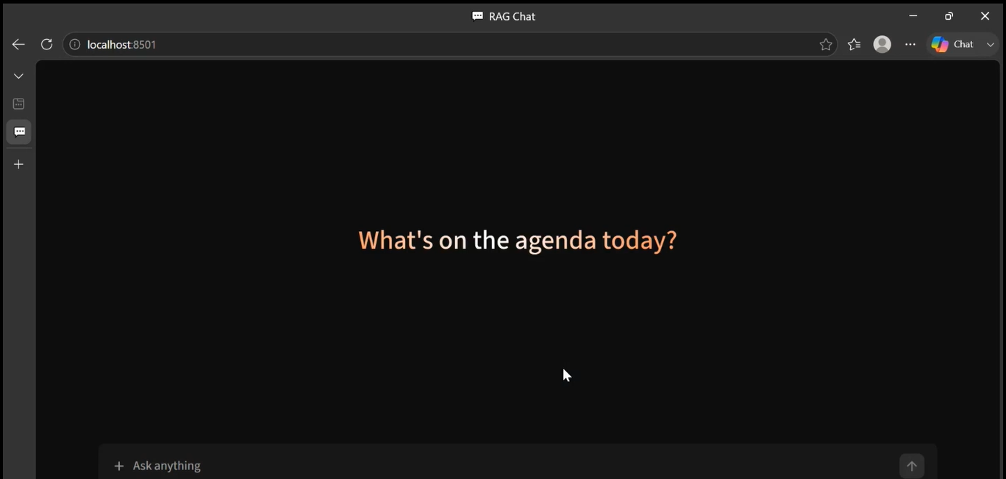
Figure 1. Initial application state prior to document upload or query submission.
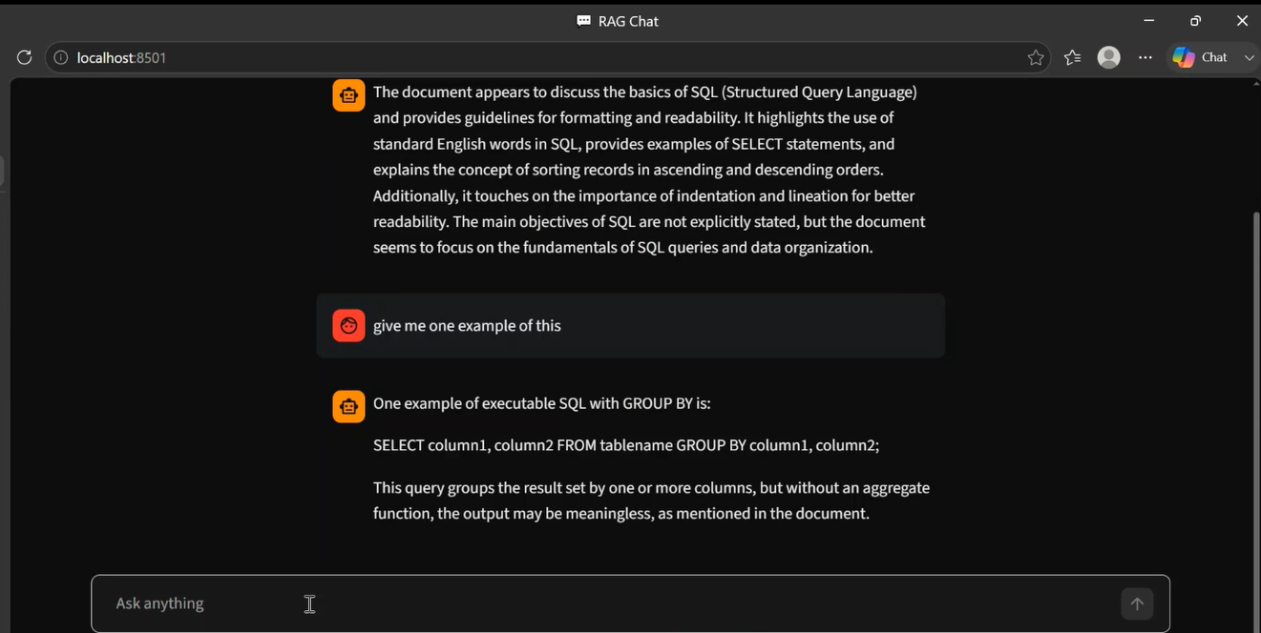
Figure 2. A representative exchange demonstrating document-grounded answering followed by a context-dependent follow-up question.
III. System Architecture
The system is composed of two independent processes communicating over HTTP: a Streamlit frontend and a FastAPI backend. This separation allows the retrieval-and-generation pipeline to be exercised independently of the user interface, and permits either component to be replaced without modifying the other.
A. Document Ingestion Path
An uploaded PDF is parsed page-by-page, split into overlapping text chunks using a recursive character splitter, and each chunk is embedded using a HuggingFace sentence-transformer model. The resulting vectors are persisted to a Chroma vector store on disk, scoped to the originating conversation.
B. Query Path
An incoming question is embedded using the same model used at ingestion time, ensuring both the document chunks and the query occupy a shared vector space. The top-k most similar chunks are retrieved and combined with the prior conversation history into a structured prompt, which is submitted to a large language model hosted by Groq. The model's response is returned to the frontend and appended to the session's conversation state.
User Question
|
v
[ Embed Question ] --(same model as ingestion)--> [ Chroma Vector Store ]
| |
| top-k relevant chunks |
|<-------------------------------------------------------+
v
[ Prompt Assembly ] (retrieved context + conversation history)
|
v
[ Groq LLM ] --> Generated Answer --> Returned to Frontend
IV. Implementation
A. Technology Stack
The backend is implemented in Python using FastAPI for request handling and LangChain for orchestrating the retrieval-and-generation pipeline. Document parsing is handled by PyMuPDF, vector storage by ChromaDB, and embeddings by HuggingFace's sentence-transformers library. Language model inference is served by Groq. The frontend is implemented in Streamlit.
B. Project Structure
rag-bot/
|-- app/
| |-- api/
| | |-- upload.py (document ingestion endpoint)
| | |-- chat.py (query endpoint)
| |-- rag/
| | |-- chain.py (retrieval-generation pipeline)
| | |-- embeddings.py (cached embedding model)
| | |-- loader.py (PDF parsing)
| | |-- prompt.py (prompt template)
| | |-- retriever.py (vector search)
| | |-- vector_store.py (chunking and persistence)
| |-- utils/config.py
| |-- main.py
|-- streamlit_app.py
|-- requirements.txt
+-- .env
C. Environment Configuration
Runtime configuration is provided via environment variables:
GROQ_API_KEY=your_groq_api_key
MODEL_NAME=llama-3.3-70b-versatile
CHUNK_SIZE=1000
CHUNK_OVERLAP=200
VECTOR_DB_PATH=vector_db
V. Deployment and Operation
The backend is started with Uvicorn, exposing a REST API and interactive documentation:
uvicorn app.main:app --reload

# Backend: http://127.0.0.1:8000
# Docs: http://127.0.0.1:8000/docs
The frontend is started independently:
streamlit run streamlit_app.py

# Frontend: http://localhost:8501
API Endpoints
- POST /api/upload — accepts a PDF, extracts and chunks its text, and persists the resulting embeddings to the vector store.
- POST /api/chat — accepts a question and conversation history, retrieves relevant context, and returns a generated answer.
VI. Engineering Considerations
Several practical issues were addressed during development that are not visible from the architecture alone. The embedding model is loaded once and cached rather than reloaded per request, which materially affects response latency. Conversation history is transmitted with every query and formatted into the prompt so that follow-up questions referencing earlier turns can be answered correctly rather than treated in isolation. The system enforces a single document per conversation at both the interface and API layers, preventing unrelated documents from being mixed within one retrieval scope. Provider-side model deprecation and rate limiting were also encountered during development and are handled by returning descriptive errors to the caller rather than failing silently.
VII. Future Work
- Multi-document knowledge bases, allowing several documents to be searched jointly within a single session.
- Category-scoped retrieval, filtering search by document type (e.g., product information, general inquiries) prior to semantic ranking.
- Persistent, queryable conversation history stored outside process memory.
- Authentication and multi-user session isolation.
- OCR support for scanned, non-text-layer documents.
- Hybrid retrieval combining dense vector search with sparse keyword ranking (e.g., BM25).

