Aeromek Video: An AI-Powered Voice-Over Video Generation Studio
A Technical System Report on Prompt-Driven, Multi-Character Short-Form Video Generation
Product Documentation — AI Media Generation Platform
Abstract
Aeromek Video is a browser-based studio for generating vertical, voice-over-driven short-form videos from a single natural-language prompt. The system pairs a conversational authoring interface with an automated production pipeline that plans a narrative concept, assigns a narrator persona, constructs a scene-by-scene blueprint, sources or generates supporting b-roll, and renders a finished 1080×1920 MP4 with captions, music, and lip-synced character voice-over. This report documents the studio's interface, its character and voice-casting subsystem, its asynchronous generation pipeline, its storyboard-based scene editor, and the deployment model observed in the current release, and closes with engineering considerations and directions for future work.
Keywords: AI video generation, text-to-video, voice cloning, lip synchronization, storyboard planning, prompt-driven authoring, short-form vertical video
I. Introduction
Short-form vertical video has become a dominant format for marketing, product explainers, and social content, but producing it conventionally still requires scripting, casting or voice talent, filming or sourcing b-roll, editing, and captioning as separate, largely manual stages. Aeromek Video collapses this workflow into a single prompt-driven studio: a user describes the desired video in plain language, optionally selects one or two on-screen characters and their voices, and the system plans, sources, and renders a complete video without further manual editing, though every generated scene remains editable after the fact.
The product is positioned for use cases such as SaaS explainers, retail promotions, restaurant and fitness marketing, local-service advertising, and travel content, reflected directly in the preset industry tags surfaced in the prompt composer (Figure 1). This report describes the system as observed in its current interface and behavior, organized around its interface layout, its generation pipeline, its storyboard/scene model, and the operational characteristics of its deployment.
II. System Overview and Architecture
The studio is organized as a three-pane single-page application: a left-hand configuration panel for casting and prompt authoring, a central preview/player pane, and a right-hand storyboard panel that reflects the state of the generated video as a sequence of scenes. A top navigation bar exposes three top-level views — Studio, History, and Providers — alongside a live backend connectivity indicator (“Backend online”) and a Local mode toggle, suggesting the system supports both a hosted backend and a local execution path for generation providers.
A. Configuration Panel: Casting and Prompt Authoring
Before generation, the user configures an optional cast of up to two on-screen characters, labeled Character A and Character B, positioned respectively on the left and right of the frame. Each character slot accepts a still image and can be linked to a matching voice drawn from a bundled voice library (attributed to “Fish Audio” in the interface), or left unset, in which case the system falls back to a default narrator persona generated during planning. A library of stock character stills and voices is bundled for quick selection (Figure 1), and once a user uploads their own likeness — for example peter.jpg and meg.jpg in the observed session — the corresponding slot displays a “Voice linked” status with a Clear action to reset it (Figure 3).
The prompt composer sits below the cast panel and accepts a free-text description of the desired video, with quick-select industry tags (SaaS, Retail, Restaurant, Fitness, Local service, Travel, Generic) that appear to seed prompt templates for common verticals. A row of toggles beneath the prompt field controls production parameters observed in the interface: target duration (e.g., 20 sec), aspect ratio (Vertical 9:16), caption burn-in (Captions on), automatic b-roll insertion (B-roll on), background music (Music on), and a running character count indicator.
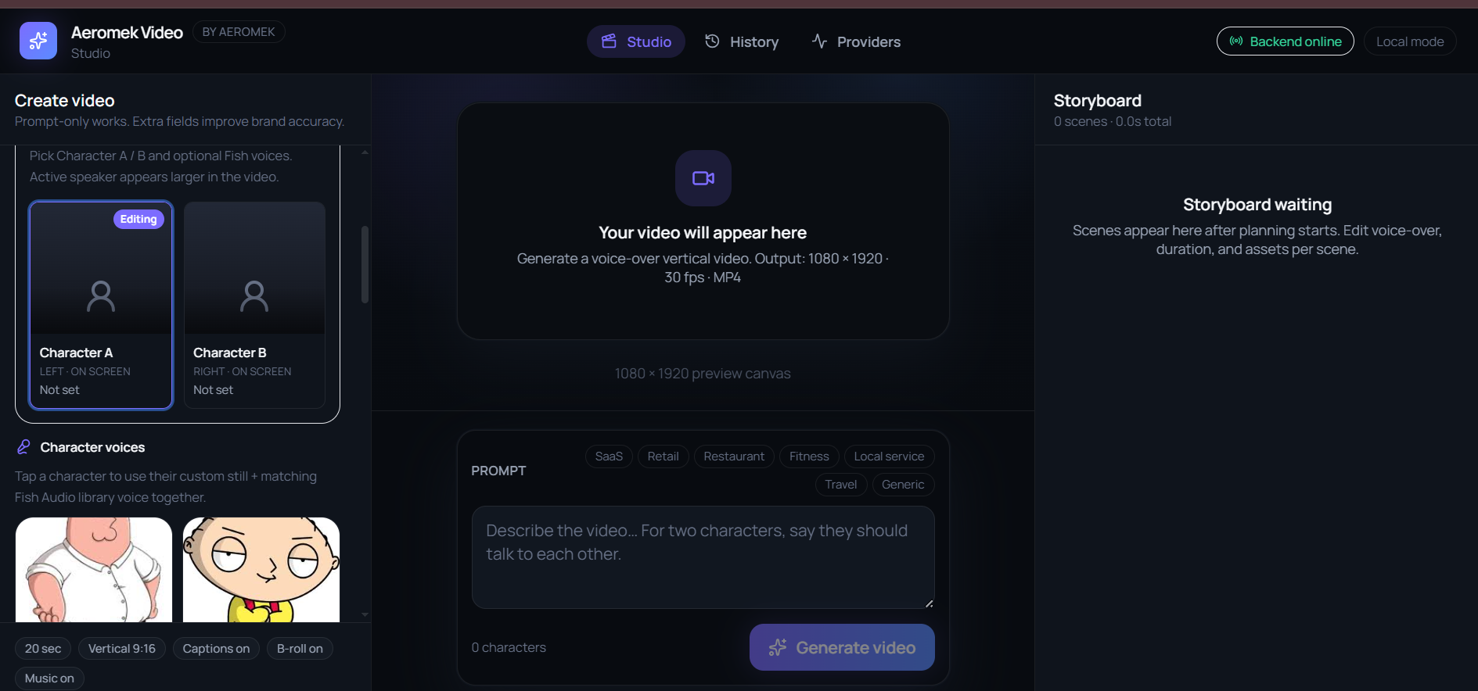
Figure 1. Idle studio state showing the character-casting panel, the bundled character/voice library, and the prompt composer with industry preset tags.
B. Generation Pipeline
Submitting the Generate video action transitions the interface into a PLANNING state that exposes a staged, percentage-driven progress indicator (Figure 2). Three sequential planning stages were observed: “Developing video concept,” “Generating narrator persona,” and “Developing video blueprint,” with the active stage marked by a spinner and completed or pending stages rendered as plain checklist rows. This staged presentation indicates that scene planning is performed by a language-model-driven concept and blueprint generator prior to any asset sourcing or rendering, and that the pipeline is cancellable mid-run via a persistent Cancel control.
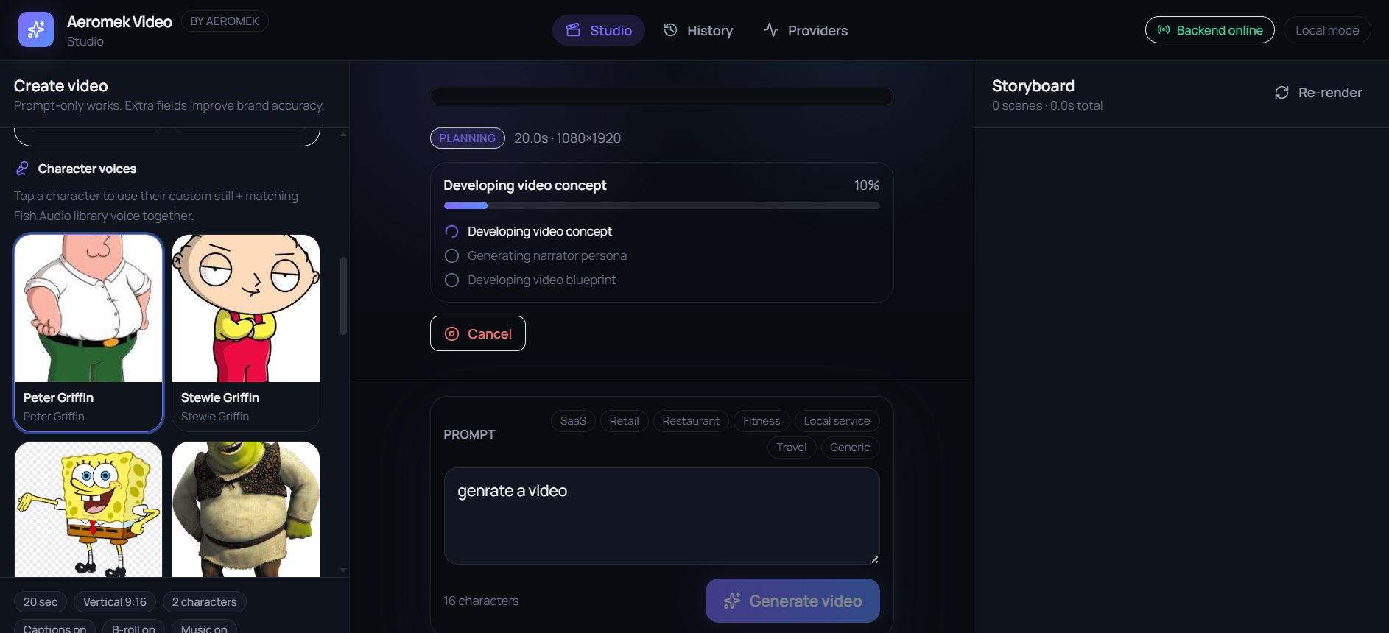
Figure 2. Planning stage of the generation pipeline, showing staged progress across concept development, narrator persona generation, and blueprint construction.
Following planning, the system materializes a per-scene storyboard, sourcing supporting footage from stock-video providers (Pixabay and Pexels were observed as credited sources) and generating narration text and voice-over for each scene, culminating in a rendered, playable preview with an accompanying downloadable MP4 (Figure 3).
C. Storyboard and Scene Model
The right-hand Storyboard panel enumerates the generated scenes as an ordered, draggable list, each entry showing a scene number, a scene-type tag (e.g., B ROLL), a duration in seconds, a completion status badge, a short scene title, the narration line attributed to that scene in quotation form, the sourcing provider and caching state, and per-scene Edit and Retry actions. A header-level Re-render control and an aggregate scene count and total duration summarize the storyboard as a whole. In the sampled project — titled “AI Agents in Modern Hospitals” — the storyboard comprised five scenes totaling 20.7 seconds, each independently completed, retryable, and editable without regenerating the full video.
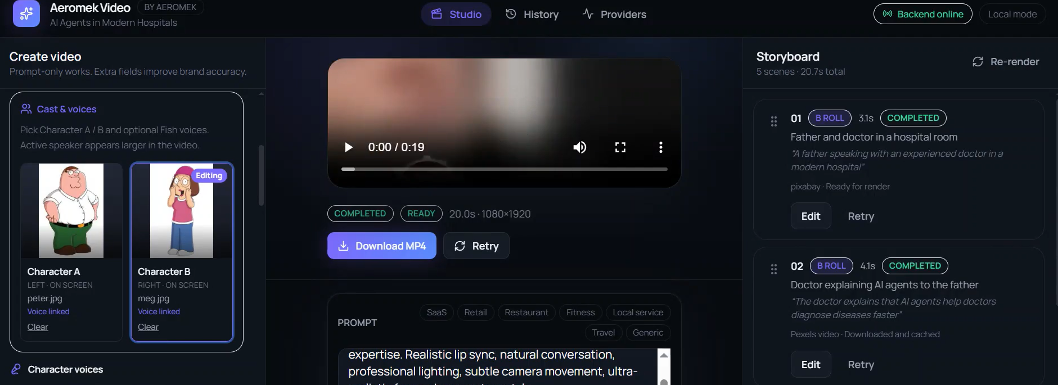
Figure 3. Completed generation showing the rendered preview player, per-character cast panel with linked custom voices, and the populated storyboard with per-scene metadata and controls.
III. Implementation
The observed feature set implies a layered implementation separating orchestration from rendering:
• Planning layer: a language-model-driven service that converts the free-text prompt, selected industry tag, and cast configuration into a structured video concept, a narrator persona, and a scene-level blueprint (scene count, per-scene narration text, and scene type).
• Voice layer: text-to-speech synthesis bound to a selected or default voice profile per character, with the interface's “Voice linked” state implying a persistent mapping between an uploaded character image and a cloned or library voice for lip-synced narration.
• Asset-sourcing layer: retrieval of stock b-roll from third-party providers (Pixabay, Pexels) keyed to each scene's narration, with a caching step (“Downloaded and cached”) to avoid redundant fetches on re-render.
• Rendering layer: composition of voice-over audio, sourced or synthesized visuals, captions, and background music into a fixed-format output — 1080×1920 resolution, 30 frames per second, MP4 container — as stated directly in the idle-state preview pane.
The project structure implied by the interface's own terminology is summarized below as an indicative content model rather than a literal file layout.
video_project/
|-- concept/
| |-- prompt.txt # user prompt + industry tag
| |-- narrator_persona.json # generated narrator profile
| `-- blueprint.json # scene-by-scene plan
|-- cast/
| |-- character_a.{img,voice}
| `-- character_b.{img,voice}
|-- scenes/
| |-- 01_b_roll/ (asset, narration, status)
| |-- 02_b_roll/ (asset, narration, status)
| `-- ...
`-- render/
`-- output.mp4 # 1080x1920, 30fps
A. Provider Abstraction
A dedicated Providers view in the top navigation, together with the Local mode toggle and the live “Backend online” status indicator, suggests that model and API providers (for planning, voice synthesis, and stock-asset retrieval) are abstracted behind a swappable configuration layer, allowing the studio to run against a hosted backend or against locally configured providers without changing the authoring workflow.
IV. Deployment
The studio is deployed as a client-rendered single-page web application, observed at the hosted address aeromek-video.vercel.app, consistent with a Vercel-hosted front end communicating with a separate generation backend over an API boundary. The interface's connectivity badge (“Backend online”) and Local mode toggle indicate that the deployment supports at least two execution modes: a remote/hosted backend for planning and rendering, and a local mode in which generation providers are configured and run on the user's own machine or network, likely for development, offline use, or bring-your-own-API-key scenarios.
A History view, alongside the Studio and Providers tabs, indicates that generated projects and their storyboards persist across sessions rather than existing only within the current browser tab, supporting iterative editing (per-scene Edit and Retry, and project-level Re-render) after initial generation completes.
V. Engineering Considerations
A. Latency and Staged Feedback
Because end-to-end generation spans multiple external calls — language-model planning, voice synthesis, and stock-asset retrieval — the interface mitigates perceived latency with an explicit, staged progress model (Figure 2) rather than an opaque spinner. This pattern is consistent with an asynchronous, job-based backend architecture in which the front end polls or subscribes to incremental pipeline state rather than blocking on a single long-running request.
B. Partial Failure and Re-render Semantics
The per-scene Retry action alongside a project-level Re-render control indicates the system is designed for partial failure: an individual scene's asset sourcing or synthesis can fail or underperform without invalidating the rest of the storyboard, and users can iterate on individual scenes before committing to a full re-render. This scene-level idempotency is important for cost control given that each scene involves independent third-party asset and synthesis calls.
C. Voice and Likeness Handling
Binding a user-uploaded image to a synthesized or cloned voice (the “Voice linked” state) raises standard likeness- and consent-handling considerations that a production system of this kind would need to address through upload attestations, usage scoping, and content-moderation checks on both the source image and the generated narration, particularly given the stock character library's inclusion of recognizable third-party cartoon likenesses for demonstration purposes.
VI. Future Work
• Multi-scene branching prompts that allow the user to specify per-scene direction rather than a single holistic prompt.
• Expanded provider abstraction to support additional stock-footage and text-to-speech vendors alongside the currently observed Pixabay, Pexels, and Fish Audio integrations.
• Finer-grained storyboard editing, including manual scene reordering, in-place b-roll replacement, and direct narration-text editing ahead of re-synthesis.
• Batch and templated generation for recurring content needs (e.g., weekly promotions) building on the existing industry preset tags.
• Expanded local-mode documentation to clarify provider configuration, credential handling, and feature parity with the hosted backend.

