An Autonomous WhatsApp AI Assistant with Retrieval-Augmented Knowledge Grounding
A Selenium-Driven Conversational Agent with Multi-Provider LLM Fallback, Humanized Message Delivery, and an Auto-Reindexing RAG Pipeline
Software Engineering Project — Browser Automation, Applied NLP & Retrieval-Augmented Generation
Abstract
This paper documents the design and implementation of a production-oriented WhatsApp automation bot that couples browser-level session control with a multi-provider large language model (LLM) back end and a locally hosted retrieval-augmented generation (RAG) pipeline. The system drives WhatsApp Web through Selenium to detect unread, one-to-one conversations, filters out groups, channels, communities, and archived threads through a layered set of structural and lexical heuristics, and extracts incoming text and PDF attachments for processing. Replies are generated by routing full per-contact conversation history through a configurable provider chain (Gemini, Groq, and OpenAI, with a static fallback), optionally augmented with context retrieved from a Chroma vector store built from documents dropped into a watched folder and re-embedded automatically in the background. Outgoing messages are delivered through a humanized, character-paced typing routine intended to avoid presenting as an obviously automated sender. The paper describes the architecture, the group/archive detection gates, the RAG indexing and retrieval flow, deployment considerations, and directions for extending the system toward a multi-tenant SaaS deployment.
Keywords: WhatsApp automation, Selenium WebDriver, retrieval-augmented generation, conversational agents, large language models, vector embeddings, Chroma, sentence-transformers, multi-provider fallback, browser automation, natural language processing.
I. Introduction
Small and medium-sized businesses increasingly rely on WhatsApp as a primary customer-facing channel, yet WhatsApp does not expose a first-party bot API accessible without a verified Business API subscription. The system described here addresses this gap through a client-side automation approach: it operates the standard WhatsApp Web interface via a Selenium-controlled Chrome instance, observes the same DOM a human user would see, and drives replies through the same input surface. This avoids dependency on the official Business API while remaining functionally equivalent for one-to-one customer conversations.
Two design goals shaped the implementation. First, replies had to be grounded in a business's own documents — pricing sheets, service catalogs, FAQs — rather than relying purely on a language model's parametric knowledge, motivating the retrieval-augmented generation (RAG) subsystem described in Section III. Second, the bot had to behave conservatively around ambiguous chat types: it must never reply inside a group, community, channel, or read-only broadcast, since a misdirected automated reply in those contexts is far more visible and damaging than a missed one-to-one message. Section II presents the overall architecture; Section III walks through the implementation of each subsystem; Section IV covers deployment; Section V discusses engineering trade-offs; and Section VI outlines future work.

II. System Architecture
The system is organized into four cooperating modules, each with a single responsibility: bot.py performs browser automation, chat classification, and message routing; ai.py owns the language-model provider chain and per-contact conversation memory; the rag package builds and queries the vector knowledge base; and config.py centralizes every tunable constant so that behavior can be adjusted without touching logic. logger_setup.py wires a shared, rotating-file logging configuration used by every module. Figure 1 shows a live end-user interaction as rendered inside WhatsApp, and Figure 2 shows the corresponding structured log output produced by the bot while handling that exchange.
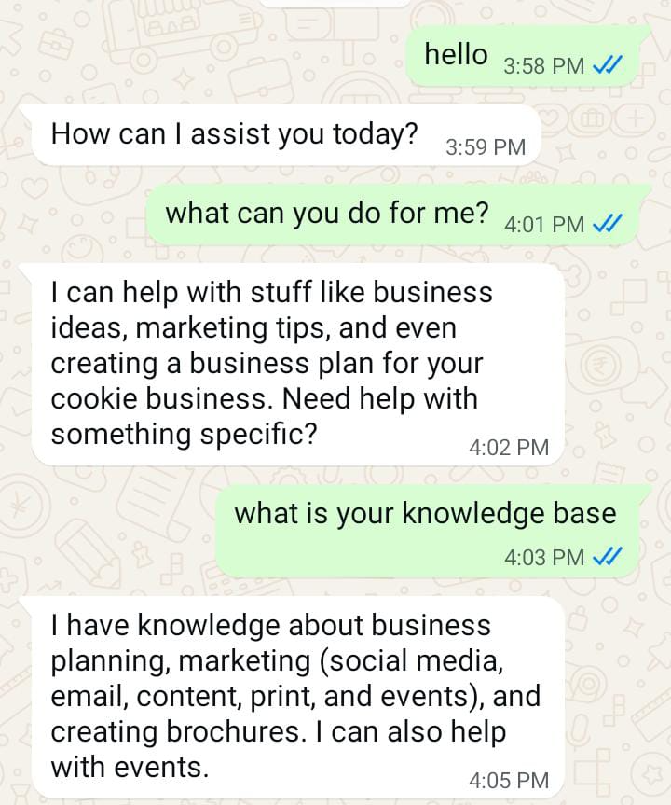
Figure 1. End-user conversation in WhatsApp, showing the bot answering a knowledge-base question after an initial greeting exchange.
The high-level control and data flow is summarized below: the main loop polls the chat list, gates each candidate chat through group/archive/read-only checks, extracts the newest incoming message, forwards it (together with retrieved context and conversation history) to the AI engine, and finally dispatches the reply through the humanized typing routine.
+-------------+ +----------------+ +------------------+
| WhatsApp | <-> | bot.py | --> | Chat filters: |
| Web (DOM) | | (Selenium loop)| | group/archive/ |
+-------------+ +----------------+ | read-only gates |
| +------------------+
v
+----------------+
| Message + PDF |
| extraction |
+----------------+
|
v
+-----------------------------------------------+
| ai.py |
| conversation_history[contact] + system prompt |
+-----------------------------------------------+
| |
v v
+----------------------+ +-----------------------------+
| rag/retriever.py | | Provider chain (config.py): |
| Chroma top-k lookup | | groq -> (gemini/openai avail)|
+----------------------+ +-----------------------------+
|
v
+--------------------------+
| Humanized _send_reply() |
| (char-paced typing, Enter)|
+--------------------------+

The rag package builds this vector store from PDFs dropped into documents/, and a background thread in bot.py (_auto_reindex_loop) periodically fingerprints that directory by filename, modification time, and size, rebuilding the Chroma index whenever a change is detected and the bot is not currently mid-reply. The project's on-disk layout is shown below.
merged_bot/
├── bot.py # Selenium automation, chat gating, main loop
├── ai.py # Provider chain, memory, RAG context injection
├── config.py # Centralized tunables (paths, delays, prompts)
├── logger_setup.py # Rotating file + console logging
├── upload.py # Manual on-demand reindex trigger
├── test.py # Standalone smoke tests
├── requirements.txt
├── rag/
│ ├── embeddings.py # Cached HuggingFace embedding model loader
│ ├── loader.py # PyPDFLoader wrapper
│ ├── indexer.py # Fingerprinting + rebuild orchestration
│ └── vector_store.py # Chunking + Chroma index construction
├── documents/ # Drop-in PDFs (watched, source of truth)
├── vector_db/ # Chroma persistence directory
├── downloads/ # Transient PDF attachment downloads
├── auth/chrome-data/ # Persistent Chrome profile (QR session)
└── logs/bot.log # Rotating application log

III. Implementation
A. Browser Session and Message Detection
The bot launches Chrome with a persistent user-data directory (config.CHROME_DATA_DIR) so that the WhatsApp Web QR handshake only needs to be performed once; subsequent runs reuse the saved session. The main polling loop (WhatsAppAIBot.start) sleeps for a randomized interval between config.POLL_INTERVAL_MIN and config.POLL_INTERVAL_MAX seconds, then calls _process_chats, which scans the visible chat list for rows carrying an unread-message indicator.
Message extraction (_extract_last_incoming_message) is written defensively against WhatsApp Web's build-to-build DOM churn: it first attempts to match message bubbles by class name, then falls back to a data-pre-plain-text attribute selector that has proven more stable across releases. PDF attachments are detected via the presence of a download control alongside a filename ending in .pdf; when found, the file is downloaded to config.DOWNLOADS_DIR, parsed page-by-page with pypdf, injected into the conversation as a bracketed [PDF Attachment Content] block, and the temporary file is deleted.
B. Group, Channel, and Archive Filtering
Because an automated reply inside a group or public channel is a much more consequential failure mode than a missed direct message, chat classification uses four independent layers before a chat is ever clicked: (1) a lexical scan of the row's visible text, title, and aria-label for terms such as "archived" or "archive"; (2) a structural scan for group, community, and channel icon elements; (3) archive-specific DOM markers; and (4) a configurable keyword list (config.GROUP_NAME_EXCLUSIONS) covering terms such as "group", "batch", "community", "broadcast", and organizational words like "class" or "faculty". A second gate runs after the chat is actually opened (_is_open_chat_a_group), inspecting the conversation header for comma-separated participant lists or "click here for group info" text, which catches any group that slipped past the pre-click checks. A third gate, _has_input_box, confirms a compose box exists at all, which excludes read-only broadcast channels.
The bot also restricts itself to number-like or otherwise unsaved contacts through _is_unsaved_or_number_like, and applies a short deduplication window (config.DEDUP_WINDOW_SECONDS) keyed on contact and message text so that a stale re-read of the same unread badge does not trigger a duplicate reply.
C. Multi-Provider AI Engine and Conversation Memory
ai.py maintains an in-process conversation_history dictionary keyed by contact identifier, storing alternating user/assistant turns and trimming to config.MAX_HISTORY_TURNS pairs. generate_reply builds a messages list consisting of a system prompt (config.SYSTEM_PROMPT, optionally extended with retrieved RAG context) followed by the full trimmed history, then iterates config.PROVIDER_ORDER — Gemini via its OpenAI-compatible HTTP endpoint, Groq via its official SDK, and OpenAI via its official SDK — calling each in turn until one returns a non-empty response. If every configured provider fails, a static config.FALLBACK_RESPONSE is returned instead of leaving the customer unanswered.
An anti-repetition check (_is_repeat) compares a freshly generated reply against the last one sent to the same contact; on a match, the same provider is invoked a second time with an appended system note asking it to rephrase, which addresses a common failure mode in which a stateless prompt reproduces its canned opening line — for example, "How can I assist you today?" — turn after turn.
D. Retrieval-Augmented Generation Pipeline
The rag package implements a self-contained document-grounding pipeline. rag/loader.py wraps LangChain's PyPDFLoader to load each PDF in config.DOCUMENTS_DIR as a list of per-page Document objects. rag/vector_store.build_full_index chunks those documents with a RecursiveCharacterTextSplitter (config.CHUNK_SIZE = 500 characters, config.CHUNK_OVERLAP = 100), embeds them with a cached sentence-transformers/all-MiniLM-L6-v2 model (rag/embeddings.py, memoized via lru_cache so the model loads once per process), and writes the result into a Chroma store at config.VECTOR_DB_PATH — wiping and rebuilding the directory from scratch on every run so stale or duplicate chunks cannot accumulate.
rag/retriever.get_retriever exposes a top-k (k = 3) retriever over the persisted store, returning None gracefully if no index has yet been built so the bot still functions on plain conversation before any documents are added. ai._get_rag_context calls this retriever for every incoming message and concatenates the returned chunks into the system prompt when non-empty. rag/indexer.py ties this together for two callers: upload.py, which triggers an immediate on-demand rebuild, and bot.py's background _auto_reindex_loop, which fingerprints documents/ every config.AUTO_REINDEX_CHECK_INTERVAL seconds (by filename, modification time, and size) and rebuilds automatically — but only once self.busy is False, so a reindex never interrupts a reply in progress.
Figure 2 shows this pipeline initializing at process startup: the embedding model is loaded onto CPU, its weights are fetched from the Hugging Face Hub, and the first incoming message ("hi") is logged with its retrieved history-turn count immediately before provider dispatch.
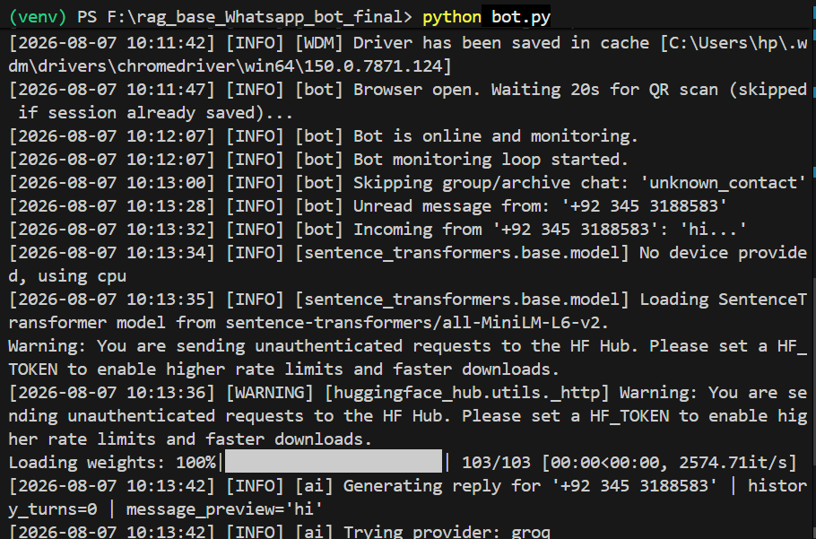
Figure 2. Structured startup and runtime log: driver initialization, embedding-model load, and generation of a reply for an incoming message.
E. Humanized Reply Delivery
_send_reply avoids pasting the full reply into the compose box in a single operation. Instead it locates the compose element across several selector variants (to tolerate WhatsApp Web markup changes), clears any residual content via a direct DOM script, and then sends the reply one character at a time with a randomized inter-character delay (config.TYPE_CHAR_MIN–TYPE_CHAR_MAX), adding a longer randomized pause after punctuation with probability config.TYPE_PUNCT_CHANCE. Literal newlines are sent as Shift+Enter so a multi-line reply remains a single WhatsApp message rather than being split into several. Randomized pre- and post-send pauses (config.PRE_SEND_PAUSE_*, POST_SEND_PAUSE_*) further separate the perceived "typing" and "sending" actions, and the send is confirmed through both an Enter keypress and, if present, an explicit click on the send control.
IV. Deployment
A. Configuration and Secrets
All operational parameters — polling intervals, typing-delay ranges, timeouts, model identifiers, the group-exclusion keyword list, and the system prompt — are centralized in config.py rather than scattered across bot.py and ai.py, so behavior can be tuned without touching automation logic. API credentials (GEMINI_API_KEY, GROQ_API_KEY, OPENAI_API_KEY) are loaded from a .env file via python-dotenv and are never hard-coded. config.py also creates its required runtime directories (logs/, downloads/, auth/chrome-data/, documents/) at import time, so a fresh checkout is runnable without a separate setup script.

B. Dependencies and Startup
The project's dependencies fall into four groups: Selenium and webdriver-manager for browser automation; requests, the groq SDK, and the openai SDK for the three LLM providers; pypdf for attachment parsing; and the LangChain ecosystem (langchain, langchain-community, langchain-text-splitters, langchain-huggingface, langchain-chroma) together with sentence-transformers for the RAG pipeline. Starting the bot is a single command; the first run pauses for config.BROWSER_INIT_WAIT seconds to allow a one-time QR scan, after which the persisted Chrome profile skips this step on every subsequent launch.
$ pip install -r requirements.txt
$ python bot.py

[INFO] [WDM] Driver has been saved in cache ...
[INFO] [bot] Browser open. Waiting 20s for QR scan (skipped if session already saved)...
[INFO] [bot] Bot is online and monitoring.
[INFO] [bot] Bot monitoring loop started.

V. Engineering Considerations
Operating against WhatsApp Web's undocumented DOM rather than an official API is the system's central engineering trade-off. Every selector-dependent routine in bot.py is written with at least one fallback selector, and the log calls (e.g., _get_footer_html_for_debug) that dump raw HTML snippets on a miss were added specifically to keep future selector breakage diagnosable rather than silent. This defensive layering is visible throughout _extract_last_incoming_message, _find_compose_box, and _find_send_button, each of which tries several XPath expressions in sequence before giving up.
A second consideration is React's re-rendering behavior: clicking a chat row causes WhatsApp Web to re-render and potentially reorder the entire chat list, invalidating every other element reference collected in that polling cycle. _process_chats therefore always breaks out of its loop after handling (or attempting to handle) one chat rather than continuing to iterate a now-stale element list — a fix documented inline after it previously caused silent StaleElementReferenceException failures. The trade-off is throughput: only one contact is served per polling cycle, which is acceptable at the conversational volumes the bot targets but would need revisiting for higher-throughput deployments.
Safety-oriented conservatism is a recurring theme: the four-layer group/archive/read-only filtering in Section III-B is deliberately redundant, on the premise that a missed reply is a minor inconvenience while an automated reply inside a group or broadcast channel is a visible and hard-to-retract error. Similarly, when a send fails, _process_chats explicitly rolls back the deduplication entry and pops the just-added assistant turn from conversation history, so the next polling cycle retries cleanly rather than leaving the contact's memory in an inconsistent state.
VI. Future Work
Several SaaS-oriented extension points are already marked in the codebase (comments prefixed SAAS:). The most direct is multi-tenancy: WhatsAppAIBot already accepts a tenant_id at construction, and ai.generate_reply's contact_id namespace is a natural key to extend into a (tenant_id, customer_id) composite once conversation memory and the vector store move from in-process dictionaries and a local Chroma directory to a shared backing store such as Redis or PostgreSQL with per-tenant document collections.
• Persist conversation turns and delivery outcomes to a database for analytics and audit, rather than the current in-memory dictionaries.
• Add a billing hook that meters token usage per tenant at the point generate_reply resolves a provider.
• Move provider calls (currently sequential and blocking) to an async chain to reduce end-to-end reply latency.
• Extend rag/loader.py beyond PDF ingestion to other document formats (DOCX, HTML, plain text) dropped into the same watched folder.
• Replace the fixed PROVIDER_ORDER with tier-based routing, selecting a provider by a tenant's billing plan rather than a single static list.
None of these require restructuring the existing module boundaries — bot.py, ai.py, config.py, and rag/ already separate automation, generation, configuration, and retrieval cleanly enough that each extension is additive rather than a refactor.

