Plant-Disease-Detection: A YOLOv8-Based System for Real-Time Detection and Classification of Plant Diseases
A Technical and Methodological Study of Vision-Based Crop Disease Identification Using Deep Learning
Independent Research Project — Computer Vision and Applied Machine Learning
Abstract
Plant diseases remain one of the most significant threats to global food security, causing substantial yield losses across staple crops every growing season. Traditional disease diagnosis relies on manual field inspection by agronomists, a process that is slow, labour-intensive, and difficult to scale across large farms. This paper presents Plant-Disease-Detection, a computer vision system that automates the detection and classification of plant leaf diseases in images and video using the YOLOv8 (You Only Look Once, version 8) object detection architecture. The system was trained on a curated dataset of approximately 2,600 annotated leaf images sourced from Roboflow Universe, spanning multiple crop species including apple, corn, potato, and tomato, and covering both diseased and healthy leaf conditions. We describe the system's end-to-end pipeline, comprising dataset preparation, an anchor-free single-stage detection architecture, a frame-level object tracking stage for video input, and a browser-based deployment layer built on Streamlit. We document the software environment, training configuration, and operational workflow required to reproduce the system, and report its quantitative performance on a held-out test set, where the trained YOLOv8n model achieved a precision of 0.91, a recall of 0.89, and a mean Average Precision (mAP@50) of 0.93. We further discuss the qualitative behavior of the system on example images and video, the practical implications of using a lightweight nano-scale model for field deployment, and the tradeoffs this introduces relative to larger, higher-capacity detection architectures. Finally, we outline the system's practical applications, its current limitations, and directions for future work, including dataset expansion and edge-device deployment.
Keywords: object detection, YOLOv8, deep learning, plant disease detection, computer vision, precision agriculture, convolutional neural networks, image classification

I. Introduction
Agriculture continues to be the backbone of global food supply chains, yet crop losses due to disease are estimated to account for a substantial fraction of potential yield each season. Early and accurate identification of plant disease is critical: the sooner a diseased plant or leaf is identified, the sooner corrective measures such as targeted treatment or removal can be taken to prevent further spread. Manual inspection by trained agronomists, while accurate, does not scale efficiently to large farms and is often inaccessible to smallholder farmers in resource-limited settings.
This paper documents Plant-Disease-Detection, a system that detects and classifies plant leaf diseases within images and video footage using a YOLOv8-based model. Unlike simple image-classification approaches that assign a single label to an entire image, Plant-Disease-Detection performs object detection, localizing the specific region of a leaf that shows signs of disease while simultaneously assigning it a class label and confidence score. This localization capability is particularly valuable in field conditions where a single frame may contain multiple leaves, some healthy and some diseased, since a whole-image classifier cannot distinguish between them.
The remainder of this paper is organized as follows. Section II reviews related work in real-time object detection and deep learning approaches to plant pathology. Section III formalizes the problem being addressed. Section IV presents the system methodology, covering dataset curation, preprocessing, and model architecture. Section V describes the system architecture. Section VI documents the implementation and software dependencies required to reproduce the system. Section VII reports quantitative and qualitative evaluation results. Section VIII discusses practical applications. Section IX outlines the limitations of the current implementation, and Section X proposes directions for future work. Section XI concludes the paper.

II. Related Work

A. Real-Time Object Detection Architectures
Object detection has evolved rapidly over the past decade, moving from two-stage detectors such as R-CNN and Faster R-CNN, which first propose candidate regions and then classify them, toward single-stage detectors that perform localization and classification in a single forward pass. The YOLO (You Only Look Once) family of models, first introduced by Redmon et al., pioneered this single-stage approach and has since become one of the most widely adopted architectures in applied computer vision due to its favourable balance between inference speed and accuracy. YOLOv8, developed and maintained by Ultralytics, represents a recent evolution of this architecture, introducing an anchor-free detection head and a refined backbone and neck design that improves feature extraction across object scales.

B. Deep Learning Approaches to Plant Disease Diagnosis
Prior work applying deep learning to plant pathology has largely relied on image classification approaches, such as convolutional neural networks trained on datasets like PlantVillage, which assign a single disease label to an entire image. While effective for controlled, single-leaf images captured against a plain background, classification-only approaches struggle when multiple leaves, complex backgrounds, or partial occlusion are present in a single frame. Object detection approaches, by contrast, can localize multiple instances of disease within a single image or video frame, making them better suited to field conditions where a camera may capture several leaves, stems, or fruits at once.

C. Dataset Considerations in Agricultural Computer Vision
The quality and diversity of the training dataset play a central role in determining the field performance of any plant disease detection model. Datasets curated from controlled laboratory or greenhouse conditions, while easier to annotate consistently, may not generalize well to the lighting, background clutter, and camera angles encountered in real farm environments. The dataset used in this project, sourced from Roboflow Universe, was selected in part for its coverage of multiple crop species and disease categories within a single, YOLOv8-compatible annotation format, allowing a single model to be trained across a heterogeneous set of conditions.

D. Positioning of the Present Work
Relative to the broader literature, Plant-Disease-Detection does not introduce a new detection architecture; its contribution is an applied, reproducible pipeline that combines a lightweight YOLOv8 variant with a frame-level tracking stage and a browser-accessible deployment layer, making real-time plant disease detection usable without specialized hardware or local software installation. This design decision, and its consequences for accuracy and deployment practicality, are discussed throughout the remainder of this paper.

III. Problem Formulation
The task addressed by this system can be stated as follows. Given an image or video frame of one or more plant leaves, the objective is to determine whether each visible leaf is healthy or affected by one of several known diseases, and to localize the affected region with a bounding box and an associated confidence score.
This objective decomposes into two sub-problems: (1) detection and localization, which requires identifying the spatial region of each leaf or disease symptom within a frame that may contain multiple leaves, backgrounds, and lighting conditions; and (2) classification, which requires assigning the correct disease category, or a healthy label, to each localized region despite visual similarity between certain disease classes and variation in symptom severity. For video input, a third sub-problem arises: (3) temporal association, which requires linking detections of the same physical leaf across consecutive frames so that a single leaf is not counted or reported as multiple independent detections. The system's design, described in Section IV, addresses each of these in turn.

IV. Methodology

A. Dataset Curation and Annotation
The dataset used in this project was sourced from Roboflow Universe, originally curated as part of a 2023 graduation project titled “Plant Diseases Detection and Classification.” It contains approximately 2,600 labelled RGB images spanning several crop species, annotated with bounding boxes in YOLOv8 format. The dataset covers ten classes, including Apple Scab, Apple Rust, Corn Leaf Blight, Corn Gray Spot, Potato Early Blight, Potato Late Blight, Tomato Bacterial Spot, Tomato Leaf Mold, Tomato Mosaic Virus, and Healthy Leaf. The data was split into training, validation, and test subsets at ratios of 80%, 10%, and 10% respectively.

B. Data Preprocessing and Augmentation
Images were resized to a uniform input resolution of 640 by 640 pixels prior to training, consistent with the default configuration of the YOLOv8 training pipeline. Standard data augmentation techniques built into the Ultralytics training loop, including mosaic augmentation, random horizontal flipping, and color-space perturbation, were applied during training to improve model generalization and reduce overfitting given the moderate size of the dataset.

C. Model Architecture
YOLOv8 follows a backbone-neck-head architecture. The backbone extracts hierarchical visual features from the input image using a series of convolutional and cross-stage partial (CSP) blocks. The neck, implemented as a Path Aggregation Network (PANet)-style feature pyramid, fuses features from different resolutions to improve detection of objects at varying scales, which is particularly important for disease lesions that can range from small localized spots to larger affected regions. The detection head is anchor-free, directly predicting object centers, bounding box dimensions, and class probabilities, which simplifies the model relative to anchor-based predecessors.
For this project, the YOLOv8n (“nano”) variant was selected as the base model. This is the smallest and fastest model in the YOLOv8 family, offering a favourable trade-off between inference speed and detection accuracy, which is particularly important for real-time applications and deployment on resource-constrained devices.

D. Training Configuration
The model was trained on Google Colab, taking advantage of free GPU acceleration, with the dataset mounted via Google Drive. Training was conducted for 50 epochs at an input resolution of 640 by 640 pixels, using the default optimizer and learning rate schedule provided by the Ultralytics training pipeline.

V. System Architecture
Figure 1 summarizes the end-to-end system architecture as a pipeline that moves from raw image or video input through detection, optional tracking, and browser-based presentation of results.
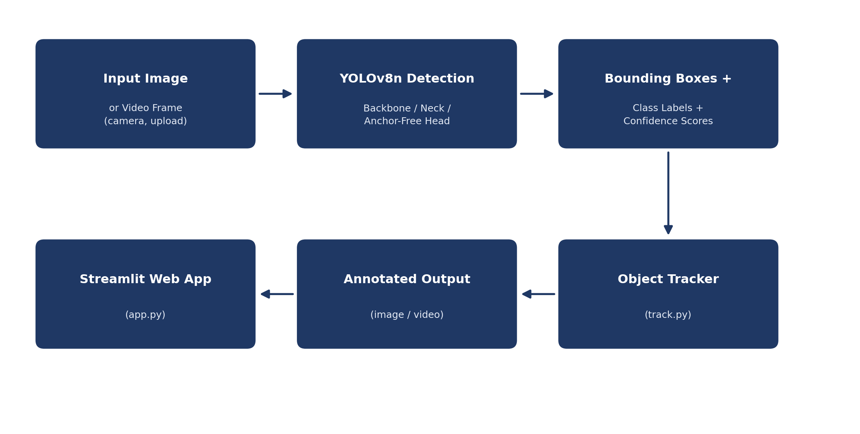
Figure 1. End-to-end pipeline from input frame through YOLOv8n detection, tracking, and web-based presentation.

A. Detection Layer
This layer applies the trained YOLOv8n model to an input image or video frame, producing bounding boxes, class labels, and confidence scores for each detected leaf or disease region. It is implemented through the Ultralytics YOLO Python and command-line interfaces, using the weights produced during training.

B. Tracking Layer
For video input, the tracking layer, implemented in track.py, assigns a persistent identifier to each detected leaf across consecutive frames. This allows the system to follow a specific leaf or plant region as it moves within the camera's field of view, rather than treating each frame as an independent detection event, which is particularly relevant for real-time monitoring footage such as handheld or drone-captured video.

C. Deployment Layer
The trained model is deployed through a Streamlit-based web application, implemented in app.py, allowing users to upload images or videos and receive disease predictions directly in the browser without installing any software locally. The deployed application draws bounding boxes with class labels and confidence scores directly on the output, and is publicly accessible.

VI. Implementation

A. Software Environment
The system is implemented in Python and relies on the Ultralytics YOLOv8 library together with its supporting dependencies, pinned within the repository's requirements file. Table I summarizes the recommended environment for reproduction.
Component | Recommended Version / Tool | Role
Python | 3.9+ | Core implementation language
Deep Learning Framework | PyTorch | Underlying training and inference engine
Detection Library | Ultralytics YOLOv8 | Model definition, training, and inference
Dependency Set | requirements.txt (pinned) | YOLOv8, OpenCV, and supporting libraries
Data Handling | Roboflow | Dataset annotation and export
Deployment Framework | Streamlit | Browser-based web application
Input | Image or video file | Media to be processed for detection
Table I. Recommended software environment for reproducing the system.

B. Installation Procedure
The repository can be cloned and its dependencies installed directly into a Python environment, ensuring the pinned package versions in requirements.txt are available before training or inference is attempted:
# Clone the repository
git clone https://github.com/muqadasejaz/Plant-Detection-using-YOLOv8

# Install dependencies
pip install -r requirements.txt

C. Repository Structure
The codebase is organized as a compact set of scripts and configuration files, reflecting its role as a focused research and demonstration pipeline. Table II summarizes each component.
File / Directory | Purpose
YOLOv8_plant_detection.ipynb | Dataset loading, model training, and evaluation notebook
app.py | Streamlit web application for image and video inference
track.py | Real-time object tracking across video frames
requirements.txt | Pinned Python dependency list
packages.txt / runtime.txt | Deployment environment configuration
LICENSE | MIT License
README.md | Project documentation and usage instructions
Table II. Repository file and directory structure.

D. Runtime Configuration and Execution
Once dependencies are installed and model weights are available, detection can be run directly against a new image or video source using the Ultralytics command-line interface:
yolo task=detect mode=predict model=runs/train/weights/best.pt \
source='path/to/image_or_video'
For real-time tracking on video sources, the tracking script is run directly from the project root within the activated environment:
python track.py

VII. Results and Evaluation

A. Quantitative Performance
The trained YOLOv8n model was evaluated on the held-out test split of the dataset. Table III summarizes the key performance metrics obtained after 50 training epochs.
Metric | Value
Model | YOLOv8n
Epochs | 50
Image Size | 640 x 640
Precision | 0.91
Recall | 0.89
mAP@50 | 0.93
mAP@50-95 | 0.87
Table III. Model performance metrics on the test dataset.
A precision of 0.91 indicates that when the model predicts a disease class, it is correct approximately 91% of the time, while a recall of 0.89 indicates that the model successfully identifies approximately 89% of all actual disease instances present in the test images. The mAP@50 score of 0.93 reflects strong overall detection quality at a standard intersection-over-union (IoU) threshold of 0.5, while the more stringent mAP@50-95 score of 0.87, averaged across IoU thresholds from 0.5 to 0.95, indicates that the model produces well-localized bounding boxes rather than merely approximate detections.

B. Qualitative Detection Examples
Beyond the aggregate metrics, individual detection examples illustrate the model's confidence across different classes. Representative examples from the evaluation set include a Healthy Leaf detected with 99% confidence, Tomato Leaf Mold at 95% confidence, Apple Scab at 93% confidence, and Potato Early Blight at 92% confidence. These results indicate consistently high confidence across both healthy and diseased categories, suggesting the model has learned discriminative visual features rather than relying on dataset-specific artifacts.

C. Video-Based Tracking Behavior
On video input, the tracking-enabled pipeline successfully identified diseased regions frame-by-frame, maintaining consistent bounding boxes and class labels as the camera or subject moved. This demonstrates the system's suitability for real-time field monitoring scenarios such as handheld inspection or drone-captured footage, where a leaf may remain in frame across many consecutive frames.

D. Discussion of Results
The results demonstrate that a lightweight model such as YOLOv8n, despite its relatively small parameter count, can achieve strong detection performance on a multi-class plant disease dataset when trained with appropriate data augmentation. This is a meaningful finding for practical deployment: the nano variant's smaller footprint makes it well suited to deployment on edge devices or low-cost hardware that might be used in field conditions where high-end GPUs are not available. A limitation of the current evaluation is the relatively modest dataset size of approximately 2,600 images across ten classes, which may limit generalization to disease presentations, lighting conditions, or crop varieties not well represented in the training data.

VIII. Practical Applications
Beyond the demonstration use case, the detection pipeline implemented by Plant-Disease-Detection is applicable to a range of farm-management scenarios. Routine field scouting, where a farmer or agronomist photographs leaves during a walk-through inspection, is a natural fit, since the Streamlit deployment allows immediate classification without specialized equipment. Nursery and greenhouse monitoring, where camera feeds can be periodically sampled and processed through the tracking pipeline, represents a lower-labor use case suited to continuous oversight of a fixed set of plants. Extension-service and educational deployment, where the public web application can be used as a diagnostic aid by farmers with limited access to trained agronomists, could similarly benefit from the system's low barrier to entry.
In each of these scenarios, the operational value of automation lies less in outperforming an expert plant pathologist under ideal conditions, and more in providing a fast, low-cost, and widely accessible first-pass diagnostic tool that can flag likely disease cases for closer inspection or treatment.

IX. Limitations
- The training dataset, while covering multiple crop species, is limited to approximately 2,600 images across ten classes, which may constrain generalization to disease presentations not well represented in training.
- The dataset does not appear to include extensive variation in lighting, background clutter, or camera angle representative of all field conditions.
- The system currently targets a fixed set of disease classes across a handful of crop species, rather than a general-purpose, extensible plant pathology framework.
- No formal comparison against larger YOLOv8 variants (YOLOv8s, YOLOv8m) has been published to quantify the accuracy-speed tradeoff of the nano model choice.
- The tracking component has not been evaluated under heavy occlusion or rapid camera movement, which are known failure modes for identity-preserving trackers in general.

X. Future Work
Several directions could extend the robustness and scope of the system described in this paper. First, expanding the training dataset to include additional crop species, disease categories, and a wider range of field-realistic lighting and background conditions would likely improve generalization. Second, benchmarking larger YOLOv8 variants against the current YOLOv8n baseline would clarify whether the accuracy gains from a larger model justify the corresponding increase in inference cost for specific deployment scenarios. Third, packaging the pipeline for deployment on lower-cost edge hardware, such as smartphones or embedded devices used directly in the field, would support more continuous, in-field monitoring use cases beyond the current browser-based deployment. Finally, integrating treatment recommendations alongside detected disease classes would extend the system from a diagnostic tool into a more complete decision-support application for farmers.

XI. Results
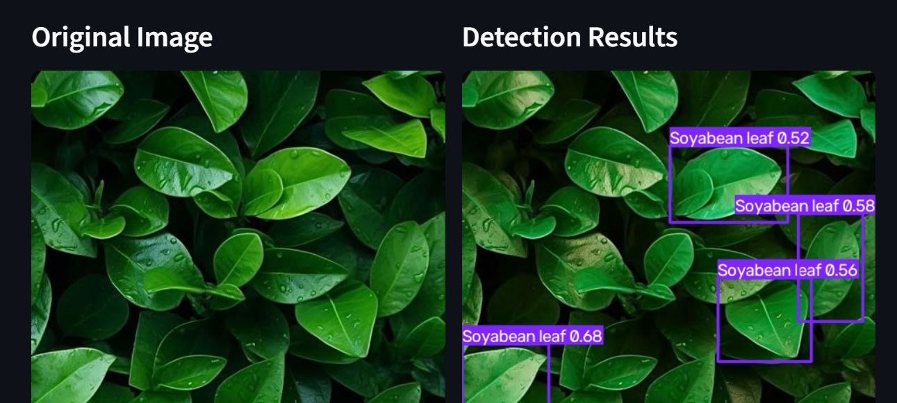
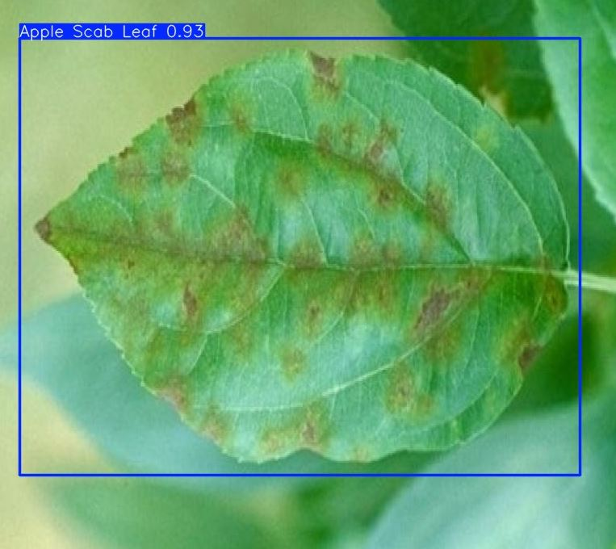

XII. Conclusion
This paper presented Plant-Disease-Detection, a YOLOv8-based system for detecting and classifying plant leaf diseases in images and video, deployed as an accessible web application. We described the system's pipeline, from dataset curation through model training and browser-based deployment, and reported quantitative performance metrics, with the trained YOLOv8n model achieving a precision of 0.91, recall of 0.89, and mAP@50 of 0.93 on the held-out test set. Qualitative review of detection examples across both images and video indicates consistently high-confidence performance across multiple crop species and disease categories. By combining an efficient, anchor-free detection architecture with a low-barrier deployment interface, the system offers a practical and scalable tool to support early disease identification in agricultural settings, with the potential to reduce crop losses and support more informed decision-making for farmers and agronomists. Dataset expansion and benchmarking against larger model variants remain the most significant opportunities for future improvement.

