Counting-Sheep: A YOLO-Based System for Real-Time Sheep Tracking, Counting, and Segmentation
A Technical and Methodological Study of Vision-Based Livestock Counting Under Variable Camera Conditions
Independent Research Project — Computer Vision and Applied Machine Learning

Abstract
Manual headcounts of livestock are slow, disruptive to animal welfare, and difficult to perform reliably at scale, particularly in open pastures, sorting pens, or during loading and transport operations. This paper presents Counting-Sheep, a computer vision system that automates the detection, tracking, counting, and segmentation of sheep in video footage using a YOLO-family object detection model combined with a configurable region-of-interest extraction stage. Unlike counting systems designed for a single fixed industrial camera, Counting-Sheep is explicitly built to accommodate footage sourced from varied, uncontrolled camera angles — including handheld and third-party video such as publicly available footage — by exposing an adjustable bounds-drawing stage that isolates the active counting region prior to detection. We describe the system's two-stage architecture, comprising a manual or semi-manual region delineation module and a YOLO-based detection, tracking, and instance segmentation pipeline, and we document the software environment, configuration workflow, and operational constraints required to reproduce it. We further discuss the qualitative behavior of the system on publicly sourced demonstration videos, the practical challenges of applying a fixed-region counting strategy to non-ideal, low-angle, or unstable footage, and the tradeoffs this introduces relative to studio-controlled industrial deployments. Finally, we outline a proposed evaluation protocol and a set of future directions, including automatic region calibration and multi-angle robustness, aimed at reducing the manual configuration burden and improving counting reliability across heterogeneous livestock-monitoring footage.
Keywords: object detection, YOLO, object tracking, instance segmentation, livestock counting, computer vision, region of interest, precision agriculture

I. Introduction
Livestock counting is a recurring operational task in sheep farming, encompassing routine headcounts, verification during loading and unloading, and monitoring of flock movement between pastures or pens. Traditional counting is performed manually, either by direct observation or by reviewing gate-crossing footage after the fact, both of which are time-consuming, susceptible to human error under fatigue, and poorly suited to large or fast-moving flocks. As with other domains of discrete-object counting, recent advances in real-time object detection have created an opportunity to automate this task using off-the-shelf computer vision models.
This paper documents Counting-Sheep, a system that detects, tracks, counts, and segments sheep within video footage using a YOLO-based model. Unlike counting systems built around a single purpose-installed industrial camera with a fixed, known geometry, Counting-Sheep was developed with an explicit design goal of tolerating footage sourced from varied and imperfect real-world conditions, including publicly available third-party video captured from arbitrary distances, angles, and lighting. To accommodate this variability, the system separates the counting problem into two distinct stages: a configurable region-delineation stage that isolates the portion of the frame in which counting should occur, and a detection-and-tracking stage that performs the actual identification, temporal association, and segmentation of individual sheep. This separation allows the same underlying detection pipeline to be reused across different camera setups by adjusting only the region-delineation configuration, rather than requiring a full model retraining or pipeline redesign for every new video source.
The remainder of this paper is organized as follows. Section II reviews related work in real-time object detection, instance segmentation, and livestock or animal counting applications. Section III formalizes the problem being addressed. Section IV presents the system methodology, covering region delineation, detection, tracking, and segmentation. Section V describes the system architecture. Section VI documents the implementation and software dependencies required to reproduce the system. Section VII discusses deployment behavior on the included demonstration videos and the qualitative evaluation of system output. Section VIII outlines the limitations of the current implementation, and Section IX proposes directions for future work. Section X concludes the paper.

II. Related Work

A. Real-Time Object Detection and Instance Segmentation
Modern real-time object detectors, most notably the YOLO family of models, frame detection as a single-pass regression problem over a grid of candidate regions, enabling inference speeds suitable for video-rate processing. Later members of the YOLO family extended the core detection framework with an instance segmentation head, allowing the model to produce pixel-level masks for each detected object in addition to bounding boxes. This capability is directly relevant to livestock counting, where overlapping or tightly clustered animals — common in pens, gateways, and dense flocks — are more reliably separated using segmentation masks than using bounding boxes alone, which tend to overlap heavily under crowding.

B. Tracking-by-Detection for Counting Applications
As in other visual counting systems, converting per-frame detections into a non-duplicated running count requires associating detections of the same physical object across consecutive frames. Tracking-by-detection approaches address this by assigning persistent identifiers to detected objects based on positional continuity and, where available, appearance or mask similarity between frames. Region-based counting logic, which increments a count only when a tracked object crosses or occupies a defined zone, is a common downstream step built on top of such tracking, and is the strategy adopted by Counting-Sheep through its region-delineation stage.

C. Animal and Livestock Counting Applications
Vision-based counting has been applied to a range of animal-monitoring contexts, including aerial livestock surveys, poultry counting in confined housing, and fish counting in aquaculture. These applications share a common challenge distinct from many industrial counting tasks: subjects are frequently non-rigid, cluster tightly, partially occlude one another, and are often filmed under uncontrolled or field conditions rather than a fixed studio-like camera rig. Sheep counting inherits all of these challenges, compounded by wool texture and coloring that can reduce contrast against certain backgrounds and by the tendency of flocks to move as a dense, overlapping mass.

D. Positioning of the Present Work
Relative to the broader literature, Counting-Sheep does not introduce a new detection or segmentation architecture; its contribution is an applied, reproducible pipeline that explicitly separates region calibration from detection, allowing a single YOLO-based counting workflow to be adapted to heterogeneous, non-studio video sources — including publicly sourced footage never captured with counting in mind. This design decision, and its consequences for accuracy and configuration effort, are discussed throughout the remainder of this paper.

E. Comparison to Fixed-Installation Counting Systems
It is useful to contrast this design philosophy with counting systems built around a single, purpose-installed industrial camera, where the region of interest is calibrated once at installation time and remains valid indefinitely because the camera never moves. Such fixed-installation systems can typically assume consistent lighting, a known object scale, and a stable background, allowing the detection model and counting logic to be tuned tightly to that one environment. Counting-Sheep instead treats the camera setup itself as a variable that changes from video to video, trading the accuracy ceiling achievable under a tightly controlled fixed installation for the flexibility to process footage the system's author never controlled the capture of. This tradeoff is central to interpreting the system's qualitative results in Section VII and its limitations in Section VIII.

III. Problem Formulation
The task addressed by this system can be stated as follows. Given a video of sheep captured under conditions that are not guaranteed to match a fixed, purpose-installed industrial camera — potentially including variable distance, angle, resolution, and stability — the objective is to produce an accurate count of sheep present or passing through a designated region of the frame, together with individual segmentation masks that support downstream analysis such as size estimation or density mapping.
This objective decomposes into three sub-problems, mirroring but extending those found in fixed-camera industrial counting: (1) region delineation, which requires identifying the sub-area of an arbitrary, possibly non-ideal frame in which counting should be evaluated, since unlike a fixed industrial installation, the camera geometry cannot be assumed constant across video sources; (2) detection and segmentation, which requires localizing and outlining individual sheep despite occlusion, wool-driven low contrast, and tight clustering; and (3) temporal association and counting, which requires linking detections of the same physical sheep across frames and converting the result into a running count without duplication. The system's design, described in Section IV, addresses each of these in turn, with particular emphasis on the region-delineation step as the primary mechanism for adapting to varied source footage.

IV. Methodology

A. Region Delineation
The first stage of the pipeline, implemented in drawing_bounds.py, is responsible for delineating and extracting the active detection area from an arbitrary input video. Because the system is designed to operate on footage from varied, sometimes uncontrolled sources rather than a single fixed camera, this stage cannot assume a pre-calibrated region and instead exposes the boundary definition as an adjustable configuration step. For each new video or camera angle, the region bounds must be reviewed and, where necessary, adjusted to correctly isolate the area in which sheep should be counted; in some cases, depending on the framing of the source footage, this stage may be disabled entirely and the full frame used instead.

B. Detection, Tracking, and Segmentation
The second stage, implemented in counting_sheeps.py, applies a YOLO-based model to the delineated region to detect individual sheep, producing both bounding boxes and instance segmentation masks. Detections are associated across frames using a tracking mechanism that assigns a persistent identifier to each physical sheep, allowing the system to distinguish continuous observation of a single animal from the appearance of multiple distinct animals. As with region-based counting systems more generally, the running count is incremented according to tracked identifiers rather than raw per-frame detections, preventing the same animal from being counted multiple times while it remains within the delineated region.

C. Role of Segmentation in Dense Flocks
Instance segmentation plays a particularly important role in this system relative to bounding-box-only counting approaches, because sheep frequently appear as tightly packed, mutually occluding groups in pens, gateways, and pastures. Pixel-level masks allow the system to better delineate the boundary between adjacent, overlapping animals than bounding boxes alone, which tend to overlap substantially under crowding and provide comparatively weak evidence about where one animal ends and the next begins.

D. Camera and Footage Assumptions
The system's documentation explicitly notes that accuracy is significantly improved by using a stable, high-angle camera capturing the full flock, consistent with best practice for fixed industrial installations. However, because the reference demonstrations were produced using publicly sourced video not captured under these ideal conditions, the system is deliberately built to remain usable — with reduced and untested accuracy — on lower-angle, less stable, or otherwise non-ideal footage, relying on the adjustable region-delineation stage to partially compensate for suboptimal camera placement.

V. System Architecture
Figure 1 summarizes the end-to-end system architecture as a two-stage pipeline: region delineation followed by detection, tracking, segmentation, and counting.
+--------------------+ +-------------------------+ +--------------------------+
| Input Video |-->| drawing_bounds.py |-->| Delineated Region / |
| (arbitrary camera, | | (region-of-interest | | Active Counting Area |
| angle, source) | | extraction, adjustable)| | |
+--------------------+ +-------------------------+ +------------+-------------+
|
v
+--------------------+ +-------------------------+ +--------------------------+
| YOLO Detection & |-->| Object Tracker |-->| Sheep Count + |
| Segmentation Model | | (persistent ID | | Segmentation Masks |
| (counting_sheeps.py)| | assignment) | | (results/ output) |
+--------------------+ +-------------------------+ +--------------------------+
Figure 1. Two-stage pipeline separating region delineation from detection, tracking, and segmentation.

A. Region Delineation Layer
This layer is responsible solely for producing a well-defined active counting area from an arbitrary input video, implemented in drawing_bounds.py. Its output is a set of region coordinates, or an explicit indication that the full frame should be used, consumed by the detection layer.

B. Detection, Tracking, and Segmentation Layer
This layer, implemented in counting_sheeps.py, consumes the delineated region together with the source video and is responsible for running YOLO-based detection and segmentation, associating detections across frames, and maintaining the running count. It is the primary component operators interact with when reproducing the system's results.

C. Output Artifacts
Processed results, including annotated video output and derived count data, are written to the results directory, while source and reference demonstration videos are organized under the videos directory, keeping input and output artifacts cleanly separated within the repository.

VI. Implementation

A. Software Environment
The system is implemented in Python and relies on a YOLO-based detection and segmentation library together with its supporting dependencies, all pinned within the repository's requirements file. Table I summarizes the recommended environment for reproduction.
Component | Recommended Version / Tool | Role
Python | 3.9 | Core implementation language
Environment Manager | Anaconda / conda | Isolated environment creation
Dependency Set | requirements.txt (pinned) | YOLO, detection, and supporting libraries
Detection Model | YOLO (segmentation-capable variant) | Sheep detection, tracking, and mask generation
Input | Video file (arbitrary source) | Footage to be processed for counting
Table I. Recommended software environment for reproducing the system.

B. Installation Procedure
The repository author recommends isolating the project within a dedicated Anaconda environment before installing dependencies, ensuring the pinned package versions in requirements.txt do not conflict with other Python projects on the same machine:
# Create an isolated environment
conda create --name [environment-name] python=3.9

# Activate the environment, then install dependencies
pip install -r requirements.txt

C. Repository Structure
The codebase is organized as a compact set of scripts and asset directories, reflecting its role as a focused research and demonstration pipeline. Table II summarizes each component.
File / Directory | Purpose
drawing_bounds.py | Delineates and extracts the active detection/counting region
counting_sheeps.py | Runs YOLO-based detection, tracking, segmentation, and counting
requirements.txt | Pinned Python dependency list
videos/ | Source and reference demonstration video files
results/ | Processed output videos and derived counting results
LICENSE | Apache License 2.0
README.md | Project documentation and usage instructions
Table II. Repository file and directory structure.

D. Runtime Configuration and Execution
Before running the pipeline on a new video, the region bounds defined in drawing_bounds.py should be reviewed and adjusted to match the camera angle and framing of that specific source, or disabled if the full frame is to be used directly. Once configured, the full pipeline is executed with a single command from the project root, within the activated environment:
python counting_sheeps.py
Because the system is intended to generalize across varied footage rather than a single fixed installation, this configuration step is expected to be repeated for each meaningfully different camera setup, in contrast to a one-time calibration typical of fixed industrial deployments.

VII. Deployment Behavior and Qualitative Evaluation

A. Demonstration Videos
The repository includes reference demonstrations produced from publicly sourced YouTube footage rather than purpose-captured industrial video, reflecting the system's design emphasis on generalizing to imperfect, real-world camera conditions. These demonstrations show the pipeline applied to flocks of varying size and density, with detection, segmentation, and running counts overlaid on the output video.

B. Operating Constraints Observed in Practice
Because the reference footage was not captured under ideal, high-angle, stable-camera conditions, the demonstrations also illustrate the practical impact of suboptimal camera placement: lower viewing angles increase mutual occlusion between sheep, reduce the reliability of the region-delineation boundary as the flock moves in depth rather than purely across the frame, and can reduce detection confidence for animals partially out of frame or heavily occluded by others. The author's own documentation acknowledges this tradeoff directly, noting that a stable, high-angle camera capturing the full flock would be expected to meaningfully improve accuracy relative to the conditions represented in the current demonstrations.

C. Formal Quantitative Evaluation
As with many applied, repository-level computer vision projects, the current release has not been subjected to a formal, statistically rigorous quantitative evaluation — such as detection precision and recall, segmentation mask quality, or counting error against manually verified ground truth — across a representative set of camera angles and flock densities. The qualitative observations above should therefore be understood as descriptive of general system behavior rather than benchmarked performance claims.

D. Proposed Evaluation Protocol
A future evaluation could establish ground truth by manually annotating sheep counts and segmentation boundaries across a curated set of videos spanning a range of camera angles, distances, and flock densities, then comparing automated output against this ground truth using standard detection metrics (precision, recall, mean average precision) alongside segmentation-specific metrics such as mask intersection-over-union, and counting-specific metrics such as mean absolute count error. Disaggregating results by camera angle and flock density would directly quantify the accuracy tradeoff introduced by non-ideal footage that the current documentation only describes qualitatively.

E. Expected Failure Modes
Based on the system's architecture, several failure modes can be anticipated even without a completed quantitative study. Near-total occlusion, where one sheep is almost entirely hidden behind another for an extended sequence of frames, is likely to cause the tracker to lose and later reassign a new identifier to the same physical animal, producing an inflated count. Rapid flock movement combined with a low camera frame rate may cause similarly abrupt identity switches. Footage in which the flock enters or exits the frame from multiple directions simultaneously, rather than through a single well-defined boundary, is also likely to strain the region-delineation strategy, since a single polygon or bounding region may not cleanly separate “not yet counted” from “already counted” animals under such conditions. Documenting these anticipated failure modes here is intended to guide both the proposed evaluation protocol and any future architectural changes aimed at mitigating them.

VIII. Practical Applications
Beyond the demonstration use case, the general pattern implemented by Counting-Sheep — configurable region delineation followed by YOLO-based detection, tracking, and segmentation — is applicable to a range of farm-management scenarios. Gate and chute counting during loading onto transport vehicles is a natural fit, since the region-delineation stage can be configured once per chute and reused across many loading events, provided the camera remains fixed for that installation. Periodic paddock or pasture headcounts, performed by walking or driving a camera past a flock and processing the resulting footage after the fact, represent a lower-precision but lower-infrastructure use case better suited to the system's tolerance for varied, non-fixed camera conditions. Sorting-yard monitoring, where sheep are drafted into separate pens, could similarly benefit from per-pen region delineation combined with the system's counting logic to provide an automated cross-check against manual tallies.
In each of these scenarios, the operational value of automation lies less in outperforming an attentive human counter under ideal conditions, and more in providing a continuous, reviewable video record and a consistent, fatigue-independent count that scales with flock size and counting frequency without proportionally increasing labor cost.

IX. Limitations
- The region-delineation stage requires manual review and adjustment for each new video or camera angle, and offers no automatic recalibration if the camera moves mid-recording.
- Accuracy is explicitly expected to degrade under low, non-overhead camera angles, which increase occlusion and reduce the reliability of the delineated counting region.
- The reference demonstrations rely on publicly sourced footage not captured under the stable, high-angle conditions recommended for best accuracy, so demonstrated behavior may not reflect performance under ideal deployment conditions.
- No formal quantitative benchmark of detection, segmentation, or counting accuracy has yet been published for the system.
- Dense, tightly overlapping flocks remain a challenging case for both detection and segmentation, even with instance-mask output.
- The pipeline currently targets a single animal class (sheep) and a single counting workflow, rather than a general-purpose multi-species livestock counting framework.

X. Future Work
Several directions could extend the robustness and rigor of the system described in this paper. First, establishing the quantitative evaluation protocol proposed in Section VII, executed across a representative range of camera angles, distances, and flock densities, would allow the accuracy tradeoffs currently described only qualitatively to be reported as reproducible figures. Second, automating or semi-automating the region-delineation stage — for example, using horizon or ground-plane estimation to infer a reasonable counting region directly from a single reference frame — would reduce the manual configuration burden the system currently places on operators for each new video. Third, extending the tracking component with appearance-aware re-identification could improve counting robustness when sheep are briefly and fully occluded rather than merely overlapping. Fourth, broadening the segmentation-based approach to support additional livestock species would generalize the pipeline beyond sheep-specific counting toward a more general livestock-monitoring tool. Finally, packaging the pipeline for deployment on lower-cost edge hardware in the field, rather than requiring an interactive Anaconda-based workstation setup, would support more continuous, in-pasture monitoring use cases.

XI. Results

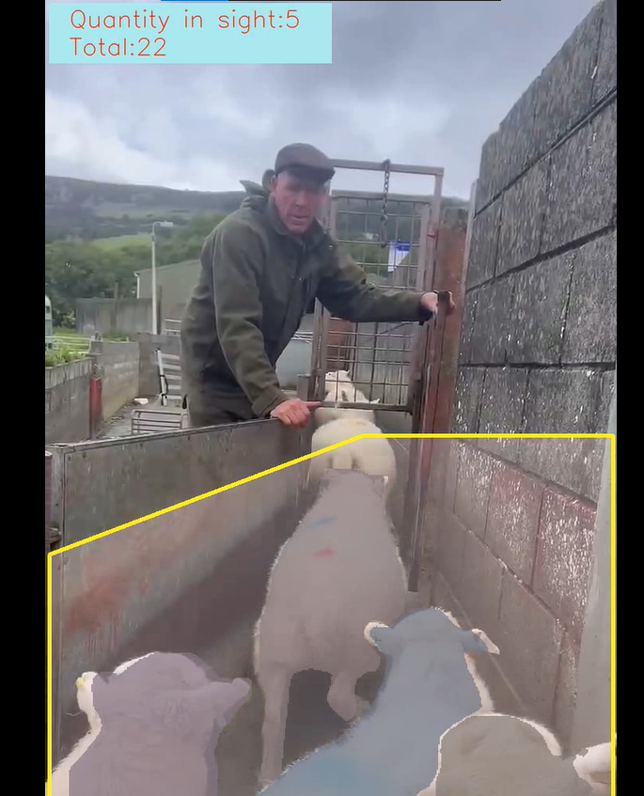
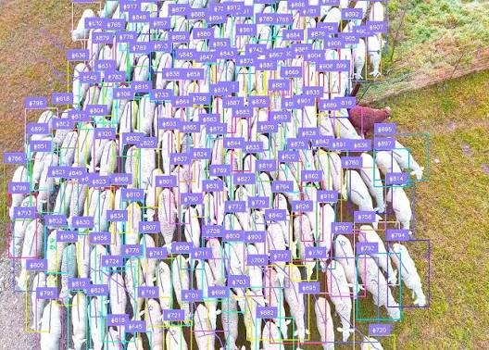

11. Conclusion
This paper presented Counting-Sheep, a YOLO-based system for detecting, tracking, counting, and segmenting sheep in video footage, with a particular design emphasis on tolerating footage from varied and imperfect camera conditions rather than assuming a single fixed industrial installation. We described the system's two-stage architecture, separating region delineation from detection, tracking, and segmentation, and detailed the software environment and configuration workflow required to reproduce and deploy it. Qualitative review of the included demonstrations, drawn from publicly sourced video, indicates that the pipeline performs its intended function while also surfacing the accuracy tradeoffs introduced by non-ideal camera angles, a tradeoff the system's own documentation acknowledges directly. The separation of region calibration from the underlying detection pipeline positions Counting-Sheep as an adaptable template for livestock counting tasks across heterogeneous footage sources, while the absence of a formal quantitative benchmark, and the manual effort required to recalibrate the counting region for each new camera setup, remain the most significant open issues for future work.

