# Stress and Depression in Computer Science Students: Can we provide a solution?

| Usama Sadiq  Information Technology University, Lahore  bscs14006@itu.edu.pk | Uzma Abdul Majeed  Information Technology University, Lahore  bscs14042@itu.edu.pk | Mohsin Raza  Information Technology University, Lahore  bscs14051@itu.edu.pk | Umer Saleem  Information Technology University, Lahore  bscs14067@itu.edu.pk |
| --- | --- | --- | --- |

# ABSTRACT

This research is focused on finding the impacts of depression on students’ performance in university and tries to formulate a solution which can help these students recover from depression and manage their stress to be successful in their career. Computer science students in Pakistani universities especially in Lahore are facing anxiety and depression due to multiple academic and non-academic reasons such as consecutive assignments, back-to-back lectures and peer pressure along with the family pressure to be successful in each exam. Such anxiety and depression lead students towards failure in their personal, academic and professional life. The victims of depression tend to indulge in wrong habits and ruin their career. Students do not have proper information and support system to recover from depression on their own.

## Author Keywords

Depression; Computer Science Students; Stress in Students; Support system;

## ACM Classification Keywords

Student Stress Management;

# INTRODUCTION

Student stress is a major part of a student’s life. Many academic and non-academic factors affect the physical and mental health of students. Academic stress includes factors like peer pressure, difficult projects and assignments along with consecutive degree classes whereas non-academic factors include family pressure, financial issues and student’s interests in the degree. All these factors contribute to a student’s overall performance in the university life. Research in international universities have shown that most of the students in their first or second year of the degree are subjects severe stress and are facing depression. Recent surveys in Pakistani medical colleges have shown that more than half of the students are victims of depression but they don’t know about it hence they are not doing anything to recover from it. According to a study of Agha Khan university 34% population of Pakistan had depression in 2006 which has mounted to 44% according to a new study published in Express Tribune. Discussing about depression is considered a taboo in the general public so students can’t share their experiences with other to get counseling from others. Due to such social experiences, most of the students don’t tell anyone that they are suffering from depression and continue their futile efforts to recover from it on their own. It increases the pressure on them and result in their failure and indulgence in wrong habits. Students who do not have any way to recover from depression remain in this vicious cycle and destroy their career. Lack of awareness and a platform to discuss problems independently are the main reasons of increased depression in Pakistani student societies. This project was focused on finding the reasons and creating a solution for students which can help them minimize the pressure and handle anxiety or depression by using all kinds of available resources.

© 1994, 1995, 1998, 2002, 2009, 2011, 2013 by ACM, Inc. Permission to copy and distribute this document is hereby granted provided that this notice is retained on all copies, that copies are not altered, and that ACM is credited when the material is used to form other copyright policies.

# Previous research

Many international surveys have been done on students to find the cause and effect of anxiety and depression in them but unfortunately, not much have been done in Pakistan in this regard. In recent years some researchers conducted in Pakistani medical colleges have highlighted this problem as a major concern. A survey done in the medical college Karachi revealed that over 70% students in the medical colleges had anxiety and depression. According to Dr. Iqbal Afridi, president Pakistan psychiatric society, 1 out of 3 persons are suffering from anxiety and depression in Pakistan. According to a report published on world health day 2017, there are only 750 psychiatrists in Pakistan which means that there is only one psychiatric for 10,000 persons in the country and there are only 4 major psychiatric hospitals in the whole country. This research has considered the studies done in the previous publications and have worked on top of them to build a better solution for controlling the increasing anxiety and depression in students. Many applications have been developed to help depressed or stressed persons handle their situation by learning from the resources but no such application is specifically made for Pakistani population.

# Field Study

1. **Survey**

For this project, an open-ended interview was conducted in the three major universities of Lahore including Information Technology University, Punjab University and University of Lahore. Random students were interviewed and their responses were recorded on the concerned topic. Students were subjected to open ended interviews where they were allowed to tell any stories, incidents or suggestions related to the causes and effects of stress and depression in students. Many students agreed that this is a major concern in their life and that either they themselves or some of their friends had been through this problem during their first or second year of university life. There were many reasons identified for this increase in stress among students including peer pressure, family burden, financial conditions and lack of supportive system.

1. **Story Board**

After thematic analysis of interviews data, story boards were created which included the most common use cases of the application.

First story board represents a scenario where a stressed student is looking for help. He wants to see a tutorial or videos to get help understanding anxiety and depression.

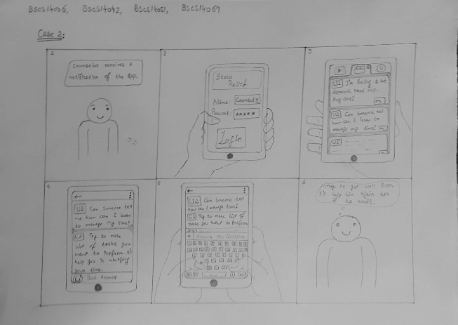

Second scenario represents the main use case of application where a concerned student or a counsellor wants to help someone on the platform. When a stressed student posts his query, the counsellor responds by his comment on his post and helps him understand the issue and its solution.

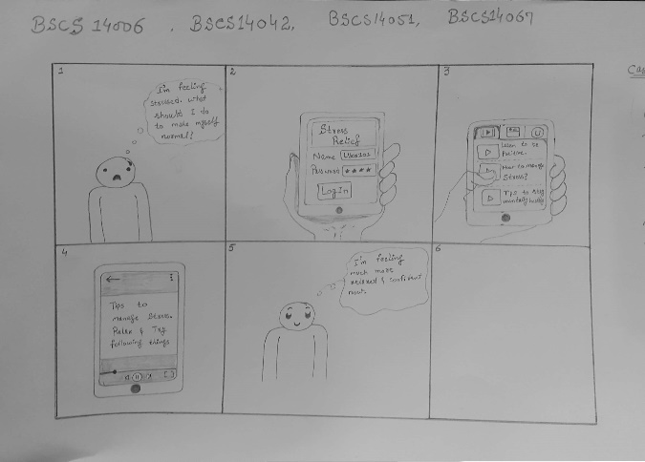

1. **Paper Prototype**

On the basis of the survey results, an android application was designed. As a first step, its screens were designed using paper and was evaluated from students of different universities. Paper prototype included following screens.

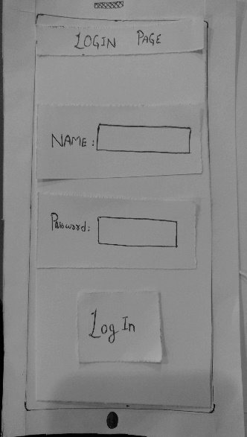 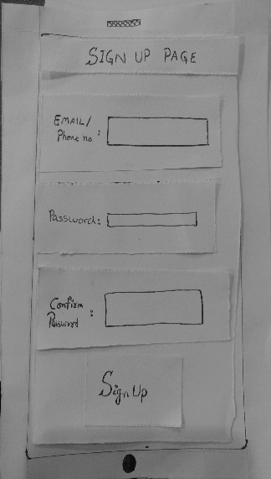

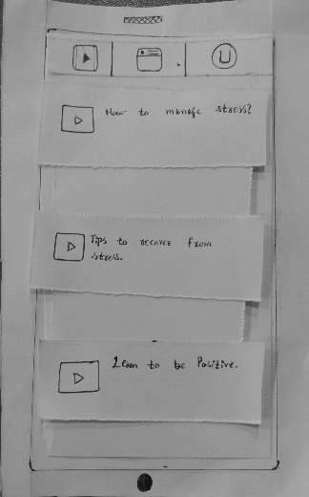 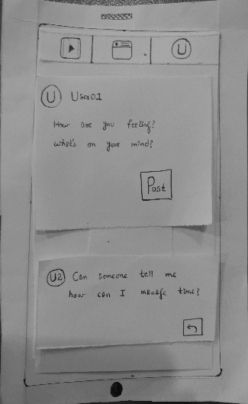

**Evaluation Results**

Users who evaluated paper prototype results, mentioned some core issues in the user interface and also suggested some improvements in the design. Users mentioned following things:

1. There should be a forgot password screen in the app.
2. There should be a search bar to search videos in the videos tab.
3. Students should also be allowed to reply on posts like counsellors.
4. **Medium Fi prototype**

On the Basis of the improvements and suggestions in the evaluation of the paper prototype, medium fi prototype was made and re-evaluated by the students from different universities of Lahore. For making the medium fi prototype, an online tool “Just in Mind Prototype” was used. New screens were made on it and were evaluated by users again.

Medium fi prototype contained following screen designs:

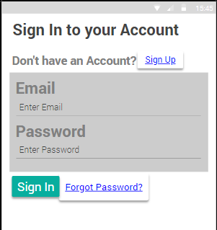 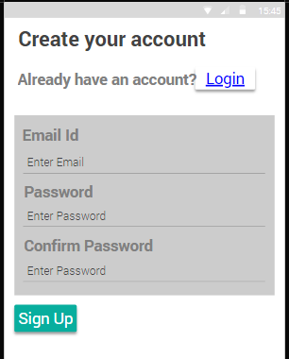

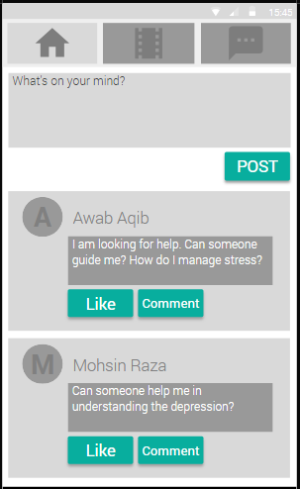 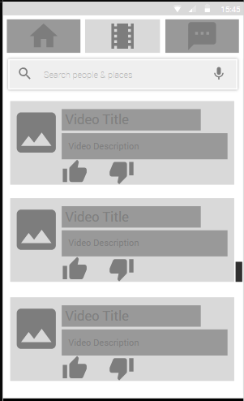

**Evaluation Results**

Medium fi prototype was evaluated from different users keeping in mind the heuristic evaluation techniques. Following were the results of the evaluation:

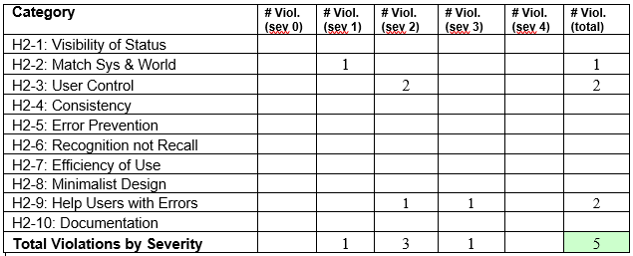

1. **Final Product**

After the evaluation results of medium fi prototype, final application was built using Android Studio platform. The application included Firebase as its database and user authentication system. Users can only login to the application using their email id and hence one user can only create one account. Following were the screen designs of final application.

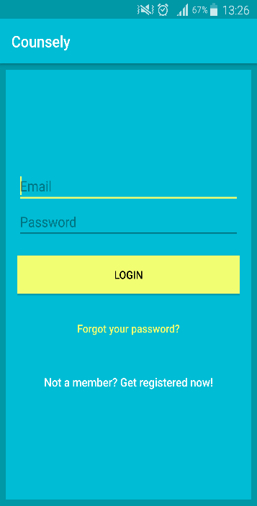 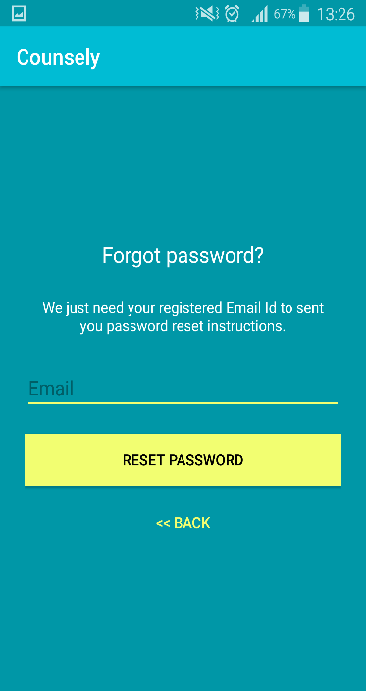

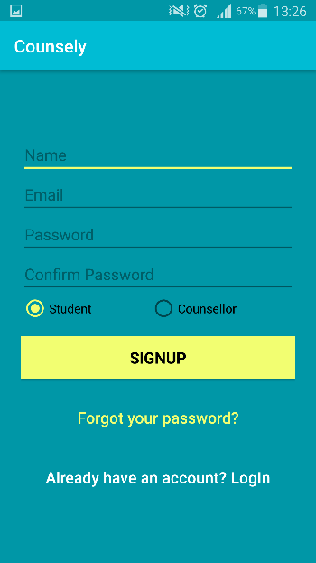 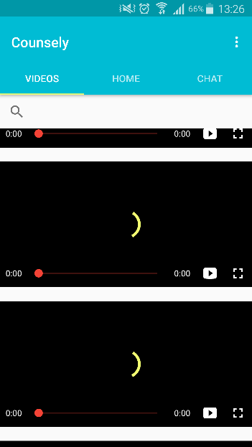

**Evaluation**

Final application was build and link of the apk file was given to students across different universities. Students installed the application and provided feedback on the application interface and usage experience.

**Application Capabilities**

Application was supposed to provide a platform to the students to interact with each other and console each other. But final application could not be completed. Currently, the final application does not have the feature of chat with other users and query posting. Right now, users can sign up in the application and can search videos and tutorials to get help about their issues related to anxiety and depression.

**DISCUSSION**

Computer science students have around same problems as were identified in the medical colleges with an exception of a relatively more international exposure in the working and further studies. Since it is an emerging field in Pakistan, more and more students are being enrolled in this field each year with a hope to get better jobs as well as free lancing opportunities in the future.

This research is focused on the issues of the computer science students which cause severe stress, anxiety and depression in these students. Many students who were being interviewed provided their positive responses and suggestions for the improvement of students in the universities. From these interviews many reasons were identified which cause anxiety and depression in the students.

First and foremost, reason is the lack of a supportive environment to the students to share their problems and difficulties with their peers in the university. In the interviews, one of the students focused on the issue that most students cannot share their personal choices or cannot express themselves due to the fear of being bullied in the university. They try to hide their anxiety by imitating others in the daily tasks because they will be bullied if anyone knew about their mental condition. A final year student told during the interview that he had anxiety since the starting of second semester of the university but had not shared this with any class fellow due to the fear of being misunderstood and teased. It was claimed that there is not a much supportive environment available in the universities to freely share such problems and discuss them with friends. Even after so much advancement in the technology and standards of education, there is not much focus on students’ mental health in the universities. In most of the universities, there is no counselor available to the students for discussing such issues and get positive feedback like international institutes.

Another major problem that came up during the interviews was the pressure of study on the students. Students claimed that coping up to the semester system after intermediate level is a rather difficult task but no one guides the new comers in this regard and as a matter of consequence, most of the students fail in their initial semesters and blow up their grades. Accumulative Grade Point average (CGPA) system hinders in the way of recovering their grades in the upcoming semesters. Students have no idea which subjects they should pick up to improve their grades gradually. Students who have no interest in the field they are studying in, show a little concern related to their studies and are only concerned with getting passing marks. Such students end up destroying their career due to not focusing on learning during their initial semesters and hence face difficulties in the upcoming semesters.

During the semester the study load on the students is normal but as the end of semester approaches, the work load on the students starts increasing with the additional pressure of projects and final papers. Most students cannot get proper time to prepare for the exams in such tension. Some students told that no matter how much they prepare for the exams or do the assignments, they always end up failing in exams because they cannot handle the stress during the exams. After failing in the exams despite their best efforts, they lose hope and fall victim to the depression and hence, stop preparing for the future exams. In the end, most of such students end up leaving the university because they can’t handle the stress.

Ironically, Bright students who have obtained merit scholarships also fall victim to anxiety because they have to focus entirely on their studies to maintain their scholarships and hence cannot give time to extra-curricular activities which are necessary for the grooming of the students. Those who work part time to support their studies due to financial circumstances also lack under same category. They can’t participate in sports or other recreating events due to their routine part time job schedule.

Interestingly, one major factor came into consideration which is not much talked about when talking about the stress of students especially in Pakistani context was the increasing involvement of young boys and girls in making relationships during their university life. Boys or girls who are shy and cannot have any friends of opposite gender usually feel inferior than others and it affects their performance in the studies but those who end up in the relationships are more vulnerable to the depression. Such students who have had a relationship experience of a small time with one another cannot handle themselves after breakup. There were many cases identified by the participants where some bright students ruined their potential by indulging in relationships.

All of the above-mentioned reasons were identified by the interviews of the students from multiple universities in Lahore. When asked about the suggestions to help students recover from anxiety and depression, most students suggested that there should be at least a counseling facility in the university so that students can discuss their problems without any fear. Those students who had been through this process suggested that there should be a common platform for students only to discuss such issues where they can talk to other concerned people and get help from them.

Some of the reasons can only be targeted on the managerial level so we cannot do anything about them but we can provide help to as much students as we can so that the students can progress in their university life.

**Conclusion**

Computer science students in the Pakistani universities are more vulnerable to anxiety, depression and the number of affected students is increasing day by day. There are many reasons for this increase in tension and stress in students which were found out in this research. Most of the students suggested to provide counseling facilities in one way or another to the affected students so they can find their way back to normal life. This research resulted in formulating a solution consisting of the concerned students and counselors being available to the students for discussing their issues and get positive help and feedback regarding their issues.

This application was built in a quest to provide students a platform where they can interact with each other and get help from each other in the hour of need. Application need some more development before it can fully provide the functionalities discussed.

**REFERENCES**

1. John A, Towes MD, Jocelyn M, et al. Analysis of stress levels among medical students’ residents and graduate students at four Canadian school of medicine. Acad Med 1997; 72:997-1002
2. Stewart SM, Betson C, Marshall i, etal. Stress and vulnerability in medical students. Med Edu 1995; 29:119-27.
3. Agha Khan University study 2005-2006
4. World Health Day 2017: Depression and Anxiety on rise in Pakistan Posted by: TVI April 7, 2017