**ASSIGNMENT – 4**

**Name – Meharamt Singh**

**Roll No. – 102003241**

**Group – 2CO10**

**Email Id –** [**msingh10_be20@thapar.edu**](mailto:msingh10_be20@thapar.edu)

1. Algorithm for Gauss elimination method:

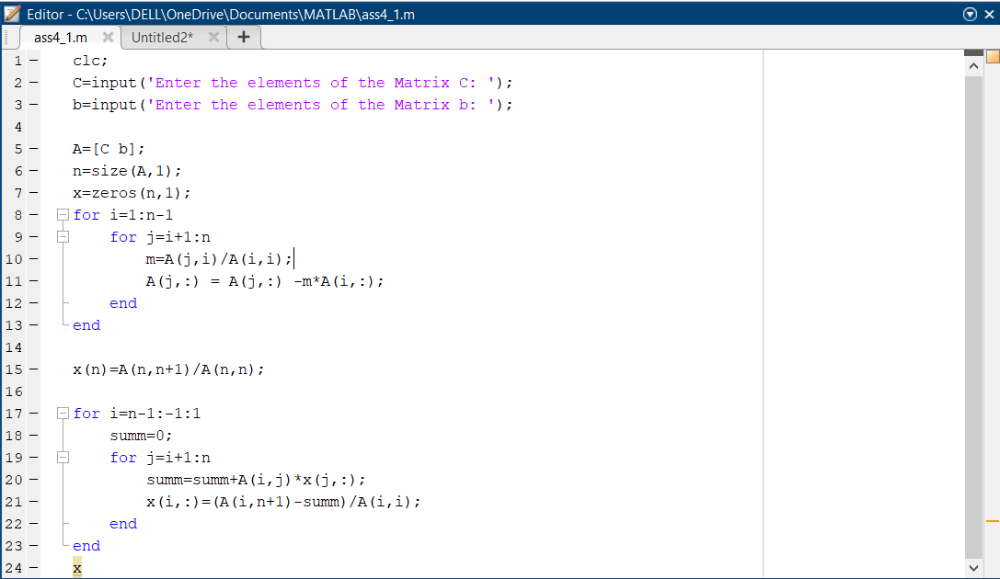

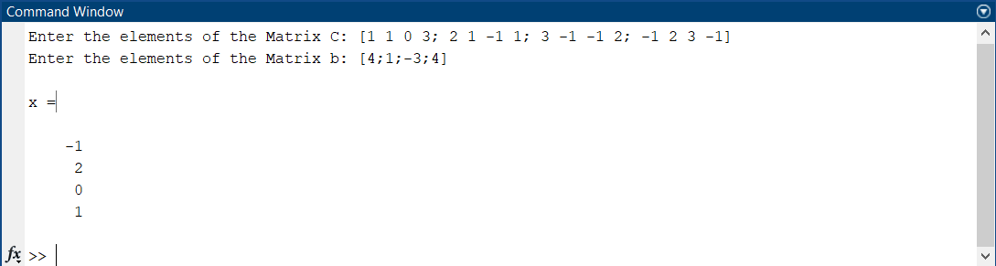

1. Algorithm for LU factorization method:

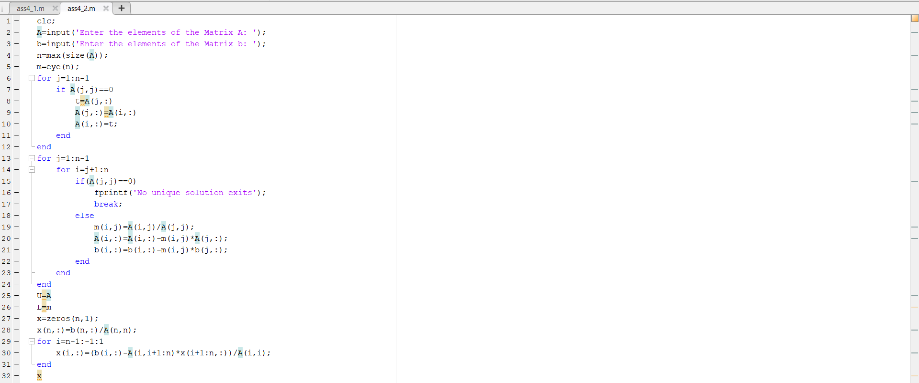

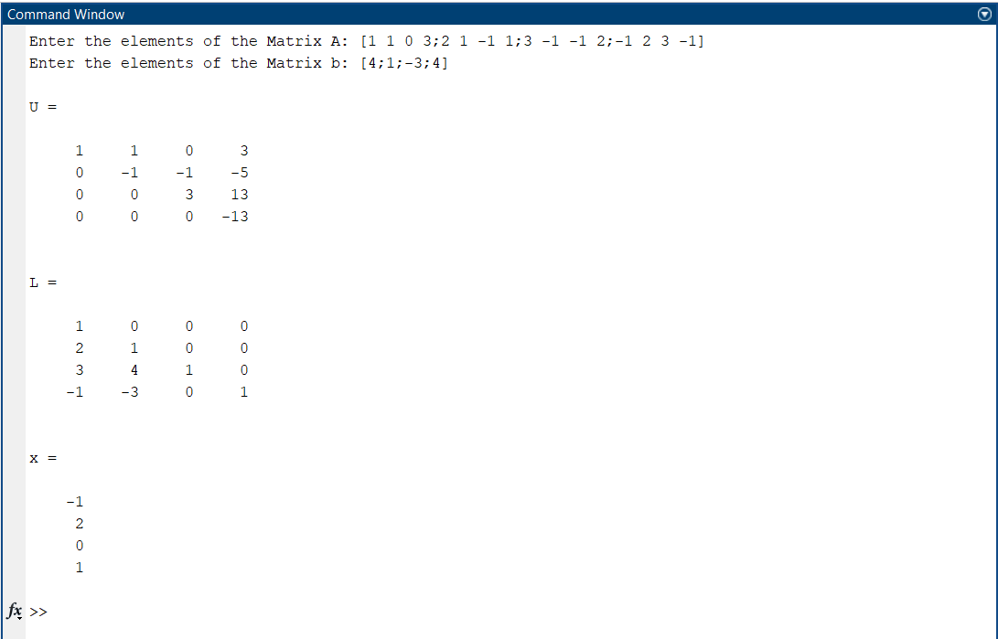

1. Use Gauss elimination method to find the solution of the following linear system of equations:

10x + 8y – 3z + u = 16

2x + 10y + z – 4u = 9

3x – 4y + 10z + u = 10

2x + 2y – 3z + 10u = 11

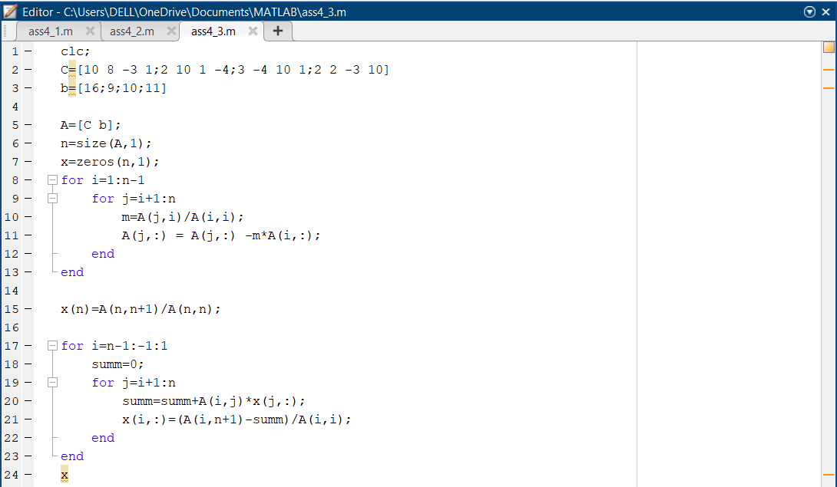

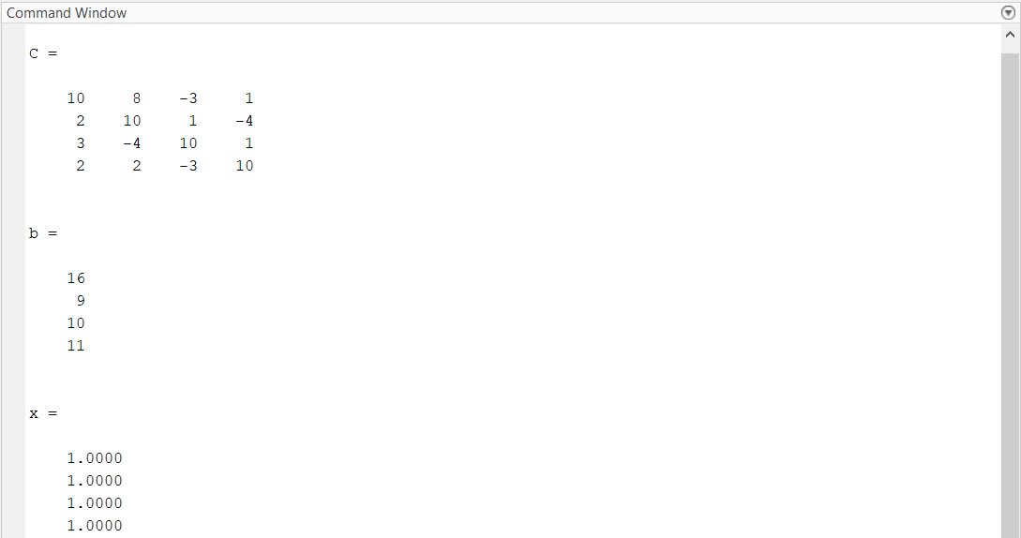

1. Solve the following linear system of equations:

𝜋𝑥1 + √2𝑥2 − 𝑥3 + 𝑥4 = 0

𝑒𝑥1 − 𝑥2 + 𝑥3 + 2𝑥4 = 1

𝑥1 + 𝑥2 − √3𝑥3 + 𝑥4 = 2

−𝑥1 − 𝑥2 + 𝑥3 − √5𝑥4 = 3

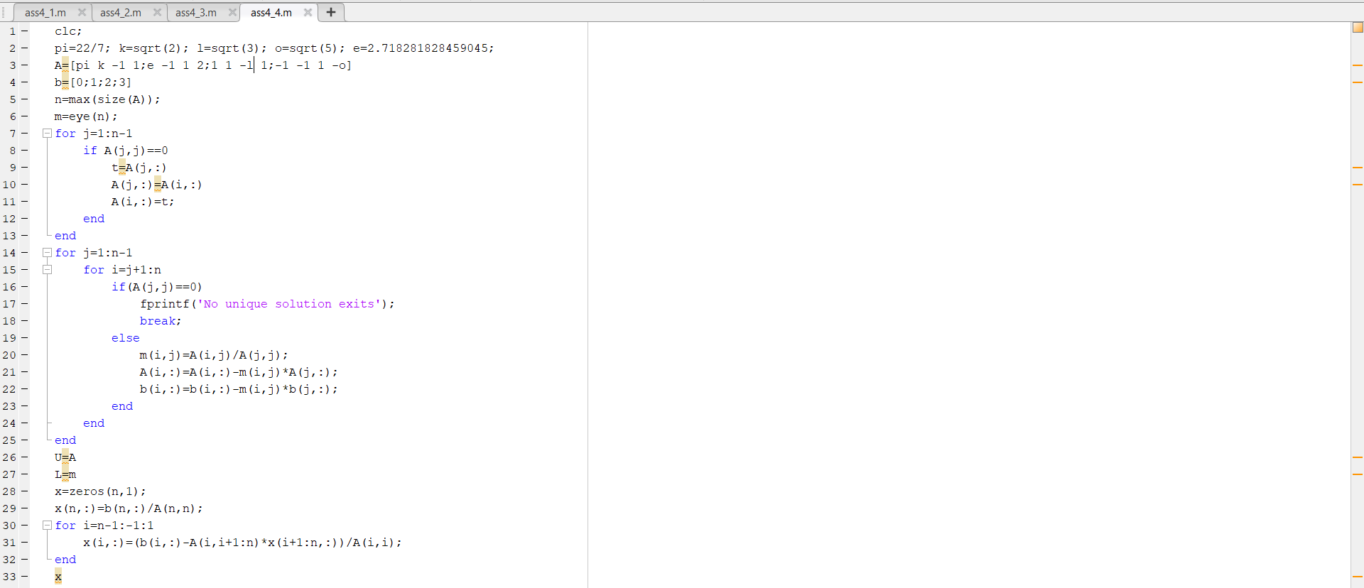

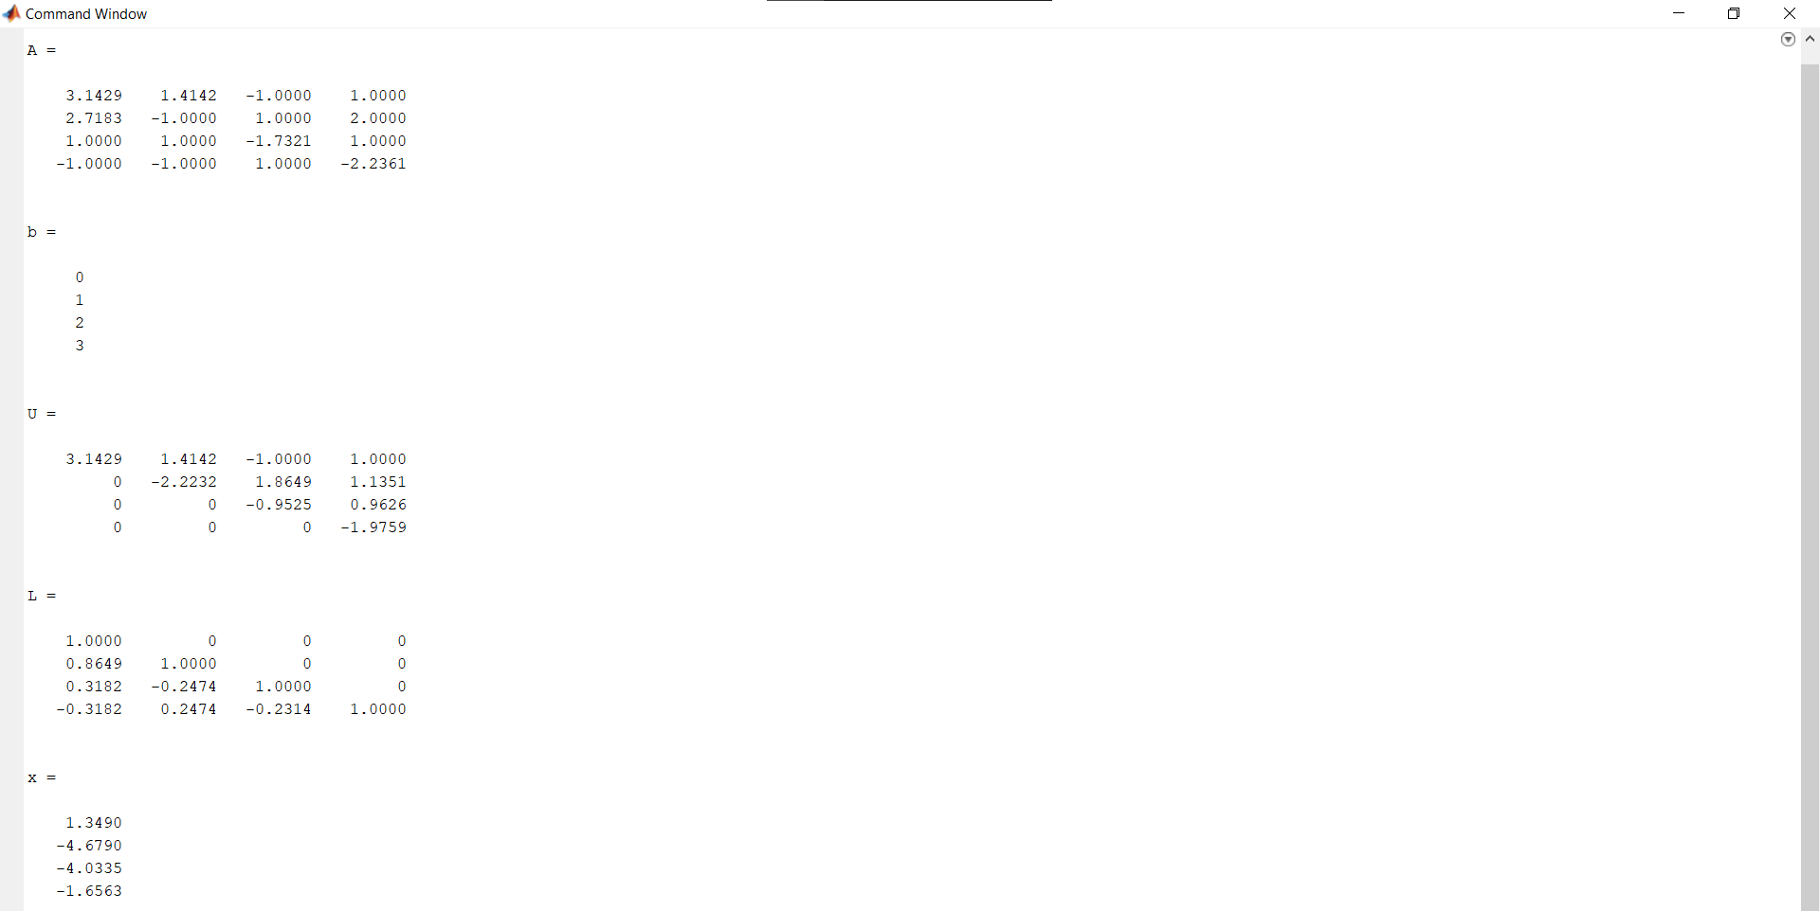

1. Kirchhoff’s laws of electrical circuits state that both the net flow of current through each junction and the net voltage drop around each closed loop of a circuit are zero. Suppose that a potential of V volts is applied between the points A and G in the circuit and that i1, i2, i3, i4 and i5 represent current flow as shown in the diagram. Using G as a reference point, Kirchhoff’s laws imply that the currents satisfy the following system of linear equations:

5𝑖1 + 5𝑖2 = 𝑉

𝑖3 − 𝑖4 − 𝑖5 = 0

2𝑖4 − 3𝑖5 = 0

𝑖1 − 𝑖2 − 𝑖3 = 0

5𝑖2 − 7𝑖3 − 2𝑖4 = 0

