**ASSIGNMENT – 5**

Name –Meharamt Singh

Roll No. – 102003241

Group – 2CO10

Email Id – [msingh10_be20@thapar.edu](mailto:msingh10_be20@thapar.edu)

2. Write an algorithm for Successive-Over-Relaxation (SOR) method.

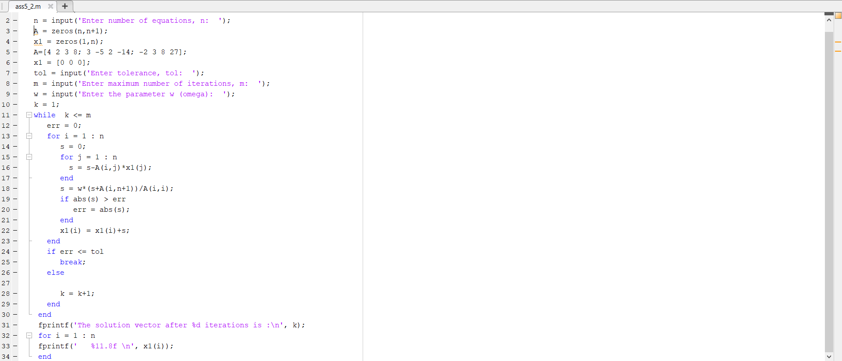

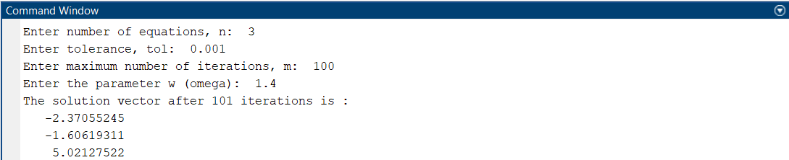

3. Use Gauss Seidel method and SOR method with w = 1.2 to find the solution of the following linear systems with an initial vector [0,0,0,0] and tolerance value 10-3 in the . ∞ norm:

(a) 10x + 8y – 3z + u = 16

2x + 10y + z – 4u = 9

3x – 4y + 10z + u = 10

2x + 2y – 3z + 10u = 11

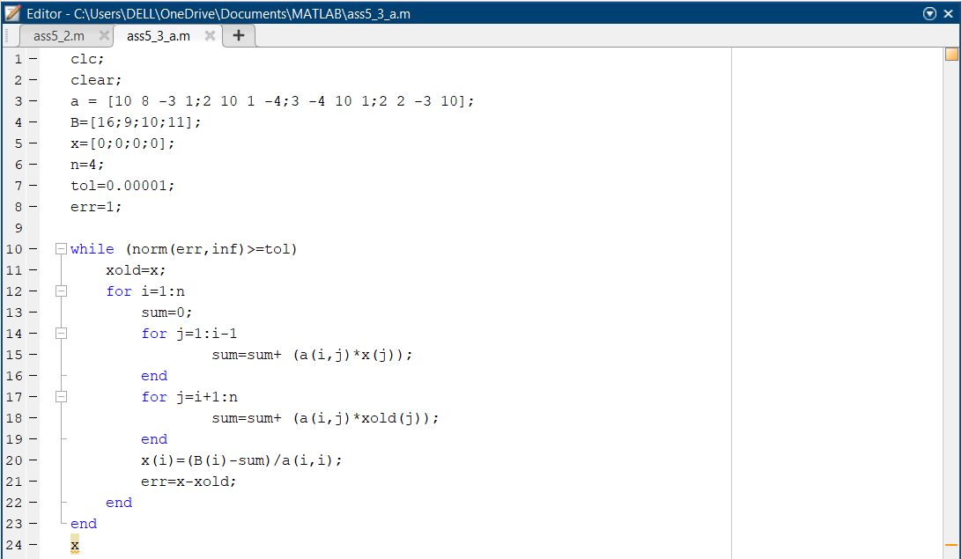

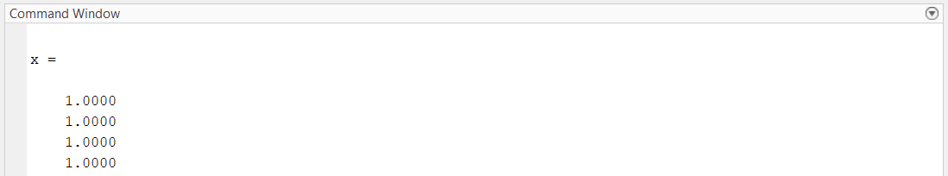

3. Use Gauss Seidel method and SOR method with w = 1.2 to find the solution of the following linear systems with an initial vector [0,0,0,0] and tolerance value 10-3 in the . ∞ norm:

(b) 4𝑥1 + 𝑥2 − 𝑥3 + 𝑥4 = −2

𝑥1 + 4𝑥2 − 𝑥3 − 𝑥4 = −1

−𝑥1 − 𝑥2 + 5𝑥3 + 𝑥4 = 0 𝑥

1 − 𝑥2 + 𝑥3 + 3𝑥4 = 1

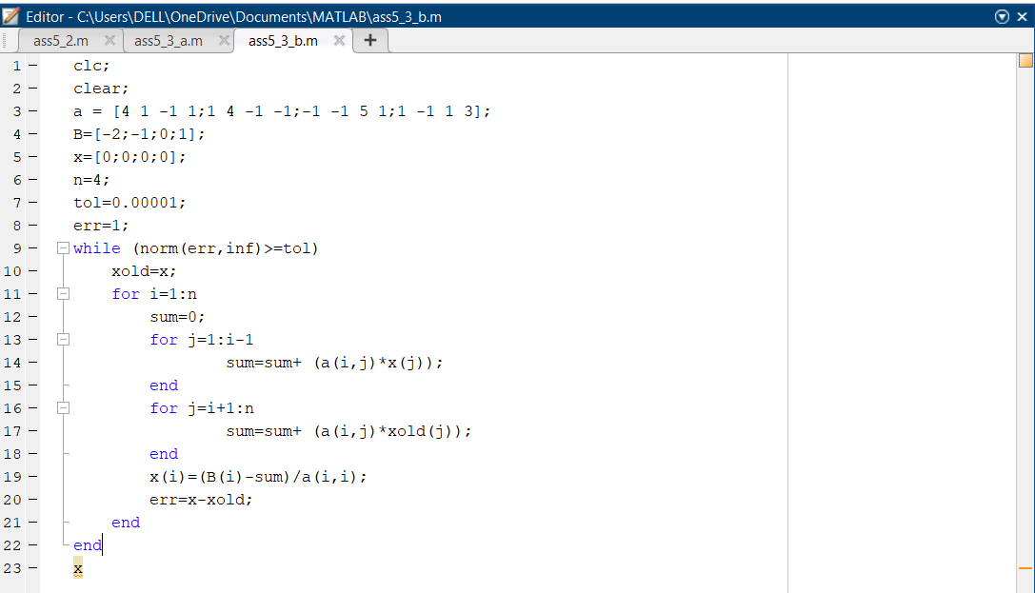

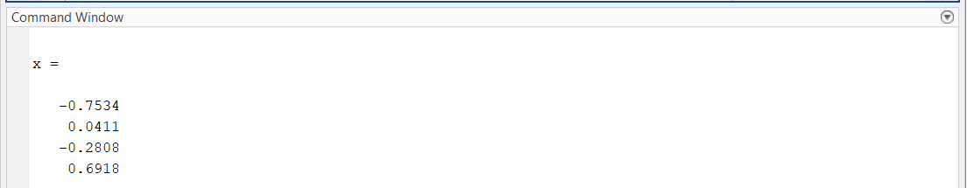

4. Use Gauss Seidel method to solve the following linear system with an initial vector [0,0,0] and tolerance value 10-3 in the . ∞ norm:

4.63𝑥1 − 1.21𝑥2 + 3.22 𝑥3 = 2.22

−3.07𝑥1 + 5.48𝑥2 + 2.11𝑥3 = −3.17

1.26𝑥1 + 3.11𝑥2 + 4.57𝑥3 = 5.11

