# Automation Framework Installation Steps

1. Install python2.7
2. Import latest code from GitHub

**git clone git@github.com:paradigmC/CureatrPythonWorkSpace.git**

1. Install below modules using pip to run DriverScript:
   1. Openpyxl-2.3
   2. Selenium
   3. datetime
   4. webbrowser
   5. email
   6. logging
   7. pil
2. Download Selenium Standalone Server from Seleniumhq (Find the below path)

<http://www.seleniumhq.org/download/>

1. Copy selenium standalone server in cureatr server(Ex: Path=/home/cureatr)
2. Execute following command in Cureatr server

**java -jar /home/cureatr/selenium-server-standalone-2.53.0.jar -role hub**

Make sure hub up and running. Find below console for reference

08:52:59.466 INFO - Launching Selenium Grid hub

2016-06-07 08:53:15.171:INFO::main: Logging initialized @19354ms

08:53:15.498 INFO - Will listen on 4444

08:53:15.943 INFO - Will listen on 4444

2016-06-07 08:53:15.952:INFO:osjs.Server:main: jetty-9.2.z-SNAPSHOT

2016-06-07 08:53:16.204:INFO:osjsh.ContextHandler:main: Started o.s.j.s.ServletContextHandler@b2d3e6d{/,null,AVAILABLE}

2016-06-07 08:53:16.227:INFO:osjs.ServerConnector:main: Started ServerConnector@acb8af4{HTTP/1.1}{0.0.0.0:4444}

2016-06-07 08:53:16.229:INFO:osjs.Server:main: Started @20413ms

08:53:16.230 INFO - Nodes should register to http://192.168.73.138:4444/grid/register/

08:53:16.231 INFO **- Selenium Grid hub is up and running**

1. Copy selenium standalone server in mac local(Ex: /Users/macmini/Cureatr)
2. Execute following command in Cureatr server(Replace hub path from Setp5 highlighted in yellow color)

java -jar /Users/macmini/Cureatr/selenium-server-standalone-2.53.0.jar -role webdriver -hub http://192.168.73.138:4444/grid/register -browser browserName=Firefox, maxInstances=3 -browser browserName=Chrome, maxInstances=3 Dwebdriver.chrome.driver=/Users/macmini/Cureatr/CureatrAutomationWorkSpace/CureatrApp/External\ Library\ Files/chromedriver_mac32/chromedriver -port 5557

1. Verify Hub and node are connected using hub URL from step 5(Find below screen shot for reference)

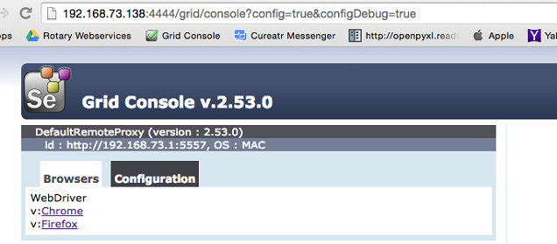

1. Run DriverScript using following command at Cureatr server

**Python DriverScript.py**