Monthly Land Use and Land Cover Mapping
from Sentinel-1 Radar with a U-Net
Technical Project Report
Deep Learning — M.Sc. Applied Data Science and Artificial Intelligence
Author: Mehatab
Matriculation number: [to be added]
Institution: SRH University Heidelberg
Repository: github.com/Mehatab1/DeepLearning
Date: November 2026

Abstract
Monthly land-cover information is difficult to obtain from optical satellites in regions and seasons with frequent cloud cover. This project investigates how much land use and land cover (LULC) information a compact convolutional network can extract from Sentinel-1 C-band radar when VV and VH backscatter are the only inputs. Monthly median composites from October 2025 to September 2026 were paired with ESA WorldCover 2021 labels, remapped to six classes (tree cover, grassland, cropland, built-up, bare/sparse vegetation and permanent water), and cut into 128 × 128-pixel patches around Stuttgart, Germany. A U-Net with 1.94 million parameters was trained with class-weighted cross-entropy and rare-class oversampling on 8,280 patches from 690 locations and selected on a spatially separate validation set.
On 27 held-out test locations observed over twelve months, the model reaches a pixel accuracy of 0.719 and a mean intersection over union (mIoU) of 0.473 against WorldCover. Water, cropland and built-up are recognised reliably (IoU 0.63–0.68), grassland remains weak (0.33) and bare/sparse vegetation, which is almost absent in the region, is not learned. A test-time ablation study shows that both polarisations are required, that cropland is identified almost entirely through the VH/VV relationship, and that spatial context matters far more than absolute backscatter level. Class-merging analysis identifies tree cover versus built-up as the largest single source of error and suggests a four-class legend (mIoU 0.643 on the same predictions). The trained model is deployed in a prototype that, for any coordinate and start month, retrieves twelve Sentinel-1 composites from Google Earth Engine, produces monthly maps and reports class shares and changes in percentage points. Limitations arising from static 2021 labels, seasonal radar effects and a single training region are discussed.
Keywords: Sentinel-1, synthetic aperture radar, land cover, semantic segmentation, U-Net, ESA WorldCover, ablation study, Google Earth Engine

Contents
1. Introduction
2. Research background
3. Study area and dataset
4. Sentinel-1 acquisition and preprocessing
5. Methodology and feature extraction
6. Model architecture and implementation
7. Experimental setup and evaluation metrics
8. Results and comparative analysis
9. Discussion and limitations
10. Conclusion and future scope
References
Appendix A. Reproducibility
Appendix B. Open items and data availability

1. Introduction
Land use and land cover maps describe what occupies the Earth's surface — forest, fields, settlements, water — and are a basic input for spatial planning, environmental reporting and the monitoring of urban growth. Global products such as ESA WorldCover are produced once per year at best, while many applications, from crop monitoring to tracking construction, would benefit from monthly updates. Optical sensors struggle to deliver these consistently because clouds obscure the surface for long periods, particularly in Central European winters.
Synthetic aperture radar (SAR) is an active sensor that observes the surface independently of cloud cover and illumination. The Sentinel-1 constellation provides dual-polarised C-band imagery over Europe every few days, which makes a complete monthly composite almost always available. The difficulty lies in interpretation: radar backscatter depends on surface roughness, geometry and dielectric properties rather than on colour, so classes that are easily separated in optical imagery can produce similar radar responses.

1.1 Research objectives
- Build a supervised dataset of Sentinel-1 VV/VH monthly composites with six-class labels derived from ESA WorldCover 2021.
- Train a semantic segmentation network that uses radar as its only input and evaluate it on spatially held-out locations.
- Develop a prototype that accepts a coordinate and a start month and produces twelve monthly maps, the share of each class per month, and month-to-month and first-to-last changes in percentage points.
- Determine which inputs the model relies on and which class pairs limit its accuracy through feature and class ablation.

1.2 Contributions
- A compact U-Net (1.94 M parameters) that reaches 0.719 pixel accuracy and 0.473 mIoU on held-out test locations from Sentinel-1 alone.
- An end-to-end prototype (Streamlit app and command-line tool) with orbit-consistent compositing, input validation and overlapping-tile inference.
- A test-time ablation study covering channel removal, permutation importance, signal properties, noise robustness, class removal and class merging.
- Independent accuracy checks of prototype runs against WorldCover for several sites around Stuttgart.

2. Research background

2.1 Radar backscatter and land cover
Sentinel-1 operates at C-band (wavelength ≈ 5.6 cm) and, in Interferometric Wide (IW) swath mode over land, records co-polarised (VV) and cross-polarised (VH) backscatter at 10 m pixel spacing [1]. Different surface types interact with the signal through different scattering mechanisms [7]. Calm water reflects the pulse away from the sensor and appears very dark in both channels. Buildings combine walls and ground into corner reflectors that return strong double-bounce echoes, mainly in VV. Vegetation canopies scatter the signal many times; this volume scattering depolarises the wave and raises VH relative to VV. Agricultural fields change their response through the year as crops grow, are harvested and as soil moisture varies, which is why the temporal behaviour of crops has been studied extensively with Sentinel-1 [8]. Radar images also contain speckle, a multiplicative interference noise that is commonly reduced by spatial filtering or temporal averaging [12].

2.2 Semantic segmentation
Semantic segmentation assigns a class to every pixel. Fully convolutional networks replaced the dense layers of image classifiers with convolutions so that a network can output a label map of the same size as its input [6]. U-Net extends this idea with a symmetric encoder–decoder design and skip connections that pass high-resolution feature maps from the encoder directly to the decoder [3]. The architecture trains well on small datasets, which has made it a standard baseline for remote-sensing segmentation.

2.3 Reference labels
ESA WorldCover 2021 is a global 10 m land-cover map with eleven classes derived from Sentinel-1 and Sentinel-2 data [2]. It provides labels on the same grid as Sentinel-1 at no cost, but it describes a single year. Using it as a label for 2025–26 imagery therefore introduces label noise wherever land cover has changed or where the map itself is wrong. All accuracies in this report are agreement with WorldCover, not with field data.

3. Study area and dataset

3.1 Study area
The study area is the region of Stuttgart in south-west Germany (Figure 2). Within roughly 20 km the landscape contains a dense city centre and suburbs, the forested slopes of the surrounding hills, arable land on the plateaus, grassland and orchards, and the Neckar river. This mix covers five of the six target classes well; bare or sparsely vegetated land is nearly absent. All data use UTM zone 32N (EPSG:32632) at 10 m resolution.
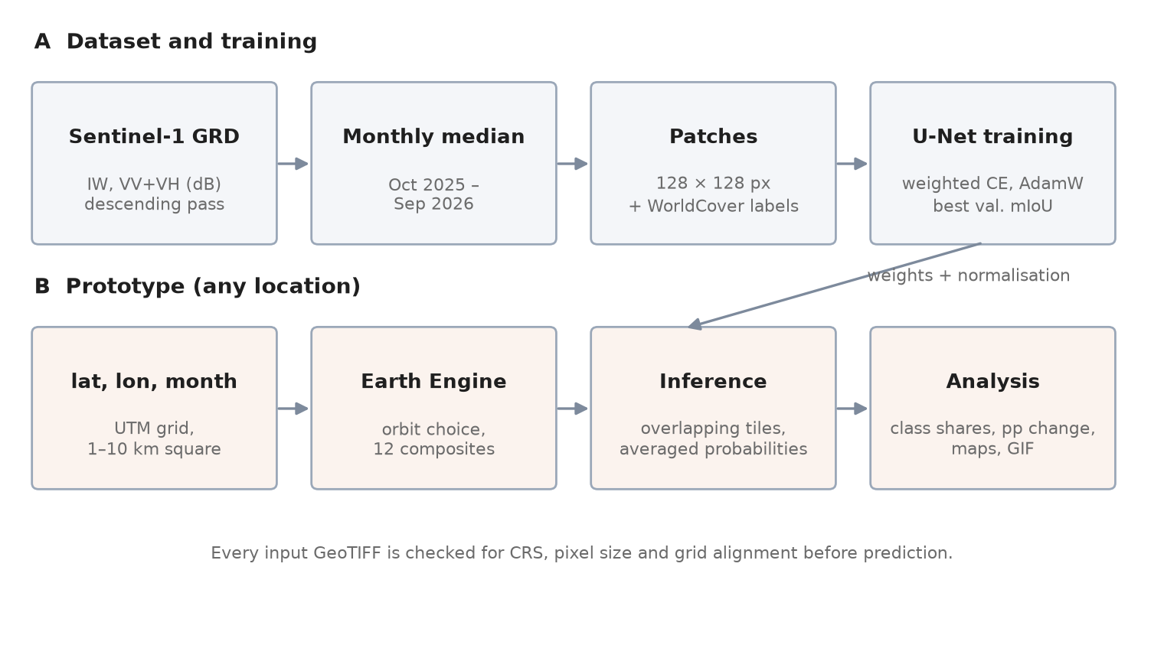
Figure 1. Overview of the project: (A) dataset construction and training, (B) the prototype that applies the trained model to any location.
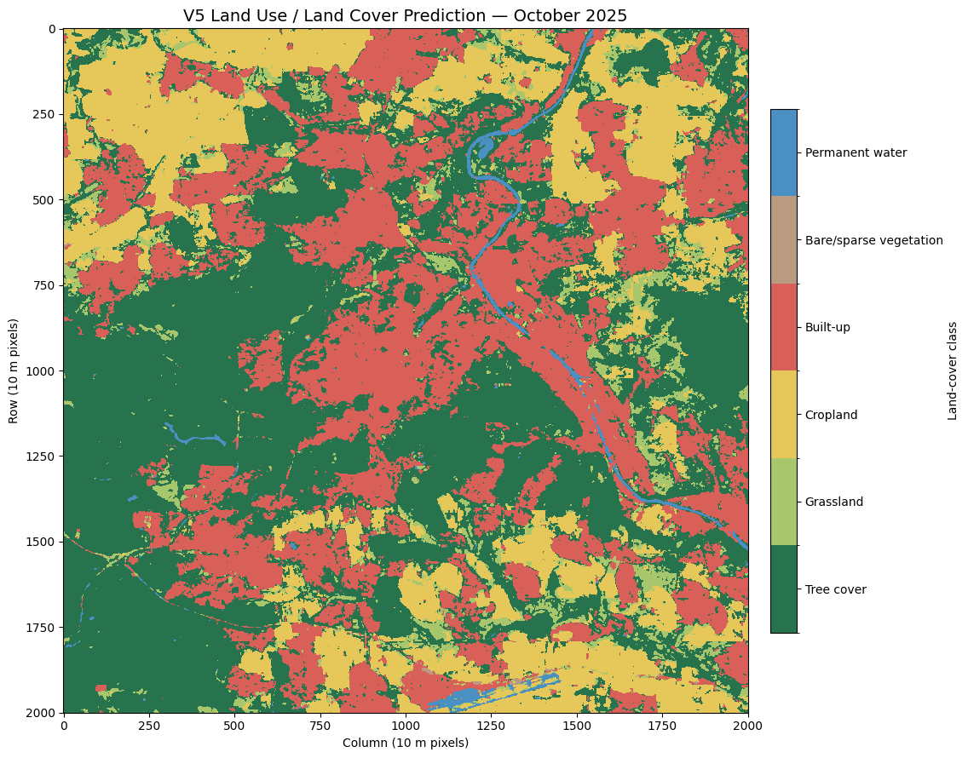
Figure 2. Model prediction for the 20 km × 20 km Stuttgart study area, October 2025 (2001 × 2001 pixels, archived notebook 10). Green: tree cover, light green: grassland, yellow: cropland, red: built-up, blue: water.

3.2 Class definitions
Table 1. Mapping of ESA WorldCover 2021 codes to the six project classes. Codes not listed (shrubland 20, snow and ice 70, herbaceous wetland 90, mangroves 95, moss and lichen 100) are set to 255 and ignored.
ID | Class | WorldCover code | Typical radar response
1 | Tree cover | 10 | Strong volume scattering, high VH
2 | Grassland | 30 | Moderate VV, low to moderate VH
3 | Cropland | 40 | Seasonally variable; VH/VV changes with crop stage
4 | Built-up | 50 | Very bright VV from double bounce
5 | Bare/sparse vegetation | 60 | Surface scattering, depends on roughness
6 | Permanent water | 80 | Very dark in both channels

3.3 Dataset splits
The dataset was built in several versions; this report describes version 5 (V5), which was used for the final model. Training, validation and test patches come from different locations so that no area is seen in more than one split. Each location contributes one patch for every month of the twelve-month period, so the model sees the same ground under changing radar conditions.
Table 2. Dataset composition. Every validation and test pixel carries one of the six labels (324 × 128 × 128 = 5,308,416 labelled pixels each).
Split | Patches | Locations × months | Source area | File
Training | 8,280 | 690 × 12 | 90 original locations + 600 outer-ring locations | patches_v5/train_v5.npz
Validation | 324 | 27 × 12 | Stuttgart core | patches_v4/val_v4.npz
Test | 324 | 27 × 12 | Stuttgart core, held out | patches_v4/test_v4.npz

Figure 3 compares the class composition of the validation and test sets. The validation set is dominated by tree cover (61.4 %), whereas the test set is more balanced, with much more built-up land (31.3 % versus 15.6 %) and grassland. Bare/sparse vegetation is effectively absent from both (0.004 % and 0.09 %). This difference in composition is relevant when comparing validation and test scores in Section 8.
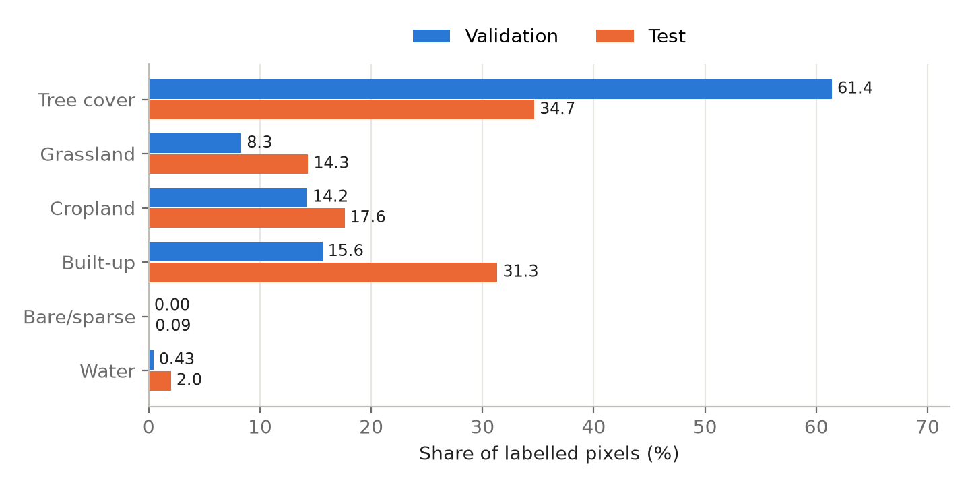
Figure 3. Share of labelled pixels per class in the validation and test sets.
Missing information. The class distribution of the training set is not stored in the repository (the corresponding notebook output is empty), and the coordinates of the individual training, validation and test locations are not documented. The original data-preparation notebooks that produced the V5 files are not in the repository; notebooks/01_data_collection.ipynb is a reconstruction of the procedure, not the code that generated train_v5.npz.

4. Sentinel-1 acquisition and preprocessing

4.1 Data source and compositing
Imagery is read from the Earth Engine collection COPERNICUS/S1_GRD [4], [13], which provides Ground Range Detected scenes that are already thermal-noise corrected, radiometrically calibrated, terrain corrected and converted to decibels. Scenes are filtered to IW mode, to the descending orbit pass and to acquisitions containing both VV and VH. For each calendar month from October 2025 to September 2026 the per-pixel median of all remaining scenes forms the monthly composite. The median suppresses speckle and outliers such as single wet-snow or frozen-ground acquisitions without an explicit speckle filter.

4.2 Orbit consistency
Backscatter depends on the incidence angle and look direction. If different months were composed from different relative orbits, part of the month-to-month change would be an artefact of geometry. The prototype therefore checks scene counts per relative orbit for all twelve months in a single server request and chooses, in this order: one descending orbit present in every month, one ascending orbit present in every month, mixed descending orbits, and mixed ascending orbits. When a mixed option is used the user is told that the viewing geometry may differ between months.
Missing information. The relative orbit numbers and the number of scenes per month used to build the V5 training data are not recorded in the repository.

4.3 Normalisation
Each channel is normalised with robust statistics computed on the training set: value_norm = (dB − median) / IQR. Median and inter-quartile range are less sensitive to the heavy tails of radar data than mean and standard deviation. The statistics are stored inside the model checkpoint so that training, evaluation and the prototype use identical values (Table 3).
Table 3. Normalisation statistics stored in weights/best_unet_v5.pt.
Channel | Median (dB) | IQR (dB)
VV | −9.043 | 3.967
VH | −15.391 | 4.470

4.4 Missing data and grid alignment
Pixels without radar data (NaN, ±infinity, or the fill value −9999 written by the download) are replaced with the median of the respective band, provided that at most 50 % of the image is affected; otherwise the month is rejected. In the prototype every downloaded or cached GeoTIFF is validated before use: it must contain two bands, use the expected coordinate reference system and 10 m pixels, and share the top-left corner of the analysis grid. A corrupt cached file is downloaded again, and an invalid fresh download stops the run with an explicit message instead of being processed silently.

4.5 Patch extraction
Training samples are 128 × 128-pixel patches (1.28 km × 1.28 km) with two input channels and one label channel. Labels use the class IDs 1–6 and 255 for ignored pixels; during training they are shifted to 0–5. No data augmentation was applied.

5. Methodology and feature extraction

5.1 Learned rather than hand-crafted features
The model receives only the two normalised backscatter channels. No vegetation-like indices, polarisation ratios, texture measures (for example grey-level co-occurrence statistics) or temporal statistics are computed beforehand. Instead, the convolutional encoder learns its own features: combinations of VV and VH at each pixel (implicitly including their ratio), local texture at several scales through successive pooling, and spatial context of up to the full 128-pixel patch. Section 8.6 tests empirically which of these learned feature types the model depends on.

5.2 Handling class imbalance
Bare/sparse vegetation and water occupy only a small fraction of the study area. Two measures counteract this imbalance. First, the cross-entropy loss is weighted: the four common classes receive a weight of 0.48, bare/sparse 2.398 and water 1.684. Second, a weighted random sampler draws patches that contain at least 100 bare or water pixels twice as often as other patches.

5.3 From monthly maps to change statistics
For month m and class c, the class share is the number of pixels predicted as c divided by the number of pixels in the area, multiplied by 100. The month-to-month change is share(m, c) − share(m−1, c), and the total change is share(last, c) − share(first, c). Both are expressed in percentage points (pp) and sum to zero across classes. In addition, the prototype reports the gross share of pixels whose class differs from the previous month, a transition matrix between the first and the last month, and the number of class switches per pixel over the year. All changes describe differences between predictions; they are not verified land-cover conversions.

6. Model architecture and implementation

6.1 U-Net
The network follows the U-Net design [3] with four resolution levels and a bottleneck (Figure 4). Each encoder level applies two 3 × 3 convolutions, each followed by batch normalisation and ReLU, and halves the resolution with 2 × 2 max pooling. The number of channels doubles from 16 to 128; the bottleneck has 256 channels at 8 × 8 pixels. The decoder upsamples with 2 × 2 transposed convolutions, concatenates the corresponding encoder features and again applies two convolutions. A final 1 × 1 convolution produces six class logits per pixel. The model has 1,942,518 trainable parameters, deliberately small given the size of the training set.
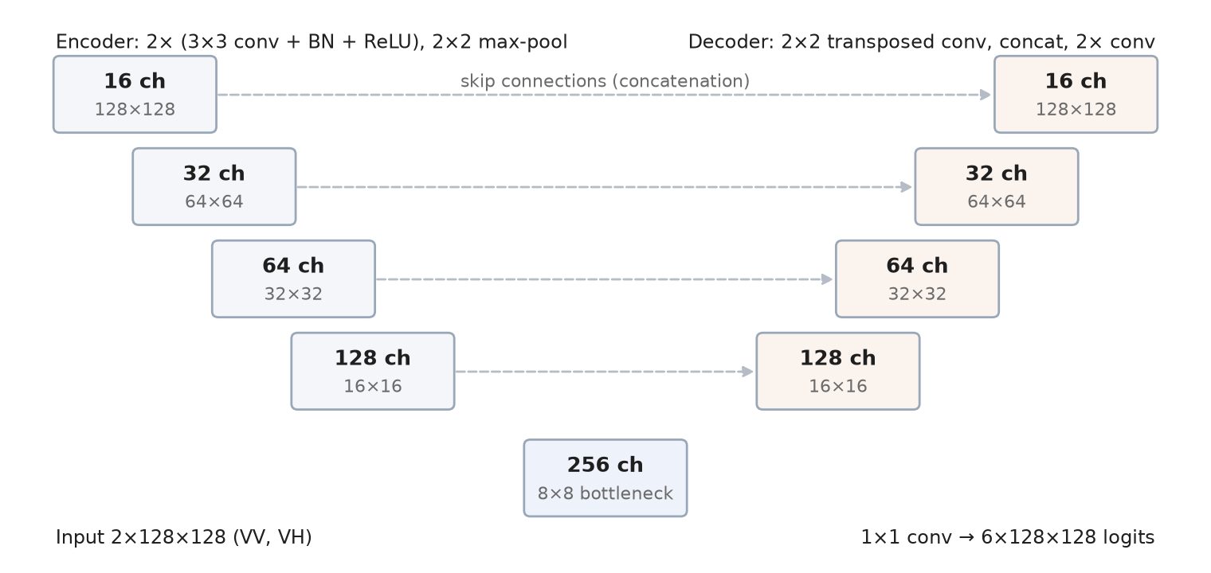
Figure 4. U-Net used in this project: four encoder and decoder levels (16–128 channels), a 256-channel bottleneck and skip connections by concatenation.

6.2 Software structure
The implementation uses Python and PyTorch [11]. The code is organised as a small package so that the notebooks, the command-line tool and the web app share one pipeline (Table 4).
Table 4. Modules of the src/ package.
Module | Responsibility
location.py | Converts latitude/longitude to a pixel-aligned UTM grid of 1–10 km
gee.py | Earth Engine access: month windows, orbit selection, composites, WorldCover labels, download
model.py | U-Net definition and checkpoint loading
inference.py | Normalisation, missing-value filling, overlapping-tile prediction
analysis.py | Class shares, percentage-point changes, transition matrix, temporal stability
visualize.py | Twelve-month map grid, GIF animation, charts
pipeline.py | End-to-end run with input validation and caching
classes.py | Class identifiers, names and colours

6.3 Inference on arbitrary areas
A requested area is usually larger than one 128-pixel tile and not a multiple of it. The image is padded at the bottom and right by reflection and divided into tiles that overlap by 64 pixels. The softmax probabilities of all tiles covering a pixel are averaged before the class with the highest probability is chosen. This removes the visible seams that independent, non-overlapping tiles produce every 1.28 km, at the cost of about four times as many forward passes.

6.4 Prototype
The prototype exposes the pipeline in two ways. The Streamlit application lets the user click on a map (OpenStreetMap or satellite basemap) or type coordinates, choose a start month from January 2017 onward and an area between 1 and 5 km, and then displays the twelve maps, an animation, the class-share table and chart, the month-to-month and total changes, change maps, the transition matrix and a download of all GeoTIFFs and CSV files. The command-line tool run_lulc.py runs the same pipeline for areas up to 10 km. Downloads are cached per location and period; a full run for a 2 km area takes a few minutes, dominated by Earth Engine. Figure 5 shows the twelve monthly maps of a 1 km area in central Stuttgart produced by an earlier version of the prototype.
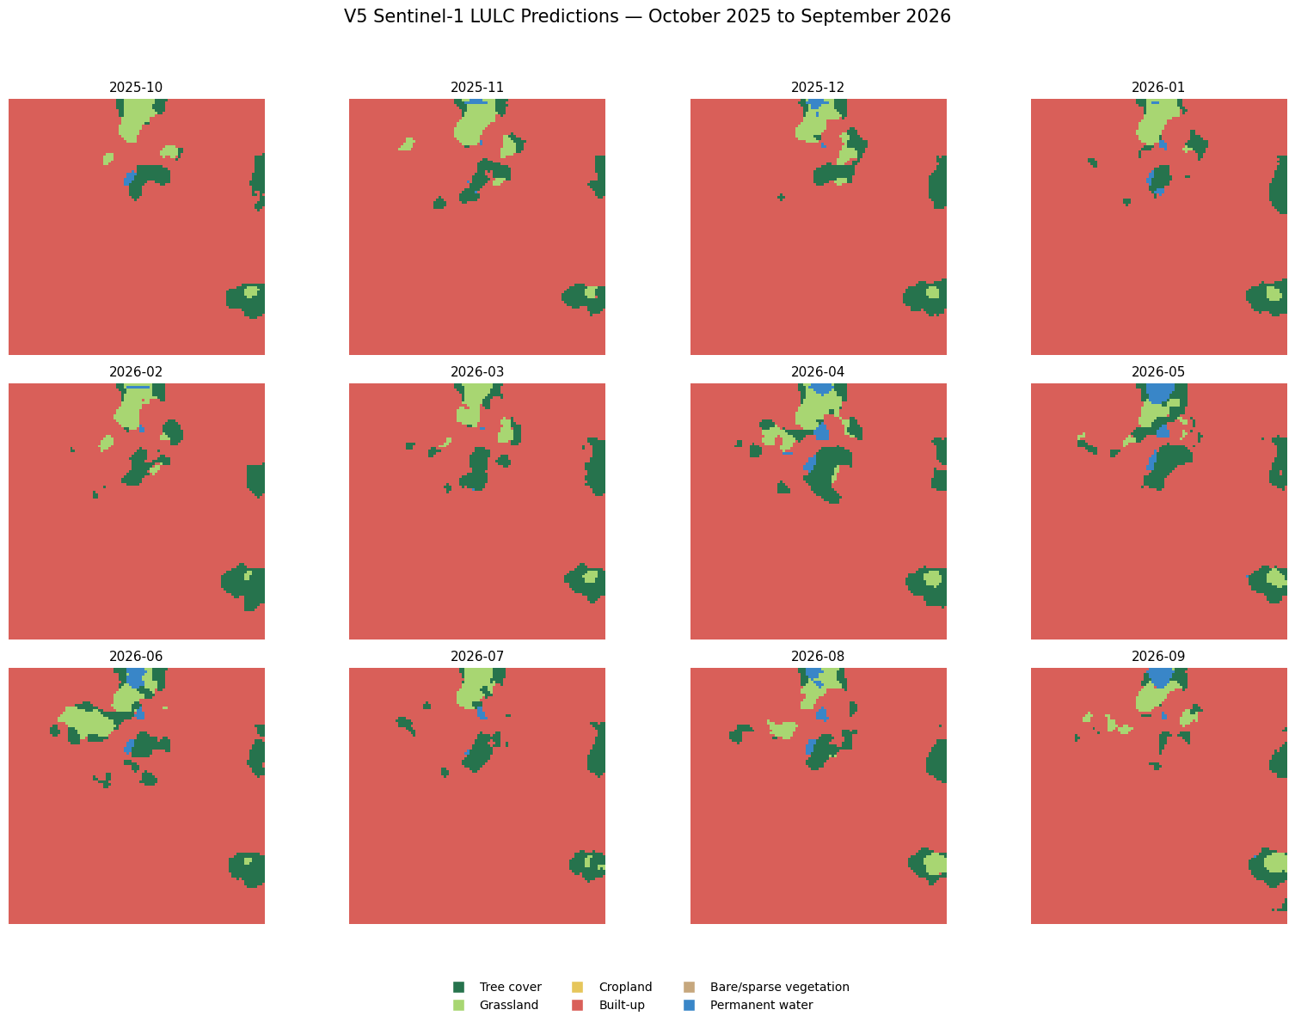
Figure 5. Twelve monthly predictions for a 1 km × 1 km area in central Stuttgart, October 2025 – September 2026 (archived notebook 11).

7. Experimental setup and evaluation metrics

7.1 Training configuration
Table 5. Training configuration (archived notebook 09).
Setting | Value
Loss | Weighted cross-entropy, ignore index 255; weights 0.48 / 0.48 / 0.48 / 0.48 / 2.398 / 1.684
Sampling | Weighted random sampler, ×2 for patches with ≥ 100 bare or water pixels
Optimiser | AdamW [5], learning rate 1 × 10⁻³, weight decay 1 × 10⁻⁴, no learning-rate schedule
Batch size / epochs | 4 / 30
Model selection | Checkpoint with the highest validation mIoU (epoch 6)
Augmentation | None
Random seed | 42
Hardware | Single CUDA GPU (university JupyterHub)

7.2 Evaluation metrics
All metrics are derived from a confusion matrix accumulated over every labelled pixel of a split; pixels with label 255 are excluded. For a class c with true positives TP, false positives FP and false negatives FN:
- Pixel accuracy — correctly classified pixels divided by all labelled pixels. Dominated by frequent classes.
- Precision — TP / (TP + FP): how many pixels predicted as c truly belong to c.
- Recall — TP / (TP + FN): how many pixels of c were found.
- Intersection over union (IoU) — TP / (TP + FP + FN): penalises both misses and false alarms.
- Mean IoU (mIoU) — the unweighted mean of the six class IoUs; each class counts equally regardless of its area.
Because a class with very few reference pixels can receive an IoU of zero, mIoU is sensitive to rare classes; for single locations, pixel accuracy and the IoU of the dominant classes are therefore reported alongside it [10].

7.3 Evaluation protocol
- Validation set — used for model selection only.
- Test set — 27 held-out locations × 12 months, evaluated once with the selected checkpoint (scripts/check_accuracy.py, Part 1).
- Prototype runs — the complete pipeline is run for a location and each monthly map is compared with WorldCover downloaded on exactly the same grid (scripts/check_accuracy.py, Part 2).
- Ablation study — inputs or outputs of the trained model are altered at test time and the change in metrics is measured on the test set (notebooks/04_ablation_study.ipynb).

8. Results and comparative analysis

8.1 Training and validation
The best validation mIoU, 0.545, was reached after 6 of 30 epochs. At this checkpoint the validation pixel accuracy is 0.847. Tree cover (IoU 0.83) and cropland (0.74) are recognised best, followed by water (0.70) and built-up (0.61); grassland reaches 0.39 and bare/sparse vegetation 0.00 (Table 6). The validation confusion matrix (Figure 6) shows the characteristic error pattern: 9 % of tree pixels are predicted as built-up and 11 % of built-up pixels as tree cover, while grassland is split between grassland (49 %), tree cover (22 %) and cropland (21 %).
Missing information — training curves. The per-epoch training and validation loss, accuracy and mIoU are saved in outputs/training_history_v5.json on the lab server but are not part of the repository, and the training notebook stored in the repository has no outputs. Running notebooks/02_train_evaluate_unet.ipynb on the server regenerates the curves (figure outputs/figures/training_curves.png); they should be inserted here as Figure 6a before submission. The observation that the best epoch is early (6 of 30) suggests over-fitting in later epochs, but this cannot be confirmed without the curves.
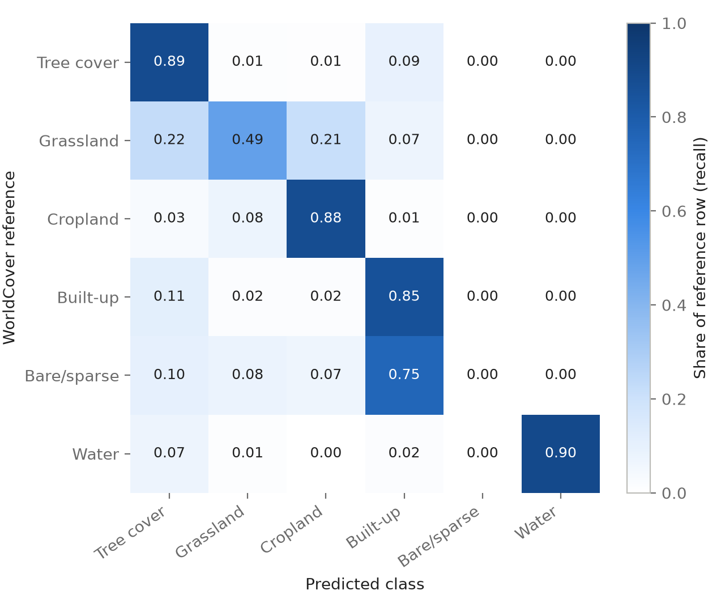
Figure 6. Validation confusion matrix of the selected checkpoint, normalised by reference class (rows sum to 1). Computed from the counts recorded in archived notebook 09.

8.2 Held-out test set
On the test set the model reaches a pixel accuracy of 0.719 and an mIoU of 0.473. Table 6 compares the per-class results with validation and Figure 7 shows the test confusion matrix. Water (IoU 0.68), cropland (0.66) and built-up (0.63) transfer well. Built-up has high recall (0.85) but lower precision (0.71): the model tends to over-predict it. Tree cover drops markedly from 0.83 on validation to 0.54 on test, mainly through lower recall (0.65), and grassland stays the weakest learned class (0.33).
Table 6. Per-class results on validation (best epoch) and test.
Class | Val IoU | Val precision | Val recall | Test IoU | Test precision | Test recall
Tree cover | 0.830 | 0.930 | 0.886 | 0.539 | 0.754 | 0.653
Grassland | 0.387 | 0.649 | 0.490 | 0.329 | 0.573 | 0.436
Cropland | 0.744 | 0.830 | 0.878 | 0.656 | 0.752 | 0.838
Built-up | 0.608 | 0.678 | 0.855 | 0.632 | 0.711 | 0.850
Bare/sparse | 0.000 | 0.000 | 0.000 | 0.000 | 0.000 | 0.000
Water | 0.698 | 0.759 | 0.897 | 0.684 | 0.817 | 0.808
Pixel accuracy | 0.847 |  |  | 0.719
mIoU | 0.545 |  |  | 0.473

The gap between validation and test is largely explained by composition. The validation set is 61 % tree cover — the class the model handles best — whereas the test set contains twice as much built-up land and the tree/built-up confusion therefore affects many more pixels. Since the checkpoint was also selected on the validation set, its validation score is optimistic by construction; the test score is the relevant estimate of performance.
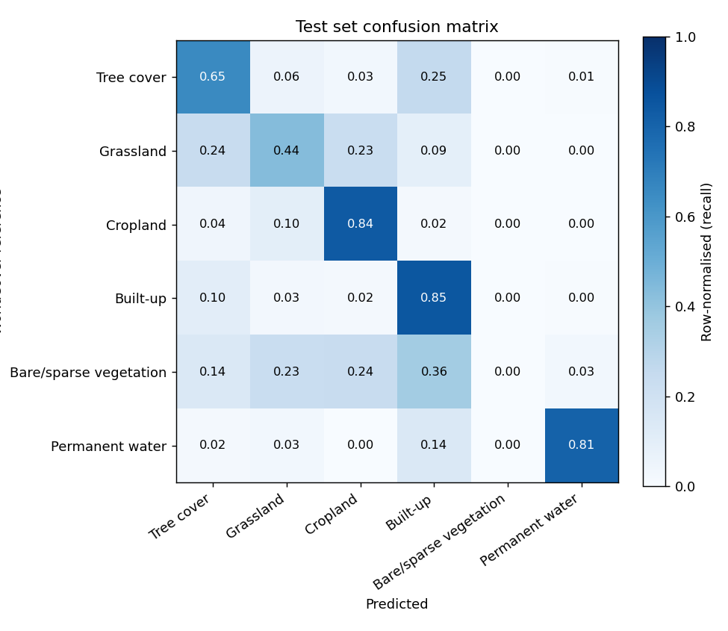
Figure 7. Test-set confusion matrix (row-normalised), produced by scripts/check_accuracy.py.
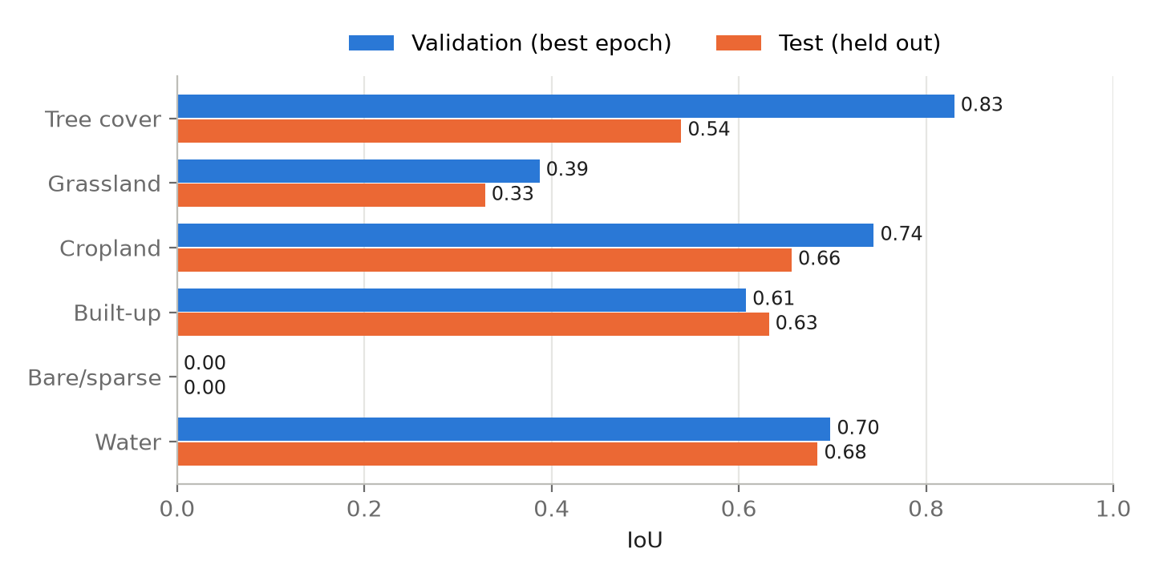
Figure 8. Class IoU on validation and test.

8.3 Performance over the year
Because every test location is observed in all twelve months, the scores can be compared by month (Figure 9). mIoU varies only between 0.455 (June 2026) and 0.484 (April 2026, with December 2025 almost identical). The lowest values occur in early summer, when growing vegetation changes the radar response of fields, grassland and trees most strongly; winter and spring months are slightly easier.
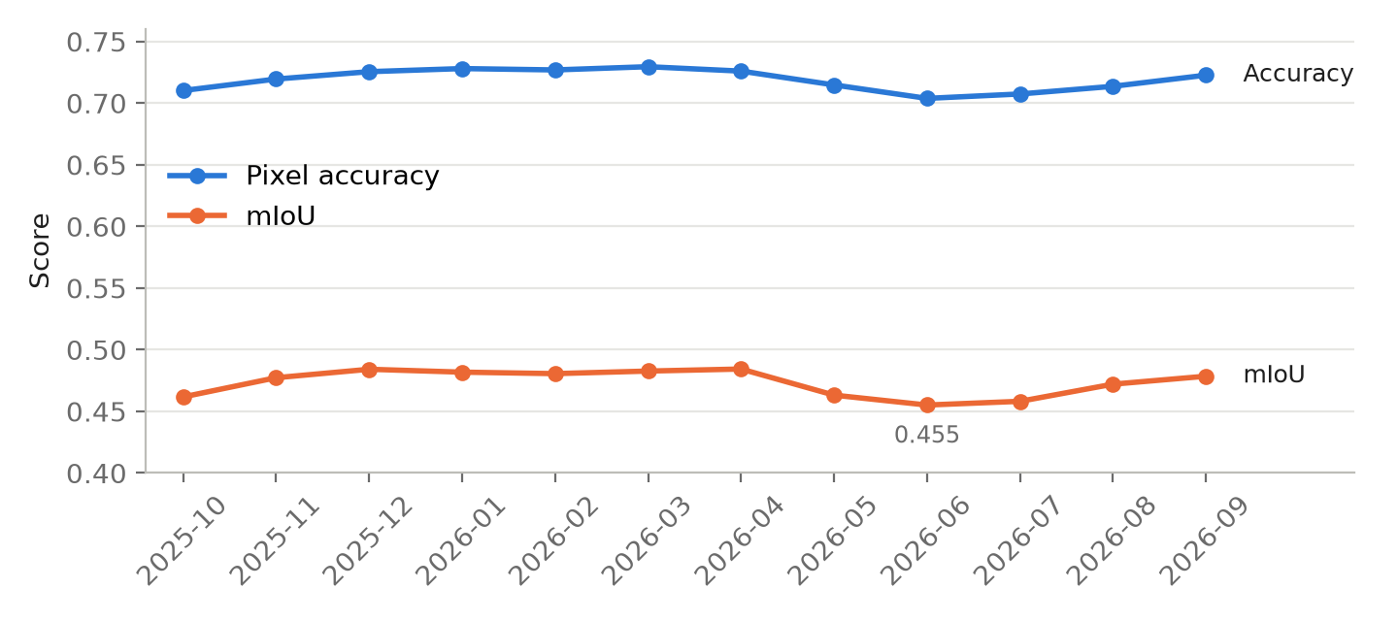
Figure 9. Pixel accuracy and mIoU on the test set for each month.

8.4 Prototype runs against WorldCover
To evaluate the deployed pipeline, complete twelve-month runs were compared with WorldCover on the same grid (Table 7, Figure 10). Accuracy ranges from 0.72 to 0.91 and depends strongly on the landscape. The forest-dominated site south-west of Stuttgart (84 % tree cover in WorldCover) reaches 0.911 with a tree-cover IoU of 0.92. In the dense city centre (73 % built-up within 2 km) accuracy is 0.791, but tree-cover recall is only 0.31: street trees, courtyards and small parks are absorbed into built-up because the bright double-bounce return of nearby buildings dominates 10 m pixels. mIoU values for single sites are low (0.20–0.41) because classes with only a few dozen reference pixels receive an IoU of zero.
Table 7. Prototype runs (October 2025 – September 2026) compared with WorldCover; all twelve months pooled.
Site | Area | Pixel accuracy | mIoU | Tree IoU | Built-up IoU | Stored in repository
Stuttgart centre (48.7758, 9.1829) | 2 km | 0.791 | 0.202 | 0.29 | 0.78 | no (console output)
Stuttgart centre (48.7758, 9.1829) | 5 km | 0.788 | 0.340 | 0.64 | 0.68 | no (console output)
South-west of Stuttgart (48.69, 9.06) | 5 km | 0.911 | 0.411 | 0.92 | 0.56 | results/accuracy/
Frankfurt am Main* | 2 km | 0.719 | 0.261 | 0.29 | 0.70 | results/accuracy/

Provenance notes. The three Stuttgart runs used non-overlapping tiles (they predate the overlapping-tile inference described in Section 6.3). * The Frankfurt files contain Cohen's kappa and F1 columns that scripts/check_accuracy.py does not produce; the script that generated them is not in the repository and its tiling mode is unknown. Its accuracy and mIoU were recomputed here from the stored confusion matrix.
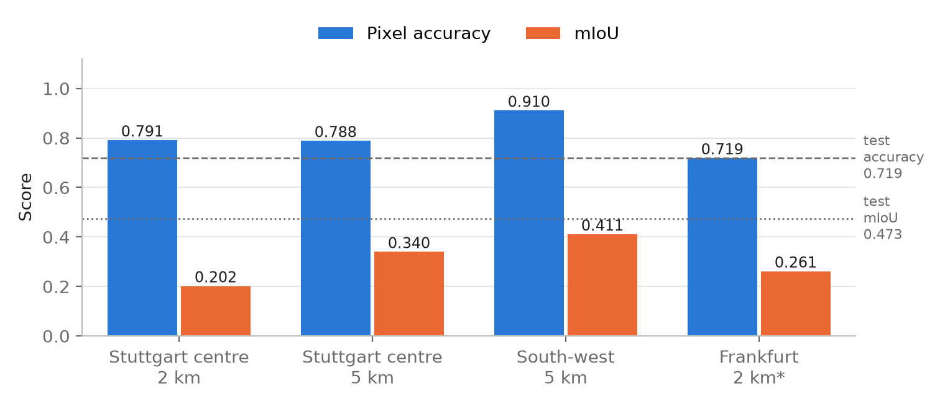
Figure 10. Pixel accuracy and mIoU of four prototype runs, compared with the test-set values (dashed and dotted lines).

8.5 Twelve-month analysis of the Stuttgart study area
An earlier full-area run applied the same model to the complete 20 km × 20 km study area (4,004,001 pixels, 400.4 km²). Table 8 summarises the first and last month. Tree cover decreases by 4.54 pp and grassland increases by 4.58 pp, while cropland and built-up change by about 2 pp each; 13.6 % of all pixels carry a different class in September 2026 than in October 2025. Month-to-month changes reach up to 3.5 pp (tree cover, July → August 2026) (Figure 11).
Table 8. Predicted class composition of the 20 km Stuttgart area in the first and last month (archived notebook 10).
Class | Oct 2025 (%) | Sep 2026 (%) | Change (pp) | Oct 2025 (km²) | Sep 2026 (km²)
Tree cover | 44.19 | 39.65 | −4.54 | 176.96 | 158.76
Grassland | 5.94 | 10.52 | +4.58 | 23.78 | 42.10
Cropland | 18.99 | 17.01 | −1.98 | 76.05 | 68.11
Built-up | 29.91 | 31.76 | +1.86 | 119.74 | 127.18
Bare/sparse | 0.05 | 0.06 | +0.02 | 0.19 | 0.25
Water | 0.92 | 1.00 | +0.08 | 3.69 | 3.99

These shifts should not be read as land conversion. A 4.5 pp loss of tree cover within one year would correspond to more than 18 km² of forest — implausible for this region. The pattern instead matches seasonal and model effects: tree cover is reassigned to grassland and built-up in late summer, and the largest monthly swings coincide with the growing season. The transition matrix confirms this: the largest off-diagonal flows are tree cover → built-up (125,218 pixels) and tree cover → grassland (114,321 pixels).
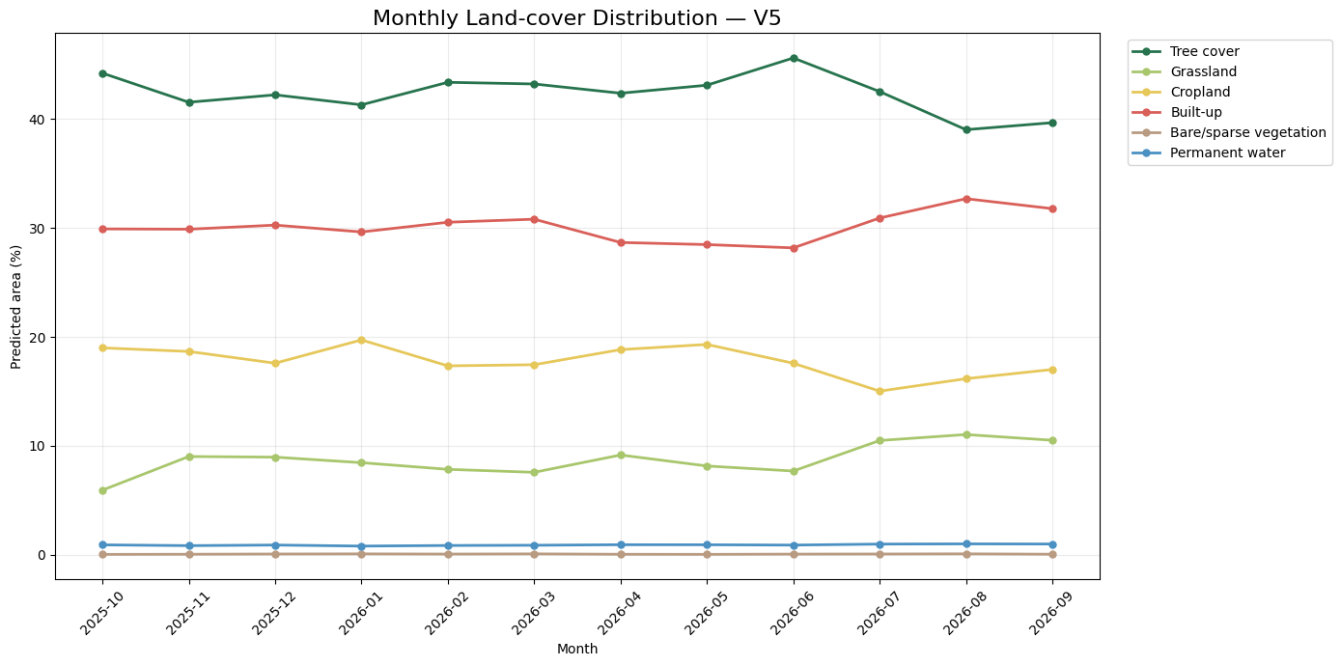
Figure 11. Monthly class shares predicted for the 20 km Stuttgart area (archived notebook 10).

8.6 Feature ablation
Since the model has only two inputs, feature ablation alters these channels and some of their properties at test time and measures the drop relative to the baseline (Table 9, Figure 12). Permutation importance [9] swaps a channel between patches, keeping a realistic value distribution while breaking its link to the location.
Table 9. Feature ablation on the test set (mean of three runs for permutation and noise).
Experiment | Pixel accuracy | mIoU | Δ mIoU
Baseline | 0.719 | 0.473 | —
VV replaced by its median | 0.326 | 0.107 | −0.366
VH replaced by its median | 0.447 | 0.182 | −0.292
VV and VH replaced | 0.176 | 0.029 | −0.444
VV permuted between patches | 0.399 | 0.157 | −0.316
VH permuted between patches | 0.451 | 0.188 | −0.285
Polarisation ratio removed (VH rebuilt from VV) | 0.575 | 0.325 | −0.148
Spatial texture removed (patch mean only) | 0.216 | 0.049 | −0.424
Brightness removed (patch mean subtracted) | 0.669 | 0.433 | −0.040
Gaussian noise σ = 0.1 (≈ 0.4 dB) | 0.714 | 0.466 | −0.007
Gaussian noise σ = 0.25 (≈ 1 dB) | 0.644 | 0.395 | −0.078
Gaussian noise σ = 0.5 (≈ 2 dB) | 0.499 | 0.231 | −0.242
Gaussian noise σ = 1.0 (≈ 4 dB) | 0.442 | 0.151 | −0.322

- Both channels are necessary; VV is slightly more important. Removing or permuting VV costs more than the same operation on VH, and neither channel alone retains even 40 % of the baseline mIoU. Water fails completely when either channel is missing (IoU 0.68 → close to zero), because the model recognises it from both channels being dark simultaneously.
- Cropland depends on the cross-polarisation relationship. When VH is rebuilt from VV so that the ratio carries no information, cropland IoU falls from 0.66 to 0.01 while the other classes change by 0.10 or less. This agrees with the physical interpretation of VH/VV as an indicator of vegetation structure on fields [8].
- Spatial patterns matter more than absolute level. Subtracting each patch's mean costs only 0.04 mIoU, whereas flattening each patch to its mean costs 0.42. Part of the second drop arises because flat images lie outside the training distribution; together, however, the results show that the network classifies mainly from spatial context and relative contrast.
- Moderate noise robustness. Perturbations below about 1 dB have little effect; from about 2 dB, cropland and grassland collapse first, while built-up and water remain the most robust.
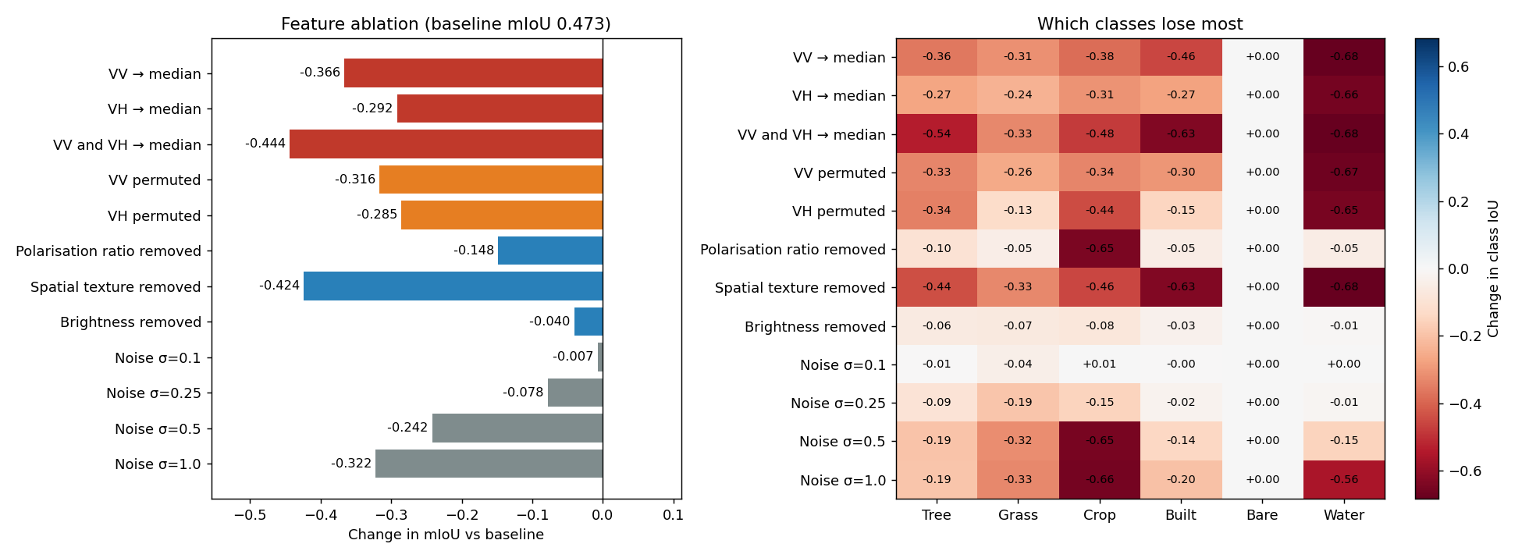
Figure 12. Feature ablation: change in mIoU (left) and change in class IoU (right) relative to the baseline (notebook 04).

8.7 Class removal and class merging
Class removal forbids the model to predict one class and scores the remaining classes on the same pixels. Removing built-up gives the largest gain for the other classes (+0.045 mIoU; tree-cover IoU +0.19), and 92 % of built-up pixels are then predicted as tree cover; conversely, tree-cover pixels fall back to built-up (48 %) and grassland (42 %). Cropland pixels become grassland (82 %). Removing bare/sparse changes nothing, because the model never predicts it.
Class merging treats groups of classes as one in both prediction and reference and recomputes all scores from the baseline confusion matrix (Table 10). It does not change the model; it shows how much error arises between the merged classes and what a coarser legend would achieve.
Table 10. Class merging on the same test predictions.
Merged classes | Classes | Pixel accuracy | mIoU | IoU of merged class
None (baseline) | 6 | 0.719 | 0.473 | —
Grassland + cropland | 5 | 0.770 | 0.514 | 0.72
Tree cover + grassland | 5 | 0.773 | 0.518 | 0.62
Bare/sparse into grassland | 5 | 0.719 | 0.568 | 0.33
Grassland + cropland + bare/sparse | 4 | 0.770 | 0.643 | 0.72
Tree cover + built-up | 5 | 0.839 | 0.504 | 0.85
All vegetation (tree, grass, crop, bare) | 3 | 0.842 | 0.700 | 0.78

Merging tree cover with built-up alone raises accuracy by 12 points — about as much as merging all four vegetation classes — which identifies this pair as the largest single source of error (≈ 12 % of test pixels). Grassland is confused with tree cover and with cropland to a similar degree (5.4 % and 5.1 % of test pixels). Merging bare/sparse into grassland changes no prediction; its mIoU gain only removes a zero from the average. A four-class legend — tree cover, low vegetation (grassland, cropland, bare/sparse), built-up and water — reaches mIoU 0.643 with physically meaningful classes and is the most promising candidate for retraining. These merged figures re-score the six-class predictions and must not be reported as the accuracy of the six-class model.
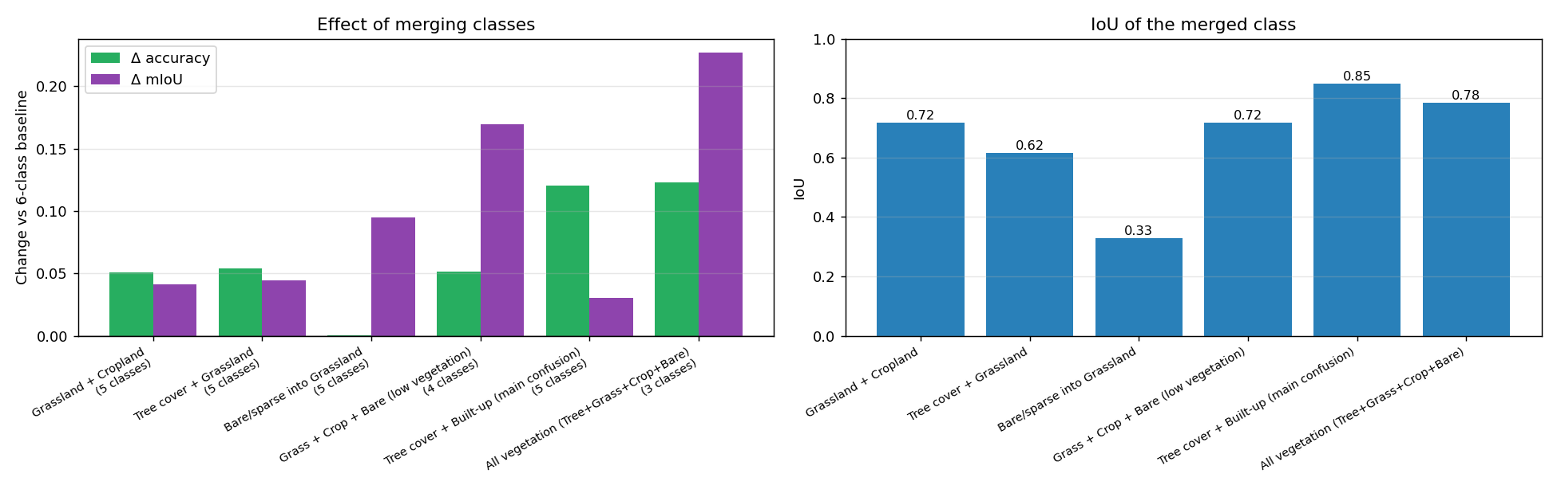
Figure 13. Class merging: change in accuracy and mIoU (left) and IoU of the merged class (right) (notebook 04).

9. Discussion and limitations

9.1 What the model has learned
The results paint a consistent picture. The network separates classes whose scattering mechanisms differ — specular water, double-bounce built-up, volume-scattering forest and the seasonally variable fields — and fails where mechanisms overlap. Its reliance on the VH/VV relationship for cropland and on spatial context for all classes agrees with radar physics. The dominant tree ↔ built-up confusion has two sources: in suburbs and the city centre, trees and buildings share 10 m pixels and the building echo dominates; and dense forest can produce strong backscatter on slopes facing the sensor. Grassland occupies the space between trees and fields and has no unique radar signature at C-band, which explains its low IoU.

9.2 Limitations
- Static reference labels. WorldCover 2021 is used for every month of 2025–26. Disagreement can therefore stem from model errors, real changes since 2021 or errors in WorldCover itself; none of the scores is an accuracy against ground truth.
- Seasonality versus change. The model sees a single month at a time, so seasonal changes in backscatter appear as class changes. The 20 km analysis shows swings of several percentage points that are not physically plausible; changes of a few percentage points in stable areas should be treated as noise.
- Single region. All data come from around Stuttgart and from descending passes. The prototype accepts any coordinate, but performance in other landscapes, climates or on ascending passes is unvalidated.
- Rare classes. Bare/sparse vegetation is never predicted, and its zero IoU lowers mIoU by about 0.10.
- Model selection bias. The validation set used for checkpoint selection differs strongly in composition from the test set, so validation scores overestimate performance.
- Map colours. The class colours used in the maps place grassland and cropland close together and are hard to distinguish, particularly for colour-vision-deficient readers; charts in this report therefore label classes directly.
- Documentation gaps. Training curves, the original data-preparation code, training-set class statistics and orbit metadata are not in the repository (Appendix B).

10. Conclusion and future scope
A compact U-Net trained on Sentinel-1 VV and VH backscatter alone reaches 0.719 pixel accuracy and 0.473 mIoU against WorldCover on held-out locations around Stuttgart, with reliable recognition of water, cropland and built-up land and clear weaknesses for grassland and the absent bare/sparse class. The ablation study shows that the model uses both polarisations, depends on their relationship for cropland and relies primarily on spatial context. The confusion between tree cover and built-up is the largest single error source. The trained model is integrated into a working prototype that produces twelve monthly maps and percentage-point change statistics for any location, with safeguards for orbit consistency and input validity.

10.1 Future work
- Retrain with a four-class legend (tree cover, low vegetation, built-up, water), which the merging analysis suggests would reach an mIoU of about 0.64 with meaningful classes.
- Multi-temporal input, for example three consecutive months, so the model can separate seasonal backscatter changes from real land-cover change.
- Geographic diversity — add training locations from other landscapes and both orbit directions to test and improve transferability.
- Data augmentation and regularisation (flips, rotations, speckle noise) and a learning-rate schedule, given the early best epoch.
- Better references — more recent or independently validated labels, for example Dynamic World [14] or local cadastral data, to separate model errors from label errors.
- Re-evaluate the prototype with overlapping-tile inference on a larger set of sites, and report uncertainty per pixel.

References
[1] R. Torres et al., "GMES Sentinel-1 mission," Remote Sensing of Environment, vol. 120, pp. 9–24, 2012.
[2] D. Zanaga et al., "ESA WorldCover 10 m 2021 v200," Zenodo, 2022, doi: 10.5281/zenodo.7254221.
[3] O. Ronneberger, P. Fischer and T. Brox, "U-Net: Convolutional networks for biomedical image segmentation," in Proc. MICCAI, LNCS 9351, pp. 234–241, 2015.
[4] N. Gorelick et al., "Google Earth Engine: Planetary-scale geospatial analysis for everyone," Remote Sensing of Environment, vol. 202, pp. 18–27, 2017.
[5] I. Loshchilov and F. Hutter, "Decoupled weight decay regularization," in Proc. ICLR, 2019.
[6] J. Long, E. Shelhamer and T. Darrell, "Fully convolutional networks for semantic segmentation," in Proc. IEEE CVPR, pp. 3431–3440, 2015.
[7] F. T. Ulaby and D. G. Long, Microwave Radar and Radiometric Remote Sensing. Ann Arbor: University of Michigan Press, 2014.
[8] A. Veloso et al., "Understanding the temporal behavior of crops using Sentinel-1 and Sentinel-2-like data for agricultural applications," Remote Sensing of Environment, vol. 199, pp. 415–426, 2017.
[9] L. Breiman, "Random forests," Machine Learning, vol. 45, no. 1, pp. 5–32, 2001.
[10] P. Olofsson et al., "Good practices for estimating area and assessing accuracy of land change," Remote Sensing of Environment, vol. 148, pp. 42–57, 2014.
[11] A. Paszke et al., "PyTorch: An imperative style, high-performance deep learning library," in Advances in Neural Information Processing Systems 32, 2019.
[12] J.-S. Lee, "Digital image enhancement and noise filtering by use of local statistics," IEEE Trans. Pattern Analysis and Machine Intelligence, vol. 2, no. 2, pp. 165–168, 1980.
[13] Google Earth Engine Data Catalog, "Sentinel-1 SAR GRD: C-band Synthetic Aperture Radar Ground Range Detected, log scaling" (COPERNICUS/S1_GRD). https://developers.google.com/earth-engine/datasets/catalog/COPERNICUS_S1_GRD
[14] C. F. Brown et al., "Dynamic World, near real-time global 10 m land use land cover mapping," Scientific Data, vol. 9, art. 251, 2022.

Appendix A. Reproducibility
Code, trained weights, curated results and notebooks are available at https://github.com/Mehatab1/DeepLearning. The repository README lists all commands; the essential steps are:
git clone https://github.com/Mehatab1/DeepLearning.git sentinel1-lulc && cd sentinel1-lulc
python -m venv .venv && source .venv/bin/activate
pip install -r requirements.txt
earthengine authenticate # or: python -c "import ee; ee.Authenticate(auth_mode='notebook')"
export EE_PROJECT=<your Google Cloud project>
pytest -q # 16 offline tests
python run_lulc.py --lat 48.7758 --lon 9.1829 --start 2025-10 --area-km 2
streamlit run app.py
python scripts/check_accuracy.py --project $EE_PROJECT

Table 11. Where the results in this report come from.
Result | Source in the repository
Training configuration, validation metrics and confusion matrix | notebooks/archive/09_train_unet_v5_expanded_area.ipynb
Test-set metrics (per class, per month, confusion matrix) | results/accuracy/test_set/
Prototype run, south-west of Stuttgart | results/accuracy/48.6900_9.0600_2025-10_5km/
Prototype run, Frankfurt | results/accuracy/frankfurt_2025-10_to_2026-09/
20 km Stuttgart analysis | notebooks/archive/10_v5_lulc_prototype.ipynb, results/figures/
Feature ablation, class removal, class merging | notebooks/04_ablation_study.ipynb, results/ablation/
Trained model and normalisation statistics | weights/best_unet_v5.pt

Appendix B. Open items and data availability
The following items were not available when this report was written. They are listed explicitly rather than filled with assumptions.
Table 12. Open items.
Item | Status / action
Dataset download link | Not yet published. Build with python scripts/package_dataset.py and upload (e.g. Zenodo).
Training curves | Stored on the lab server only. Re-run notebook 02 and insert as Figure 6a.
Notebook outputs (01–03) | Notebooks are stored without outputs; notebook 04 contains outputs.
Original data-preparation code | Not in the repository; notebook 01 is a reconstruction.
Training-set class distribution, orbit numbers, scene counts | Not recorded.
Coordinates of validation and test locations | Not documented.
Stuttgart-centre prototype runs (Table 7) | Values taken from console output; result files were overwritten.
Frankfurt evaluation script | Not in the repository.
Screen recording of a full run | To be recorded (plan in docs/RECORDING.md).
Matriculation number | To be added on the title page.

