@title Combinatorics & Packing — Quantitative Assessment @description This document contains two newly-generated multiple-choice math questions similar to the provided base questions. Each question preserves LaTeX formatting where applicable and includes subject/unit/topic tags from the curriculum.

@question Each athlete at Lakeview School wears a uniform consisting of 1 jersey and 1 pair of shoes. The table shows the colors available for each item. How many different uniforms are possible?

Shirt Colors: Blue, Green, White Shoe Colors: Black, Brown, White, Gray

@instruction Select the number of distinct uniform combinations possible. @difficulty easy @Order 1

@option (A) Three @option (B) Four @option (C) Seven @option (D) Ten @@option (E) Twelve

@explanation There are 3 jersey choices and 4 shoe choices. Using the counting principle, number of combinations = 3 = 12. Therefore the correct answer is 12. @subject Quantitative @unit Math Problem Solving @topic Counting & Arrangement Problems @plusmarks 1

@question The top view of a rectangular package of 8 tightly packed balls is shown. If each ball has a radius of 3 centimeters, which of the following are closest to the dimensions, in centimeters, of the rectangular package?

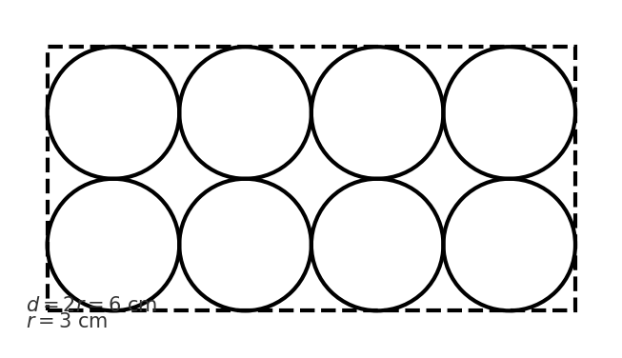

@instruction Choose the correct option that matches the package dimensions (height × width × length). @difficulty moderate @Order 2

@option (A) $3×6×12$@option (B) $6×12×18$@option (C) $6×8×24$@option (D) $6×12×24$@@option (E) $9×12×24$

@explanation Each ball has diameter $d=2r=6\text{ cm}$. The balls are arranged in 2 rows and 4 columns, so width = $2d=12\text{ cm}$, length = $4d=24\text{ cm}$, and height = $d=6\text{ cm}$. Dimensions (height × width × length) are $6×12×24$, so option (D) is correct. @subject Quantitative @unit Math Geometry and Measurement @topic Circles (Area, circumference) @plusmarks 1