+-----------------------------------------------------------------------------+
| NOTICE: Check the Documentation.pdf for design/implementation details. |
+-----------------------------------------------------------------------------+
ENVIRONMENT REQUIREMENTS
=======================
- JDK/JRE 1.7+
- JAVA_HOME variable properly configured to the root dir of the JDK installation
- Apache Tomcat 8 installed as follows:
--- Tomcat downloaded from https://tomcat.apache.org/download-80.cgi
--- Zip file extracted to C:\apache-tomcat (Note that you rename the folder removing the tomcat version)
--- CATALINA_HOME added to the system's environment variables. Its value should be C:\apache-tomcat
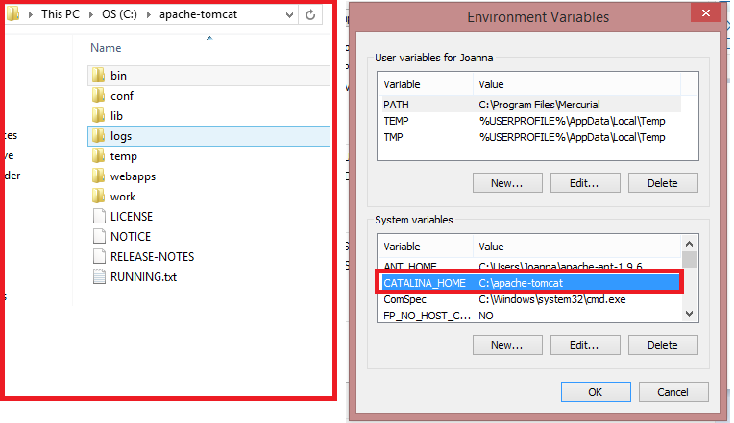

*** IMPORTANT ***
It is mandatory that tomcat is installed in this folder (C:\apache-tomcat). Otherwise, the compile.bat and the database access of the application will be compromised.
If needed, the following adjustments shall be made to make the Web site work properly:

- In the class src\edu\rit\swen755\models\Model.java the path variable (line 16) should be changed to the application's root directory in the Tomcat. (This is the folder that contains the assignment4.db database.)
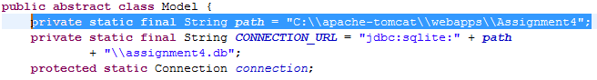

- When compiling classes, change -cp "C:/apache-tomcat/lib/servlet-api.jar" to a path in accordance to your Tomcat's installation

HOW TO RUN/TEST APPLICATION USING COMMANDS
=======================
+-----------------------------------------------------------------------------------+
| NOTICE: If you have Windows OS, you can compile the application using compile.bat |
+-----------------------------------------------------------------------------------+

+ Compilation Commands
javac -cp "C:/apache-tomcat/lib/servlet-api.jar" -d WebContent\WEB-INF\classes src/edu/rit/swen755/controllers/*.java src/edu/rit/swen755/models/*.java src/edu/rit/swen755/views/*.java

+ Create a folder named “Assignment4” within the the "webapps" folder of Tomcat
+ Copy the entire contents of the folder "WebContent" to the folder “Assignment4” just created
+ Start tomcat (c:\apache-tomcat\bin\startup.bat)
+ Open a Web Browser and type the following url http://localhost:8080/Assignment4 (you may need to adjust URL accordingly based on the HTTP port configured for Tomcat).

OUTPUTS SHOWN
=======================
Please, check Documentation.pdf for a complete explanation of the output. Table 1 within that document shows the user accounts that can be used to login the system.

