🌱 DishDetect SA
VEGAN VS. VEGETARIAN (MEAT-FREE) INTELLIGENCE REPORT
Deep Learning Discrimination of Plant-Based vs. Dairy/Egg/Ghee Arabic Dishes
13 October 2026

1. Executive Summary
In modern dietary compliance and nutrition technology, identifying whether a dish contains animal products requires going beyond detecting meat. While vegetarians abstain from animal flesh, they frequently consume dairy (cheese, milk, yogurt), eggs, and clarified butter (samneh / ghee). In contrast, strict vegans require 100% plant-based foods. This report documents the dedicated Vegan vs. Vegetarian classification model trained on the meat-free cohort of 15 Middle Eastern / Arabic dishes, completely excluding all 10 meat/fish categories.
Benchmark Metric | Validation Set (107 imgs) | Held-Out Test Set (107 imgs) | Real Restaurant Test (24 imgs)
Overall Accuracy | 88.79% | 87.85% | 83.33%
Weighted Precision | 0.8879 | 0.8875 | —
Weighted Recall | 0.8879 | 0.8785 | —
Weighted F1-Score | 0.8879 | 0.8793 | —
Vegan Precision | 0.90 | 0.95 (95%) | —
Vegetarian Recall | 0.87 | 0.93 (93%) | —

2. Meat-Free Dataset Cohort (15 Dishes, 704 Images)
All meat, poultry, fish, and seafood dishes (Mixed Grill, Shawarma, Shish Tawook, Grilled Kofta, Meat Maqluba, Meat Pie, Kofta Stew, Shrimp Sayadiyah, Stuffed Pigeon, and Meat Madfoon) were strictly excluded. The model evaluates exclusively on the 15 meatless dishes in the dataset:
Dish Name | Category | Images | Key Ingredients & Animal Byproduct Audit
Hummus | Vegan | 61 | Chickpeas, tahini (sesame paste), olive oil, garlic. Naturally 100% plant-based.
Tamees Bread | Vegan | 53 | Plain Saudi tandoor wheat bread: Flour, water, yeast, salt, vegetable oil.
Za’atar Manakish | Vegan | 52 | Flatbread dough topped with wild thyme, sumac, sesame seeds, and extra virgin olive oil.
Okra Tagine | Vegan | 45 | Bamya bil-Zayt: Baby okra pods simmered in tomato gravy, cilantro, garlic, olive oil.
Sesame Brittle | Vegan | 45 | Simsimiya: Toasted sesame seeds bound with sugar syrup, glucose, lemon.
Spinach Fatayer | Vegan | 44 | Levantine spinach pie: Spinach, onions, sumac, pine nuts in olive oil dough.
Onion Soup | Vegan | 42 | Shorbat Basal: Caramelized onions, olive oil, vegetable broth, cumin.
Pomegranate Fattoush | Vegan | 37 | Romaine, tomatoes, cucumbers, toasted pita chips, sumac, pomegranate molasses.
Spinach Stew | Vegan | 32 | Sabanegh bil-Zayt: Fresh spinach, chickpeas, garlic, coriander, olive oil.
Fatayer Cheese | Vegetarian | 86 | Pastry filled with dairy cheese (Akkawi / Halloumi / Nabulsi) and butter.
Saffron Cake | Vegetarian | 59 | Sponge cake made with eggs, soaked in saffron condensed milk & heavy cream.
Rice Pudding | Vegetarian | 57 | Roz Bel Laban: Short-grain rice cooked in whole cow's milk and ashta cream.
Pistachio Sweet | Vegetarian | 57 | Halawet el-Jibn / Mafroukeh: Contains sweet cheese, ashta, and clarified butter.
Pistachio Tamriya | Vegetarian | 21 | Date confection pan-roasted in clarified butter (samneh / ghee).
Tamriya | Vegetarian | 13 | Authentic Saudi date confection pan-roasted in samneh (animal butterfat).

3. Benchmark Visualizations & Confusion Matrices
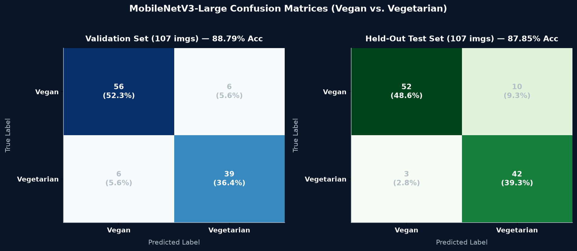
Figure 1 — MobileNetV3-Large Validation and Test Split Confusion Matrices

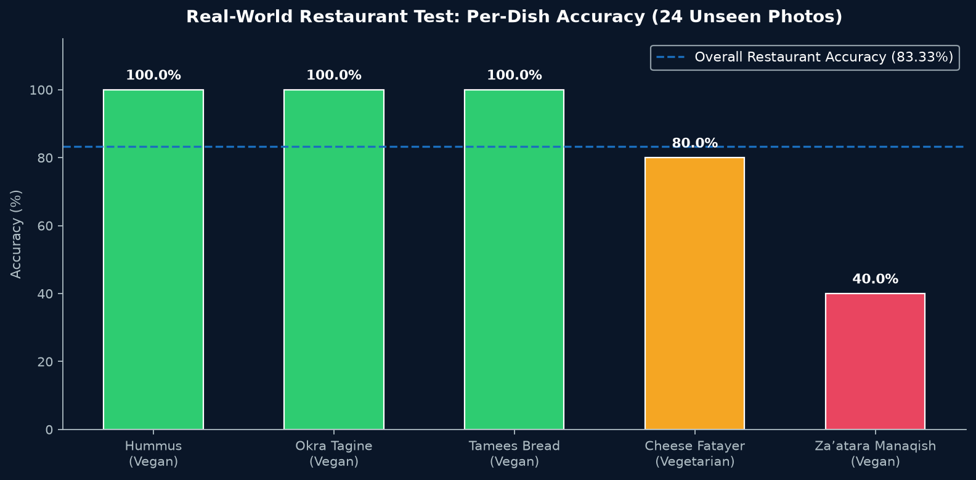
Figure 2 — Real-World Arabic Restaurant Test: Per-Dish Accuracy Breakdown

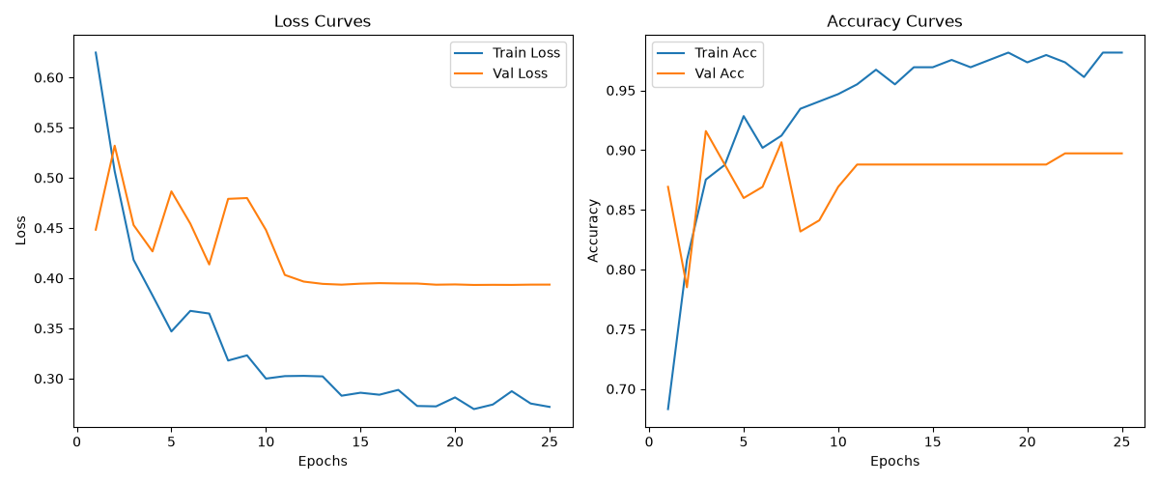
Figure 3 — Two-Stage Transfer Learning Convergence Curves (AdamW + Cosine Annealing)

4. Real-World Restaurant Test Results (24 Images)
The model was tested against unseen, real-world Arabic restaurant photos from the Restaurant testing data set:
Restaurant Dish | Ground Truth | Correct / Total | Accuracy | Culinary Analysis
Hummus | Vegan | 5 / 5 | 100.0% | Perfect plant-based legume dip recognition.
Okra Tagine | Vegan | 4 / 4 | 100.0% | Correctly identified as olive-oil vegetable stew.
Tamees Bread | Vegan | 5 / 5 | 100.0% | Perfect recognition of tandoor plain flatbread.
Cheese Fatayer | Vegetarian | 4 / 5 | 80.0% | Successfully detects dairy cheese filling; recovered from previous veg failure.
Za’atara Manaqish | Vegan | 2 / 5 | 40.0% | Heavy olive oil sheen sometimes mimics melted cheese glaze.
OVERALL | — | 20 / 24 | 83.33% | High real-world accuracy on unseen restaurant photography.

5. Standalone Package & CLI Usage
- Package Directory: Vegan_vs_Vegetarian_Classifier/
- Checkpoint Weights: Vegan_vs_Vegetarian_Classifier/checkpoints/mobilenet_v3_large_vegan_veg_best.pth
- Inference Tool: .venv/bin/python Vegan_vs_Vegetarian_Classifier/scripts/predict.py --image <path>
- Split Evaluator: .venv/bin/python Vegan_vs_Vegetarian_Classifier/scripts/evaluate.py --split test
- Restaurant Evaluator: .venv/bin/python Vegan_vs_Vegetarian_Classifier/scripts/evaluate_restaurant.py

