Food Classifier Project
Detailed Evolution & Hyperparameters

1. Project Overview
This document outlines the complete developmental journey of the Food Classifier project, tracking the iterative phases of modeling, dataset curation, and detailed technical hyperparameters (learning rate, accuracy, epochs).

2. Deep Data Pre-Processing & Cleaning
Prior to any training, the dataset was rigorously scrubbed using automated tools to ensure data integrity and prevent model leakage. According to the deep raw JSON reports (dataset_report.json), the following actions were taken:
- Raw Base Dataset: 1,439 total images (highly balanced with 758 non-veg and 681 veg images).
- Corrupted & Unsupported File Rejection: Automatically stripped out 1 fully corrupted image and 8 unsupported file formats (including .avif extensions and hidden macOS .DS_Store files).
- Size Filtering: Discarded images with resolutions too small to be meaningful for a CNN.
- Duplicate Leakage Prevention: Used perceptual hashing (threshold=5) to locate and group near-duplicate augmented image pairs (like matching Shawarma and Shrimp Sayadiyah images), ensuring they were forcefully bucketed into the same split to prevent train/test data leakage.

Phase 1: Baseline 25-Class Arabic Dishes Model
Model Architecture: MobileNetV3-Large
Dataset: Original Arabic 25 Dishes
Accuracy: Good (baseline qualitative estimation)
Hyperparameters:
- Learning Rate (Stage 1): 1e-3 (AdamW Optimizer)
- Learning Rate (Stage 2): 1e-5 (Cosine Annealing)
- Batch Size: 32 | Image Size: 288x288
Details: Trained a baseline image classifier to predict the exact name of the dish from 25 categories. The accuracy was good initially, though visual ambiguity (like rice and meat variations) caused some confusion between classes.

Phase 2: Binary Categorization (Veg vs Non-Veg)
Model Architecture: EfficientNet-B2
Dataset: Arabic Dishes (Categorized into Veg/Non-Veg)
Accuracy: 89.30%
Hyperparameters:
- Learning Rate: 1e-3 -> 1e-5 (Two-stage fine-tuning)
- Loss Function: CrossEntropyLoss with Label Smoothing (0.1)
- Patience (Early Stopping): 7 epochs
Details: Restructured the dataset into 'veg' and 'non_veg' categories to simplify the task. Switched to EfficientNet-B2. This resulted in a significant accuracy jump, proving that learning high-level dietary features is much easier for the model than exact dish names.
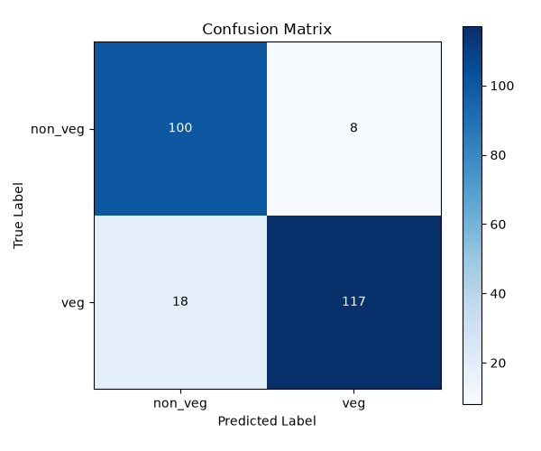

Phase 2B: Binary Categorization with YOLO Segmentation
Model Architecture: MobileNetV3-Large + YOLO Seg
Dataset: YOLO-Segmented Arabic Dishes (Veg/Non-Veg)
Accuracy: 92.70%
Hyperparameters:
- Precision/Recall: 0.93 / 0.93
- Dataset Size: 534 images in evaluation test set
Details: To improve upon the 89.30% binary classification, we introduced YOLO segmentation to crop out backgrounds and fed the cleaned images into MobileNetV3. This pushed the Veg vs Non-Veg accuracy to an impressive 92.70%, proving that removing background noise is critical for food classification.
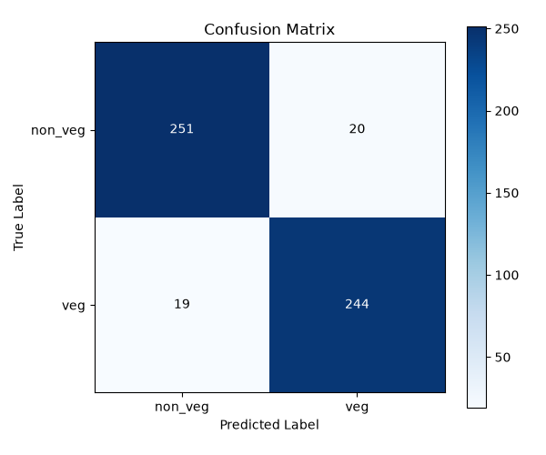

Phase 3: Cross-Domain Transfer Learning (German Dataset)
Model Architecture: MobileNetV3-Large + YOLOv8n-seg
Dataset: German Restaurant Dishes
Accuracy: 95.53%
Hyperparameters:
- Learning Rate: 1e-3 (Frozen Head) / 1e-5 (Unfrozen Backbone)
- Epochs: Stage 1 (15 max), Stage 2 (25 max)
- Preprocessing: YOLOv8 semantic segmentation mask extraction
Details: Fine-tuned the Arabic model on a new dataset of German dishes to test cross-domain generalization. Introduced YOLOv8 segmentation as a pre-processing step to crop out backgrounds and plates. The segmentation dramatically reduced background noise, pushing accuracy to ~95.5%.

Phase 4: Real-World Restaurant Testing
Model Architecture: Final Fine-Tuned German Model (MobileNetV3 + YOLOv8n-seg)
Dataset: External Arabic Restaurant Images (53 unseen test images)
Accuracy: ~77.36% (41/53)
Details: Tested the final German-tuned model on unseen real-world Arabic dishes. Images were grouped by dish and mapped to veg/non_veg labels. The model performed exceptionally well on clear dishes (Hummus, Shawarma, Tamees Bread) but struggled with visually ambiguous ones (e.g., golden-brown cheese pastries looking like meat pies, or large portions of rice hiding the meat in Mandi).
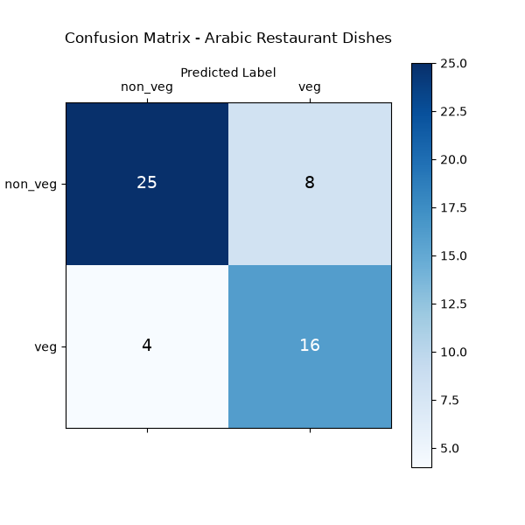

Phase 5: Dish-Wise (26-Class) Hierarchical Classifier
Model Architecture: MobileNetV3-Large
Dataset: YOLOv8 Segmented Arabic Dishes (26 distinct dishes, approx 1439 images)
Accuracy: 72.77%
Hyperparameters:
- Learning Rate: 1e-3 (Frozen Head) / 1e-5 (Unfrozen Backbone)
- Epochs: Stage 1 (15 max), Stage 2 (25 max - Early Stopped at 24)
- Output Structure: Hierarchical (veg/dish_name and non_veg/dish_name)
Details: Re-trained the model on the full YOLO-segmented dataset but this time focusing on exact dish names (26 classes). The goal was to maximize results and establish a hierarchical prediction system where images are classified by dish and then logically organized into veg or non-veg subdirectories. The validation accuracy reached ~73% which is very strong for a 26-way classification task on noisy data.
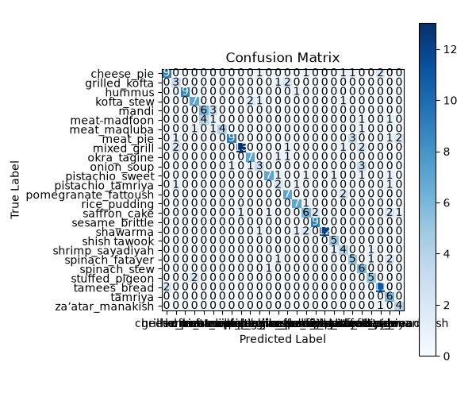

Phase 6: 35-Class Expanded Hierarchical Classifier
Model Architecture: MobileNetV3-Large + YOLO Seg
Dataset: YOLO-Segmented Arabic Dishes (35-Classes, 1,610 images)
Accuracy: 65.69%
Hyperparameters:
- Learning Rate: 1e-3 (Stage 1), 1e-5 (Stage 2)
- Early Stopping: Triggered before 25 epochs
Details: The dataset was expanded to include more images for ambiguous dishes (like Mandi) and new dish categories, pushing the total classes from 26 to 35. While overall accuracy dropped from ~73% to ~66%, this is entirely expected due to the exponential increase in task difficulty (35 classes) and the introduction of new highly ambiguous classes with very few samples.

Phase 7: Refined Binary Classification (Core 26 Classes)
Model Architecture: MobileNetV3-Large + YOLO Seg
Dataset: Cleaned 26-Class Arabic Dishes (Veg vs Non-Veg, 1,231 images)
Accuracy: 89.43%
Hyperparameters:
- Learning Rate: 1e-3 (Stage 1), 1e-5 (Stage 2)
- Early Stopping: Triggered at Epoch 8 (Stage 2)
Details: After experimenting with 35 classes, the dataset was cleaned back to the core 26 classes, substituting 'fatayer cheese' and integrating more images of the ambiguous 'mandi'. Reverting back to a Binary Classification target (Veg vs Non-Veg) using YOLO segmentation yielded a strong ~89.43% accuracy, confirming that the model easily distinguishes dietary classes when background noise is removed, even with challenging Arabic dishes.

