Food Classifier Project
Developer Walkthrough & Architecture

1. Project Overview
This document serves as a developer walkthrough for the newly reorganized Food Classifier project. The monolithic structure has been modularized into distinct directories for models, scripts, tools, and UI applications.

2. Codebase Structure
The root directory is clean and organized into logical components:
- core/: Contains the main application logic and model definitions. Inside core/models/, you will find dedicated model files like mobilenet.py and efficientnet.py. The __init__.py acts as a factory that loads the requested model.
- scripts/: Contains the active pipeline scripts used for model training and core evaluations (e.g., train.py, evaluate.py, yolo_seg_crop.py, predict.py).
- tools/: Contains all diagnostic and reporting scripts (e.g., dataset_check.py, full_dataset_diagnostic.py). Use these to check dataset integrity.
- app/: Contains your user interface scripts (ui.py, patch_ui.py) for running the interactive front-end.
- docs/: Contains generated project reports (e.g., Project_Evolution_History.docx, Architecture_Comparison_Report.docx).

3. Common Workflows & Commands

Setup & Requirements
Install all project dependencies:
pip install -r requirements.txt

Validating the Dataset
Before training, always ensure the dataset is clean and valid. This generates a dataset_report.json:
python tools/dataset_check.py --dataset /path/to/dataset

Training the Model
Run the main training pipeline. By default, it will load the model from core.models based on your arguments. Training results are saved to results/ and checkpoints/:
python scripts/train.py --dataset /path/to/dataset

Evaluating the Model
After training, evaluate the model on the test split. This generates classification reports and a confusion matrix:
python scripts/evaluate.py --dataset /path/to/dataset

Running the UI Application
To start the graphical user interface for live predictions:
python app/ui.py

4. Current Model Performance (MobileNetV3 + YOLO Seg)
The current primary architecture leverages a MobileNetV3-Large backbone with YOLO segmentation as a preprocessing step. Below are the key visualizations outlining the model's robustness.

Training Convergence
The training and validation curves demonstrating convergence over the epochs:
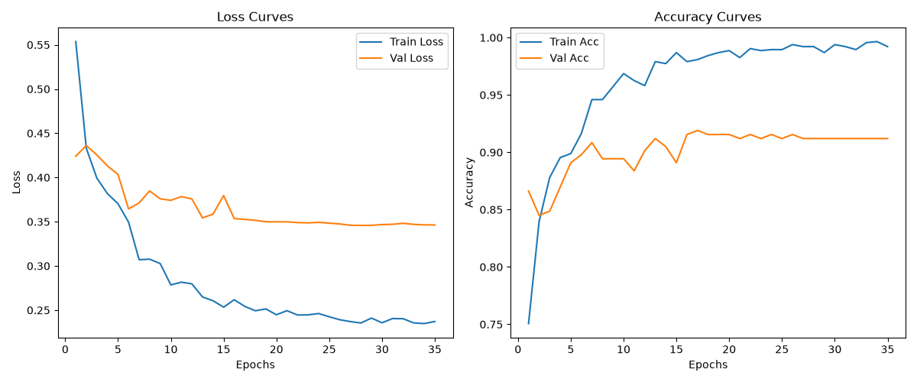

Standard Validation Results
Confusion matrix for the standard validation set, distinguishing between purely 'Veg' and 'Non-Veg' categories:
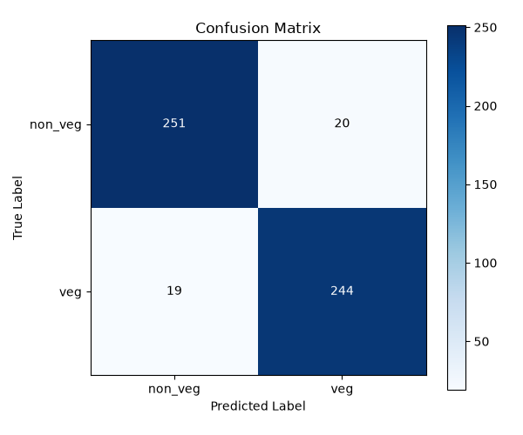

Real-World Restaurant Testing
Testing against highly ambiguous out-of-distribution real-world restaurant images (e.g., hidden meat under rice in Mandi, mixed ingredient stews).
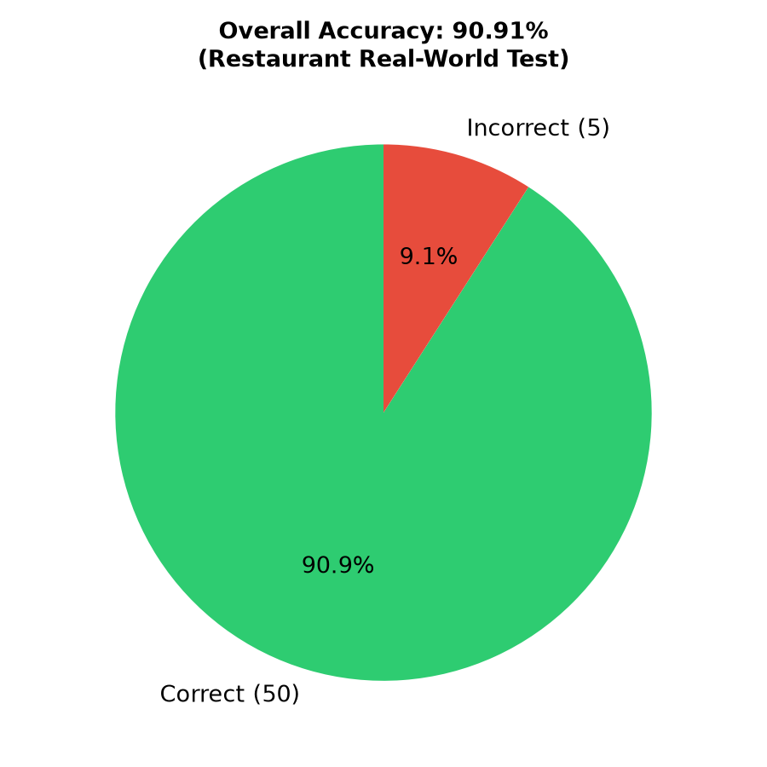
Per-Dish breakdown of the restaurant test:
