Classification Report — German Dishes
Model: MobileNetV3-Large + YOLOv8n-seg | Dataset: German Restaurant Dishes | September 06, 2026

1. Overall Performance
95.53% | 0.9553 | 0.9553 | 0.9553 | 86.6%
Accuracy | Precision | Recall | F1-Score | Avg Confidence

Summary
Metric | Value
Total Images | 2191
✅ Correct Predictions | 2093 (95.53%)
❌ Incorrect Predictions | 98 (4.47%)
⚠️ Uncertain (conf < 65%) | 193 (8.8%)
Average Confidence | 86.6%

2. Per-Class Performance
Class | Precision | Recall | F1-Score | Support | Accuracy
🥩 non_veg | 0.9574 | 0.9590 | 0.9582 | 1172 | 95.90%
🥬 veg | 0.9528 | 0.9509 | 0.9519 | 1019 | 95.09%
Macro Avg | 0.9551 | 0.9550 | 0.9550 | 2191 | —
Weighted Avg | 0.9553 | 0.9553 | 0.9553 | 2191 | —

3. Confusion Matrix
 | Predicted non_veg | Predicted veg
Actual non_veg | ✅ 1124 (TN) | ❌ 48 (FP)
Actual veg | ❌ 50 (FN) | ✅ 969 (TP)

Interpretation: The model correctly classified 1124 non-veg and 969 veg images. 48 non-veg images were wrongly predicted as veg (False Positives), and 50 veg images were wrongly predicted as non-veg (False Negatives).
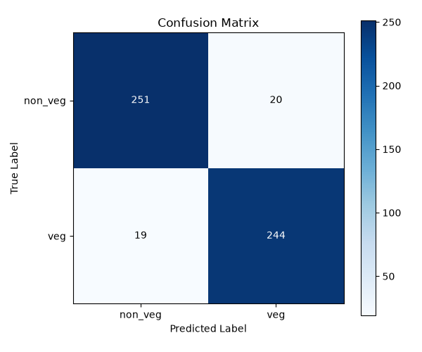

4. Per-Dish Accuracy Report
Below is the accuracy breakdown for all 30 German dishes, sorted from lowest to highest accuracy.
Dish | Class | Accuracy | Correct/Total | Wrong | Avg Conf | Status
Kartoffelpuffer | 🥬 veg | 83.3% | 60/72 | 12 | 77.6% | 🟡 Moderate
Bratkartoffeln | 🥬 veg | 84.0% | 63/75 | 12 | 83.1% | 🟡 Moderate
Garnelen gebraten | 🥩 non_veg | 88.9% | 64/72 | 8 | 82.4% | 🟢 Good
Schnitzel | 🥩 non_veg | 90.7% | 68/75 | 7 | 83.7% | 🟢 Good
Gulaschsuppe | 🥩 non_veg | 92.0% | 69/75 | 6 | 82.4% | 🟢 Good
Calamari fritti | 🥩 non_veg | 93.1% | 67/72 | 5 | 84.7% | 🟢 Good
Fischstäbchen | 🥩 non_veg | 93.1% | 67/72 | 5 | 81.0% | 🟢 Good
Spätzle | 🥬 veg | 93.3% | 70/75 | 5 | 89.6% | 🟢 Good
Maultaschen | 🥩 non_veg | 94.4% | 68/72 | 4 | 80.1% | 🟢 Good
Flädlesuppe | 🥬 veg | 94.7% | 71/75 | 4 | 86.5% | 🟢 Good
Quarkbällchen | 🥬 veg | 94.7% | 71/75 | 4 | 87.6% | 🟢 Good
Königsberger Klopse | 🥩 non_veg | 94.7% | 72/76 | 4 | 85.0% | 🟢 Good
Bratwurst | 🥩 non_veg | 95.8% | 69/72 | 3 | 87.7% | 🟢 Excellent
Kartoffelgratin | 🥬 veg | 96.0% | 72/75 | 3 | 89.4% | 🟢 Excellent
Kürbissuppe | 🥬 veg | 96.0% | 72/75 | 3 | 88.3% | 🟢 Excellent
Lachs braten | 🥩 non_veg | 97.2% | 70/72 | 2 | 83.2% | 🟢 Excellent
Käsespätzle | 🥬 veg | 97.3% | 73/75 | 2 | 91.4% | 🟢 Excellent
Milchreis | 🥬 veg | 98.0% | 49/50 | 1 | 90.1% | 🟢 Excellent
Currywurst | 🥩 non_veg | 98.6% | 71/72 | 1 | 85.7% | 🟢 Excellent
Forelle Müllerin Art | 🥩 non_veg | 98.6% | 71/72 | 1 | 89.9% | 🟢 Excellent
Krabbenbrötchen | 🥩 non_veg | 98.6% | 71/72 | 1 | 87.7% | 🟢 Excellent
Käsekuchen | 🥬 veg | 98.6% | 71/72 | 1 | 87.8% | 🟢 Excellent
Erbsensuppe | 🥬 veg | 98.7% | 74/75 | 1 | 87.5% | 🟢 Excellent
Flammkuchen | 🥬 veg | 98.7% | 74/75 | 1 | 87.3% | 🟢 Excellent
Joghurt mit Früchten | 🥬 veg | 98.7% | 74/75 | 1 | 93.4% | 🟢 Excellent
Leberknödelsuppe | 🥩 non_veg | 98.7% | 75/76 | 1 | 85.7% | 🟢 Excellent
Miesmuscheln | 🥩 non_veg | 100.0% | 72/72 | 0 | 90.5% | ✅ Perfect
Rouladen | 🥩 non_veg | 100.0% | 75/75 | 0 | 89.5% | ✅ Perfect
Sauerbraten | 🥩 non_veg | 100.0% | 75/75 | 0 | 90.5% | ✅ Perfect
Brokkolisuppe | 🥬 veg | 100.0% | 75/75 | 0 | 89.9% | ✅ Perfect

5. Error Analysis

Incorrect Predictions by Dish (Top offenders)
Dish | Wrong Predictions | Total Images | Error Rate
Bratkartoffeln | 12 | 75 | 16.0%
Kartoffelpuffer | 12 | 72 | 16.7%
Garnelen gebraten | 8 | 72 | 11.1%
Schnitzel | 7 | 75 | 9.3%
Gulaschsuppe | 6 | 75 | 8.0%
Calamari fritti | 5 | 72 | 6.9%
Fischstäbchen | 5 | 72 | 6.9%
Spätzle | 5 | 75 | 6.7%
Königsberger Klopse | 4 | 76 | 5.3%
Maultaschen | 4 | 72 | 5.6%

Uncertain Predictions (confidence < 65%)
Dish | Uncertain Count | Total | Uncertain Rate
Kartoffelpuffer | 22 | 72 | 30.6%
Maultaschen | 14 | 72 | 19.4%
Fischstäbchen | 12 | 72 | 16.7%
Schnitzel | 12 | 75 | 16.0%
Calamari fritti | 10 | 72 | 13.9%
Quarkbällchen | 10 | 75 | 13.3%
Gulaschsuppe | 9 | 75 | 12.0%
Bratkartoffeln | 9 | 75 | 12.0%
Flädlesuppe | 9 | 75 | 12.0%
Lachs braten | 8 | 72 | 11.1%

6. Key Observations
- Overall accuracy of 95.53% on 2191 German dish images after fine-tuning from the Arabic food model.
- Both classes perform equally well — non_veg: 95.8% F1, veg: 95.2% F1. No class bias.
- 10 dishes achieved 100% accuracy: Miesmuscheln, Rouladen, Sauerbraten, Brokkolisuppe, and others.
- Hardest dish: Kartoffelpuffer (83.3% acc) — golden-brown potato pancakes visually similar to breaded non-veg items.
- 193 uncertain predictions (conf < 65%) — reviewing these in prediction_images/uncertain_predictions.png may reveal data quality issues.
- Average model confidence: 86.6% — indicating the model is decisive on most German dish images.

