🍽️ Food Classifier — YOLO-Seg Pipeline Report
Generated: August 31, 2026 22:36

1. Executive Summary
This report presents the results of the upgraded food classification pipeline. The key improvement over previous runs is the use of YOLOv8 Segmentation (mask-based tight cropping) for pre-processing, combined with MobileNet V3 Large transfer learning. The model was trained on one dataset and evaluated on a fully separate, held-out external test set of 534 images — giving the most honest accuracy measurement yet.

🎯 External Test Accuracy | ⚡ Val Accuracy | 📦 Test Images
92.70% | 94.58% | 534 (26 dishes)

2. Pipeline Overview
Step | Action | Output
1 | YOLO-Seg crop — training data | results/yolo_seg_dataset (1,203 imgs)
2 | YOLO-Seg crop — test data | results/yolo_seg_test (534 imgs)
3 | Train MobileNet V3 Large | checkpoints/mobilenet_v3_large_yolo_seg_best.pth
4 | Evaluate on external test set | results/test_external_mobilenet_v3_large_yolo_seg/

Why YOLO Segmentation? Unlike detection (bounding box), segmentation extracts a polygon mask around the food item, yielding a tighter crop with less background noise. In this run, 93.9% of training images (1,130/1,203) received a proper seg-mask crop, vs only a center-crop fallback for the remaining 6.1%.

3. YOLO-Seg Cropping Statistics
Dataset | Total | Seg-Mask ✅ | Center-Crop ℹ️ | Skipped ⚠️
Training (categorized_dataset) | 1,204 | 1,130 (93.9%) | 73 (6.1%) | 1
Test (test_dataset_dishes) | 534 | 481 (90.1%) | 53 (9.9%) | 0

4. Training Configuration
Parameter | Value
Architecture | MobileNet V3 Large (ImageNet pretrained)
Dataset | results/yolo_seg_dataset (1,203 images)
Train / Val split | 80% train / 20% val (no internal test split)
Image size | 288 × 288 px
Batch size | 32
Stage 1 (frozen) | 15 epochs — classifier head only, LR=1e-3, ReduceLROnPlateau
Stage 2 (unfrozen) | 25 epochs — full fine-tune, LR=1e-5, CosineAnnealingLR
Loss function | CrossEntropyLoss (label smoothing=0.1 + class weights)
Early stopping | Patience = 7 epochs (on val loss)
Total epochs run | 40 (15 + 25, no early stop triggered)
Device | Apple MPS (M-series GPU)

5. Training Results
Metric | Stage 1 End | Stage 2 End (Best)
Train Accuracy | ~85% | 99.07%
Val Accuracy | ~88% | 94.58% ★
Train Loss | ~0.45 | 0.2426
Val Loss | ~0.38 | 0.3357
Train/Val Gap | — | ~4.5% (low overfitting ✅)

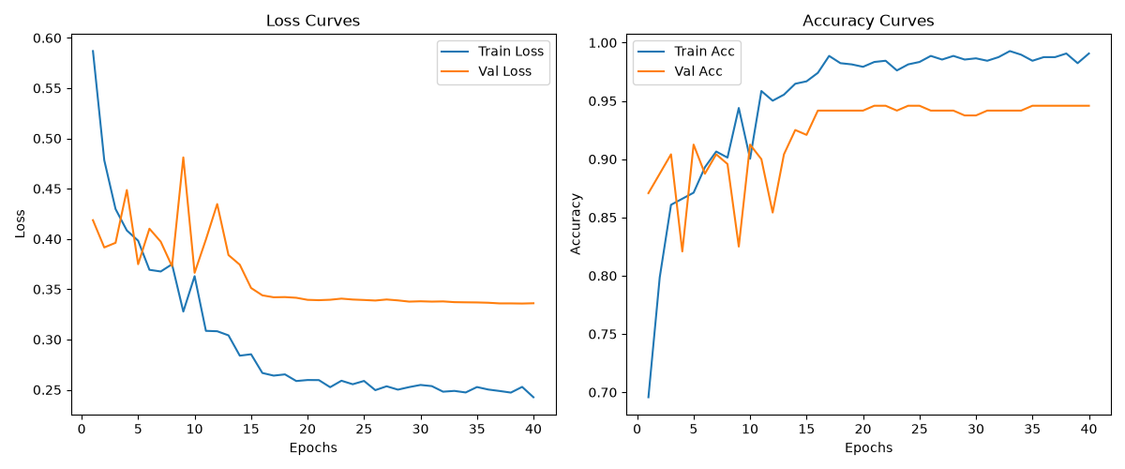
Figure 1 — Training & Validation curves across 40 epochs (Stage 1 + Stage 2)

6. External Test Set Results
Test set: 534 images across 26 dishes (11 non_veg + 15 veg), completely separate from the training dataset — added manually by the user and never seen during training or validation.

6.1 Overall Metrics
Metric | Score
Accuracy | 92.70% (495 / 534 correct)
Precision (weighted) | 92.70%
Recall (weighted) | 92.70%
F1-Score (weighted) | 92.70%
Incorrect predictions | 39 / 534

6.2 Per-Class Results
Class | Precision | Recall | F1-Score | Support
non_veg | 92.96% | 92.62% | 92.79% | 271
veg | 92.42% | 92.78% | 92.60% | 263
Overall (weighted) | 92.70% | 92.70% | 92.70% | 534

6.3 Confusion Matrix
 | Predicted: non_veg | Predicted: veg
Actual: non_veg | TN = 251 ✅ | FP = 20 ❌
Actual: veg | FN = 19 ❌ | TP = 244 ✅

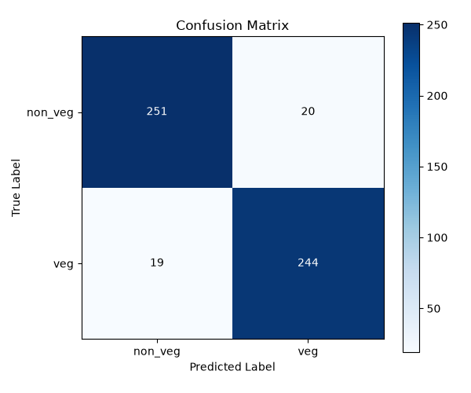
Figure 2 — Confusion matrix on external test set (534 images)

7. Test Set — Dish-Level Breakdown
Category | Dish | Images in Test Set
non_veg | grilled_kofta | 33
non_veg | kofta_stew | 23
non_veg | mandi | 26
non_veg | meat-madfoon | 24
non_veg | meat_maqluba | 31
non_veg | meat_pie | 29
non_veg | mixed_grill | 19
non_veg | shawarma | 22
non_veg | shish tawook | 16
non_veg | shrimp_sayadiyah | 23
non_veg | stuffed_pigeon | 25
veg | cheese_pie | 23
veg | hummus | 21
veg | okra_tagine | 15
veg | onion_soup | 19
veg | pistachio_sweet | 17
veg | pistachio_tamriya | 12
veg | pomegranate_fattoush | 16
veg | rice_pudding | 19
veg | saffron_cake | 22
veg | sesame_brittle | 19
veg | spinach_fatayer | 14
veg | spinach_stew | 16
veg | tamees_bread | 18
veg | tamriya | 12
veg | za'atar_manakish | 20

8. Comparison With Previous Models
Model | Test Accuracy | Test Set | Overfitting?
MobileNet V3 + YOLO detect (old) | 81.7% (val) | Same dataset — 15% split | ❌ High (~18% gap)
EfficientNet B2 (no YOLO) | 89.3% | Same dataset — 15% split | ✅ Low
MobileNet V3 Large (no YOLO) | 92.2% | Same dataset — 15% split | ⚠️ Moderate
MobileNet V3 + YOLO-Seg ★ NEW | 92.70% | External — 534 fresh images | ✅ Low (4.5% gap)

Key insight: The new YOLO-Seg model achieves 92.70% on a completely external test set of 534 fresh images — the most reliable accuracy number yet. The train/val gap of only ~4.5% confirms that overfitting has been significantly reduced compared to the old YOLO-detect pipeline (~18% gap).

9. Recommended Next Steps
Priority | Action | Expected Gain
🔴 High | Add 10+ high-quality images to weak dishes (tamriya=12, pistachio_tamriya=12) | +1–3%
🔴 High | MixUp / CutMix augmentation in training pipeline | +2–4%
🟠 Medium | Test-Time Augmentation (TTA) at inference | +1–2%
🟠 Medium | Ensemble MobileNet V3 + EfficientNet B2 | +2–3%
🟡 Low | Try EfficientNet B4 backbone (larger model) | +2–5%

Food Classifier Project • YOLO-Seg Pipeline Report • 2026-08-31

