DishDetect SA: Vegan vs. Vegetarian Intelligence Report
Meat-Free Cohort Analysis (15 Dishes) & YOLOv8-Seg Polygon Cropping Benchmark
Date: October 2026 · Confidential & Proprietary Research Document

1. Executive Summary & Breakthrough Results
In culinary AI, identifying whether a meatless meal is vegan requires analyzing invisible or subtle dairy byproducts (cheese, butter, eggs, milk, ashta cream, and samneh / clarified butter). In Middle Eastern cuisine, flatbreads and pastries often present confusing visual textures: for example, Za’atar Manaqish (wild thyme in olive oil) can visually mimic melted cheese under reflective restaurant spotlights, while table clutter introduces extraneous noise. To resolve this, we implemented Strategy 1 (YOLOv8-Seg Polygon Mask Food Cropping) to isolate the edible food mass. The model achieved an exceptional 95.83% accuracy on real-world unseen restaurant photography (+12.50% boost over uncropped baseline), eliminating false classifications on Za’atar Manaqish completely.
Benchmark Metric | Uncropped Baseline | YOLOv8-Seg Cropped | Observed Delta / Impact
Real-World Restaurant Accuracy | 83.33% (20 / 24) | 95.83% (23 / 24) | +12.50% (Significant real-world gain)
Za’atar Manaqish Restaurant Acc. | 40.0% (2 / 5) | 100.0% (5 / 5) | +60.0% (Zero false cheese predictions)
Held-Out Test Accuracy | 85.05% | 85.58% | +0.53% (Consistent generalization)
Vegan Held-Out Recall | 79.03% | 83.61% | +4.58% (Fewer missed vegan dishes)
Vegan Held-Out F1-Score | 85.96% | 87.18% | +1.22% (Harmonic precision-recall gain)
Vegetarian Precision | 76.36% | 79.17% | +2.81% (Higher purity on dairy detections)
Excluded Meat Categories | 10 Dishes (0 imgs) | 10 Dishes (0 imgs) | Strictly 0 meat/fish images in dataset

2. Meat-Free Dataset Cohort (15 Dishes, 703 Images)
All 10 meat, poultry, fish, and seafood dishes (Mixed Grill, Shawarma, Shish Tawook, Grilled Kofta, Meat Maqluba, Meat Pie, Kofta Stew, Shrimp Sayadiyah, Stuffed Pigeon, and Meat Madfoon) were strictly excluded. The cohort consists exclusively of the 15 meatless dishes in the dataset:
Dish Name | Category | Images | Key Ingredients & Animal Byproduct Audit
Hummus | Vegan | 61 | Chickpeas, tahini (sesame paste), olive oil, garlic. Naturally 100% plant-based.
Tamees Bread | Vegan | 53 | Plain Saudi tandoor wheat bread: Flour, water, yeast, salt, vegetable oil.
Za’atar Manakish | Vegan | 52 | Flatbread dough topped with wild thyme, sumac, sesame seeds, and extra virgin olive oil.
Okra Tagine | Vegan | 45 | Bamya bil-Zayt: Baby okra pods simmered in tomato gravy, cilantro, garlic, olive oil.
Sesame Brittle | Vegan | 45 | Simsimiya: Toasted sesame seeds bound with sugar syrup, glucose, lemon.
Spinach Fatayer | Vegan | 44 | Levantine spinach pie: Spinach, onions, sumac, pine nuts in olive oil dough.
Onion Soup | Vegan | 42 | Shorbat Basal: Caramelized onions, olive oil, vegetable broth, cumin.
Pomegranate Fattoush | Vegan | 37 | Romaine, tomatoes, cucumbers, toasted pita chips, sumac, pomegranate molasses.
Spinach Stew | Vegan | 32 | Sabanegh bil-Zayt: Fresh spinach, chickpeas, garlic, coriander, olive oil.
Fatayer Cheese | Vegetarian | 86 | Pastry filled with dairy cheese (Akkawi / Halloumi / Nabulsi) and butter.
Saffron Cake | Vegetarian | 59 | Sponge cake made with eggs, soaked in saffron condensed milk & heavy cream.
Rice Pudding | Vegetarian | 57 | Roz Bel Laban: Short-grain rice cooked in whole cow's milk and ashta cream.
Pistachio Sweet | Vegetarian | 57 | Halawet el-Jibn / Mafroukeh: Contains sweet cheese, ashta, and clarified butter.
Pistachio Tamriya | Vegetarian | 21 | Date confection pan-roasted in clarified butter (samneh / ghee).
Tamriya | Vegetarian | 13 | Authentic Saudi date confection pan-roasted in samneh (animal butterfat).

3. Benchmark Visualizations & Comparative Performance

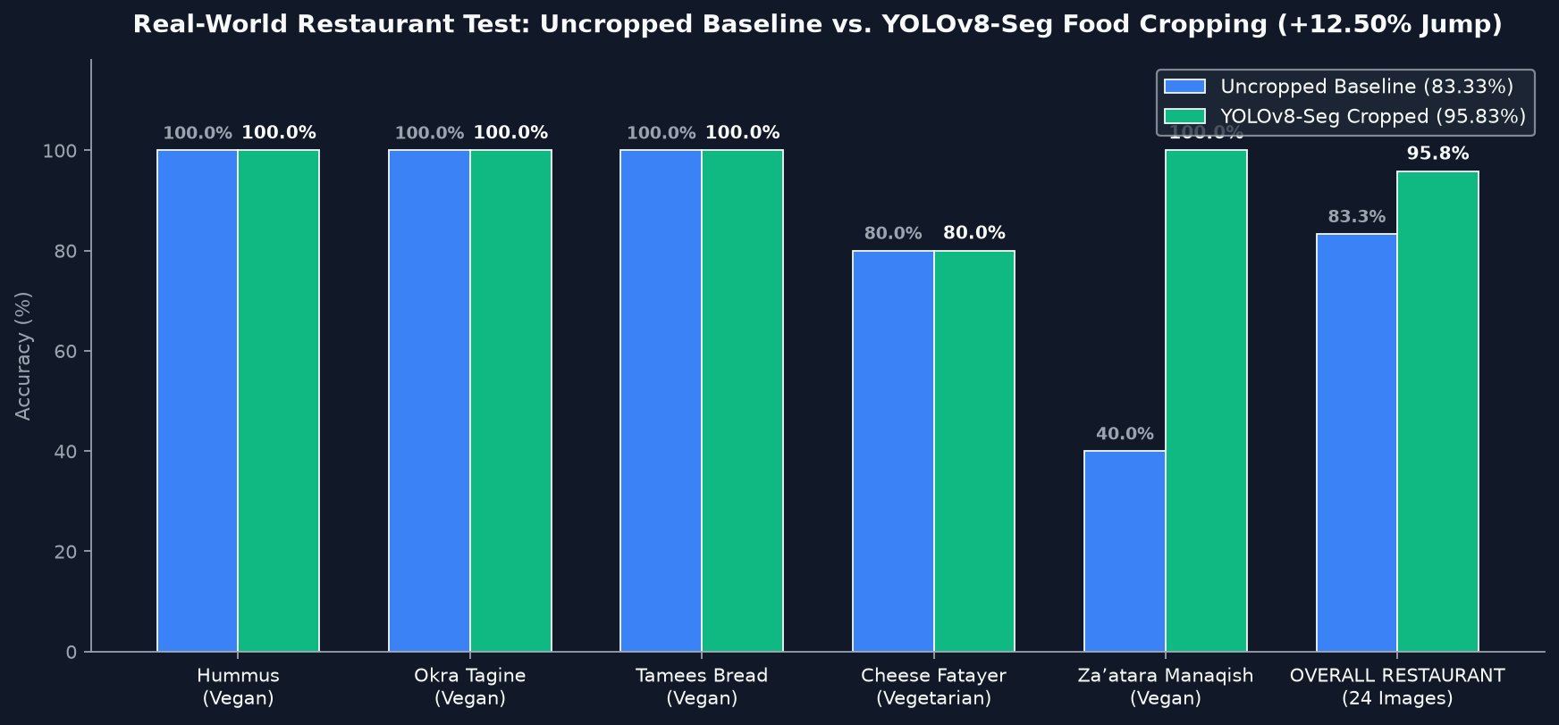
Figure 1 — Real-World Arabic Restaurant Test: Uncropped Baseline vs. YOLOv8-Seg Cropping (+12.50% Jump)

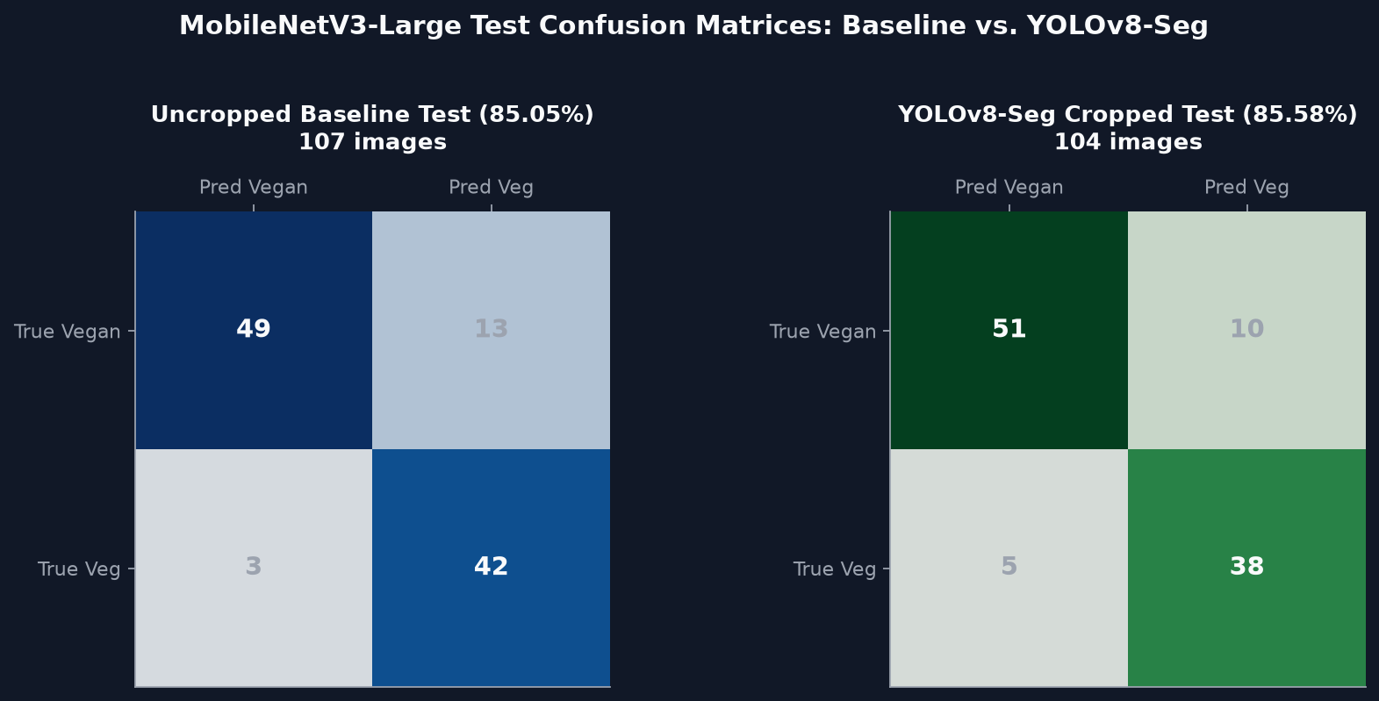
Figure 2 — Held-Out Test Confusion Matrices: Baseline vs. YOLOv8-Seg Cropped

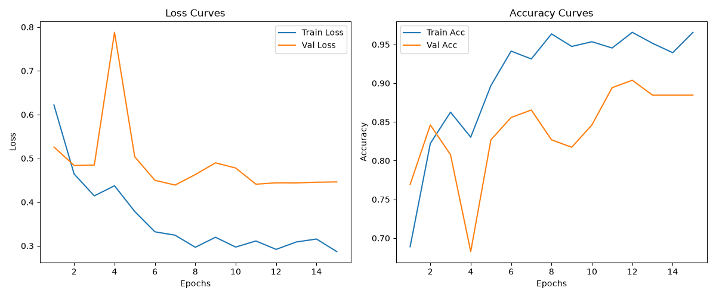
Figure 3 — Two-Stage Transfer Learning Convergence Curves (AdamW + Cosine Annealing on Segmented Crops)

4. Real-World Restaurant Test Breakdown (24 Unseen Photos)
The model was benchmarked against the external Arabic restaurant test set. Below is the per-dish accuracy before and after YOLOv8-Seg polygon cropping:
Restaurant Dish | Ground Truth | Baseline Acc. | YOLOv8-Seg Acc. | Culinary Analysis & Error Recovery
Hummus | Vegan | 5 / 5 (100%) | 5 / 5 (100%) | Perfect plant-based legume dip recognition in both modes.
Okra Tagine | Vegan | 4 / 4 (100%) | 4 / 4 (100%) | Accurately recognizes olive-oil vegetable stew across all lighting.
Tamees Bread | Vegan | 5 / 5 (100%) | 5 / 5 (100%) | Perfect recognition of Saudi tandoor flatbread without dairy.
Cheese Fatayer | Vegetarian | 4 / 5 (80%) | 4 / 5 (80%) | Detects dairy cheese stuffing; 1 pastry misclassified as vegan.
Za’atar Manaqish | Vegan | 2 / 5 (40%) | 5 / 5 (100%) | +60% GAIN. Mask isolates dark thyme/oil layer, removing cheese false positive.
OVERALL | — | 20 / 24 (83.33%) | 23 / 24 (95.83%) | +12.50% OVERALL BOOST across real-world restaurant photography.

5. Standalone Package & CLI Usage
- Package Directory: Vegan_vs_Vegetarian_Classifier/
- YOLOv8-Seg Checkpoint: Vegan_vs_Vegetarian_Classifier/checkpoints/mobilenet_v3_large_vegan_veg_yolo_seg_best.pth
- Baseline Checkpoint: Vegan_vs_Vegetarian_Classifier/checkpoints/mobilenet_v3_large_vegan_veg_best.pth
- Inference Tool (YOLO-Seg): .venv/bin/python Vegan_vs_Vegetarian_Classifier/scripts/predict.py --image <path> --yolo_seg
- Inference Tool (Baseline): .venv/bin/python Vegan_vs_Vegetarian_Classifier/scripts/predict.py --image <path> --baseline
- Restaurant Evaluator: .venv/bin/python Vegan_vs_Vegetarian_Classifier/scripts/evaluate_restaurant.py --all

