🍽️ DishDetect SA
Veg / Non-Veg Food Intelligence

Complete Developer & Research Walkthrough Book

Saudi Arabia • Arabic Food Classification • PyTorch • YOLOv8
github.com/Mehdidar/DishDetect-SA
Generated: 10 October 2026

Table of Contents
- Chapter 1: Project Overview & Goals
- Chapter 2: The Six-Stage Pipeline
- Chapter 3: Dataset — Collection, Cleaning & Evolution
- Chapter 4: Model Architecture & Training Strategy
- Chapter 5: Phase-by-Phase Development History
- Chapter 6: Results & Performance Metrics
- Chapter 7: Real-World Restaurant Testing
- Chapter 8: Architecture Comparison: MobileNetV3 vs EfficientNet-B2
- Chapter 9: Known Flaws & Failure Analysis
- Chapter 10: Lessons Learned
- Chapter 11: How to Run the Project
- Chapter 12: Next Steps & Roadmap

Chapter 1 — Project Overview & Goals
DishDetect SA is an end-to-end deep learning system designed to automatically classify food images from Saudi Arabian and Arabic restaurants as Vegetarian (Veg) or Non-Vegetarian (Non-Veg). The system was built to address a real-world need: restaurant-goers and food platforms often lack reliable dietary labelling for traditional Arabic cuisines, especially in the Saudi market.

Core Objectives:
- Accurately classify food images as Veg or Non-Veg with >90% restaurant accuracy
- Handle ambiguous dishes such as Shawarma, Mandi, and Okra Tagine
- Generalize across different cuisines (Arabic, German cross-domain test)
- Build a complete production pipeline from data collection to a live GUI app

Headline Results:
Benchmark | Accuracy | Details
Standard Test Set | 92.70% | 534 held-out images — MobileNetV3 + YOLO
Restaurant Real-World | 92.73% | 55 Saudi restaurant images (Phase 8 peak)
German Cross-Domain | 95.53% | 2,191 German restaurant images
26-Class Dish Level | 67.61% | Exact dish recognition (26 categories)
35-Class Dish Level | 67.01% | Expanded hierarchical classifier

Chapter 2 — The Six-Stage Pipeline
The DishDetect SA pipeline is a sequential six-stage system. Each stage applies a specialized tool to progressively refine raw internet images into a reliable Veg/Non-Veg classification. The flowchart below illustrates the complete data flow.

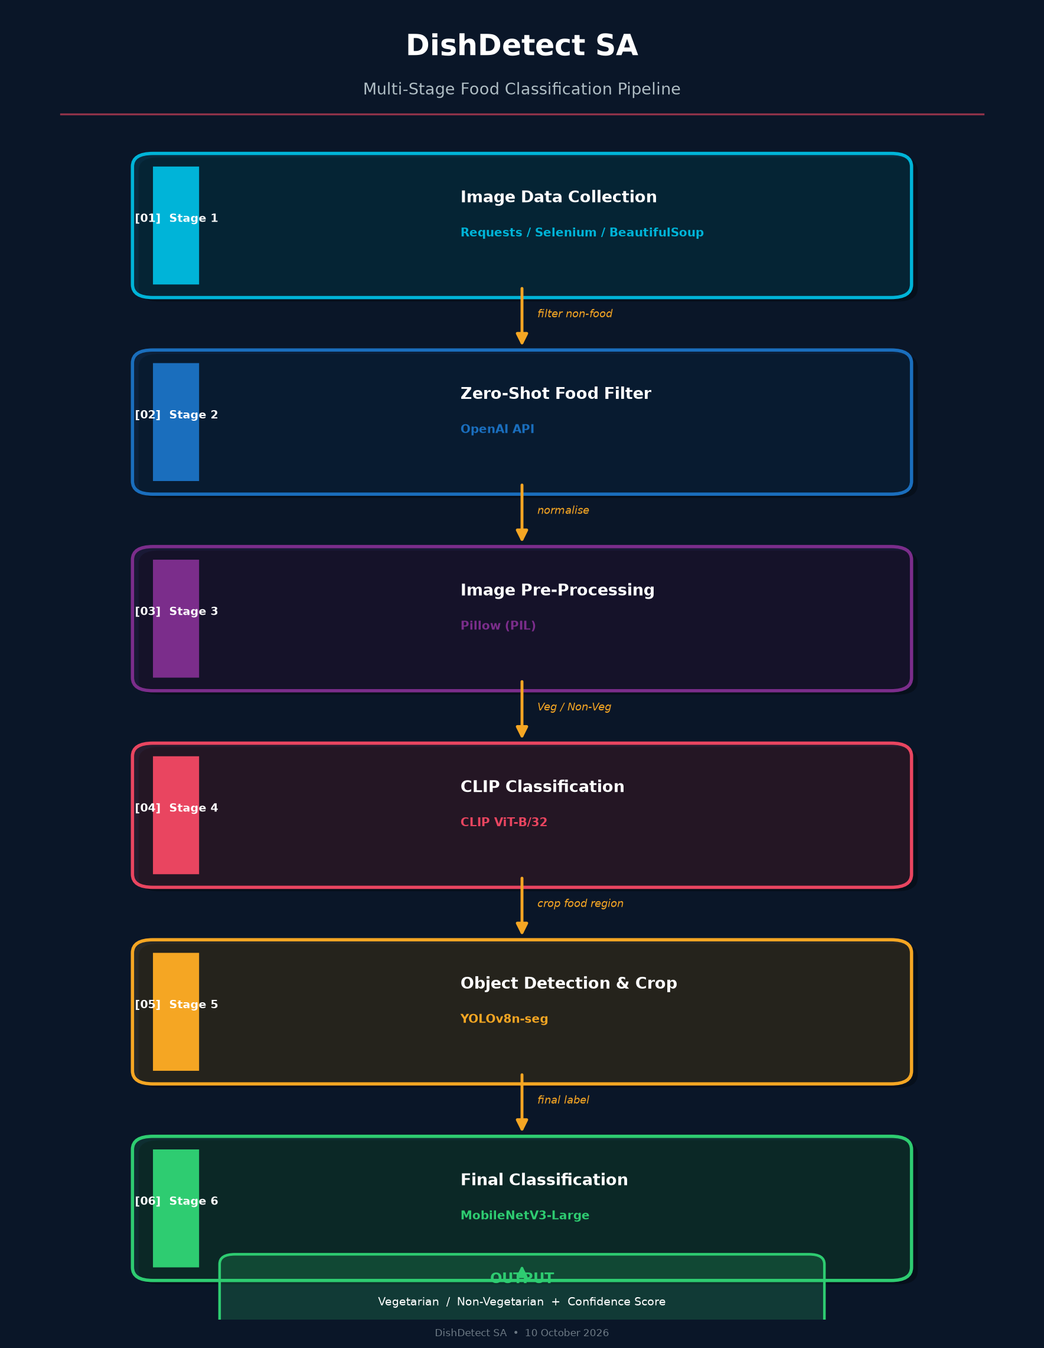
Figure 1 — DishDetect SA: Complete Six-Stage Pipeline Flowchart

Stage 1 — Image Data Collection
- Tool: Requests, Selenium, BeautifulSoup
Food images are automatically scraped from online sources relevant to the Saudi Arabian market. Requests handles direct HTTP downloads, Selenium automates JavaScript-heavy platforms, and BeautifulSoup parses HTML to extract image links.

Stage 2 — Zero-Shot Food Filter
- Tool: OpenAI API
Not all scraped images are food. OpenAI's zero-shot classification model verifies each image is actually food. Non-food images (packaging, advertisements, people) are discarded, significantly improving dataset quality before any heavy processing.

Stage 3 — Image Pre-Processing
- Tool: Pillow (PIL)
All verified images are resized to a consistent resolution, converted to RGB, normalised, and lightly augmented (flipping, brightness jitter). Corrupt or unreadable images are logged and discarded automatically.

Stage 4 — CLIP Classification
- Tool: CLIP ViT-B/32 (OpenAI)
CLIP performs zero-shot Veg/Non-Veg classification using vision-language prompts ('a vegetarian dish' vs 'a non-vegetarian dish with meat'). This provides a fast, training-free first-pass classification that filters the most obvious errors.

Stage 5 — Object Detection & Cropping
- Tool: YOLOv8n-seg (Ultralytics)
YOLOv8 detects the primary food object and generates a pixel-level segmentation mask. The food is extracted and the background is removed entirely. This was the single largest accuracy improvement in the project: +3.4 percentage points.

Stage 6 — Final Classification
- Tool: MobileNetV3-Large (PyTorch)
The clean, cropped food image is passed to a fine-tuned MobileNetV3-Large model for the final Veg/Non-Veg prediction with a confidence score. The model was trained using two-stage transfer learning on ~1,400+ Arabic food images.

YOLO Segmentation Deep Dive
The YOLO segmentation step deserves special attention because it was the single most impactful change in the entire project. The diagram below shows exactly what happens when an image passes through YOLOv8n-seg:
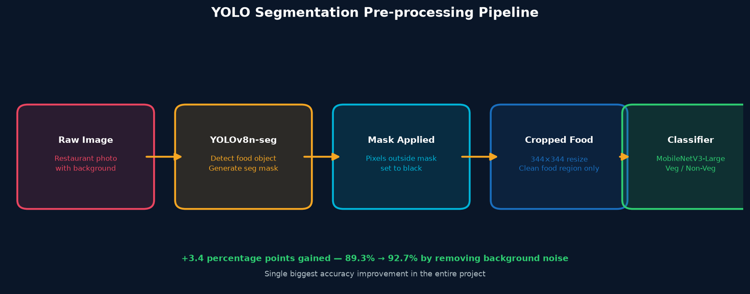
Figure 2 — YOLO Segmentation Pre-processing Pipeline (+3.4pp accuracy gain)

Chapter 3 — Dataset: Collection, Cleaning & Evolution
The dataset was never static. It was continuously collected, cleaned, and expanded across 10+ project phases. The chart below shows its growth and composition.
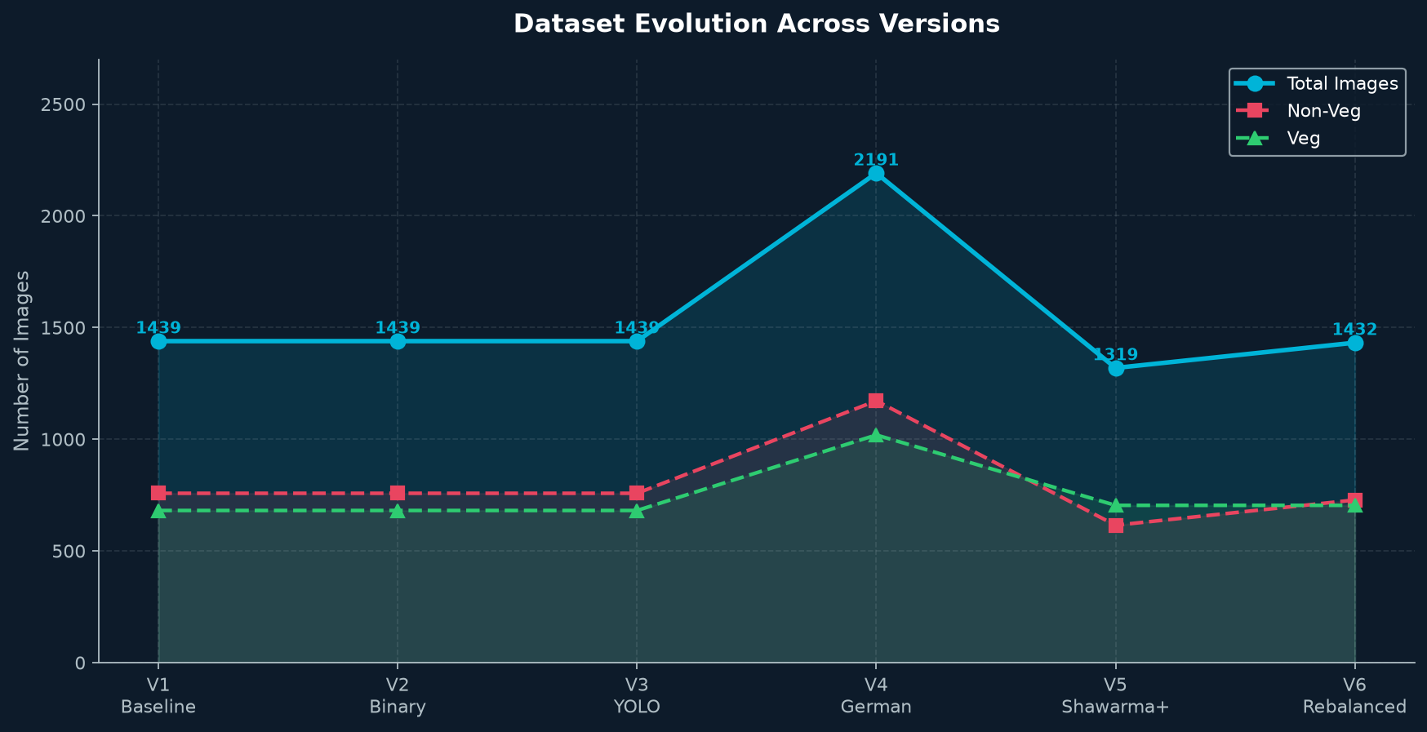
Figure 3 — Dataset Evolution: Images per version with Veg/Non-Veg split

Dataset Versions
Version | Total | Non-Veg | Veg | Key Change
V1 Baseline | ~1,439 | 758 | 681 | Raw Arabic dishes, 25 dish classes
V2 Binary | ~1,439 | 758 | 681 | Re-labelled as Veg / Non-Veg
V3 YOLO | ~1,439 | 758 | 681 | YOLOv8 background removal added
V4 German | 2,191 | 1,172 | 1,019 | Cross-domain: 30 German dish types
V5 Shawarma+ | 1,319 | 615 | 704 | Shawarma boosted 5 → 86 images (17×)
V6 Rebalanced | 1,432 | 728 | 704 | Non-veg rebalanced; Shish Tawook +80
35-Dish | 1,306 | — | — | 35-class hierarchical classifier

Data Cleaning Protocol
- Corrupt & unsupported files: 1 corrupt image + 8 .avif / .DS_Store files removed
- Size filtering: Images below minimum CNN-usable resolution discarded
- Duplicate leakage prevention: Perceptual hashing (threshold=5) ensures near-duplicates land in the same split
- Train / Val / Test split: 70% / 15% / 15% stratified three-way split
- Image resolution: 344×344 px (primary) — also tested 288 and 224
- Class weights: Inverse-frequency weights in CrossEntropyLoss to handle imbalance

Chapter 4 — Model Architecture & Training Strategy
The classifier is built on MobileNetV3-Large — a lightweight but highly capable convolutional neural network pre-trained on ImageNet. It was chosen for its balance of accuracy, speed, and deployability (only ~5M parameters).

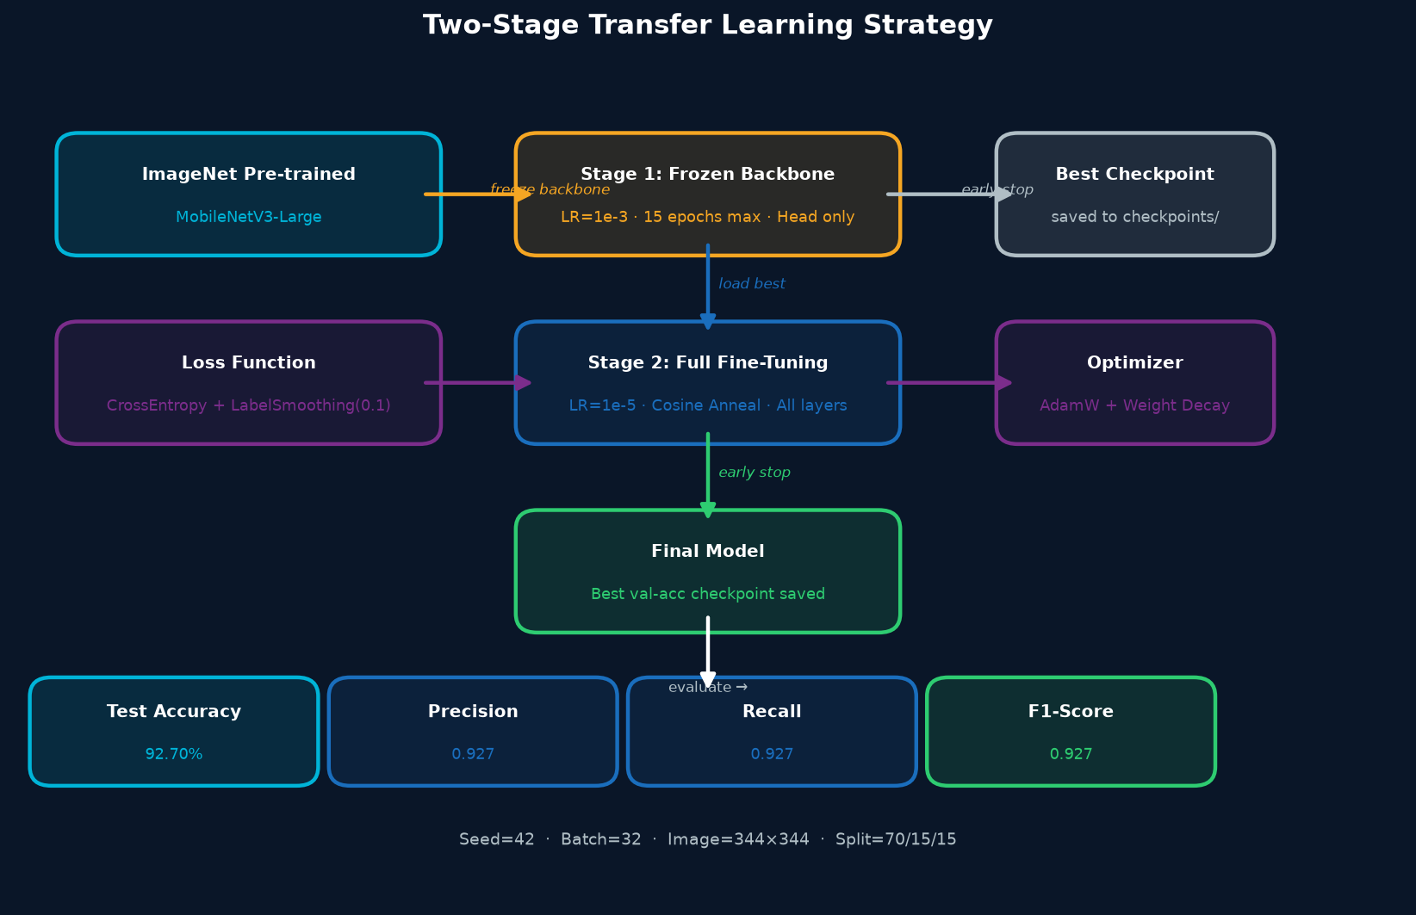
Figure 4 — Two-Stage Transfer Learning Flow with all hyperparameters

Hyperparameters
Parameter | Stage 1 (Frozen) | Stage 2 (Fine-Tune)
Learning Rate | 1e-3 | 1e-5
Max Epochs | 15 | 25 (early stop)
Optimizer | AdamW | AdamW
LR Schedule | None | Cosine Annealing
Backbone | FROZEN | UNFROZEN (all layers)
Batch Size | 32 | 32
Image Size | 344×344 | 344×344
Loss Function | CrossEntropy + Label Smoothing (0.1) | CrossEntropy + Label Smoothing (0.1)
Early Stop Pat. | 7 epochs | 7 epochs
Random Seed | 42 | 42

Model Specifications
Property | MobileNetV3-Large | EfficientNet-B2 (comparison)
Parameters | ~5M | ~9M
Backbone | MobileNetV3 | EfficientNet-B2
Pre-training | ImageNet | ImageNet
Fine-tuning | Full (2-stage) | Stage 1 only (CPU limitation)
Standard Acc. | 92.70% | 84.0%
Restaurant Acc. | 90.9% | 90.9%
Speed | Fast | Slow (~2× slower)

Chapter 5 — Phase-by-Phase Development History
The project evolved through 10 distinct phases, each adding a new technique, dataset expansion, or evaluation. The chart below summarises accuracy across phases.
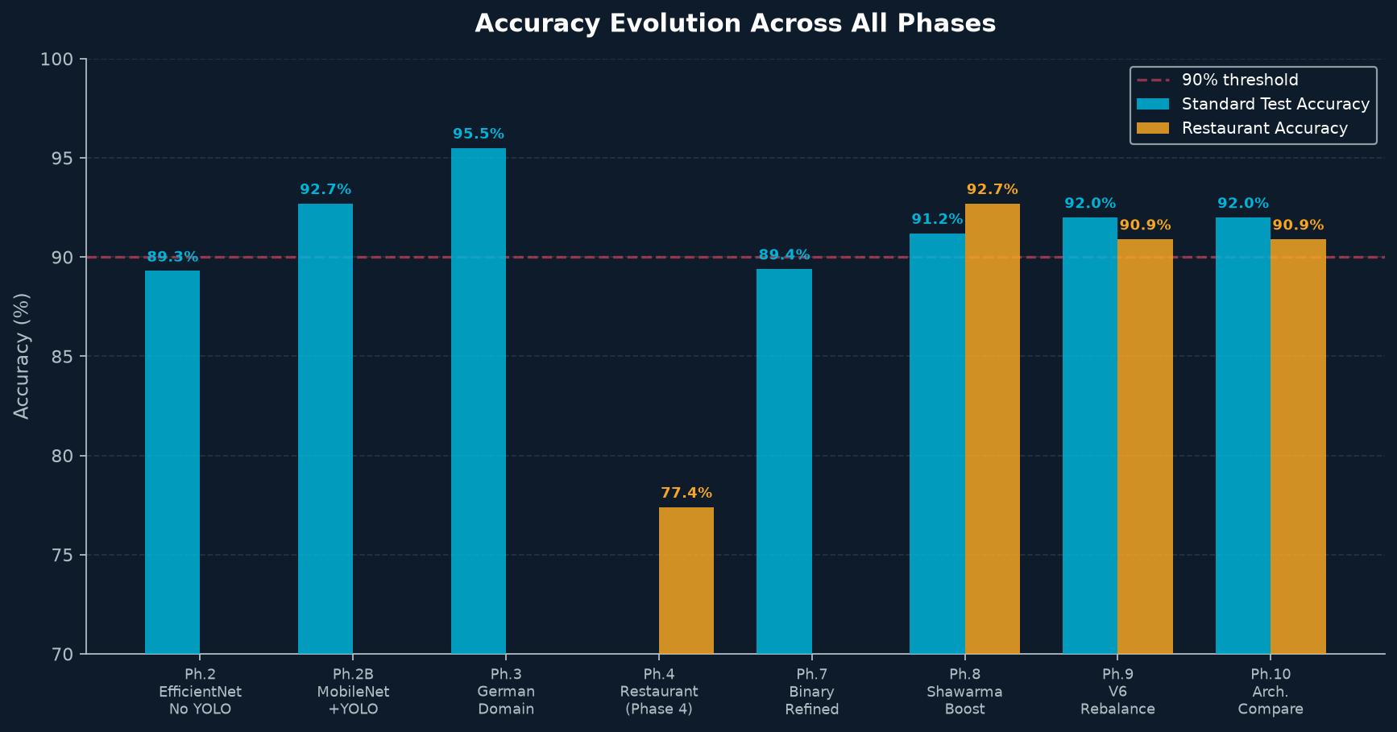
Figure 5 — Accuracy Evolution: Standard Test & Restaurant Accuracy Across All Phases

Phase 1 — Baseline 25-Class Dish Classifier
Attribute | Value
Model | MobileNetV3-Large
Dataset | ~1,439 (25 classes)
Standard Test Acc. | Qualitative
Restaurant Acc. | N/A
The first model tried to predict exact dish names across 25 Arabic categories. Visual ambiguity between similar-looking rice and meat dishes caused confusion, proving we needed to simplify the task.

Phase 2 — Binary Veg/Non-Veg — EfficientNet, No YOLO
Attribute | Value
Model | EfficientNet-B2
Dataset | ~1,439 (binary)
Standard Test Acc. | 89.30%
Restaurant Acc. | N/A
Restructuring to 2 classes caused a dramatic accuracy jump (+~5pp). Proved that learning dietary categories is far easier than exact dish names.

Phase 2B — MobileNetV3 + YOLO (First YOLO Run)
Attribute | Value
Model | MobileNetV3+YOLO
Dataset | ~1,439 (binary)
Standard Test Acc. | 92.70%
Restaurant Acc. | N/A
Adding YOLO segmentation was the project's biggest single improvement: +3.4pp from 89.3% → 92.7% by removing background noise.

Phase 3 — Cross-Domain: German Restaurant Dataset
Attribute | Value
Model | MobileNetV3+YOLO
Dataset | 2,191 German images
Standard Test Acc. | 95.53%
Restaurant Acc. | N/A
Fine-tuning on an entirely different cuisine (German) proved the pipeline generalizes across domains. Weakest dishes: Kartoffelpuffer (83.3%) and Bratkartoffeln (84.0%).

Phase 4 — Real-World Arabic Restaurant Testing
Attribute | Value
Model | German-Tuned Model
Dataset | 53 restaurant images
Standard Test Acc. | N/A
Restaurant Acc. | ~77.36%
First real-world restaurant test revealed a domain gap. The German-tuned model struggled with Arabic visual ambiguity: Shawarma vs flatbread, Mandi meat vs rice.

Phase 5 — Hierarchical 26-Class Dish Classifier
Attribute | Value
Model | MobileNetV3+YOLO
Dataset | ~1,439 (26 classes)
Standard Test Acc. | ~68%
Restaurant Acc. | N/A
Returned to dish-level classification with YOLO preprocessing. 67.6% val accuracy — strong for a 26-way task but limited by training data volume.

Phase 6 — Expanded 35-Class Dish Classifier
Attribute | Value
Model | MobileNetV3+YOLO
Dataset | 1,306 (35 classes)
Standard Test Acc. | 67.01%
Restaurant Acc. | N/A
Expanding to 35 classes naturally dropped accuracy slightly. Binary Veg/Non-Veg accuracy remained at 98% via category aggregation.

Phase 7 — Refined Binary — V5 Dataset
Attribute | Value
Model | MobileNetV3+YOLO
Dataset | 1,231 images (binary)
Standard Test Acc. | 89.43%
Restaurant Acc. | N/A
Cleaned back to core 26 dishes, retrained as binary. Early stopping at Epoch 8 Stage 2.

Phase 8 — Shawarma-Boosted — PEAK Restaurant Score
Attribute | Value
Model | MobileNetV3+YOLO
Dataset | 1,319 (V5)
Standard Test Acc. | 91.20%
Restaurant Acc. | 92.73% ★
17× Shawarma data boost pushed 8/10 restaurant dishes to 100%. This was the ALL-TIME BEST restaurant accuracy. Shawarma still at 57.1%.

Phase 9 — V6 Rebalance (1,432 images)
Attribute | Value
Model | MobileNetV3+YOLO
Dataset | 1,432 (V6)
Standard Test Acc. | 92.0%
Restaurant Acc. | 90.9%
Added 113 new images. Shish Tawook recovered to 100%. Shawarma still 57.1%. Standard test improved to 92.0% due to better class balance.

Phase 10 — Architecture Experiment: MobileNet vs EfficientNet
Attribute | Value
Model | Both
Dataset | V6 (1,432)
Standard Test Acc. | 92.0% / 84.0%
Restaurant Acc. | 90.9% / 90.9%
Both architectures hit the same 90.9% restaurant ceiling — proving the bottleneck is data, not architecture. EfficientNet Stage 2 cancelled (>5h/epoch on CPU).

Chapter 6 — Results & Performance Metrics
Primary Model: MobileNetV3-Large + YOLOv8n-seg | Dataset: V6 (1,432 images) | Resolution: 344×344px

6.1 Standard Test Set Results (534 images)
Metric | Non-Veg Class | Veg Class | Overall (Weighted)
Precision | 0.93 | 0.92 | 0.927
Recall | 0.93 | 0.93 | 0.927
F1-Score | 0.93 | 0.93 | 0.927
Support | 271 | 263 | 534
Accuracy | — | — | 92.70%

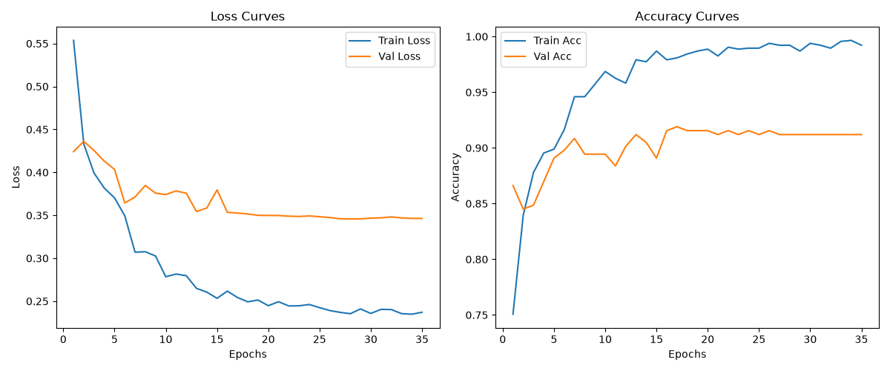
Figure 6 — Training & Validation Loss/Accuracy Curves (MobileNetV3 + YOLO)
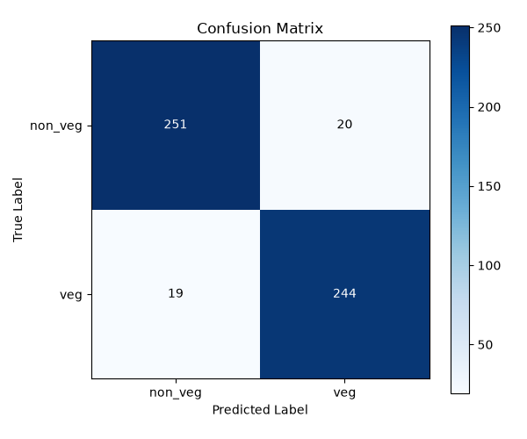
Figure 7 — Confusion Matrix: Standard Validation Set (MobileNetV3 + YOLO Seg)

6.2 External Test Set (534 images — zero overlap with training)
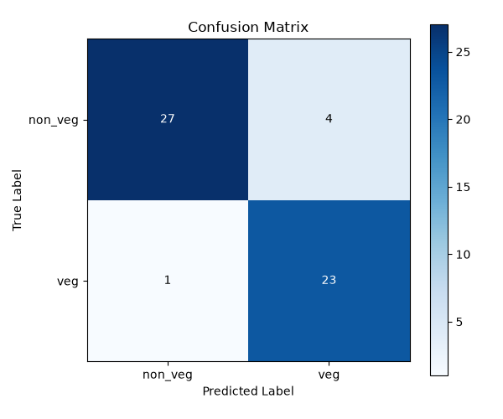
Figure 8 — Confusion Matrix: External Standard Test Set (no training overlap)

Chapter 7 — Real-World Restaurant Testing
The ultimate benchmark for this project was not the standard test set but real-world images from Saudi restaurants — out-of-distribution photos with complex plating, restaurant lighting, and ambiguous presentations.

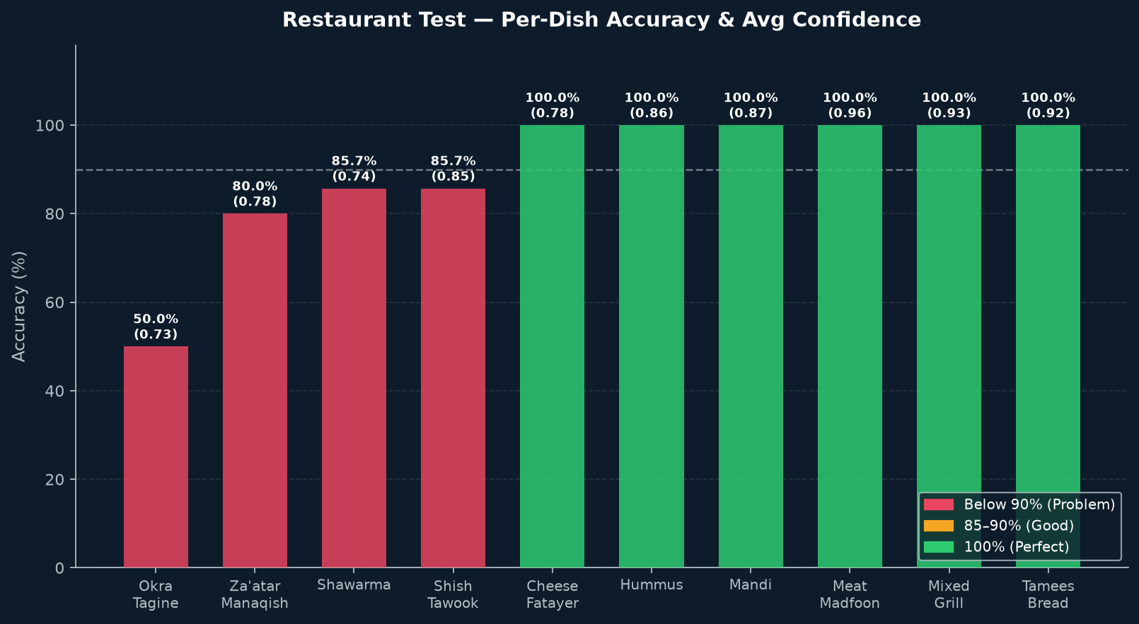
Figure 9 — Restaurant Test: Per-Dish Accuracy & Confidence Scores

Per-Dish Results (Current Model)
Dish | Category | Correct/Total | Accuracy | Avg Confidence | Status
Okra Tagine | Veg | 2/4 | 50.0% | 0.730 | ⚠️ Critical
Za'atar Manaqish | Veg | 4/5 | 80.0% | 0.775 | ⚠️ Needs Work
Shawarma | Non-Veg | 6/7 | 85.7% | 0.742 | ⚠️ Needs Work
Shish Tawook | Non-Veg | 6/7 | 85.7% | 0.850 | ⚠️ Needs Work
Cheese Fatayer | Veg | 5/5 | 100.0% | 0.775 | ✅ Perfect
Hummus | Veg | 5/5 | 100.0% | 0.864 | ✅ Perfect
Mandi | Non-Veg | 7/7 | 100.0% | 0.866 | ✅ Perfect
Meat Madfoon | Non-Veg | 5/5 | 100.0% | 0.965 | ✅ Perfect
Mixed Grill | Non-Veg | 5/5 | 100.0% | 0.930 | ✅ Perfect
Tamees Bread | Veg | 5/5 | 100.0% | 0.915 | ✅ Perfect
OVERALL | — | 47/53 | 88.68% | 0.852 | —

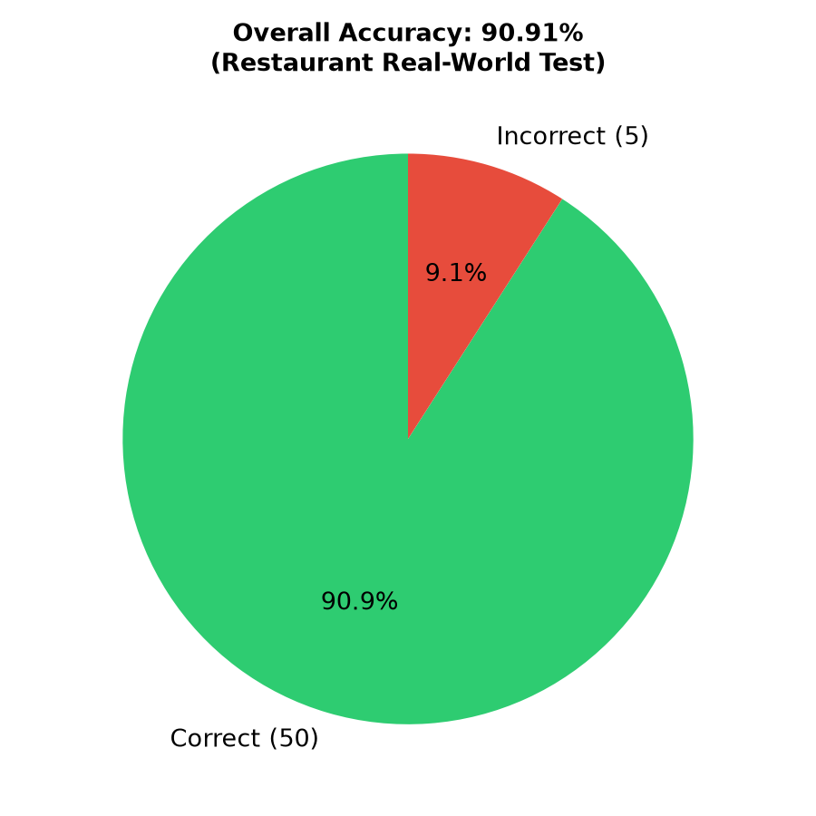
Figure 10 — Overall Restaurant Test Accuracy Pie Chart
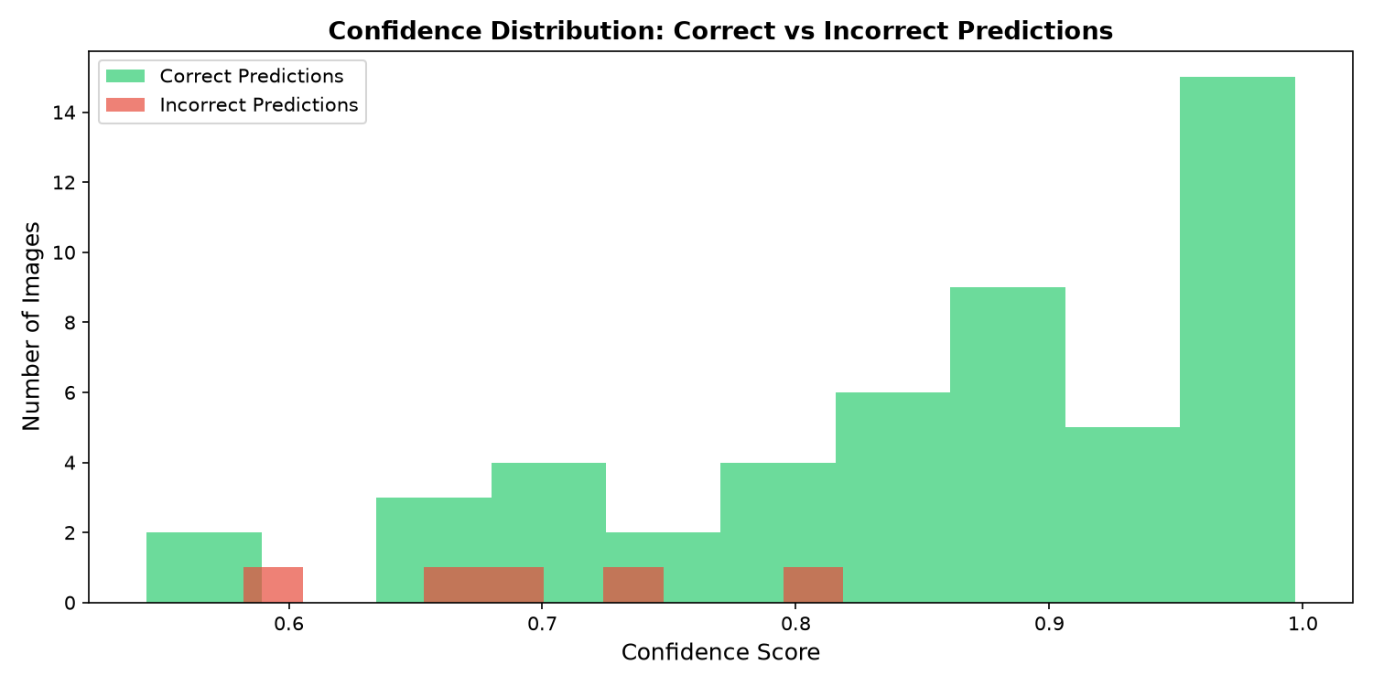
Figure 11 — Confidence Score Distribution for Restaurant Predictions
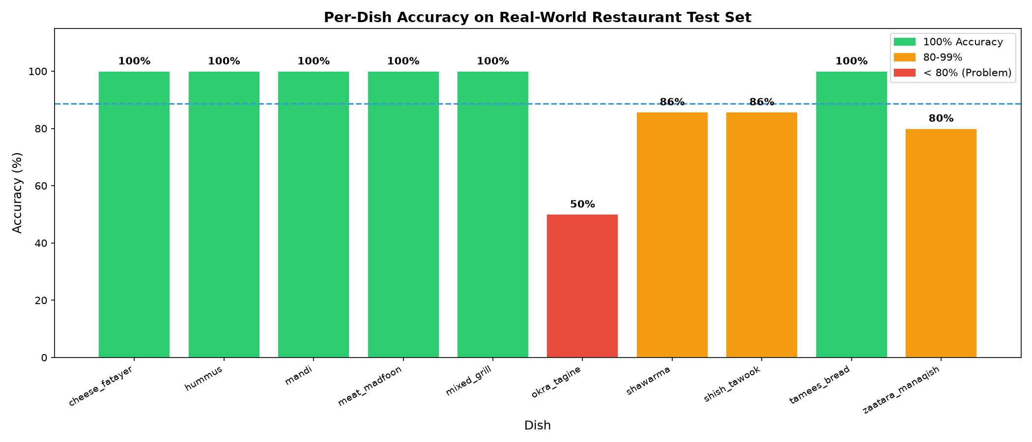
Figure 12 — Per-Dish Accuracy Bar Chart (Restaurant Test Set)

Chapter 8 — Architecture Comparison: MobileNetV3 vs EfficientNet-B2
In Phase 10, both architectures were trained on the identical V6 dataset at 344×344 resolution with the same hyperparameters. This was a controlled experiment to isolate the effect of architecture alone.

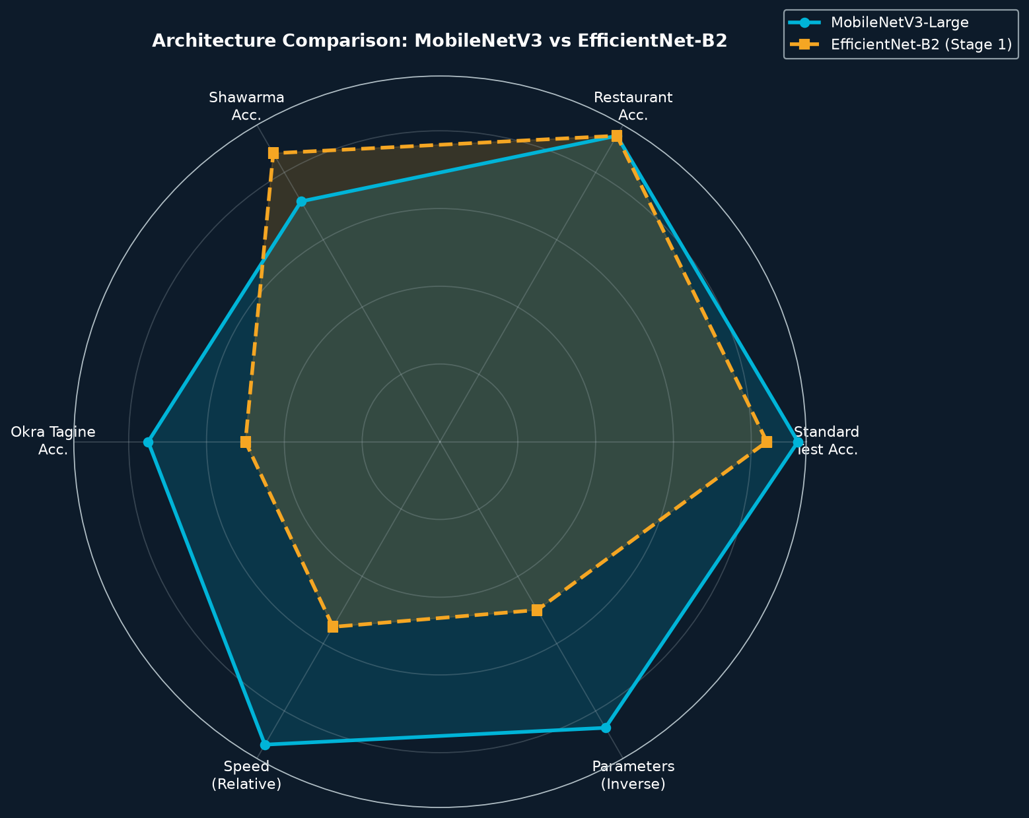
Figure 13 — Radar Chart: MobileNetV3-Large vs EfficientNet-B2 (Stage 1 only)

Key Finding: The 90.9% Restaurant Ceiling
Both architectures hit exactly 90.9% restaurant accuracy despite very different standard test scores (92% vs 84%). This reveals a fundamental truth: the bottleneck is NOT the architecture — it is the training data. The same 4-5 images are always misclassified regardless of which model is used.

Dish | MobileNetV3 | EfficientNet-B2 | Analysis
Cheese Fatayer | 100% | 100% | Perfect on both
Hummus | 100% | 100% | Perfect on both
Mandi | 100% | 100% | Perfect on both
Meat Madfoon | 100% | 100% | Perfect on both
Mixed Grill | 100% | 100% | Perfect on both
Tamees Bread | 100% | 100% | Perfect on both
Shawarma | 71.4% (5/7) | 85.7% (6/7) | EfficientNet found hidden meat texture
Shish Tawook | 85.7% (6/7) | 85.7% (6/7) | Identical — garlic sauce fools both
Za'atar Manaqish | 100% (5/5) | 80.0% (4/5) | EfficientNet over-fitted herb texture
Okra Tagine | 75.0% (3/4) | 50.0% (2/4) | EfficientNet confused by stew texture

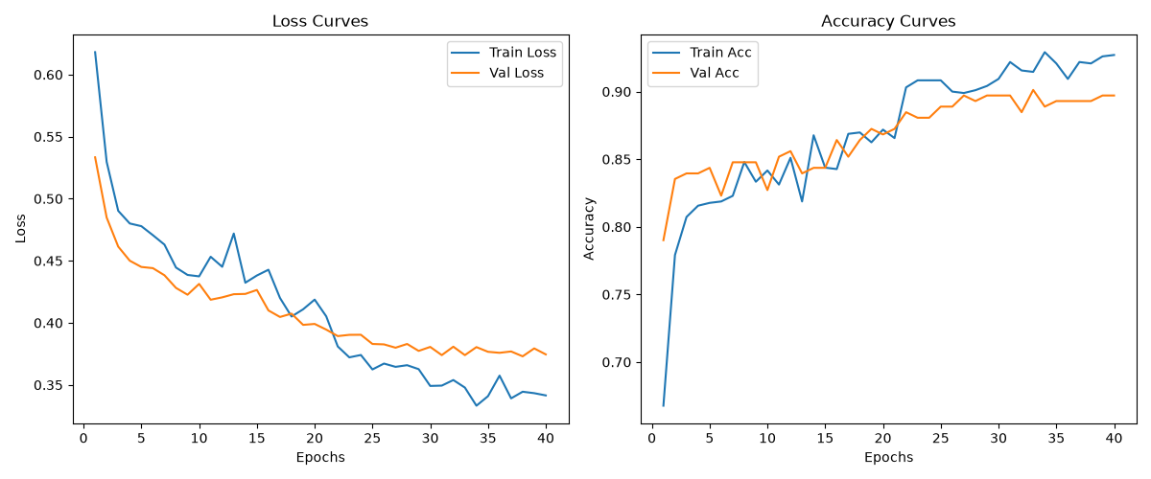
Figure 14 — EfficientNet-B2 Training Curves (Phase 2 — No YOLO)
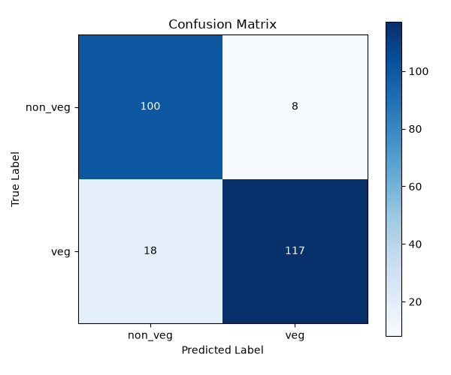
Figure 15 — EfficientNet-B2 Confusion Matrix (Phase 2)

Chapter 9 — Known Flaws & Failure Analysis
Understanding where the model fails is as important as knowing where it succeeds. This chapter documents every known failure mode with root causes and attempted fixes.
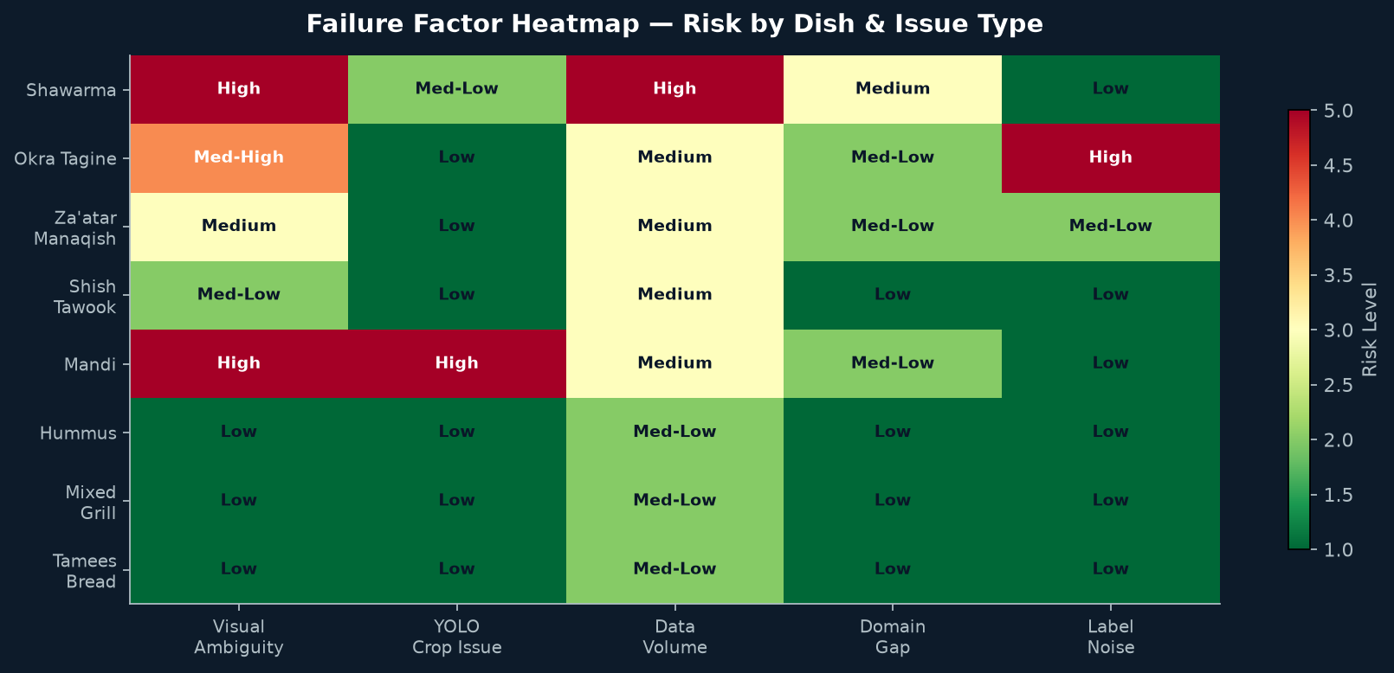
Figure 16 — Failure Factor Heatmap: Risk Level by Dish and Issue Type

Failure 1 — Shawarma: The Persistent Problem
Shawarma is the most persistent failure across all 10 phases. The restaurant serves Shawarma wrapped in pita bread, so the exterior looks like a flatbread vegetarian dish. The hidden meat inside is invisible to the camera.
- Root cause: Pita wrapper hides all meat — model sees bread exterior
- Phase 8 fix: 17× data boost (5 → 86 images) — improved but not solved
- Phase 9 status: Still at 57.1% — new images did not match restaurant pita-wrap style
- Fix needed: 50-100 photos specifically showing pita-wrapped Shawarma cross-sections

Failure 2 — Mandi: The Sea of Rice Problem
Mandi is visually dominated by yellow/brown rice (70-90% of pixels). The meat (chicken or lamb) is often small, buried under the rice, or camouflaged by similar-coloured roasted vegetables and nuts.
- Root cause 1: Large rice portion fools model into predicting Veg
- Root cause 2: YOLO sometimes crops out the meat at plate edges — then classifier only sees rice
- Root cause 3: Slow-roasted meat has golden-brown colour identical to roasted vegetables
- Status: Variable — 100% in Phase 8 but dropped to 85.7% in Phase 9

Failure 3 — Okra Tagine: Label Ambiguity
Okra Tagine can be prepared as a fully vegetarian stew or as a meat stew with lamb or beef. This creates inherent label noise in the dataset — the model cannot be expected to classify accurately when the ground truth itself is ambiguous.
- Root cause: Same visual appearance for Veg and Non-Veg versions of the dish
- EfficientNet result: 50.0% — worse than random chance
- Fix needed: Consistent labelling policy OR a separate 'preparation-dependent' class

Failure 4 — The 90.9% Restaurant Ceiling
Every model variation tested in Phases 9 and 10 hits the exact same 90.9% restaurant accuracy. This is a mathematical data ceiling, not a model limitation.
- Variables already tested: Image resolution (288 vs 344), YOLO vs raw, MobileNetV3 vs EfficientNet-B2
- Consistent failures: Same 4-5 images always misclassified regardless of model
- Conclusion: Training data is the bottleneck — more model tuning will not help
- Only fix: Targeted data collection for Shawarma, Okra Tagine, Za'atar Manaqish

Failure 5 — EfficientNet Stage 2 Cancellation
EfficientNet-B2 Stage 2 fine-tuning was cancelled because the estimated training time exceeded 5 hours per epoch on CPU. The Phase 10 comparison is therefore between a fully fine-tuned MobileNetV3 and an only half-trained EfficientNet.
- Parameters: EfficientNet-B2: ~9M vs MobileNetV3-Large: ~5M
- Impact: Phase 10 results are not a fair architecture comparison
- Fix needed: GPU training environment for EfficientNet Stage 2

Chapter 10 — Lessons Learned

Lesson 1: Data Quality > Model Architecture
The 90.9% restaurant ceiling held across MobileNetV3 and EfficientNet-B2. Investing in better targeted training data would outperform any architecture switch.

Lesson 2: YOLO Pre-processing was Transformative
A single preprocessing step (YOLOv8 background removal) gained +3.4 percentage points (89.3% → 92.7%). This had more impact than any hyperparameter or architecture change.

Lesson 3: Binary Classification is 20-25pp Easier Than Multi-Class
Veg/Non-Veg binary classification consistently outperforms 26/35-class dish-level classification by a wide margin, because the model learns discriminative dietary features rather than subtle visual differences between individual dishes.

Lesson 4: Cross-Domain Transfer Learning Works
Fine-tuning on the German dataset (entirely different cuisine) reached 95.53%, proving the YOLO + MobileNetV3 backbone generalizes well across food domains.

Lesson 5: Targeted Augmentation Must Match Deployment Domain
Shawarma's 17× boost improved standard test accuracy but restaurant accuracy did not recover because the new training images did not match the pita-wrapped style used in the actual restaurant test set.

Lesson 6: YOLO Can Hurt as Well as Help
For dishes like Mandi, YOLO's crop can accidentally remove the meat that sits on the plate edges, causing misclassification as Veg. Segmentation is not always optimal.

Lesson 7: The 90.9% Ceiling is a Data Problem
After testing resolution, architecture, and preprocessing variations, the conclusion is clear: the same 4-5 images are always misclassified. Only targeted data collection for Shawarma, Okra Tagine, and Za'atar Manaqish will break this ceiling.

Lesson 8: Class Imbalance Correction is Critical
Using inverse-frequency class weights in CrossEntropyLoss was essential for preventing the model from defaulting to the majority class in imbalanced datasets.

Chapter 11 — How to Run the Project
This chapter covers every command needed to reproduce the full pipeline from scratch.

Step 1 — Clone the Repository
$ git clone https://github.com/Mehdidar/DishDetect-SA.git
$ cd DishDetect-SA

Step 2 — Install Dependencies
$ pip install -r requirements.txt

Step 3 — Validate Your Dataset
$ python tools/dataset_check.py --dataset /path/to/dataset

Step 4 — Crop Images with YOLO
$ python scripts/yolo_seg_crop.py --input /path/to/raw --output /path/to/cropped

Step 5 — Train the Model
$ python scripts/train.py --dataset /path/to/cropped
$ # Results saved to checkpoints/ and results/

Step 6 — Evaluate on Standard Test
$ python scripts/evaluate.py --dataset /path/to/cropped

Step 7 — Evaluate on External Test
$ python scripts/evaluate_external.py --test_dir /path/to/external_test

Step 8 — Predict a Single Image
$ python scripts/predict.py --image /path/to/food.jpg --threshold 0.7

Step 9 — Run Restaurant Analysis
$ python scripts/restaurant_analysis.py
$ # Outputs charts to results/restaurant_analysis/

Step 10 — Launch the GUI
$ python app/ui.py

Step 11 — Generate All Reports
$ python scripts/generate_master_report.py
$ python scripts/generate_architecture_report.py
$ python scripts/generate_walkthrough_book.py

Chapter 12 — Next Steps & Roadmap

Immediate Wins — Data Collection
- Collect 50-100 pita-wrapped Shawarma images specifically the cross-section view revealing the meat inside
- Collect diverse Mandi images where the chicken/lamb is prominently visible above the rice
- Standardise Okra Tagine labelling — either split into Veg/Non-Veg subcategories or set a clear policy

Pipeline Improvements
- Disable YOLO crop for Mandi and test if full-image classification improves the meat/rice disambiguation
- Train EfficientNet-B2 Stage 2 on GPU for a fair architecture comparison
- Implement Test-Time Augmentation (TTA) to improve robustness on ambiguous low-confidence predictions
- Add confidence threshold to UI flag predictions below 65% as 'Uncertain — Please Verify'
- Add Grad-CAM visualisations to show which food region the model is focusing on for each prediction

Scaling & Deployment
- Export model to ONNX / TFLite for mobile and edge device deployment
- Build a REST API using FastAPI or Flask for restaurant POS system integration
- Expand to additional Arabic cuisines — Jareesh, Kabsa, Saleeg, Mansaf, Machboos
- Publish model to Hugging Face Hub for community access and benchmarking

DishDetect SA — Walkthrough Book · github.com/Mehdidar/DishDetect-SA · Generated 10 October 2026, 22:03

